
Development of an Image Processing-Based System for Microplastic Detection in Water
Using Fluorescence of Rhodamine B and Silver Nanoparticles

Nitchakarn Pholherm^{1*}, Rawisara Chaiprasit¹
Natpassorn Laonet², Wipharat Chuachuad Chaiyasith³, Rattapoom Waranusast³
^{1,2}Princess Chulabhorn Science High school Phitsanulok No.86 Village No. 4 Makham Sung, Mueang Phitsanulok, Phitsanulok, 65000 Thailand
³Naresuan University No. 99 Village No. 9 Tha Pho, Mueang Phitsanulok, Phitsanulok 65000 Thailand
*e-mail: nitchakarn.niixq@gmail.com

Abstract
Microplastics have emerged as a significant environmental concern due to their ubiquity in water, soil, and air, as well as their potential to accumulate in the human body and pose various health risks. Consequently, this project developed a microplastic detection system utilizing Surface-Enhanced Fluorescence (SEF) combined with image processing techniques. Silver nanoparticles (AgNPs) were employed to enhance the fluorescence signal of Rhodamine B solution, thereby increasing detection sensitivity. The detection system was designed as a closed unit to minimize ambient light interference, equipped with a webcam and internal UV LED lighting to stimulate fluorescence. Experiments were conducted to determine the optimal conditions by varying the Rhodamine B concentration between 10⁻⁵ to 10⁻³ M and adjusting the ratio of silver nanoparticles to Rhodamine B solution from 1:1 to 3:1. The results indicated that the most effective condition was Rhodamine B at a concentration of 10⁻³ M mixed with silver nanoparticles at a 2:1 ratio. This yielded the highest absorbance value of 1.85±0.01 AU, which correlated directly with the most distinct fluorescence signal, enabling the system to effectively differentiate microplastics from the background solution. Upon testing the image processing system with 5000 sample images of microplastics at concentrations of 1–10 ppm, a coefficient of determination of 0.94 was observed. This developed system facilitates a more convenient and rapid microplastic detection process, addressing the demand for effective monitoring in various environments and mitigating the current issue of discontinuous environmental surveillance.

Keywords: Microplastics; Rhodamine B; Silver Nanoparticles; Surface-Enhanced Fluorescence (SEF)
Introduction
"Microplastics" are small plastic particles with a diameter of less than 5 millimeters down to an extremely small size invisible to the naked eye, which mostly originate from the degradation and fragmentation of larger plastic waste. Currently, they are considered a major environmental problem because their contamination can be found universally in water sources, soil, and air, as well as being mixed into food and beverages consumed by humans in daily life. When these microplastics enter the ecosystem, they directly impact living organisms in nature, particularly marine animals that often ingest them inadvertently, causing accumulation in the food chain, and ultimately, the impact reverses back to humans, who are the apex consumers, both in terms of health and livelihood.
The impact of microplastics on humans has continuously begun to receive more attention and awareness of its importance. According to study data, humans may consume microplastics into the body at an average of approximately 5 grams per week, or equivalent to 1 credit card, which accounts for a cumulative amount of over 250 grams per year. Although the World Health Organization (WHO) states that the body has mechanisms to excrete these foreign substances, if the microplastics are so small that they remain or are not entirely excreted, they may pose long-term health risks, such as disrupting the working system of hormones, obstructing the blood circulatory system, or potentially being a risk factor for causing cancer.

To cope with this problem, a chemical substance like "Rhodamine B" has been applied for detection. This substance is classified as a fluorescent agent with prominent chemical properties, consisting of amino acids and organic acids that can absorb energy and emit light when stimulated by an appropriate light source, such as ultraviolet (UV) light, allowing us to clearly observe the fluorescence, which is a fundamental and important property that helps identify the position of target objects in inspection.
Furthermore, "Silver Nanoparticles" (AgNPs) technology has been introduced to help enhance efficiency. These particles are extremely small at the nanometer scale, featuring a prominent point of a high surface area, ability to fluoresce, and good responsiveness to the environment. Additionally, they possess a special ability to bind with other molecules, such as plastic particles, through chemical processes, enabling them to capture and react with target substances more efficiently.
The working principle of this developed system relies on the collaboration between the fluorescent agent Rhodamine B and silver nanoparticles to detect microplastics by utilizing the "hydrophobic" property of all three substances, causing them to aggregate to avoid water. This results in a phenomenon called Surface-Enhanced Fluorescence (SEF), in which the silver nanoparticles will help amplify the fluorescence signal of Rhodamine B to be more intense and distinct when adhered to the surface of microplastics, helping the system detect and differentiate microplastics from sample water accurately and rapidly.
Currently, although standard inspection methods provide precise results, they often have limitations regarding high costs and complexity in operation. The authors have therefore developed a prototype microplastic detection device innovation, which works in conjunction with an "Image Processing" system within a closed system that controls interfering light, equipped with a camera and a UV lamp to analyze results through software automatically. This method helps reduce errors from human visual assessment, making it possible to clearly identify the quantity of microplastics. Moreover, it has a low cost compared to advanced analytical instruments, making it an alternative that helps increase opportunities for widespread and sustainable surveillance and management of microplastic contamination problems in the environment.
Methodology
The research process was systematically designed by dividing the operation into 3 main parts, namely: (1) studying the concentration of Rhodamine B solution that gives the best fluorescence signal of microplastics; (2) studying the ratio of silver nanoparticles (AgNPs) and Rhodamine B (RhB) that gives the clearest fluorescence of microplastics and is appropriate for further analysis; and (3) developing a microplastic detection system using image processing.
The study of the concentration of Rhodamine B
Prepare Rhodamine B (RhB) solution in the concentration range of 1×10⁻⁵ M to 1×10⁻³ M for measurement. Bring the RhB solution at each concentration to mix with PET microplastics, and then perform excitation with UV light at the wavelength range of 312–365 nanometers. After that, observe and compare the intensity of the fluorescence by measuring the absorbance value with a Spectrophotometer to evaluate the concentration of RhB that gives the best fluorescence signal of microplastics.
Study the ratio of silver nanoparticles (AgNPs) and Rhodamine B (RhB)
Perform the synthesis of silver nanoparticles (AgNPs) by the Lee–Meisel method using sodium citrate as a reducing agent until the solution changes to yellow–brown, and adjust the concentration of silver nanoparticles (AgNPs to be constant at 0.01 mM, while checking the position of the absorption peak which is in the range of approximately 400–450 nm with UV–vis spectroscopy. Then, perform a study on the effect of the ratio between the silver nanoparticles (AgNPs) and RhB solutions by mixing both solutions in various ratios, namely 1:1, 1:2, 1:3, 2:1, and 3:1, by keeping the concentration of silver nanoparticles (AgNPs) constant at 0.01 mM and the concentration of RhB according to the optimal value from Part 1. After that, excite the fluorescence with a BTU-6 model UV light generator and observe the difference in fluorescence in a Petri dish by comparing the signal intensity between each ratio to find the AgNPs:RhB ratio that gives the clearest fluorescence of microplastics and is appropriate for further analysis.
The development of a microplastic detection System
The machine is designed as a closed system in the form of an opaque box with a size of 23x23 centimeters, manufactured from black acrylic sheets to eliminate interfering light from the outside. The front is installed with a drawer for placing the sample Petri dish. Inside, it contains UV LED lamps (wavelength 312–365 nm) acting to excite the fluorescence of microplastics. Around the center of the box lid, a Webcam camera is installed for recording high-angle images to cover the entire area of the Petri dish, in which the system will connect with a Raspberry Pi board to process images and display analysis data through a monitor screen installed on the top of the machine.
The development of an image processing system
The image processing system was developed on a Raspberry Pi 5 board in conjunction with a 1080p resolution Webcam camera, using the OpenCV library to analyze 5000 sample photographs of microplastics (concentration 1-10 ppm). The processing steps begin with defining the image boundaries (Cropping) specifically around the Petri dish area, and converting the color space into the LAB format to emphasize and make the fluorescence signal prominent. After that, objects are separated from the background using the Adaptive Thresholding technique, and noise is reduced with Morphological Closing to obtain the most complete boundaries of the microplastics. When the pixel area data of the objects is obtained, the system will take such values to analyze and find statistical relationships with a linear regression equation (Linear Regression) through Scikit-learn in order to create a model for calculating and converting the detected area values back into the concentration quantity of microplastics (ppm).
Result and Discussion
The analysis results of both types of solutions confirm the ability to fluoresce in being used as an important component for microplastic detection, in which the Rhodamine B (RhB) solution and silver nanoparticles can efficiently enhance the fluorescence of microplastics.
Table 1 Study of the concentration of RhB solution
RhB (M) concentration | Mean (AU)
10⁻³ | 1.85±0.01
10⁻⁴ | 1.25±0.04
10⁻⁵ | 0.31±0.00
The analysis results of the concentration of Rhodamine B solution from Table 1 found that the 10⁻³ M RhB and AgNPs can absorb the highest light, which consequently results in having a high fluorescence capability.
Table 2 Study of the effect of the ratio between silver nanoparticles (AgNPs) and Rhodamine B (RhB) solutions on fluorescence intensity
AgNPs:RhB | First | Second | Third
2:1

The analysis results of the ratio between AgNPs and RhB solutions on fluorescence intensity from Table 2 found that the 2:1 ratio of AgNPs to RhB is the ratio that gives the best result in microplastic detection, because it gives a fluorescence signal of microplastics that has clarity and can differentiate from the solution the best.
Image processing
The program will process the image and then take the obtained values to plot a relationship graph used for converting the detected area of microplastics into the concentration of microplastics (ppm), which is y = 8.85x – 5.82, providing the results as shown in the graph below.
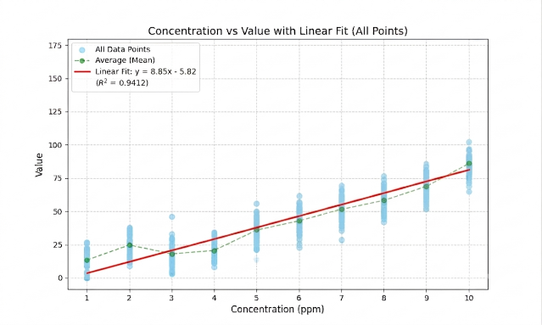
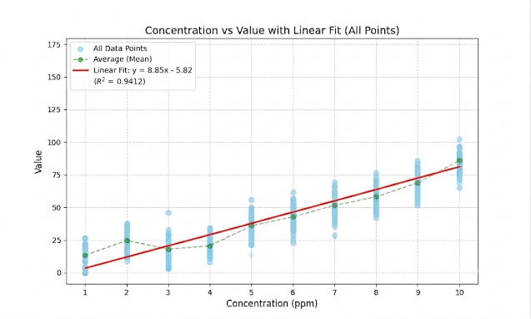

Figure 5 Graph of microplastic area versus concentration
The study results found that the fluorescence signal value varies directly with the concentration of microplastics (1–10 ppm), having a linear relationship according to the equation y = 8.85x – 5.82 corresponding to the principle of Surface-Enhanced Fluorescence (SEF). By having an R² $≈$ 0.94, it demonstrates a significant response. However, in the high concentration range (9–10 ppm), an increased dispersion of data was found, which might be a result of the instability in the accumulation of microplastics in the system.
Conclusion
The development of a microplastic detection system in water using image processing from the fluorescence of Rhodamine B and silver nanoparticles achieved success according to the objectives. In the step of studying the concentration of Rhodamine B solution, it was found that the concentration level at 10⁻³$\text{ M}$ gives the highest light absorbance and gives a sharp fluorescence signal, helping the system efficiently isolate microplastic particles from the background solution. For finding the optimal ratio between silver nanoparticles and Rhodamine B, it was found that the 2:1 ratio gives the best experimental result, having a prominent fluorescence signal around the microplastics, which makes it easy for quantitative analysis using image processing.
From the quantitative relationship analysis through image processing, it was found that the total brightness value (Value) tends to vary directly with the concentration of microplastics in the range of 1–10 ppm, having a linear relationship according to the y = 8.85x – 5.82 and having a coefficient of determination R² $≈$ 0.94, which reflects a significant response according to the principle of Surface-Enhanced Fluorescence (SEF). In this regard, although in the high concentration range between 9–10 ppm a wider dispersion of data was found due to variations in the accumulation of microplastics, the developed system still demonstrates the potential to efficiently detect and classify the quantity of microplastics.
Acknowlegements
Express gratitude to teacher Natpassorn Laonet, the project advisor, who has constantly provided knowledge, assistance, comments, and continuously given advice regarding conducting this project, and to Princess Chulabhorn Science High School Phitsanulok and all laboratory staff, who provided assistance, accommodated the venue, and various materials and equipment.
References
Huiyan Tong et al. 2021.
Research studies indicate that ethanol is the most effective solvent for preparing Rhodamine B (RhB) solutions for staining microplastics (MPs), especially types that are small, white, or transparent, such as PE, PP, PS, PVC, and PU. In which RhB has high fluorescence stability (durable for at least 24 hours), even under light conditions or solutions with aggressive properties (KOH, ${\text{HNO}}_{3}$, NaCl). In addition, staining with RhB does not affect Raman spectral results, therefore making it a simple, effective method that is suitable for polymer type identification under a fluorescence microscope.
Ratchadaporn Seedad. 2022.
The synthesis of silver nanoparticles (AgNPs) and AgNPs@CDs nanocomposite materials found that they have high efficiency in being used as heavy metal ion detection sensors through color change and fluorescence. In which AgNPs can detect ${\text{Pb}}^{2+}$ in natural water sources well, while AgNPs@CDs have high sensitivity and specificity in the analysis of ${\text{Cr}}^{3+}$ and ${\text{Co}}^{2+}$ in dietary supplement products. This method features prominent points in low cost, uncomplicated procedures, and has the potential to be developed into a high-precision field test kit.

