Estimation of Spinal Curvature without Radiation Exposure Using a Polynomial Regression Equation Calculated from Shoulder, Waist and Hip Inclination Angles

Aratchaporn Jiraprathip¹, Punyarat Boonyou¹ Tritsawan Suddee¹*
Sonruedee Srisawat¹ and Supreeya Phothong²
¹Princess Chulabhorn Science High School Phetchaburi, Kao-Yai, Cha-Am, Phetchaburi
²Bangkok Hospital Hua Hin, Hua Hin, Hua Hin, Prachuap Khiri Khan
*Email : 67tritsawan.sud@pccphet.ac.th

Abstract
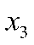
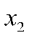
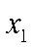
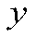
Scoliosis is a condition characterized by abnormal curvature of the spine, which affects posture, balance, and overall mobility. The Cobb angle obtained from X-ray imaging is the standard measure of spinal curvature; however, repeated exposure limits long-term follow-up. This study developed a non-radiographic method for estimating the Cobb angle ( ) using observable body-tilt variables, including shoulder tilt ( ), waist tilt ( ), and hip tilt ( ) Polynomial Regression was applied to create predictive equations based on the Apex of the spinal curve, and the model was developed in two groups according to the direction of the Apex, yielding the following results.
The first regression equation is:
$$y=13.1445x_{1}-2.8507x_{2}+14.2826x_{3}-1.6406x_{1}^{2}-0.0018x_{2}^{2}-0.5919x_{3}^{2}+1.5023x_{1}x_{2}-1.4141x_{1}x_{3}-0.9068x_{2}x_{3}$$
with an accuracy of $R^{2}=0.9988$
The second regression equation is:
$$y=15.1265x_{1}+2.4006x_{2}+5.0196x_{3}-1.3531x_{1}^{2}+0.0039x_{2}^{2}-0.9461x_{3}^{2}-0.3011x_{1}x_{2}+1.2812x_{1}x_{3}-0.0732x_{2}x_{3}$$
with an accuracy of$R^{2}=0.9966$
The model evaluation showed an average prediction error ranging from 4.26% to 4.66%, which is acceptable for preliminary use. The high determination coefficients
($R^{2}≈0.9966-0.9988$) confirm that body-tilt variables can effectively support scoliosis screening without radiation. The equations were integrated into a prototype radiation-free Cobb angle assessment device that calculates spinal curvature from external body-tilt data. This system simplifies screening, reduces radiation exposure, and shows strong potential for practical use in hospitals and community healthcare settings.

Keywords: Scoliosis, Cobb angle, Polynomial regression, Body-tilt equation, Non-radiographic assessment

Introduction
Scoliosis is a three-dimensional spinal deformity characterized by an abnormal lateral curvature accompanied by vertebral rotation. If left untreated, the condition may progressively impair posture, balance, mobility, and the functions of the musculoskeletal, respiratory, circulatory, and nervous systems, thereby reducing patients’ quality of life. Early detection and continuous monitoring are therefore essential for preventing disease progression and improving treatment outcomes.
The severity of scoliosis is commonly evaluated using the Cobb angle, which is measured from standing posteroanterior radiographs and is widely recognized as the clinical gold standard. Although radiographic assessment provides reliable diagnostic information, repeated examinations expose patients to cumulative ionizing radiation. This concern is particularly important for adolescents with idiopathic scoliosis, who often require periodic follow-up throughout their growth period. Alternative imaging modalities, such as magnetic resonance imaging (MRI), eliminate radiation exposure but remain costly, time-consuming, and unsuitable for routine screening.
Several external physical characteristics of scoliosis, including asymmetry of the shoulders, waist, and hips, are visually observable and have been used in preliminary screening methods such as the Adam’s Forward Bending Test. These anatomical features suggest that external body morphology may correlate with the magnitude of spinal curvature and could potentially be used to estimate the Cobb angle without radiographic imaging.
Based on this concept, the present study proposes a radiation-free method for estimating the Cobb angle using external body inclination angles. Shoulder, waist, and hip inclination angles were extracted from radiographic images and employed as predictor variables for constructing polynomial regression models. The resulting models were subsequently incorporated into a prototype radiation-free Cobb angle assessment device. This approach aims to reduce radiation exposure, improve accessibility to scoliosis screening, and provide a practical tool for continuous patient monitoring in both clinical and community settings.
Methodology

1.) Collection and Selection of X-ray Images
Standing anteroposterior X-ray images of patients with scoliosis were collected and selected for eligibility. Only images in which the patients were standing upright and the anatomical landmarks, including the shoulders, waist, hips, and spinal vertebrae, were clearly visible were included in the study. The selected X-ray images were then categorized into two types of spinal curvature: C-shaped scoliosis (Figure 1A) and
S-shaped scoliosis (Figure 1B).

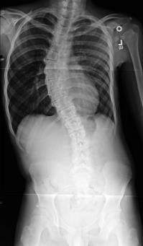
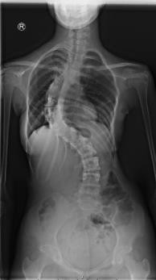


(B)

apex

apex

(A))
Figure 1. (A) Example of an X-ray image of a patient with C-shaped scoliosis. (B) Example of an X-ray image of a patient with S-shaped scoliosis.
2.) Measurement of Angles from X-ray Images
The shoulder, waist, and hip tilt angles were measured using a horizontal reference line. The left side of the image was designated as the fixed reference point, with the shoulder endpoint, the narrowest point of the waist, and the most prominent point of the hip selected as anatomical landmarks (Figure 2A). A straight line was then drawn through each reference point, following the inclination of the shoulder, waist, and hip (Figures 2B and 2C), to calculate the tilt angle of each anatomical structure.
The Cobb angle was measured according to standard medical guidelines. The apex of the spinal curvature, defined as the vertebra showing the greatest deviation from the spinal midline (Figure 2D), was identified and used to determine the direction of the spinal curvature.

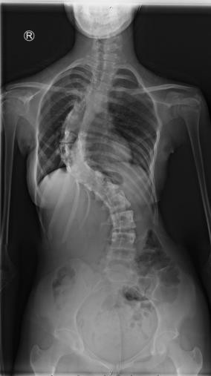
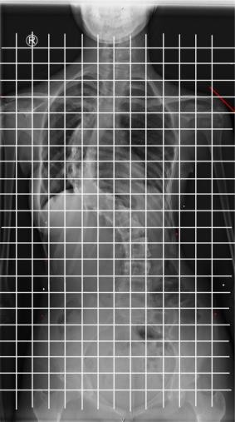

(B))

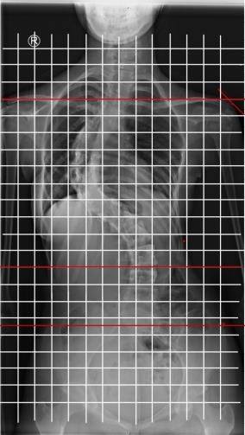
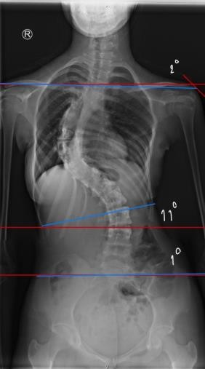

Figure 2. Method for measuring the shoulder, waist, and hip tilt angles, and the Cobb angle.
3.) Development of a Polynomial Regression Equation for Cobb Angle Prediction
The external body structure measurements, including the shoulder tilt angle, waist tilt angle, and hip tilt angle, obtained from X-ray image analysis, were used to investigate their relationship with the Cobb angle. The independent variables were defined as the
shoulder tilt ($x_{1}$), waist tilt ($x_{2}$), and hip tilt ($x_{3}$)
, while the dependent variable was the Cobb angle ($y$).
The dataset was divided into two groups according to the direction of spinal curvature: the left-apex group and the right-apex group. The data from each group were then substituted into the general polynomial regression model to estimate the coefficients of all variables and develop a mathematical model for predicting the Cobb angle. The constant term of the regression equation was set to zero to ensure that the model reflected the physical relationship between external body asymmetry and the severity of scoliosis.
The general form of a polynomial regression equation for a single independent variable is as follows :
$f(x)=a_{n}x^{n}+a_{n-1}x^{n-1}+...+a_{1}x+a_{0}$

where${ a}_{n},a_{n-1},...,a_{0}$denotes the regression coefficients, and (x ) denotes the independent variable.
4.) Evaluation of the Cobb Angle Prediction Equation in Patients with Scoliosis
1. Selection of Participants
Photographic images of 10 patients with scoliosis were selected from publicly available data on independent websites. For each patient, the collected data included an upright standing photograph, an image obtained during the Adam’s Forward Bending Test, and the Cobb angle measured by a medical specialist.
2. Classification of the Direction of Spinal Curvature
Photographs obtained during the Adam’s Forward Bending Test were used to classify the direction of spinal curvature. The classification was based on the prominence of the rib hump, as shown in Figure 3. In patients with right-sided scoliosis, a prominent rib hump was observed on the right side. Conversely, in patients with left-sided scoliosis, the rib hump was more prominent on the left side.

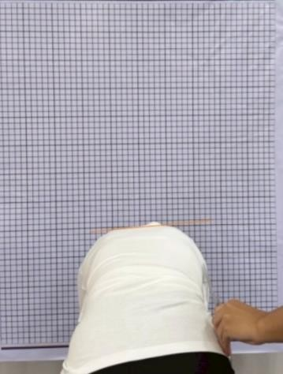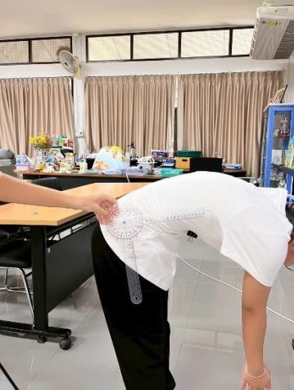

Figure 3. Example of a patient performing the Adam’s Forward Bending Test for scoliosis screening.
3. Measurement of Body Structure Tilt Angles from Photographs
The photographs of the selected cases were imported into Kinovea for analysis. Anatomical landmarks were identified, including the endpoints of both shoulders, the narrowest point of the waist, and the most prominent point of the hips. The Angle tool in Kinovea was then used to draw lines connecting these reference points and measure the tilt angles of the shoulders, waist, and hips, as shown in Figure 4. The measured values were subsequently recorded. 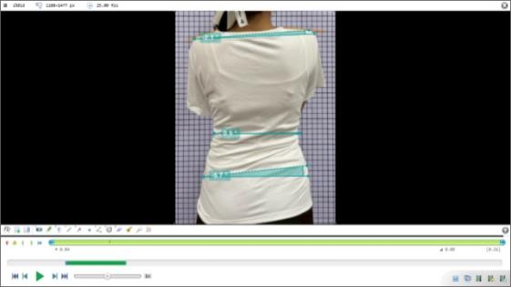

Figure 4. Example of an image displayed in Kinovea software for measuring shoulder, waist, and hip tilt angles.
4. Recording of Cobb Angle and Shoulder, Waist, and Hip Tilt Angle Data
The shoulder, waist, and hip tilt angles were recorded together with the direction of spinal curvature and the Cobb angle for 10 participants. The collected data were then summarized in Table 1.
Table 1 body tilt angles and spinal curvature directions of the 10 participants.

No. | Body Tilt angle (° ) |  |  | Direction of Curve | Actual Cobb Angle(° )
No. | Shoulder | Waist | Hip | Direction of Curve | Actual Cobb Angle(° )
1 | 1 | 5 | 4 | Left | 33
2 | 3 | 2 | 1 | Left | 47
3 | 1 | 7 | 4 | Left | 36
4 | 1 | 5 | 1 | Left | 28
5 | 1 | 5 | 2 | Left | 33
6 | 4 | 7 | 8 | Right | 32
7 | 7 | 13 | 4 | Right | 69
8 | 4 | 2 | 1 | Right | 36
9 | 1 | 1 | 6 | Right | 52
10 | 3 | 8 | 5 | Right | 41

Results
- From the development of the
polynomial regression equations for forecasting the Cobb angle, with the constant term set to 0, two equations were obtained as follows:
Polynomial regression equation for the right Cobb angle:
With an $R^{2}$value of 0.9988 and a percentage error of 4.2588%
Polynomial regression equation for the left Cobb angle:
With an $R^{2}$value of 0.9966 and a percentage error of 4.6457%
Where $x_{1}$ represents the shoulder tilt angle,
$x_{2}$represents the waist tilt angle,${ x}_{3}$represents the hip tilt angle, and y represents the Cobb angle in degrees.
2.)From the equations, the performance of the mathematical models can be analyzed and evaluated by determining the coefficient of determination $R^{2}$and the equation error values, comparing the calculated Cobb angles with the standard measured Cobb angles, as follows:
The polynomial regression equation for the right Cobb angle has an $R^{2}$value of 0.9988 and a percentage error of 4.2588%, and the polynomial regression equation for the left Cobb angle has an $R^{2}$value of 0.9966 and a percentage error of 4.6457%.
3.) A prototype of a tool model for predieting the Cobb angle can be designed, and the results are demonstrated as follows:

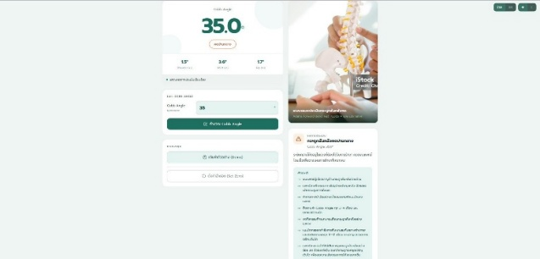
Figure 5: Display of the Cobb angle from the measurement using the corrective garment

Discussion
From the study, the authors used the primary Cobb angle to classify the equations into two models because the primary Cobb angle involves the force and deviation direction that most significantly impact the body structure, thereby enhancing model accuracy.
Scatter plots between body structures (shoulder, waist, and hip) and the Cobb angle revealed a non-linear relationship and scattered distribution. Therefore, polynomial model equations were selected, yielding high accuracy ($R^{2}$>0.90 and error≈4.2−4.6%). This indicates a high correlation between the physical characteristics of scoliosis patients and the Cobb angle.
Consequently, these findings align with previous research reporting that adolescent scoliosis patients exhibit structural asymmetry—such as uneven shoulders, asymmetrical waistlines, or rib cage prominence—which serves as a severity indicator. Furthermore, it is consistent with the standard initial screening (Adam’s Forward Bending Test), which identifies spinal deviation by bending the trunk forward to observe rib cage prominence. This relationship can be applied to design a prototype model for predicting the Cobb angle, which can be further developed as an innovation for early scoliosis screening.

Conclusion
- .From the data analysis, it was
found that the relationship between the tilt angles of the shoulder, waist, and hip, and the Cobb angle is non-linear. Therefore, polynomial regression equations were selected to construct the models. Two predictive equations were successfully developed: an equation for the right Cobb angle and an equation for the left Cobb angle. These equations can accurately estimate the Cobb angle from the tilt angles of the shoulder, waist, and hip, yielding the equations as follows:
For the right Cobb angle:
($R^{2}$ = 0.9988 , error = 4.2588 % )
For the left Cobb angle:
($R^{2}$= 0.9966 , error = 4.6457 % )
2.) .From the model performance evaluation, it was found that the model for the right Cobb angle has a coefficient of determination ($R^{2}$) of 0.9988 and a percentage error of 4.2588%. Meanwhile, the model for the left Cobb angle has a coefficient of determination ($R^{2}$) of 0.9966 and a percentage error of 4.6457%. This indicates that the models possess high accuracy, effectively explain the relationships of the data, and have a mean percentage error of less than 5%, which demonstrates sufficient efficiency for estimating the Cobb angle.

3.) The developed models can be applied to the design of a radiation-free Cobb angle assessment tool prototype. By utilizing the tilt angles of the shoulder, waist, and hip as input data to calculate the Cobb angle and displaying the evaluation results through a prototype system, it helps reduce reliance on X-ray examinations for initial assessments. Furthermore, it can be further developed into a tool for screening, monitoring symptoms, and supporting the diagnosis of scoliosis in the future.

Recommendations
1.) Future studies should include a larger and more diverse dataset covering different age groups, genders, and scoliosis severities to improve the robustness and generalizability of the developed polynomial regression models.
2.) Computer vision or artificial intelligence techniques should be integrated to automatically detect body landmarks and measure shoulder, waist, and hip inclination angles, thereby reducing human error and improving assessment efficiency.
3.) The developed prototype should be further validated in hospitals and community healthcare settings using larger independent patient populations to evaluate its clinical performance and practical applicability for routine scoliosis screening and long-term patient monitoring.
4.) Future research may incorporate additional external body parameters or advanced machine learning algorithms to further improve the accuracy and reliability of radiation-free Cobb angle estimation.

Acknowledgements
The authors would like to express their sincere gratitude to Princess Chulabhorn Science High School Phetchaburi for providing research facilities and continuous academic support throughout this study. The authors also gratefully acknowledge their research advisors,teachers, and all participants who contributed to the collection of radiographic images and body measurement data. Their valuable guidance, encouragement, and cooperation made this research possible.

References
[1] J. R. Cobb, Outline for the Study of Scoliosis. Ann Arbor, MI, USA: American Academy of Orthopaedic Surgeons, 1948.
[2] F. Altaf, A. Gibson, Z. Dannawi, and H. Noordeen, "Adolescent idiopathic scoliosis," BMJ, vol. 346, p. f2508, 2013.
[3] P. Côté, B. G. Kreitz, J. D. Cassidy, A. K. Dzus, and J. Martel, "A study of the diagnostic accuracy and reliability of the Scoliometer and Adam's forward bend test," Spine, vol. 23, no. 7, pp. 796–802, 1998.
[4] J. Fairbank, "Historical perspective: William Adams, the forward bending test, and the spine of Gideon Algernon Mantell," Spine, vol. 29, no. 17, pp. 1953–1955, 2004.
[5] E. F. Robinson and W. D. Wade, "Statistical assessment of two methods of measuring scoliosis before treatment," Canadian Medical Association Journal, vol. 129, no. 8, pp. 839–841, 1983.
[6] R. Kundu, A. Chakrabarti, and P. K. Lenka, "Cobb Angle Measurement of Scoliosis with Reduced Variability," arXiv preprint arXiv:1211.5355, 2012.
[7] H. Sun, X. Zhen, C. Bailey, P. Rasoulinejad, Y. Yin, and S. Li, "Direct Estimation of Spinal Cobb Angles by Structured Multi-Output Regression," arXiv preprint arXiv:2012.12626, 2020.

