WISIGN: Development of a Solution for Spatial Wireless Network Design and Analysis Using the Log-Distance Path Loss Model for Electromagnetic Wave Propagation Simulation
TH Sarabun New 14 หนา
TH Sarabun New 12 เอียง
TH Sarabun New 14 หนา
TH Sarabun New 12 เอียง
Tanathit Nualtim¹ and Patthamaporn Srisuwan²
Mr. Wutthiphong Prathumma and Dr. Songrit Kitisriworaphan
TH Sarabun New 16
¹Princess Chulabhorn Science High School Mukdahan
281 Moo 6, Nong Hoi Village, Bang Sai Yai Sub-district,Mueang Mukdahan District, Mukdahan, Thailand 49000
*e-mail: songrit@npu.ac.th
ระยะห่าง 2 cm

Abstract
ระยะห่าง 3cm
This project aims to develop a low-cost spatial wireless network design and analysis solution for planning and improving the communication quality of basic Wi-Fi systems. The solution can simulate signals in the form of 2D indoor heatmaps, utilizing the Log-Distance Path Loss model to simulate electromagnetic wave propagation according to the following equation $PL(dB)=PL(d_{0})+10n\log{(\frac{d}{d_{0}})}$ When implementing the developed solution for network planning within the study area at the Ratchawit All-Purpose Building, Princess Chulabhorn Science High School Mukdahan, signal coverage was evaluated based on predefined signal quality criteria (RSSI ≥ −67 dBm and SNR ≥ 25 dB). The results indicated that the solution significantly expanded RSSI signal coverage by 1.7 times compared to the traditional approach, demonstrating a statistically significant difference at p < .01. Furthermore, the SNR signal coverage was enhanced by 1.58 times over the baseline, which also exhibited a statistically significant difference at p < .01. Consequently, it can be concluded that the developed solution can be effectively deployed for practical spatial wireless network design and analysis.
TH Sarabun New 14 ตัวหนา
Keywords: RSSI, SNR, Electromagnetic Waves, Signal Coverage, Access Point
TH Sarabun New 14

Introduction
Wi-Fi networks are an essential part of communication infrastructure, playing a significant role in various settings, including educational institutions, government organizations, and business and industrial sectors. However, problems such as unstable connections and signal loss still occur frequently. One of the main causes is the incorrect placement of Access Points (APs), which fails to suit the spatial layout of the building. As a result, network devices cannot be used to their full potential. Traditional methods of assessing signal quality to determine AP placement usually depend on the installer's experience and estimation, which can lead to technical errors. In addition, commercial tools used for detailed wireless network analysis are often expensive and difficult for small organizations or educational institutions to access. Consequently, network planning still lacks accuracy and practical flexibility in real-world use.
เนื้อหาเปน TH Sarabun New 14 Point ตัวปกติ
This project therefore focuses on developing a solution for designing and analyzing wireless networks in terms of spatial coverage. It applies a logarithmic distance path loss model to simulate the propagation pattern of electromagnetic waves and presents the results in the form of a two-dimensional heat map. The significance of this project lies not only in developing a low-cost and accessible wireless network analysis solution, but also in applying it to solve real network problems that occur within indoor environments. The results improve the quality of wireless communication, which can be further developed into the design of smart network systems in the context of IoT, Smart Buildings, and Smart Cities in the future.
เนื้อหาเป็น TH Sarabun New 14 Point ตัวปกติ
TH Sarabun New 14 ตัวหนา
Methodology
1) Development of a Low-Cost Solution for Spatial Wireless Network Design and Analysis
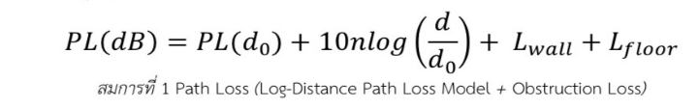
The signal loss value increases according to the logarithm of the distance between the transmitter and the receiver, and is further influenced by the walls and floors located along the signal propagation path. Here, $PL(dB)$ is the total signal loss, measured in decibels (dB), at distance d from the signal transmitter; $PL(d₀)$ is the reference signal loss at the reference distance $(d₀)$, which is typically set at 1 meter in indoor environments; n is the path loss exponent, which reflects the characteristics of the wave propagation environment; d is the distance between the transmitter and the receiver; and $L_{wall}$ and $L_{floor}$ are the signal losses caused by walls and floors, respectively, which depend on the number and type of materials the signal must pass through. These values are then used to evaluate the total signal loss.  The Received Signal Strength Indicator (RSSI) is calculated based on the transmission power of the device combined with the signal loss that occurs during propagation, where $G(TX)$ is the gain of the transmitting antenna, measured in decibels $(dB)$, and $PL(dB)$ is the total signal loss that occurs between the transmitter and the receiver, which is calculated using the signal loss model. The resulting RSSI value therefore reflects the actual signal power level received by the device and is used as a basic indicator for evaluating signal quality. It is then applied in the analysis and creation of a Heatmap of the wireless signal within the building
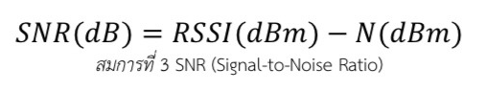
The Signal-to-Noise Ratio (SNR) is calculated, which is an indicator of signal quality in wireless communication systems. The SNR value is expressed in decibels (dB). In this equation, $RSSI(dBm)$ is the strength of the signal received by the receiving device from the transmitting device after the signal loss during propagation has been subtracted, while N(dBm) is the Noise Floor of the system, which is caused by electrical interference, heat generated by devices, as well as interference from nearby devices or wireless networks. The SNR value can be used to evaluate the performance of the wireless communication system, as it indicates how clearly the received signal stands out above the noise, which affects the stability and data transmission rate. This value is then used, together with the RSSI value, to create a Heatmap at a later stage.
เนื้อหาเป็น TH Sarabun New 14 Point ตัวปกติ

1) Improving the Quality of Basic Wi-Fi Communication Systems
The experiment is divided into two sets, using the developed WISIGN solution to simulate the installation positions and parameters of the Access Points by setting requirements according to each experiment set. Afterward, the AP positions were installed and the parameters were adjusted according to the simulated points, and signals were measured at 68 points within the designated area.

Experiment Set A involved Access Points at the school that were adjusted automatically, while Experiment Set B involved Access Points whose parameters were adjusted using position-analysis software, followed by improving the quality of the basic Wi-Fi communication system.
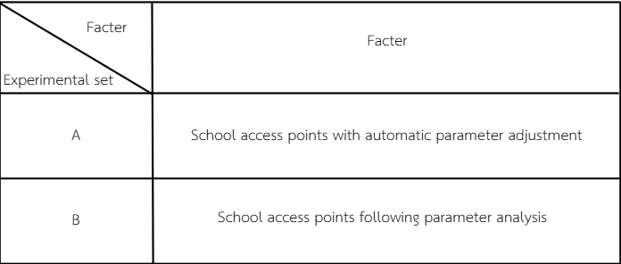
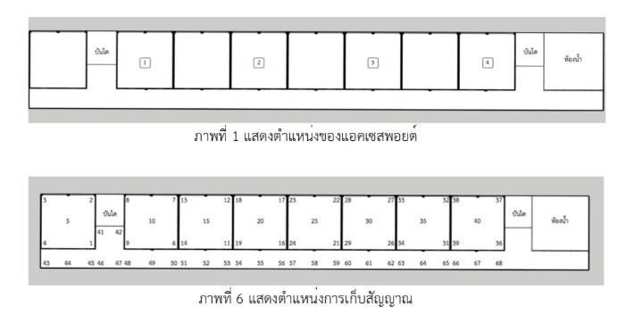
Result and Discussion
- Signal Coverage Area Results
  - Results of RSSI Signal Coverage Area
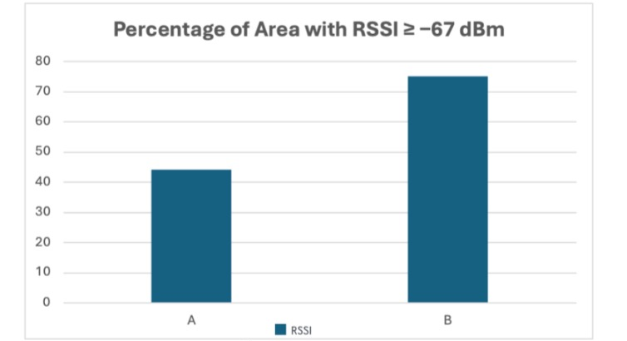
Table 1 and Graph 1 show the RSSI signal coverage area when the RSSI threshold is set at ≥ -67 dB. Experiment Set A achieved a signal coverage area of 44.12%, while Experiment Set B achieved a signal coverage area of 75.00%.
  - Results of SNR Signal Coverage Area
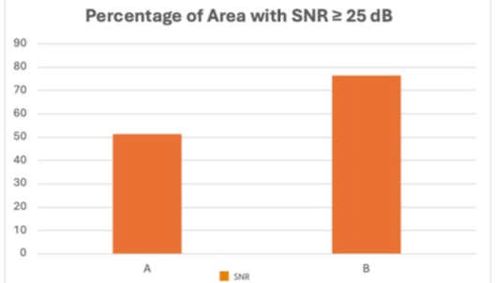
Table 1 and Graph 1 show the SNR signal coverage area when the SNR threshold is set at ≥ 25 dB. Experiment Set A achieved a signal coverage area of 48.53%, while Experiment Set B achieved a signal coverage area of 76.47%
  - Results the Mean Difference Analysis Using the Paired Samples T-Test Between Before and After the Network System Improvement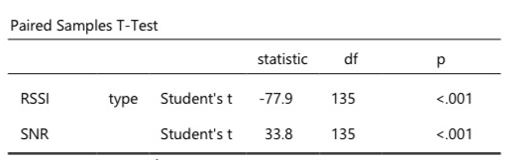
(It was found that the RSSI value had t = -77.9 and the SNR value had t = 33.8, with both variables showing p < .001, indicating that the differences in RSSI and SNR values before and after the improvement were statistically significant at the .01 level. This means that adjusting the Access Point parameters resulted in a significant change in signal quality, with RSSI values tending to improve (becoming less negative) and SNR values increasing. This reflects improved signal strength and clarity, resulting in the overall wireless network performance becoming more stable and more suitable for practical use.
TH Sarabun New 14 ตัวหนา
  - Results of the Descriptive Statistics Analysis (Group Descriptives) of the RSSI, SNR, and Noise Floor Variables Between Before (a) and After (b) the Network System Improvement.

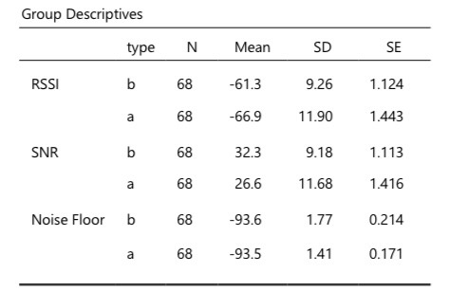
It was found that the mean RSSI value after the improvement was -61.3 dBm, which was higher (less negative) compared to the mean value before the improvement of -66.9 dBm, indicating improved signal strength. In addition, the mean SNR value after the improvement was 32.3 dB, higher than the mean value before the improvement of 26.6 dB, reflecting that the signal was clearer above the noise. Meanwhile, the Noise Floor values were similar between before and after the improvement (-93.5 and -93.6 dBm), indicating that the noise environment did not change significantly. Therefore, the changes in RSSI and SNR values were primarily caused by the adjustment of the Access Point parameters, resulting in improved overall signal quality and network performance.
เนื้อหาเป็น TH Sarabun New 14 Point ตัวปกติ
TH Sarabun New 14 ตัวหนา
Conclusions
The experiment set that analyzed both the parameters and the installation positions of the Access Points provided signal coverage areas that met both the RSSI and SNR criteria significantly higher than the analysis of either factor alone. This result can be explained based on the concept of the logarithmic distance path loss model, which explains that the signal loss value increases according to the logarithm of the distance between the transmitter and the receiver, and is further influenced by obstacles and the indoor environment. Adjusting only the Access Point parameters, although it helps increase signal strength to a certain extent, cannot effectively reduce the signal loss caused by distance and attenuation from walls and floors. Similarly, adjusting only the installation position of the Access Point without considering the device parameters cannot fully compensate for the signal loss according to this model. When both the parameters and the installation position are analyzed together, this helps reduce the total signal loss according to the logarithmic distance path loss model, resulting in higher RSSI and SNR values, which is reflected in a signal coverage area of better quality.
Following the analysis and adjustment of the Access Point parameters using the developed solution, the signal coverage area that met the quality criteria increased clearly, in terms of both RSSI and SNR values. The area with RSSI ≥ −67 dBm increased from 44.12% to 75.00%, and the area with SNR ≥ 25 dB increased from 48.53% to 76.47%, which was a statistically significant difference (p < .01).
Acknowledgments
This project was successfully completed with the kind assistance and support of many individuals. The project team would like to express our sincere gratitude to everyone on this occasion.
Our deepest thanks go to Mr. Wutthiphong Prathumma, teacher in the Mathematics Department at Princess Chulabhorn Science High School Mukdahan, our project advisor, for his continuous guidance on data analysis and mathematics throughout the course of the project.
We are also grateful to Assistant Professor Dr. Songrit Kitisriworaphan, lecturer in the Department of Computer Engineering at Nakhon Phanom University, our special advisor, for his valuable consultation and expertise in technology and telecommunications engineering.
Special appreciation is extended to Mr. Khanchai Wongsit, teacher at the Network Control Center of Princess Chulabhorn Science High School Mukdahan, for providing fundamental knowledge of wireless signals and for his assistance in adjusting the Access Point installation positions during the field experiments.
Finally, the project team wishes to convey heartfelt appreciation to the parents of the project developers, for their unwavering support and encouragement throughout the course of this work. It is our sincere hope that this project will contribute to the advancement of knowledge in telecommunications engineering, and serve as a guideline for further improving the quality of wireless communication in society.
จำนวนหน้าต้องไม่เกิน 6 หน้ากระดาษ
TH Sarabun New 14 ตัวหนา
References
Alhassan, H., Abdulhameed, R., Ngala, M. J., & Diugwu, C. (2020). Comparison of indoor propagation models at 2.4 GHz for 5G wireless mobile networks using SDN simulator. In Proceedings of the EAI International Conference on Cyberspace (IMDC-SDSP 2020). EAI.
Shafie, M. S., & Nasir, A. (2023). Wi-Fi received signal strength indicator (RSSI) factors in influencing indoor signal: A review. International Journal of Business and Technology Management, 5(S5), 385–394.
Zhang, L., Valaee, S., Xu, Y., Ma, L., & Vedadi, F. (2017). Graph-based semi-supervised learning for indoor localization using crowdsourced data. Applied Sciences, 7(5), 467.
Sangkusolwong, W., & Apavatjrut, A. (2017). Indoor WiFi signal prediction using modelized heatmap generator tool. In Proceedings of the 2017 International Conference on Software Engineering and Computer Systems (ICSEC) (pp. 1–6).
Soldo, I., & Malarić, K. (2013). Wi-Fi parameter measurements and analysis. In Proceedings of the 9th International Conference MEASUREMENT 2013 (pp. 339–342).

