The Study of an Optimal Ratio for Liquid Plaster with Antibacterial Activity Against Staphylococcus aureus Using Galangal Essential Oil Extract

Natthabhorn A-runseangsil and Wareekan Kaowpong*
Princess Chulabhorn Science High School Phetchaburi , Kaoyai , Cha-Am , Phetchaburi
*E-mail : 64wareekarn.kha@pccphet.ac.th

Abstract

Acute wounds located in areas of frequent movement and in regions with limited
surface area for applying sheet-type plasters present challenges for protecting the wound
from environmental exposure. This is especially true for small wounds or those situated in
hard-to-reach areas such as periungual regions or finger joints, which are also at increased
risk of infection from skin microorganisms. This study aimed to develop a liquid bandage
containing galangal essential oil that can form a conformable, flexible wound-sealing film
with antimicrobial activity against Staphylococcus aureus. Liquid bandage formulations were
prepared using ethanol, ethyl acetate, polyvinyl butyral, polyvinylpyrrolidone, and
polyethylene glycol 400. Galangal essential oil was incorporated at concentrations of 20%,
30%, and 40%. The physical properties including viscosity, water permeation, drying time,
and contact angle were evaluated, along with the antimicrobial efficacy of the galangal
essential oil. The results demonstrated that the formulation containing ethanol : ethyl
acetate : polyvinyl butyral : polyvinylpyrrolidone : polyethylene glycol 400 in the ratio 58 :
30 : 10 : 2 : 0 exhibited a viscosity of 162.8 MPa·s, water permeation of 0.078 g/day, a drying
time of 7.83 minutes, and a contact angle of 53 degrees, closely resembling the physical
characteristics of commercial products. Additionally, inhibition of Staphylococcus aureus
growth was achieved with only 20% galangal essential oil. It can be concluded that the
liquid bandage containing galangal essential oil provides effective wound sealing and shows
antibacterial activity against Staphylococcus aureus.

keywords : liquid bandage, galangal essential oil, Staphylococcus aureus, film physical
properties, antimicrobial activity

Introduction
Fresh wounds caused by injuries can become serious if they are not properly treated, leading to an increased risk of bacterial infection, particularly by Staphylococcus aureus. This bacterium can cause wound inflammation, the formation of exudate or pus, redness, swelling, and pain. In severe cases, the infection may progress to necrotizing fasciitis, commonly known as a “flesh-eating disease,” in which bacteria rapidly destroy soft tissues. The infection may also spread into the bloodstream, resulting in life-threatening complications. Bacterial infections commonly occur on the skin, hands, or other frequently used parts of the body, where pathogens enter through open wounds. Therefore, proper wound care and management are essential to reduce the risk of infection.

Currently, various medical products have been developed to protect wounds, such as adhesive bandages and hydrogel wound dressings. However, these materials still have limitations regarding wound coverage and antibacterial effectiveness. To overcome these limitations, liquid plaster has been developed as an alternative wound dressing. Liquid plaster forms a protective film that conforms to the size and shape of the wound, providing more complete coverage. In addition, synthetic antibacterial agents have been incorporated into liquid plasters to inhibit bacterial growth. Nevertheless, these synthetic compounds may cause adverse effects, including skin irritation and allergic reactions

Methodology
- Preparation of Three Liquid Plaster Formulations

Three liquid plaster formulations were prepared by varying the proportions of polymers and solvents to investigate the effects of formulation composition on the properties of the resulting films.

Formulation 1 consisted of ethanol, ethyl acetate, polyvinyl butyral (PVB), polyvinyl pyrrolidone (PVP), and polyethylene glycol 400 (PEG 400) at a ratio of 66 : 22 : 8 : 2 : 2.

Formulation 2 was prepared using a ratio of 58:30:10:2:0, while Formulation 3 consisted of 58.5:28:11:2.5:0, respectively.

These three formulations were subsequently evaluated to determine the influence of their compositions on the physical and functional properties of the liquid plaster films.

2) Characterization of Liquid Plaster

2.1 Viscosity

The viscosities of the three liquid plaster formulations and a commercially available liquid plaster (control) were measured using a Digital Viscometer.

2.2 Drying Time

A square test area measuring 2.5 × 2.5 cm was marked on a glass plate. Five drops of each liquid plaster formulation were applied within the designated area and spread evenly to form a thin film. The sample was then placed on an analytical balance with a precision of 0.0001 g. The sample weight was recorded every 30 seconds until the weight remained constant, which was considered the complete drying time of the liquid plaster.

2.3 Contact Angle

Five drops of each liquid plaster formulation were deposited onto a flat surface. Images of the droplets were captured for contact angle analysis. The contact angle was determined from the photographs using the Angle Meter 360 application.

2.4 Water Vapor Transmission Rate (WVTR)

A cylindrical glass bottle was used as the testing chamber. Approximately 15 g of calcium chloride (CaCl₂) was placed inside the bottle and evenly distributed. A liquid plaster film with a thickness of 0.2 mm was used to seal the opening of the bottle, which was then tightly secured.

The initial weight of the test assembly was recorded before the samples were stored under controlled conditions at 25–30°C and 75 ± 5% relative humidity. The weight of each bottle was

measured once daily at the same time for five consecutive days.

The increase in weight was plotted against time, and the slope of the resulting graph was used to calculate the water vapor transmission rate (WVTR) according to the following equation:

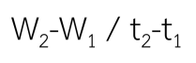

where:

* W₁ = weight of calcium chloride at the initial time (t₁)
* W₂ = weight of calcium chloride at the final time (t₂)
* t₁ = initial time
* t₂ = final time

3) Chemical Characterization of Galangal Essential Oil

The chemical functional groups present in the galangal essential oil extract were analyzed using Fourier Transform Infrared Spectroscopy (FTIR).

4) Antibacterial Activity Against Staphylococcus aureus

Mannitol Salt Agar (MSA), a selective medium for the identification of Staphylococcus aureus, was first prepared by dissolving the culture medium powder in distilled water, sterilizing the solution, and pouring it into Petri dishes. After solidification, S. aureus colonies were cultured on MSA and adjusted to a uniform bacterial

concentration to ensure consistent inoculum density.

Subsequently, Nutrient Agar (NA) plates were prepared as the general culture medium for the antibacterial assay. The bacterial suspension was evenly spread over the entire surface of each NA plate. Each plate was divided into separate sections for testing liquid plaster formulations containing different concentrations of galangal essential oil.

The liquid plaster samples were prepared by mixing a constant volume of 5 mL ethanol with 1.0, 1.5, and 2.0 mL of galangal essential oil extract, corresponding to 20%, 30%, and 40% (v/v) concentrations, respectively. Equal volumes of each formulation were then applied onto the designated sections of the inoculated agar plates.

The plates were incubated at 35°C for 48 hours. After incubation, antibacterial activity was evaluated by observing the zones of inhibition, defined as the clear areas surrounding the liquid plaster where bacterial growth was suppressed. The inhibition zones were used to assess the antibacterial efficacy of the liquid plaster formulations containing galangal essential oil against Staphylococcus aureus.

5) Min–Max Normalization for Determining the Optimal Formulation

The experimental results obtained from the characterization of the liquid plaster formulations, including the control formulation,

Formulation 1, Formulation 2, and Formulation 3, were normalized using the Min–Max Normalization method to identify the optimal formulation. The normalization was performed using the following equation:

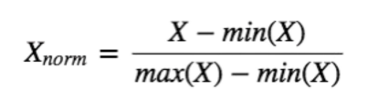
where:

* X = experimental value of each formulation
* min(X) = minimum value in the dataset
* max(X) = maximum value in the dataset

Result and Discussion

1) Viscosity

Figure 1 shows the viscosity values of the control formulation, Formulation 1, Formulation 2, and Formulation 3.
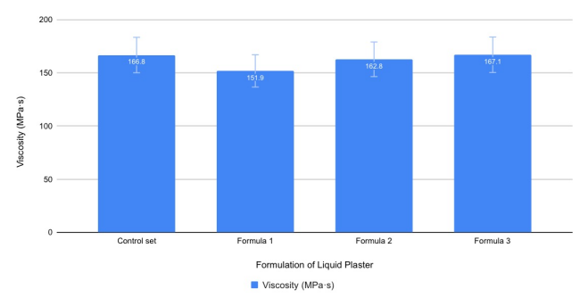
Figure 1. Viscosity of the liquid plaster formulations.

As shown in Figure 1, Formulation 3 exhibited a viscosity value that was the closest to that of the commercial control formulation. Compared with the other formulations, this result indicates that the polymer-to-solvent ratio in Formulation

3 provided an appropriate viscosity for practical application and effective film formation.

- Drying Time

Figure 2 shows the drying times of the control formulation, Formulation 1, Formulation 2, and Formulation 3.
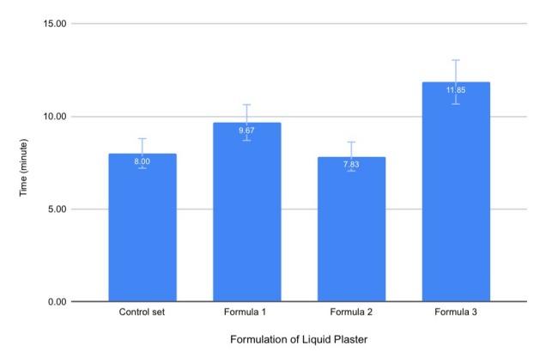
Figure 2. Drying time of the liquid plaster formulations.

The results indicate that Formulation 2 exhibited a drying time closest to that of the commercial control formulation. This suggests that the formulation was able to form a dry film within an appropriate period, making it suitable for practical application without excessive flow or film cracking.

3) Contact Angle

Figure 3 presents the contact angles of the control formulation, Formulation 1, Formulation 2, and Formulation 3.

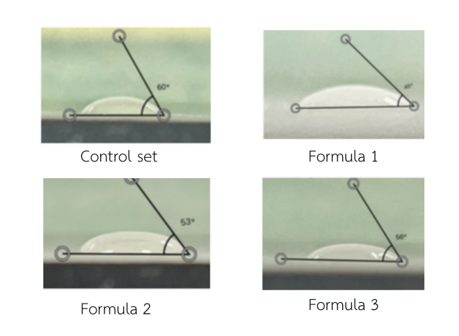
Figure 3. Contact angle of the liquid plaster formulations.

The contact angle measurements showed that Formulation 3 exhibited a value closest to that of the control formulation. This result indicates that Formulation 3 possessed appropriate wettability and spreading properties, which are favorable for adhesion to the skin surface.

4) Water Vapor Transmission Rate (WVTR)

Figure 4 shows the water vapor transmission rates of the control formulation, Formulation 1, Formulation 2, and Formulation 3.
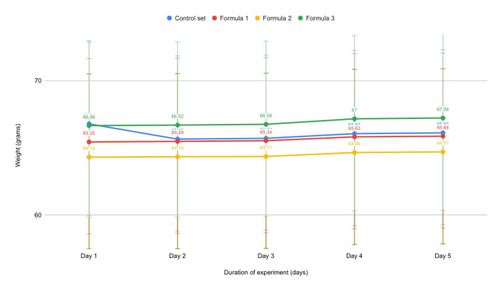

Figure 4. Water vapor transmission rate (WVTR) of the liquid plaster formulations.

The results demonstrated that Formulation 2 exhibited a water vapor transmission rate closest to that of the control formulation, indicating that

the film provided an appropriate balance of moisture permeability, which is beneficial for maintaining an optimal wound-healing environment.

5) Antibacterial Activity Against Staphylococcus aureus

Figure 5 presents the antibacterial activities of the control formulation, Formulation 1, Formulation 2, and Formulation 3 against Staphylococcus aureus.
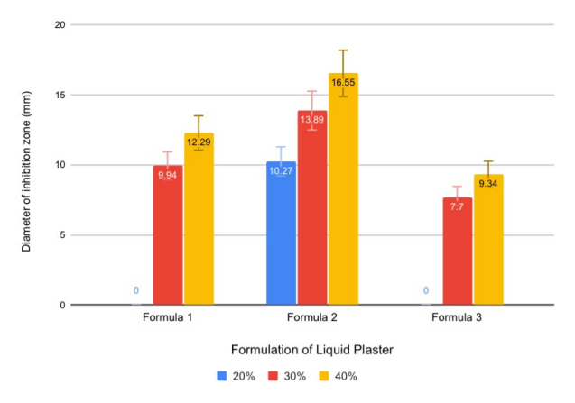
Figure 5. Antibacterial activity of the liquid plaster formulations against Staphylococcus aureus.

The results showed that Formulation 2 exhibited the strongest antibacterial activity. In particular, the formulation containing 20% galangal essential oil extract produced the largest inhibition zone, demonstrating the highest antibacterial efficacy against Staphylococcus aureus.

6) Min–Max Normalization

Figure 6 illustrates the normalized scores of the control formulation, Formulation 1, Formulation
2, and Formulation 3 obtained using the Min–Max normalization method.
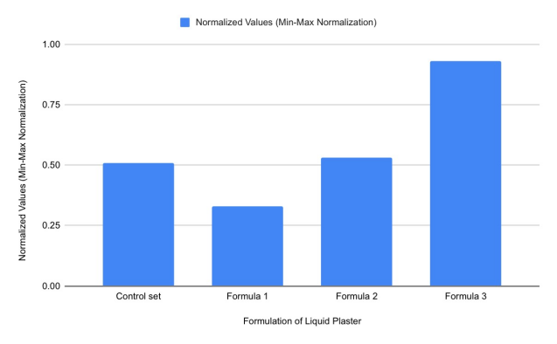
Figure 6. Min–Max normalization results of the liquid plaster formulations.

The normalized results revealed that Formulation 3 exhibited the overall performance most comparable to the commercial control formulation, particularly in terms of viscosity and water vapor transmission rate, indicating that it provided the most balanced physical properties among the tested formulations.

7) FTIR Analysis of Galangal Essential Oil Extract

Figure 7 presents the Fourier Transform Infrared (FTIR) spectrum of the galangal essential oil extract.
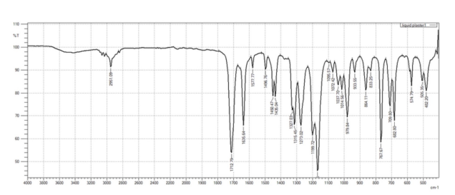
Figure 7. FTIR spectrum of the galangal essential oil extract.

The FTIR spectrum revealed characteristic absorption bands corresponding to the chemical constituents of the galangal essential oil. The absorption peaks indicated the presence of phenolic compounds, while the peaks observed around 3000 cm⁻¹ were attributed to
phenylpropanoid compounds. These functional groups are associated with the bioactive components responsible for the antibacterial properties of the essential oil.

Discussion

The present study investigated the optimal formulation of a liquid plaster containing galangal (Alpinia galanga) essential oil for antibacterial activity against Staphylococcus aureus. The developed liquid plaster exhibited suitable properties for practical application, including good film-forming ability, flexibility, and antibacterial potential. These results indicate that the formulation components were appropriately balanced and worked synergistically to produce an effective wound dressing.
Ethanol and ethyl acetate served as the primary solvents, allowing both the polymers and the bioactive compounds in galangal essential oil to disperse uniformly throughout the formulation. As a result, the liquid plaster possessed an appropriate viscosity for topical application while evaporating rapidly after use, which is an essential characteristic of liquid bandages. In addition, ethyl acetate improved the flexibility

the resulting film, reducing film cracking after drying and enabling the film to adapt to skin movement.
Polyvinyl butyral (PVB) and polyvinyl pyrrolidone (PVP) functioned as the primary film-forming polymers. Together, they produced a strong yet flexible polymer network, allowing the dried film to adhere firmly to the skin while maintaining resistance to tensile stress and abrasion during use. These characteristics are consistent with the
intended application of liquid plaster as an effective wound dressing.

Conclusions

This study successfully developed a liquid plaster containing galangal (Alpinia galanga) essential oil as the active antibacterial ingredient. The developed formulations exhibited favorable physical properties and antibacterial activity against Staphylococcus aureus. Among the formulations investigated, Formulation 2 demonstrated the most suitable overall performance, exhibiting physical properties comparable to those of the commercial control while providing the strongest antibacterial activity. These findings suggest that Formulation 2 has strong potential for further development as an effective liquid plaster for wound protection and infection prevention.

Acknowledgments
The authors would like to express their sincere gratitude to Ms. Suchaya Sriudom, the project advisor, for her invaluable guidance, constructive suggestions, and continuous support throughout this study.
The authors also gratefully acknowledge Princess Chulabhorn Science High School Phetchaburi for providing the laboratory facilities and equipment necessary for conducting this research.

References

1. Thadachaiphongsathorn, N., Khakitpaisan, I., & Khongwanit, K. (2022). Antibacterial activity of lime peel patches containing crude sappan wood extract against Staphylococcus aureus. Journal of Public Health. (in Thai)
2. Wichaiyo, S., Tachiki, K., & Igau, T. (2024). Pyroxylin-based liquid bandage forms a mechanically active protective film to facilitate skin wound healing in mice.
3. Sripho, W., Uan-on, T., & Jinta, N. Antibacterial efficacy of galangal essential oil against Escherichia coli, Staphylococcus aureus, and Salmonella Typhimurium. (in Thai)
4. Athipornchai, A., Samesri, S., & Homwiset Wongsa, S. (2019). Anti-inflammatory properties and toxicity of herbal extracts used in diabetes treatment. (in Thai)

