Development of Cocoa Pod Husk Biochar-Integrated Mortar for Carbon Footprint Reduction

Natavan Saenglom¹*, Natthawat Soontreewong¹, Sirikwan Nuphuti¹, Apasri Chumchuen¹ and Khwanchiwa Yongsata²
¹Princess Chulabhorn Science High School Trang, Bang Rak, Mueang, Trang 92000, Thailand
²Rajamangala University of Technology Srivijaya, Trang Campus, 179 Mai Fat, Sikao, Trang 92150, Thailand
*E-mail: 06365@pcshstrg.ac.th

Abstract
This research aimed to produce and evaluate the physical, mechanical, and chemical properties, as well as the CO₂ sequestration efficiency, of mortar integrated with cocoa pod husk biochar as a natural sand replacement. The biochar was synthesized via pyrolysis and utilized to substitute natural sand at weight ratios of 0% (C0), 3% (C3), 6% (C6), 9% (C9), and 12% (C12). The specimens were water-cured and tested for their properties at 28 days in compliance with the TIS 1776-2560 standard. The experimental results: Formulas C3 and C6 are highly suitable for structural applications, characterized by high density and outstanding compressive strengths ranging from 150.51 - 93.63 kg/cm², respectively, which surpass the minimum TIS standard threshold by 3 to 5 times. Formulas C9 and C12 are ideal for lightweight walling and insulation applications; the honeycomb-like porous structure of the biochar reduced the material density to a minimum of 1.64 g/cm³, imparting excellent thermal insulation properties while maintaining compressive strengths of 54.34 - 38.10 kg/cm², respectively, which still exceed the minimum standard requirement (25.49 kg/cm²). Furthermore, the porous architecture combined with surface hydroxyl and carbonyl functional groups on the biochar enhanced CO₂ capture via dipole-quadrupole interactions that are stronger than those of silanol groups in conventional sand. Synergized with the carbonation reaction, this mechanism permanently immobilized carbon within the hardened mortar matrix by up to 5.91%. Additionally, the maximum water absorption was strictly controlled at only 16.62%, which is significantly lower than the standard limit of 25%.
Keywords: Cocoa pod husk biochar, Low-carbon mortar, Carbon dioxide sequestration, SEM

Introduction
At present, the construction industry is continuously expanding, leading to a rising demand for cement, which serves as the primary material. However, the cement production process releases a massive volume of carbon dioxide (CO₂) into the atmosphere, accounting for approximately 5 – 8% of global greenhouse gas emissions (International Energy Agency [IEA], 2021). This emission is a major driver accelerating the global warming crisis and climate change. Concurrently, Thailand's agricultural sector has experienced a dramatic surge in cocoa cultivation to meet growing global market demands, resulting in a substantial increase in agricultural waste, particularly cocoa pods (Department of Agricultural Extension, 2023). Without proper management, these agricultural residues are typically disposed of through open burning, which causes air pollution and particulate matter (PM). To address these challenges, the authors proposed the conversion of cocoa pods into biochar through pyrolysis—a thermal process that sequesters carbon into a highly stable solid material. This biochar is subsequently utilized as a partial replacement for fine aggregates in concrete. The development of this innovative mortar incorporating cocoa pod-derived biochar not only adds value to agricultural waste under the circular economy framework but also reduces the consumption of natural resources. Furthermore, it yields an alternative construction material capable of absorbing and sequestering carbon dioxide, thereby promoting sustainability within an eco-friendly construction industry.

Methodology
1. Production and Characterization of Cocoa Pod-Derived Biochar
Fresh cocoa pods were sun-dried until completely dehydrated and subsequently subjected to a pyrolysis process. This thermal conversion was conducted in a biochar kiln at an elevated temperature of 450 °C for a duration of 5 hours under oxygen-limited conditions. To determine the pH value, 20 grams of the resulting biochar was finely ground, mixed with 200 milliliters of distilled water, and allowed to soak for 30 minutes; the solution was then separated using filter paper prior to measurement with a pH meter. Furthermore, the morphology, surface characteristics, and pore structures of the biochar samples were analyzed using a scanning electron microscope (SEM).
2. Mix Proportion and Specimen Preparation of Biochar-Incorporated Mortar
The particle size of the biochar was controlled by grinding it with a mortar and pestle, followed by sieving through a No. 4 mesh screen. The weight ratio of binder to total aggregate was maintained constant at 1 : 2 : 1 (cement : sand : rock dust). The water-to-cement (w/c) ratio was also kept fixed across all experimental groups. Natural sand was partially replaced with biochar at dosage rates of 0%, 3%, 6%, 9%, and 12% by weight of sand. The experimental groups were designated as C0 (control), C3, C6, C9, and C12, respectively. The detailed net material quantities for casting each group are presented in Table 1.
Table 1 Net material quantities for mortar specimen casting per experimental group.
Mix ID | Cement (g) | Sand (g) | Biochar (g) | Rock dust (g) | Water (g)
C0 | 750 | 1,500 | 0 | 750 | 375
C3 | 750 | 1,455 | 45 | 750 | 375
C6 | 750 | 1,410 | 90 | 750 | 375
C9 | 750 | 1,365 | 135 | 750 | 375
C12 | 750 | 1,320 | 180 | 750 | 375
For specimen casting, all dry ingredients were blended thoroughly. Water was then added and mixed until a homogeneous consistency was achieved. The fresh mortar was poured into 5 x 5 x 5 cm cubic steel molds in accordance with the TIS 1776-2560 standard. The mixture was compacted to eliminate air voids and left to set in the molds for 24 hours. Subsequently, the mortar specimens were demolded and cured in clean water until their designated testing ages.
3. Performance Testing of Mortar
3.1 Water Absorption
The water absorption test was conducted on mortar specimens cured for 28 days. The surface of each specimen was wiped to a saturated surface-dry condition to measure its wet weight (W_{w}). The specimens were then dried in a hot-air oven at 110 °C for 24 hours to determine their dry weight (W_{d}). The water absorption percentage (WA) was subsequently calculated using the following equation:
$$WA = \frac{W_{w}-W_{d}}{W_{d}}×100$$
3.2 Compressive Strength
The compressive strength test was performed in accordance with the TIS 1776-2560 standard. Mortar specimens cured for 7, 14, and 28 days were wiped dry and subjected to compression using a universal testing machine (UTM). The maximum peak load (P) was recorded to calculate the compressive strength (CS) using the equation, where the cross-sectional area of the specimen (A) was defined as 25 cm².
$$CS = \frac{P}{A}$$
3.3 Microstructural Analysis
Mortar samples were submitted for morphological analysis via SEM at the Center for Scientific and Technological Equipment, Walailak University, to investigate the surface morphology and pore distribution.
3.4 Carbon Dioxide Adsorption
Mortar specimens cured for 28 days were placed in a closed-system testing apparatus equipped with an air quality monitor. Carbon dioxide (CO₂) gas was generated through a chemical reaction between 1 gram of baking soda (NaHCO₃) and 20 milliliters of vinegar (CH₃COOH). The initial gas concentration was recorded, and subsequent measurements were taken continuously every 3 minutes for a total duration of 15 minutes. The data were used to calculate and compare the percentage reduction of carbon dioxide against an empty box control group.

Result and Discussion
1. Results of Cocoa Pod-Derived Biochar via Pyrolysis
1.1 Microstructural Analysis
Scanning electron microscopy (SEM) analysis revealed that the surface of the cocoa pod-derived biochar exhibited a highly porous structure distributed throughout the material, resembling a honeycomb network. This structure was attributed to the volatilization of volatile organic compounds under oxygen-limited conditions during the pyrolysis process.
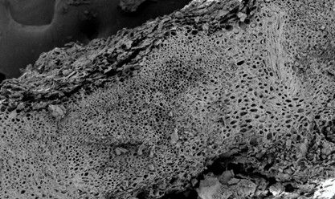
Fig. 1 Scanning electron micrograph of the porous surface of biochar derived from cocoa pods at 100x magnification.
1.2 pH Value
The cocoa pod-derived biochar exhibited a pH value of 8.33, indicating an alkaline property. This alkaline nature contributes to enhancing the stability and durability of the mortar matrix structure when incorporated with cement. This alkalinity is mainly driven by the accumulation of inorganic soluble salts (such as potassium carbonates) and the formation of basic surface functional groups during high-temperature pyrolysis.
2. Properties of Biochar-Blended Mortar
2.1 Structural Analysis
Scanning electron microscopy (SEM) analysis of the biochar-blended mortar specimens after 28 days of water curing revealed that the cocoa pod-derived biochar particles were uniformly distributed and embedded within the cement paste matrix. The pores within the biochar structure were well-interlocked with the cement hydration products, resulting in a continuous internal microstructure across all mix proportions. The rough surface texture and open pores of the biochar facilitated mechanical interlocking, allowing the calcium silicate hydrate (C-S-H) gel to grow into the pores and create a stronger interfacial transition zone.
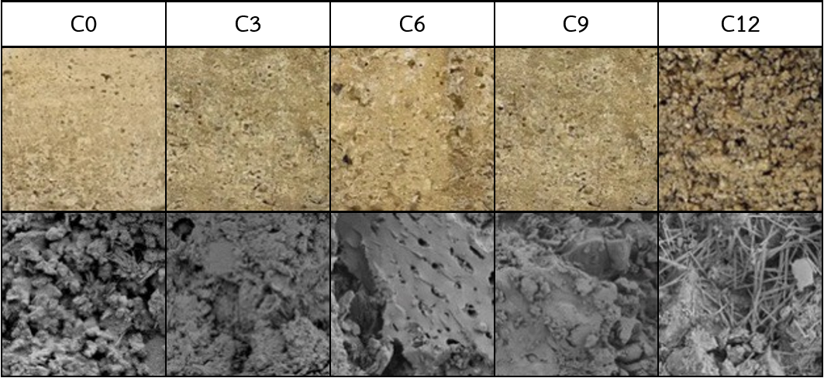
Fig. 2 Biochar-blended mortar specimens of each mix proportion: (top) external physical appearance and (bottom) internal pore microstructure via SEM at 1,000x magnification.
2.2 Physical Properties (Water Absorption) The physical property testing regarding the water absorption of mortar specimens cured for 28 days was evaluated based on the TIS 1776-2560 standard, which stipulates that the water absorption must not exceed 25%. The results indicated that as the replacement ratio of sand with biochar increased, the water absorption of the mortar exhibited a corresponding upward trend. The C12 mix displayed the highest water absorption at 16.63%, which was attributed to the increased internal porosity introduced by the biochar that absorbed water. Nevertheless, the water absorption values of all biochar-blended mortar mixes successfully conformed to the specified TIS standard criteria.
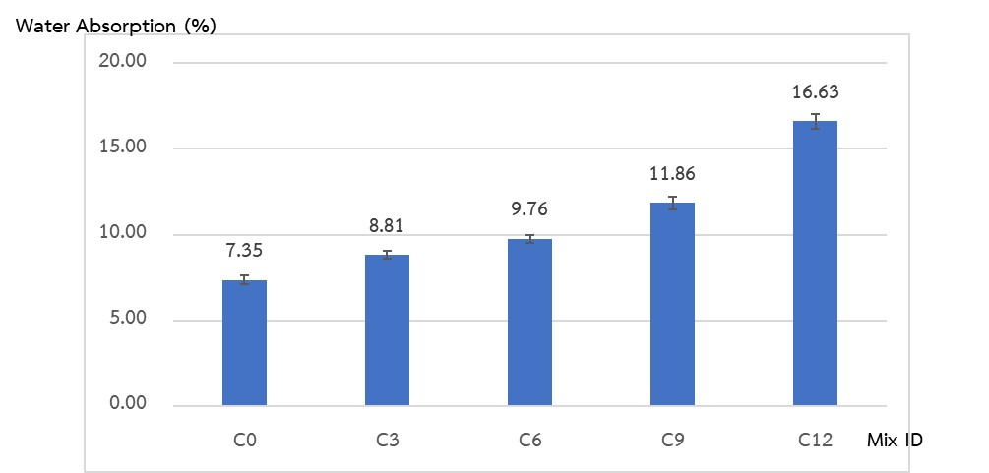
Fig. 3 Column chart illustrating the water absorption values of mortar for each mix proportion.
2.3 Physical Properties (Compressive Strength)
Compacting test of biochar-blended mortar cured for 7, 14, and 28 days followed TIS 1776-2560 standard, stipulating a minimum compressive strength of 25.49 kg/cm². The experimental results are as follows:
1) With increasing curing age, all mortar mixes exhibited an increase in compressive strength due to the ongoing hydration reaction.
2) As the biochar content increased, the compressive strength showed a downward trend. The C12 mix yielded the lowest compressive strength at 37.60 kg/cm². Nevertheless, all mixes clearly exceeded the minimum TIS 1776-2560 standard threshold, demonstrating their suitability for practical applications. This reduction in compressive strength is primarily attributed to the lower intrinsic mechanical strength of biochar compared to natural silica sand, as well as the higher porosity within the mortar matrix which reduces its load-bearing capacity.
3) The C3 mix achieved the highest compressive strength among all biochar-blended groups, indicating the optimum balance between mechanical properties and the introduction of a porous microstructure.
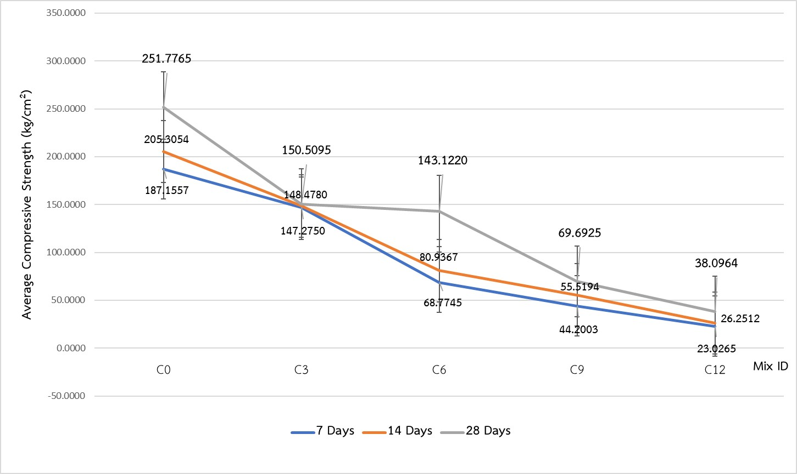
Fig. 4 Compressive strength development of biochar-blended mortar at 7, 14, and 28 days of curing age.
2.4 CO₂ Adsorption Efficiency
The CO₂ sequestration and adsorption efficiency testing in a closed system for 15 minutes revealed that the biochar-blended mortar exhibited significantly superior CO₂ capture performance compared to natural sand and the control mix. This efficiency was directly proportional to the increased biochar replacement ratio. The experimental results are summarized as follows:
1) The empty chamber (Blank) control showed a natural gas reduction of only 2.05%.
2) The C12 mortar mix achieved the highest CO₂ adsorption efficiency at 5.92%, whereas the C3 mix yielded an adsorption efficiency of 2.27%. When evaluated alongside compressive strength, the C3 mix clearly enhanced carbon sequestration performance compared to the control mix while maintaining the highest mechanical strength, making it the most cost-effective proportion for practical applications.
3) The CO₂ adsorption mechanism comprises three primary pathways:
-Physical Structure: The highly porous, honeycomb-like structure of biochar increases the specific surface area and acts as cavities that trap CO₂ molecules via weak van der Waals forces.
-Chemical Functional Group Attraction: Dipole-quadrupole interactions occur between the carbon surface and gas molecules. These interactions are stronger than those of the silanol groups (Si-OH) found in conventional natural sand, thereby enhancing gas capture capacity.
-Chemical Adsorption (Chemisorption): Chemical bonding occurs with minerals and hydration products in the cement paste matrix. This process permanently and stably converts CO₂ gas into carbonate compounds precipitated on the material surface.
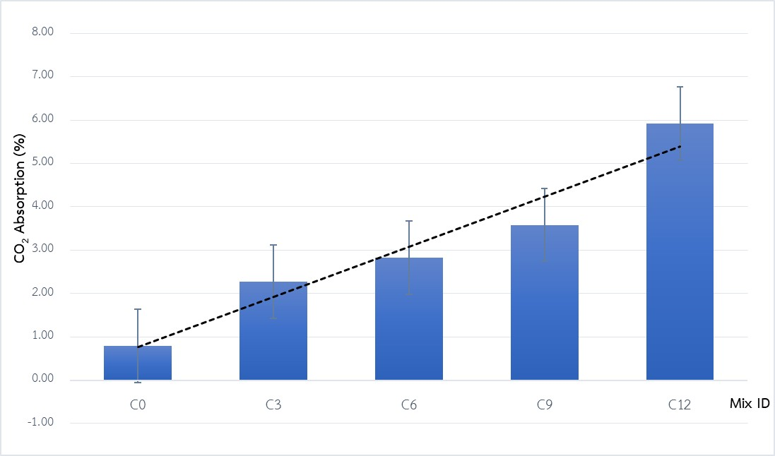
Fig. 5 Relationship between CO₂ adsorption and time of mortar at different biochar replacement ratios.

Conclusions
This study evaluated the application of cacao shell biochar as a sand replacement in mortar to enhance CO₂ sequestration. Physical and mechanical testing revealed that all biochar-blended mixes successfully satisfied the TIS 1776-2560 standard specifications. The water absorption of all mixes remained well below the 25% limit, with the C12 mix exhibiting the highest absorption at 16.63%. For 28-day compressive strength, although increasing biochar content led to a downward trend—with the C12 mix yielding the lowest value of 38.10 kg/cm² —all experimental mixes clearly exceeded the minimum TIS threshold of 25.49 kg/cm², led by the C3 mix at 150.51 kg/cm². Regarding the 15-minute closed-system CO₂ adsorption, the efficiency was directly proportional to the biochar content, yielding 5.92% for C12, 3.56% for C9, 2.83% for C6, and 2.27% for C3.In conclusion, cacao shell biochar can be effectively utilized as an eco-friendly admixture in mortar, with every mix proportion satisfying engineering standards. Consequently, the selection of the optimal mix design depends entirely on the specific application, categorized into two types: the C3 and C6 mixes are suitable for structural elements due to compressive strengths exceeding the TIS standard by 3 to 5 times, while the C9 and C12 mixes are ideal for lightweight wall and thermal insulation applications, where the honeycomb-like pores reduce the material density to 1.64 kg/cm³ while maintaining compressive strengths above the required standard.

Acknowledgments
The author wishes to express sincere gratitude to Mrs. Sirikwan Nuphuti and Ms. Arpasri Chumchuen, the project advisors, as well as Ms. Khwanchiwa Yongsata and Mr. Prasan Jitphet, faculty members of the Department of Engineering Technology, Faculty of Engineering and Technology, Rajamangala University of Technology Srivichai, Trang Campus, for their invaluable guidance. Special thanks are also extended to Mr. Wuttiphong Romphan, Head of the Mathematics Department at Bannokngang School, for his kind support and assistance throughout this study.

References
Thai Industrial Standards Institute. (2017). Thai Industrial Standard: Mortar for Masonry and Plastering (TIS 1766-2560). Ministry of Industry: Ministry of Industry.
Wanichpongpan, P., & Tuntiwiwattanapun, N. (2022). Guidelines for using biochar to enhance carbon sequestration efficiency in cement-based materials. Journal of Research and Development Institute of The Engineering Institute of Thailand, 33(4): 25-36.
Wimolmala, E., & Muangjanbun, P. (2023). Influence of pore volume in biochar on physical and mechanical properties of mortar. Journal of Industrial Education, 17(1): 45-58.

