An Artificial Intelligence–Based Application for the Analysis and Evaluation of Banana Ripeness Levels to Enhance Agricultural Logistics Management

Panus Ngamchawee and Supanat Ma-in
Wachirawit Eiamwilai and Sunantha Sirimongkol
¹ Princess Chulabhorn Science High School Lopburi No. 216, Village No.1, Khok Samrong, Lopburi, 15120 Thailand
*E-mail: pcshslcenter@pccl.ac.th

Abstract
Currently, Thailand has approximately 9.3 million agricultural households, accounting for 37.5% of all households. Bananas are an important economic crop and are widely consumed; however, one of the major problems encountered is banana spoilage during transportation and product handling. Therefore, this project aims to develop an artificial intelligence–based application for analyzing and evaluating the ripeness levels of bananas in order to support agricultural logistics management. Roboflow was used for dataset preparation, and the model was trained using the YOLOv26 algorithm. The application was then developed using Visual Studio Code. The application operates by allowing farmers to capture images of bananas, which are processed by the system to display the ripeness level in the form of descriptive text, enabling accurate quality assessment. The experimental results showed that the application achieved an accuracy of 94% in classifying banana ripeness levels. In conclusion, the developed application can effectively assist farmers in classifying banana ripeness and improving the management of banana quality.
keywords : Application, Artificial Intelligence, Banana, Farmer
Introduction
Agriculture is one of the most important sectors in Thailand's economy and society. Bananas are a widely cultivated crop with high domestic and international demand. However, post-harvest losses remain a significant problem, particularly spoilage during transportation and distribution. This is partly due to inaccurate assessments of banana ripeness, as this is largely based on visual observation and the assessor's experience. This can lead to inefficient transportation and distribution planning and significant economic losses for farmers.
Currently, Artificial Intelligence (AI), Deep Learning, and Computer Vision technologies are widely developed and applied in the agricultural sector because they can quickly and accurately analyze and classify the physical characteristics of agricultural products. Therefore, the project team conceived the idea of ​​developing an Android application for analyzing and classifying the ripeness level of bananas using AI technology. This was accomplished by preparing a dataset of banana images at different ripeness levels using the Roboflow platform, training the model with YOLOv26, and developing the user interface using the Flutter Framework to ensure ease of use and suitability for agricultural users.
The developed application aims to support a more accurate, faster, and systematic assessment of banana ripeness. Users can analyze ripeness levels using smartphone photographs. The results can be used as data for planning transportation and distribution, reducing the risk of post-harvest loss. Furthermore, it promotes the application of digital technology and artificial intelligence in agriculture, leading to improved agricultural production management and supporting the sustainable development of Thai agriculture.

Methodology
1) System design and equipment installation
Flutter requires Windows 11 or higher operating system and the installation of the Android development environment, Chrome, and Visual Studio to develop Android, web, and Windows applications, respectively
2) Data collection process
A total of 7,546 banana images were collected and categorized into six classes: 1. Very unripe, 2. Unripe, 3. Freshripe, 4. Ripe, 5. Overripe, and 6. Rotten. Roboflow then generated a new dataset version from these images using augmentation to increase image diversity. This resulted in a total of 18,074 images used for model training, divided into a train set of 15,792 images, a valid set of 1,525 images, and a test set of 757 images.
3) Model Training
Data from Roboflow, consisting of a categorized dataset, was exported and used to train a model in Visual Studio Code using YOLO26n as the pretained model. A total of 20 training runs were performed. Due to computer limitations, data processing took approximately 10 hours, a suitable timeframe for achieving high model performance. The model was then exported as TF Lite for use in Flutter, enabling further application development
4) Application Development
Use the `flutter create` command in the terminal to create the basic folder and file structure for developing a new mobile application. This will allow you to write code in Visual Studio Code, then design the UX (User Experience) and UI (User Interface) to be beautiful and functional. Writing code in Visual Studio Code begins with modifying the basic code included with the Flutter installation and adding the necessary packages to match the newly modified code. This ensures the code recognizes the desired functions, such as those allowing the phone to store data directly on the device, accessing the camera, and calling models, allowing the application to function without errors. Next, write code to add features such as image scanning, inventory management, and statistics. Finally, import the resulting model in TF Lite format into Visual Studio Code and incorporate it into the application for scanning images and analyzing the ripeness of bananas
5) Condition Checking
When a user takes a picture, the application sends the image data to the model for processing. If the scanned image does not detect a banana, the system will send a notification to the user indicating that no banana was found and instructing them to scan again. However, if the model successfully detects a banana in the image, the system will allow the user to save the data, specifying the ripeness level as analyzed by the model

Result and Discussion
The development of an artificial intelligence application for analyzing and assessing banana ripeness levels to enhance the management of agricultural logistics systems. Testing the performance of AI for analyzing and assessing banana ripeness levels to improve the management of agricultural logistics systems yields the following conclusions.
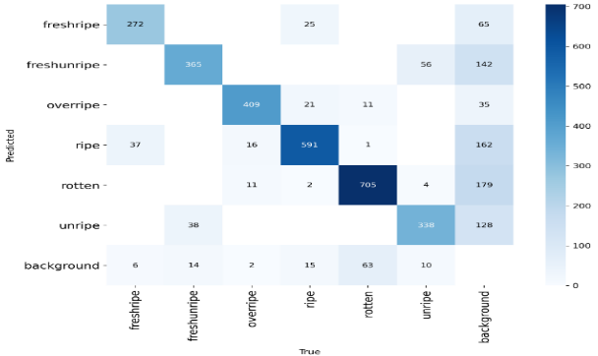
1) Testing the effectiveness of artificial intelligence in analyzing and evaluating the ripeness level of bananas to improve the management of agricultural product logistics systems.
Fig. 1 Confusion Matrix
By analyzing the images and charts of the model training and testing, it is found that the classification ability of the model for banana maturity is quite accurate. The chaotic matrix displays the results as values close to 1 on all main diagonals, while other values display the results as values close to 0, which means that the model can detect few errors relatively accurately
A confusion matrix is ​​a table used to evaluate the performance of various ML classification models in conjunction with a test dataset whose true values ​​or results are known. It compares the actual value to the value obtained from the ML model's result or the predicted value, and then summarizes the results in a matrix table consisting of True negative (TN), False positive (FP), False negative (FN), and True positive (TP) values.
1. True Positives (TP) refer to the number of data points that are correctly categorized into the desired category (Positive class) or group of interest. In this case, it refers to data that was predicted to be positive, and which actually turned out to be true; in other words, the prediction was correct in that it accurately reflected our assessment.
2. True Negatives (TN) are the number of data points that are correctly classified within a non-target category (Negative class) or a category we are not interested in. In this case, it is data that was predicted to be negative and the actual data is negative; that is, the prediction was correct that it was not what we estimated.
3. False Positives (FP) represent the number of data points that were incorrectly predicted within the category we are interested in. In this case, it refers to data that was predicted to be positive but were actually negative; that is, the prediction was incorrect based on our assessment.
4. False Negatives (FN) are the number of data points that are incorrectly classified within a category we are not interested in. In this case, it's data that was predicted to be negative but is actually positive; that is, an incorrect prediction that it doesn't match our assessment.

Accuracy = $\frac{TP+TN}{TP+TN+FP+FN}$ = 0.859

Precision = $\frac{TP}{TP+FP }$= 0.9

Recall =$\frac{TP}{TP+FN}$= 0.940

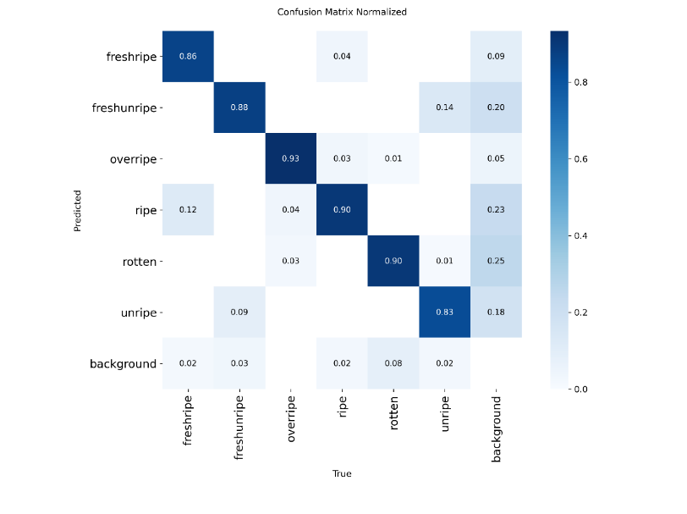
F1-Score = $\frac{Precision X Recall}{Precision+Recall}$= 0.895
Fig. 2 Confusion Matrix Normalized
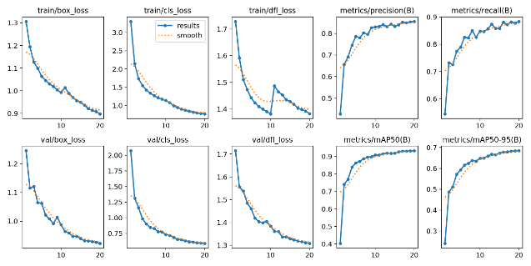
Fig. 3 Results
From the analysis of the classification results, it was found that the developed model was quite efficient, being able to correctly classify banana happiness levels. However, limitations were still found in distinguishing similar appearance characteristics between the Fresh unripe and Unripe classes, which resulted from setting classes that were too close. This includes the classification of objects out of the background, which is an important factor affecting the overall accuracy value.

Conclusions
From the results of the development and testing of artificial intelligence system applications for the analysis and evaluation of banana ripening level, the results can be discussed as follows:
1) The effectiveness of the model in classifying ripeness.
The test results showed that the developed YOLOv26 model had an overall accuracy of 85.9%, which is acceptable for practical application. This is comparable to related research, such as the research by Ornuma Pramot et al. (2021) which used Deep Learning to classify banana ripeness with 98.62% accuracy, or the research by Somchai Wongyai et al. (2022) which classified mango ripeness using CNN with 96.8% accuracy. Although this project's accuracy is slightly lower, it has advantages in processing speed (average 0.8-1.5 seconds) and real-time capability, making it suitable for real-world use. Confusion Matrix analysis revealed that the model was more efficient at classifying Ripe and Overripe than Fresh, Unripe, and Unripe, due to clearer differences in color and external appearance. In contrast, unripe bananas have very similar characteristics, leading to some confusion between the two classes. This is consistent with what was stated in Chapter 4, which mentions limitations in distinguishing between similar appearances of fresh, unripe, and unripe bananas. The high recall rate of 94.0% demonstrates that the model can detect bananas at each ripeness level quite comprehensively, with low false negatives. This is important for use in logistics systems, as missing overripe bananas could lead to the delivery of substandard produce.
2) Environmental factors that affect detection.
Testing in various environments revealed that lighting is a crucial factor affecting system accuracy. Under sufficient and consistent lighting conditions (e.g., natural daylight or white light in shade), the system detects and classifies objects very well. However, in conditions of insufficient light (e.g., in a dark greenhouse) or excessively bright light (e.g., direct sunlight causing shadows and reflections), accuracy significantly decreases. Furthermore, complex background clutter, such as bananas placed on a surface with other objects or objects similar in color, can cause the model to misdetect object boundaries, resulting in inaccurate bounding box detection or even detecting objects other than bananas. Therefore, for practical applications, it is recommended that users photograph bananas against a simple background, such as a white surface or light-colored canvas, using natural or consistent artificial light. These experimental results align with the research of Piyanut Sawangsri and Weerapong Kaewmanee (2021), who found that controlling lighting and background conditions is vital for the performance of computer vision systems. Future development could include features to guide users in optimizing lighting conditions or using image preprocessing techniques to improve image quality before importing into the model.
3) Multi-object view and object detection.
Testing revealed that photographing bananas at optimal angles (e.g., a 45-degree side view or a top-down view) yielded better results than photographing them when many bananas were overlapping. When many bananas are stacked, the model may not be able to count them all or may only distinguish some clearly visible parts, leading to inaccurate overall quality assessment. This is a common limitation of object detection systems, especially when detecting irregularly shaped objects in clusters. Research by Nattapon Chanphen and Supaporn Thongkam (2023) on durian ripeness assessment encountered a similar problem and recommended that users separate the fruit individually before photographing. For practical application, the system should provide a guide or example images showing the correct positioning and shooting techniques to enable users to properly pose and photograph the fruit. This could include developing a real-time feedback feature that provides guidance on camera angle or lighting adjustments, or utilizing instance segmentation techniques that are more effective at separating overlapping objects than conventional object detection.
Acknowledgments
This project was successfully completed thanks to the invaluable guidance, suggestions, and corrections from our project advisors, Mr. Wachirawit Eiamwilai and Ms. Sunanta Sirimongkol. Their unwavering support, encouragement, and guidance in preparing the report and making necessary improvements have led to the successful completion of this project. We extend our deepest gratitude to them. We also extend our sincere thanks to Dr. Sakda Khamso, Director of Chulabhorn Royal Academy Science School, Lopburi, for providing the opportunity to study the sample group for application development and for his generous time and assistance in completing this project. Finally, we remember all the kindness and assistance provided by everyone involved and hope that the results of this project will benefit all stakeholders.

References
Chanphen, Na., & Thongkham, S. (2023).
Development of a mobile application for assessing the ripeness of durian using Deep Learning techniques. Journal of Information Technology, 19(2), 45-58.
Department of Agricultural Extension. (2024).
Banana Production and Marketing Statistics 2023/2024. Ministry of Agriculture and Cooperatives.
Jocher, G., Chaurasia, A., & Qiu, J. (2023).
Ultralytics YOLOv8 [Computer software].
https://github.com/ultralytics/ultralytics
Redmon, J., Divvala, S., Girshick, R., & Farhadi, A. (2016).
You only look once: Unified, real-time object detection. In Proceedings of the IEEE Conference on Computer Vision and Pattern Recognition (pp. 779-788). https://doi.org/10.1109/CVPR.2016.91
Sawangsri, P., & Kaewmanee, W. (2021).
A system for checking the quality of Shogun oranges using color and shape analysis with computer vision techniques. Journal of Research and Development, Chiang Mai University, 14(2), 156-171.
Wongyai, S., Prasitchai, P., & Suwan, K. (2022).
Mango ripeness classification using image processing and machine learning techniques. Journal of Engineering, King Mongkut's University of Technology Thonburi, 2022 (3), 78-92.

