Synthesis of Heteroatom-Doped Carbon Dots with Enhanced Near-Infrared Fluorescence and Photothermal Properties toward Bioimaging and Photothermal Therapy Applications.

Supitnee Ketkaewsathaporn¹, Nattawat Suthidecharat¹ and Natthaphat Phodmanirat^{1*}
Manas Sittishoktram¹ and Cheewita Suwanchawalit²
¹Princess Chulabhorn Science High School Phetchaburi No. 427, Village No. 8, Khao Yai, Cha-Am, Phetchaburi, 76120 Thailand
²Silpakorn University, Phra Pathom Chedi, Mueang, Nakhon Pathom, 73000 Thailand
*e-mail: 64natthaphat.poj@pccphet.ac.th

Abstract

This study focuses on the synthesis of nitrogen and sulfur co-doped carbon dots (N, S-doped CDs) via a solvothermal method using citric acid, urea, and dimethyl sulfoxide (DMSO) as precursors to develop an advanced material for near-infrared (NIR) bioimaging and cancer photothermal therapy (PTT). Experimental results demonstrated that the optimal precursor ratio consisted of 5 mL of DMSO, 3 g of urea, and 1 g of citric acid, yielding an exceptionally high photothermal conversion efficiency (PCE) of up to 61.8%. Appropriate nitrogen doping effectively enhanced light absorption and generated optimal defect (trap) states that promoted both radiative (fluorescence) and non-radiative (photothermal) decay pathways. However, prolonged synthesis times negatively impacted performance due to particle aggregation. In conclusion, the synthesized N, S-doped CDs possess outstanding properties, demonstrating great potential as highly efficient theranostic agents for simultaneous cancer localization and targeted photothermal destruction in future biomedical applications.

keywords : Carbon Dots, Heteroatom Doping, Near-Infrared, Photothermal Therapy, Theranostics

Introduction
Cancer remains a critical global public health crisis with a continuously rising number of cases worldwide. However, conventional treatment modalities often inflict severe side effects and cause collateral damage to healthy, normal cells. To overcome these limitations, photothermal therapy (PTT) has been developed as a highly selective and targeted alternative.
In this context, carbon dots (CDs) have emerged as exceptionally attractive nanomaterials compared to traditional, expensive metal nanoparticles, owing to their cost-effectiveness and superior biocompatibility. When co-doped with heteroatoms such as nitrogen (N) and sulfur (S), the electronic and energy band structures of CDs are modified. This tuning enables them to absorb and emit light in the near-infrared (NIR) region, which is highly advantageous due to its deep tissue penetration capabilities and low background signal interference.
The underlying mechanism of these N, S-doped CDs relies on their dual-action behavior upon light excitation: they release energy via photoluminescence to locate and image the malignant tumor, while simultaneously converting absorbed photon energy into heat through non-radiative vibrational relaxation to destroy cancer cells. Therefore, this research aims to systematically investigate the optimal synthesis conditions to obtain carbon dots with maximum efficiency for single-step, integrated cancer diagnostics and therapy (theranostics).

Methodology
1) Effects of Synthesis Time and Temperature on Photothermal and Near-Infrared Fluorescence Properties of Carbon Dots
Initially, dimethyl sulfoxide (DMSO, 15 mL), citric acid (1 g), and urea (3 g) were mixed and stirred until completely homogeneous. The mixture was then transferred into an autoclave reactor and heated at 160 °C for 4 hours. After completing the solvothermal process, the reactor was allowed to cool naturally to room temperature. The resulting dark solution was collected and stored in an amber glass bottle at 4 °C for further characterization. To study the effects of synthesis parameters, the experiment was repeated by systematically varying two controlled variables: reaction time (2, 8, 12, and 16 hours) and reaction temperature (180 °C and 200 °C).
2) Effects of Heteroatom Doping on Photothermal and Near-Infrared Fluorescence Properties
2.1 Study of Nitrogen (N) Doping
To investigate the effect of nitrogen doping, urea solutions of 350 g/L were prepared in different volumes (3, 6, 9, and 12 mL). Each volume was mixed with citric acid (1 g) and DMSO (15 mL). The prepared mixtures were subjected to the solvothermal process in an autoclave reactor under a fixed condition of 160 °C for 4 hours. Once the reaction was complete, the solutions were cooled to room temperature and stored in amber glass bottles at 4 °C for comparative evaluation of nitrogen content on CD performance.
2.2 Study of Sulfur (S) Doping
Sulfur doping was investigated by varying the volume of the DMSO solvent, which also acts as the sulfur source. Solutions were prepared by mixing 1 g of citric acid and 3 g of urea in varying volumes of DMSO (5, 10, 15, 20, and 25 mL). The mixtures were stirred thoroughly until homogeneous, transferred into autoclave reactors, and heated at 160 °C for 4 hours under solvothermal conditions. After cooling to room temperature, the dark solutions were stored in amber glass bottles at 4 °C to maintain stability prior to subsequent analysis.
3) Characterization and Performance Testing of Synthesized Carbon Dots
3.1 UV-Visible Absorption Measurements
The optical absorption properties of the synthesized carbon dots were analyzed. A 3-mL aliquot of each carbon dot solution was transferred into a cuvette using a micropipette. The absorption spectra were recorded using a UV-visible spectrophotometer across a wavelength range of 200 to 1000 nm. This measurement was repeated for all precursor ratios and the data were recorded.

3.2 Fluorescence Spectroscopy Measurements
To evaluate the photoluminescence properties, a 3-mL aliquot of the carbon dot solution was placed in a cuvette. The emission spectra were recorded using a fluorescence spectrophotometer. The excitation wavelengths were set at 365 nm (ultraviolet range), 532 nm (green light range), 655 nm (red light range), and 808 nm (near-infrared, NIR, range) to compare their excitation-dependent emission behavior.
3.3 Photothermal Performance Evaluation
To assess the light-to-heat conversion ability, a 3-mL carbon dot sample was prepared in a cuvette and irradiated using a laser diode at wavelengths of either 655 nm or 808 nm (NIR), with a fixed power density of 1 W/cm². Temperature changes were monitored in real-time using an infrared thermal camera. Thermal images and temperature readings were recorded every 1 minute for a continuous duration of 10 minutes to evaluate the photothermal performance of each sample.

Result and Discussion
1) Influence of Reaction Time on Absorption, Fluorescence, and Photothermal Conversion Properties
The solvothermal reaction parameters, including reaction time, dopant concentration, and precursor ratios, significantly affected the optical absorption, photoluminescence, and photothermal conversion capabilities of the synthesized carbon dots (CDs).
The evaluation of synthesis duration revealed that samples prepared at 4, 8, 12, and 16 hours exhibited highly similar absorption behaviors within the near-infrared (NIR) region (Figure 1). However, a discernible downward trend in fluorescence intensity was observed as the reaction time extended (Figure 2). Prolonged synthesis hours induced particle aggregation, which subsequently degraded the temperature-rising performance. Conversely, insufficient reaction times yielded inadequate photothermal performance due to the deficient generation of structural defect states necessary for non-radiative thermal dissipation.
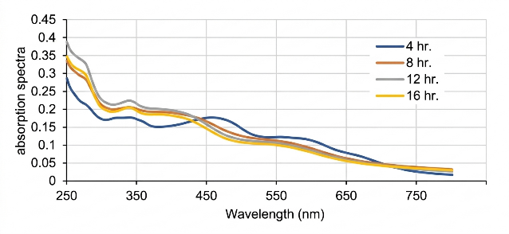
Fig. 1 Near-infrared (NIR) absorption of carbon dots
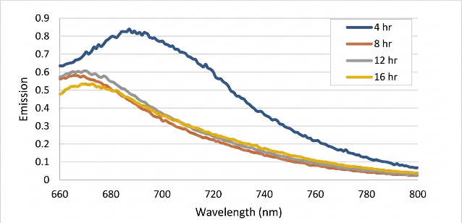
Fig. 2 Temperature changes of carbon dots synthesized at different reaction times under excitation

2) Effect of Nitrogen Doping on NIR Absorption and Photothermal Performance
For nitrogen doping, it was found that the use of 6 g of urea yielded the highest optical absorption intensity in the region around 650 nm, as shown in Figure 3. Meanwhile, the 3 g urea formulation exhibited the maximum fluorescence intensity, as illustrated in Figure 4, and provided the highest temperature elevation upon NIR laser irradiation. When the nitrogen precursor was increased to 12 g, despite a decrease in the absorption values, it was still capable of generating heat at a secondary level. This performance is attributed to the formation of numerous trap states that significantly promoted the non-radiative decay pathways, as shown in Figure 5.
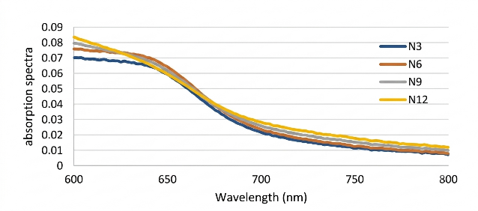
Fig. 3 UV-Vis absorption spectra of nitrogen-doped carbon dots.
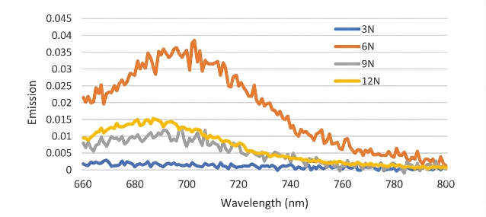
Fig. 4 Photoluminescence spectra of nitrogen-doped carbon dots.
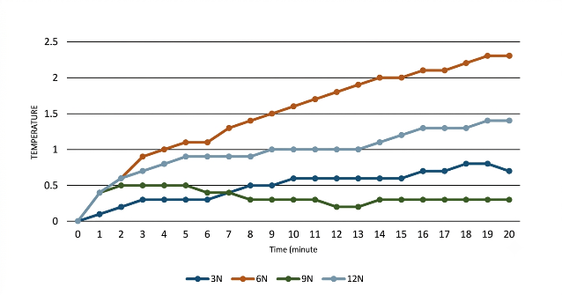
Fig. 5 Temperature changes of nitrogen-doped carbon dots with different nitrogen doping levels under excitation.

3) Effect of Sulfur Doping via DMSO Alteration on Carbon Structure and Photothermal Properties
Varying the volume of DMSO effectively altered the sulfur doping levels and carbon core crystallization. A decrease in DMSO volume consequently raised the relative concentrations of citric acid and urea, which intensified the nucleation and growth of the carbon core. The resulting carbon frameworks possessed optimal structural configurations favorable for nitrogen doping and bandgap narrowing. As a result, the NIR absorption (Figure 6), NIR fluorescence emission (Figure 7), and light-to-heat photothermal conversion (Figure 8) were all significantly enhanced.
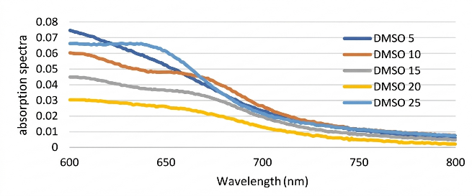
Fig. 6 UV-Vis absorption spectra of DMSO-doped carbon dots.
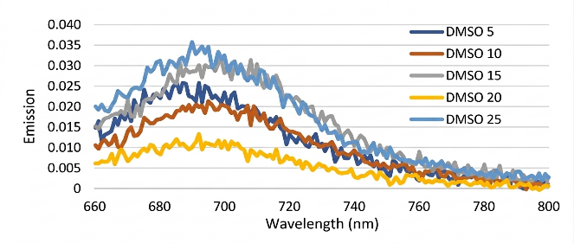
Fig. 7 Photoluminescence spectra of DMSO-doped carbon dots.
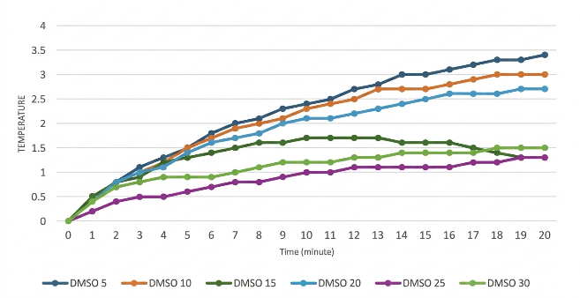
Fig. 8 Temperature changes of DMSO-doped carbon dots with different DMSO doping levels under excitation.

4) Photothermal Conversion Efficiency (PCE) Evaluation
Among all tested synthesis formulations, the optimal ratio consisting of 5 mL of DMSO, 3 g of urea, and 1 g of citric acid generated the highest temperature increase under laser irradiation. Therefore, this specific formulation was selected to determine the Photothermal Conversion Efficiency ($η$or PCE) using the following steady-state calorimetric equation:

$$η= \frac{hS(T_{max}-T_{surr} )-Q_{dis}}{I(1-{10}^{-A_{λ}})}$$

Where:
$η$is the photothermal conversion efficiency.
$h$is the heat transfer coefficient, set at W/cm²K
$S$is the surface area of the container exposed to the laser, defined as 1 cm²
$T_{max}$is the maximum equilibrium temperature of the carbon dot solution.
$T_{surr}$ is the ambient surrounding temperature.
$Q_{dis}$ is the baseline heat dissipation of the solvent, measured using DI water under identical laser irradiation conditions.
$I$ is the incident laser power density.
$A_{λ}$ is the optical absorbance of the carbon dot solution at the excitation wavelength.
Based on the calculation, the optimized N, S-doped CDs achieved an exceptionally high PCE of 61.8%.
Experimental findings demonstrated that the synthesis conditions directly dictated the energy dissipation pathways of the carbon dots, particularly influencing the balance between fluorescence emission and photothermal conversion. As the synthesis duration extended, the fluorescence intensity decreased. This reduction occurred because the majority of the absorbed photon energy was transferred through non-radiative decay mechanisms, which was fundamentally driven by the formation of structural defect states within the carbon framework, as shown in Figure 9.
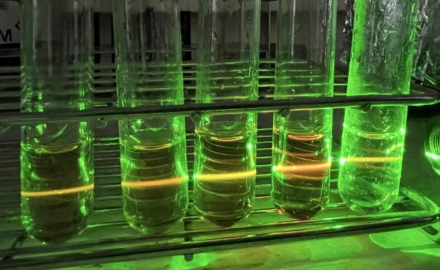
Fig. 9 Carbon dots under 532 nm excitation.
For nitrogen doping, an optimal level (using 6 g of urea) effectively tuned the energy bandgap to precisely align with the NIR light absorption band, thereby maximizing the photothermal conversion efficiency. However, an excessive amount of dopants led to adverse effects, as an overabundance of structural defects acted as energy recombination centers that hindered performance. Similarly, reducing the volume of the DMSO solvent increased the relative concentrations of the other precursors, which facilitated an optimized structural rearrangement of the carbon core that favored heat generation. The outstanding photothermal conversion efficiency (PCE) of up to 61.8% strongly validates that the synthesized carbon dots possess immense potential as highly efficient photothermal therapeutic agents for cancer treatment, serving as a promising and cost-effective alternative to expensive gold nanoparticles.

Conclusions
In this study, nitrogen and sulfur co-doped carbon dots (N, S-doped CDs) were successfully synthesized via a one-step solvothermal approach utilizing citric acid, urea, and DMSO as precursor materials. The experimental investigations demonstrated that the critical key to controlling the optical and thermal performance of these nanomaterials lies in the precise regulation of the synthesis duration, reaction temperature, and heteroatom doping ratios. These parameters directly govern the structural defects (defect/trap states) within the carbon core, which in turn dictate the competitive energy dissipation pathways between radiative photoluminescence emission and non-radiative thermal vibration.
The optimized precursor formulation was established to be 5 mL of DMSO, 3 g of urea, and 1 g of citric acid, which yielded a highly efficient light-to-heat conversion with a remarkable photothermal conversion efficiency (PCE) of 61.8%. Furthermore, prolonged synthesis times were found to promote particle aggregation, which detrimental to both fluorescence intensity and photothermal performance. These findings firmly conclude that these carbon dots, synthesized from low-cost and highly biocompatible precursors, offer exceptional dual-functionality (near-infrared fluorescence bioimaging and photothermal therapeutic properties). This research highlights their immense potential as a highly effective and affordable theranostic platform for simultaneous cancer diagnosis and targeted photothermal therapy, serving as a promising alternative to conventional, expensive gold nanoparticles.

Acknowledgments
This research project was successfully completed with the invaluable guidance, advice, and support of various individuals and institutions. The authors wish to express their sincere gratitude to the Chemistry Department at Princess Chulabhorn Science High School Phetchaburi for providing essential research equipment and laboratory space. Special thanks are also extended to the Department of Chemistry, Faculty of Science at Silpakorn University (Sanam Chandra Palace Campus), for their kind cooperation, technical guidance, and permission to utilize their advanced analytical instruments and facilities.

References
Xuan Bao et al. (16 November 2018).
In vivo theranostics with near infrared emitting carbon dots-highly efficient photothermal therapy based on passive targeting after intravenous administration.
https://www.nature.com/articles/s41377-018-0090-1
Louis E. Brus. (1 May 1984).
Electron-electron and electron-hole interactions in small semiconductor crystallites: The size dependence of the lowest excited electronic state.
https://pubs.aip.org/jcp/article/80/9/4403/184497

