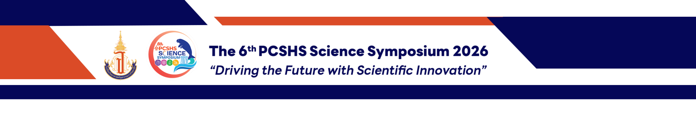
Dhapanawat Siridhipayan¹, Thittawan Vitthayaphum¹, Aileenmirinda Narat¹ and Duangrudee Tessanan^{1*}

Duck Check : An AI-Powered Medication Safety Screening Chatbot on Application

¹Princess Chulabhorn Science High School Loei, That, Chiang Khan, Loei 42110, Thailand
*E-mail: dhapanawat05606@pcshsloei.ac.th

Abstract
This innovation project developed Duck Check, an intelligent health assistant and medication screening chatbot with a user interface similar to the LINE application to reduce household medication errors. Existing drug search platforms require users to know the correct generic or brand names, making them difficult for older adults to use and increasing the risks of inappropriate medication use, repeated drug allergies, and drug–drug interactions.Duck Check integrates a Large Language Model (LLM) for natural language understanding with a rule-based safety engine that makes all medication safety decisions using a curated drug database. This architecture prevents AI hallucinations while enabling allergy detection, drug interaction analysis, and urgency screening. The system does not diagnose diseases but always recommends consultation with pharmacists or physicians when necessary.Prototype evaluation showed that the database included 40 medications and 124 common colloquial names. The system achieved 100% accuracy in recognizing medication names, 100% accuracy in medication safety decisions (12/12 scenarios), and 100% recall in emergency screening without excessive warnings. These findings demonstrate that Duck Check can improve health literacy, promote safer medication use, and help reduce the burden on the healthcare system sustainably.

Keywords: Drug interaction, Health literacy, Medication error, Natural Language Processing

