Duck Check : An AI-Powered Medication Safety Screening Chatbot on Application
Dhapanawat Siridhipayan¹, Thittawan Vitthayaphum¹ and Aileenmirinda Narat¹
Duangrudee Tessanan^{1*}
¹Princess Chulabhorn Science High School Trang No. 196, Village No. 4, Bang Rak, Mueang Trang, Trang, 92000 Thailand
*e-mail: dhapanawat05606@pcshsloei.ac.th

Abstract

This innovation project developed Duck Check, an intelligent health assistant and medication screening chatbot with a user interface similar to the LINE application to reduce household medication errors. Existing drug search platforms require users to know the correct generic or brand names, making them difficult for older adults to use and increasing the risks of inappropriate medication use, repeated drug allergies, and drug–drug interactions.Duck Check integrates a Large Language Model (LLM) for natural language understanding with a rule-based safety engine that makes all medication safety decisions using a curated drug database. This architecture prevents AI hallucinations while enabling allergy detection, drug interaction analysis, and urgency screening. The system does not diagnose diseases but always recommends consultation with pharmacists or physicians when necessary.Prototype evaluation showed that the database included 40 medications and 124 common colloquial names. The system achieved 100% accuracy in recognizing medication names, 100% accuracy in medication safety decisions (12/12 scenarios), and 100% recall in emergency screening without excessive warnings. These findings demonstrate that Duck Check can improve health literacy, promote safer medication use, and help reduce the burden on the healthcare system sustainably.
keywords : Drug interaction, Health literacy, Medication error, Natural Language Processing
Introduction
Minor illnesses such as headaches, fevers, body aches, and diarrhea are common occurrences in the daily lives of every household. A large number of people choose to purchase over-the-counter medications for self-treatment before consulting a physician, driven by convenience and the desire to save both time and money. This behavior is not inherently wrong, provided that the consumers possess adequate knowledge. In reality, however, the general public often lacks the necessary health literacy.
This gap in knowledge leads to a critical issue: household medication errors. These errors include the misuse of medication types, accidental overdosing due to combination drugs with overlapping active ingredients, repeated allergic reactions caused by an inability to recognize that a new drug belongs to the same class as a previously known allergen, and dangerous drug-drug interactions when newly purchased medicines clash with regular daily prescriptions. These problems are particularly severe among the elderly, who often suffer from multiple chronic conditions and face significant barriers in accessing digital information.
Although several drug search platforms exist today, they suffer from two major limitations. First, they force users to know the exact generic or trade names of the medication, whereas ordinary citizens typically refer to medicines by familiar physical characteristics, such as "the green painkiller." Second, these platforms offer only a one-way search mechanism that ignores the individual’s specific context, making it impossible to issue personalized hazard warnings. Concurrently, deploying Large Language Models (LLMs) to directly answer medical queries poses a severe risk of AI hallucination, which could generate dangerously inaccurate information.
To address these challenges, the development team designed a system that isolates the role of AI from the safety-critical decision-making process, delivered through an intuitive mobile application. This architectural approach serves as the foundation for the innovation known as "DuckCheck."

Methodology
2.1 Table1:Development Tools and Technologies
Component | Tool / Technology | Rationale
Core Programming Language | Python 3.14 | Ideal for NLP tasks and backend development.
Web Server | FastAPI + Uvicorn | Enables rapid API development and secures API keys.
Medication Database | JSON Files | Allows easy verification and review by medical experts.
Language Model (LLM) | Claude (via proxy) | Proficient in understanding spoken Thai, clarifying contexts, and rephrasing.
Frontend | HTML / CSS / JavaScript | Mobile-compatible and requires no app installation.
Testing | Pytest + Test Dataset | Enables automated and reproducible accuracy verification.
2.2 Project Implementation Steps
Phase1: Database Design and Safety Mechanism Development
This phase focuses on designing a multidimensional drug database structured to capture comprehensive data attributes for each medication entry. These attributes encompass generic names, trade names, colloquial or local names, drug classes, indications, dosages, contraindications, precautions, and warnings. Dedicated tables are established to categorize drug classes, drug-drug interactions, and critical red flags, with all entries cross-referenced against the National List of Essential Medicines and Common Household Medicines. Concurrently, a rule-based safety screening engine is developed. This engine processes drug inputs alongside the user’s personal health profile (including age, underlying conditions, medical history, drug allergies, and current prescriptions) to output safety determinations. The screening scope strictly covers group-level drug allergies, drug-drug interactions, disease-specific contraindications, age-related precautions, and the filtering of prescription-only medications.

Phase2:LINE-StyleUser Interface (UI) Development
The system's frontend is designed as a mobile-first web application featuring a chat-based interface that mimics the familiar interaction model of the LINE application. The UI elements include standard chat bubbles (green on the right for the user, white on the left for the bot), a friendly duck mascot, quick-reply buttons, and dynamic drug information cards color-coded by risk levels (Green, Yellow, and Red). To accommodate elderly users, the interface prioritizes large, adjustable text sizes. The application navigation is anchored by a 4-button bottom tab bar comprising: Chat, My Medications, Duck Mascot, and Settings.

Phase 3: Decoupled Large Language Model (LLM) Integration
A specialized backend architecture is developed to orchestrate sequential processing pipelines as follows: (1) user text messages are processed through the LLM to extract the user's intent and key entities (such as drug names and symptoms); (2) if the input is ambiguous, the LLM prompts a clarifying question accompanied by quick-choice buttons; (3) the extracted keywords are passed to the rule-based safety engine to execute safety evaluations against the pre-established database; and (4) the LLM synthesizes the engine's structured output into a clear, easy-to-understand Thai response, strictly constrained to communicate only the data provided by the safety engine. Additionally, a local mock-mode fallback system is developed to ensure system stability and functionality during live demonstrations even in the absence of an active LLM connection.

Phase 4: Behavioral Enhancement Features and System Evaluation
This final phase introduces a medication adherence reminder system integrated with a gamified duck-raising feature, where users can earn tokens by logging their medication intake on time. Lastly, an automated testing suite is developed to comprehensively evaluate the accuracy, safety, and operational reliability of the entire system.

2.3 System Architecture
User Input (Spoken Language)
▼
LLM: Comprehends language → Intent + Drug Name / Symptoms
▼
Safety Engine + Medication Database (Evaluates overall safety: Drug class cross-allergy · Drug-drug interactions · Contraindications by disease/age · Triage)
▼
LLM: Formulates response → Simple Thai response + Result card
Result and Discussion
3.1 Scope of the Developed Drug Database
Table 1 Drug Database Coverage
Items | Quantity
Total Medications | 40 items
— Household Remedies / OTC Drugs | 31 items
— Prescription-Only Medicines (POM) | 9 items
Drug Classes | 12 classes
Drug Interaction Pairs | 10 pairs
Colloquial Drug Names (Aliases) | 124 terms
Red Flags (Emergency Symptoms) | 11 items
The key highlight is the inclusion of colloquial names, averaging more than 3 terms per drug—a dimension that standard medicine databases typically lack
3.2 Accuracy in Understanding Spoken Drug Names Tested using 25 vernacular drug terms, such as "พารา", "ยาเขียวแก้ปวด" ," เบตาดีน"

Table 3: Accuracy of Spoken Drug Name Matching
Metric | Result
Top-1 Accuracy (Accuracy@1) | 100.0%
Top-N Accuracy (Accuracy@top) | 100.0%
The system achieved a 100% match rate between spoken terms and their correct medications. This demonstrates that collecting aliases from real-world interviews, combined with removing filler words (เช่น “ขอ” “หน่อย”) significantly enhances the system's comprehension of vernacular language
4.3 Safety Decision Accuracy Tested on 12 scenarios covering cross-allergies, drug interactions, disease contraindications, and age precautions. Result: Passed 12/12 (100%).
Table 4: Examples of Safety Decision Results by Scenario
Scenario | Result
Penicillin allergy → Amoxicillin | Contraindicated (High)
Amoxicillin allergy → Penicillin V (Cross-reactivity) | ontraindicated (High)
Peptic ulcer → Ibuprofen | ontraindicated (High)
Taking Warfarin → Ibuprofen | ontraindicated (High)
10-year-old child → Aspirin (Reye's syndrome) | ontraindicated (High)
Hypertension → Ibuprofen | Warning (Moderate)
No underlying conditions → Paracetamol | Safe

The system accurately distinguished between absolute contraindications and warnings, preventing "alert fatigue" (over-alerting) that could cause users to ignore the system.
4.4 Emergency Triage
Table 5: Emergency Triage Results
Metric | Result
Red Flag Detection (Recall) | 8/8 = 100%
Common Symptoms (False Alarm Rate) | 6/6 (false alarm 0%)

The system successfully detected all red flags—such as chest pain radiating to the arm, facial drooping with one-sided weakness, vomiting blood, drug overdose, and suicidal ideation—prompting immediate referral to a hospital or the 1669 hotline, while avoiding false alarms for minor symptoms.
4.5 Interface and Demonstration Results The fully functional prototype was successfully demonstrated end-to-end through a LINE-like user interface.
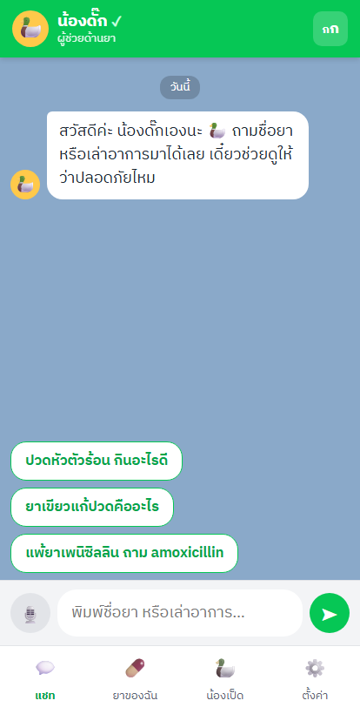
Figure 1: Main chat screen displaying the duck mascot, chat bubbles, and quick reply buttons.

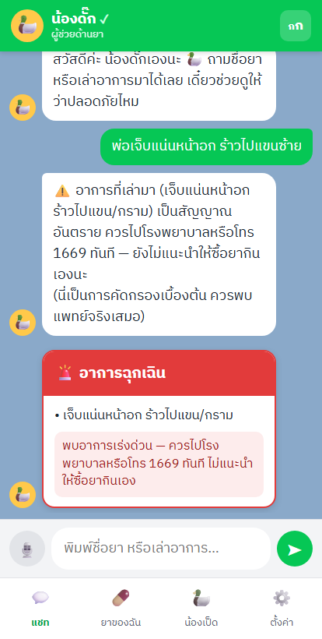
Figure 2: Emergency triage screen; when the user reports chest pain, the system displays a red card and advises calling 1669

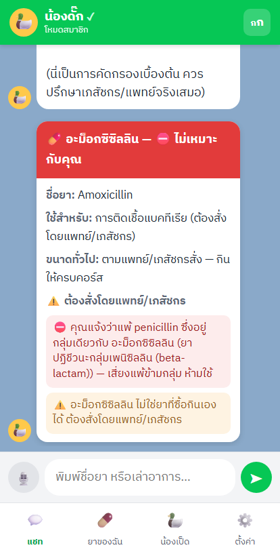
Figure 3: Personalized allergy alert; system warns of beta-lactam cross-allergy and strictly prohibits use.
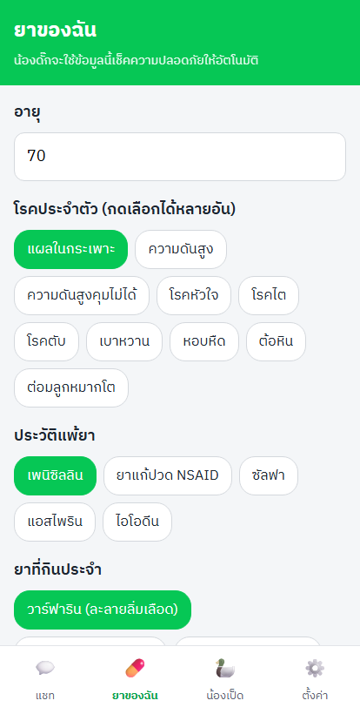
Figure 4: "My Medications" profile displaying user health data with large buttons.

Conclusions
Key to Success: The system restricts the LLM to language processing, while safety decisions are strictly governed by rule-based logic mapped to a curated database. This architecture ensures complete traceability and ethical safety, eliminating AI hallucinations.Furthermore, integrating vernacular drug names with a LINE-like UI lowers barriers for the elderly. Distinctly separating "absolute contraindications" from "warnings" effectively prevents alert/alarm fatigue.
Discussion
The core of this success lies in the architectural design that restricts the LLM strictly to language processing, while assigning all safety decisions to a rule-based mechanism validated against a curated database. This design directly addresses ethical and safety concerns because every decision is fully traceable to its underlying rule and data sources—unlike allowing AI to answer medication queries directly, which poses a high risk of hallucination.
Additionally, incorporating vernacular drug names alongside a LINE-like user interface significantly lowers barriers for elderly users. Finally, distinguishing between "absolute contraindications" and "cautious warnings" effectively mitigates the issue of over-alerting, which otherwise leads to user desensitization and alarm fatigue.

Acknowledgments
This research project was successfully completed thanks to the kind assistance and support of many individuals. The researchers would like to express their deepest gratitude to our project advisor, faculty members, and all experts for providing invaluable guidance and constructive suggestions throughout the study. We also sincerely thank the participants and all related parties for their excellent cooperation.
Finally, the researchers wish to thank our parents and families for their unwavering support and encouragement, which made the successful completion of this research project possible.

References
[1] Bureau of Health Administration.//(202X).//Guidelines for Promoting Health Literacy.//Bangkok:/Ministry of Public Health.
[2] Food and Drug Administration (FDA) of Thailand.//(202X).//Household Remedies List.//Nonthaburi:/Ministry of Public Health.
[3] Food and Drug Administration (FDA) of Thailand.//(202X).//National List of Essential Medicines.//Nonthaburi:/Ministry of Public Health.
[4] Package Inserts of the medicinal products referenced in the database.//(202X).//Product Insert Data Sheets.//Database Records.
[5] Sardi, L., Idri, A., & Fernandez-Aleman, J. L.//(2017).//A systematic review of gamification in e-Health.//Journal of Biomedical Informatics.//71://31-48.
[6] World Health Organization (WHO).//(1997).//Guidelines for the Regulatory Assessment of Medicinal Products for Use in Self-Medication.//Geneva:/WHO.

