The Effect of CMC Coating Derived from Cellulose Extracted from Corn Husk on Slowing the Release of Phosphate Adsorbed by Biofertilizers

Pumrapee Chana^{1*}, Pawarisa Saenphich¹, Thunwarat Khunatep¹,
Natthawat Ai-kaew¹ and Thongpian Singchai¹
¹Princess Chulabhorn Science High School Chiang Rai, 345 Moo 2 Rob Wiang Subdistrict, Muang District,
Chiang Rai 57000, Thailand
*e-mail: 05785Pumrapee@pcccr.ac.th

Abstract
This project aimed to study the effect of carboxymethyl cellulose (CMC) coating derived from corn husk on the delayed release of phosphate adsorbed by biofertilizers, addressing concerns regarding excessive chemical fertilizer use that leaves persistent phosphate residues in soil. Biofertilizers were first prepared and subsequently used to adsorb phosphate from DI water containing 1.0 M dissolved phosphate ions. The amount of phosphate adsorbed was quantified using the molybdenum blue method with a UV–Vis spectrophotometer and compared with a standard calibration curve, indicating the high phosphate uptake capacity of the biofertilizers. The phosphate-loaded biofertilizers were then coated with CMC extracted from corn husk cellulose, and FT-IR analysis confirmed the presence of characteristic CMC functional groups, with CH₂ stretching at 1,400–1,450 cm⁻¹ and C–O–C stretching vibrations at 1,000–1,200 cm⁻¹, which were consistent with those of commercial CMC. To evaluate the effect of the coating on controlling phosphate release, the coated biofertilizers were immersed in synthetic water for 10 hours. Phosphate concentrations in the water were measured every 2 hours, revealing an average phosphate concentration of 4.386 mg/L, demonstrating a delayed phosphate release effect compared with uncoated biofertilizers. Overall, the findings indicated that CMC coating derived from corn husk effectively slowed phosphate release from biofertilizers and demonstrated strong potential for sustainable applications in agricultural soil management.
keywords : Biofertilizers, Carboxymethyl Cellulose, Phosphate

Introduction
At present, phosphate contamination caused by the excessive use of chemical fertilizers and industrial wastewater has become one of the major environmental problems leading to eutrophication in aquatic ecosystems. When phosphate accumulates in water sources, it stimulates the rapid growth of algae and bacteria, which reduces dissolved oxygen levels and negatively affects aquatic organisms. This can disrupt the ecological balance of aquatic ecosystems and cause severe environmental damage. Therefore, the removal and control of phosphate in water sources are important issues in environmental management.
One promising approach is the use of adsorbent materials derived from agricultural waste, since they are inexpensive, biodegradable, and environmentally friendly. Bio-based materials can adsorb phosphate effectively; however, their ability to control or slow phosphate release is still limited. If the adsorbed phosphate is later used as fertilizer, it may be released too quickly and contribute to phosphate accumulation in soil.
To address this limitation, this study proposed the use of cellulose extracted from corn husk as a coating material. Corn husk is an abundant agricultural by-product that can be transformed into a value-added material. Carboxymethyl cellulose (CMC) derived from corn husk cellulose was expected to act as an effective coating for controlled phosphate release. The use of CMC may help improve nutrient release control and increase the practical value of biofertilizers materials. Therefore, this study aimed to investigate the effectiveness of CMC coating in controlling phosphate release from biofertilizers. The findings may contribute to the development of sustainable materials for agricultural and environmental applications.

Methodology
1) The preparation of biofertilizers pellets
Eggshell, calcined rice straw, and chitosan were ground, mixed, and sieved through a mesh. Then, 10 g of the mixture was treated with 15 mL of 0.2 M acetic acid (CH₃COOH) and stirred until a viscous paste was obtained. The paste was molded in a plastic mold and dried at room temperature for 24 hours, or until completely dry, before removal for further testing.
2) The extraction and synthesized carboxymethyl cellulose (CMC)
Corn husk was washed, dried at 70 °C for 24 hours, cut into 1.0 cm pieces, and treated with 8.0% (w/v) NaOH at 100 °C for 3 hours. The cellulose was filtered, washed to neutrality, bleached with 5.0% (v/v) NaClO, and dried at 60 °C for 24 hours. Cellulose (5.0 g) was mixed with 90.0 mL of isopropyl alcohol for 30 min, then with 50.0 mL of 30.0% NaOH for 1 hour, followed by 8 g of C₂H₃ClO₂ at 60 °C for 3 hours, and cooled to room temperature.
The mixture was neutralized with acetic acid (CH₃COOH), filtered, washed with 70.0% (v/v) ethanol to obtain CMC, and dried at 60 °C for 12 hours. CMC was then identified by FT-IR at the Scientific and Technological Research Services Center, Faculty of Science, Chiang Mai University. For coating, 3.0 g of CMC was dissolved in 100.0 mL of DI water, heated at 80 °C for 10 min, cooled, and 20.0 mL of this solution was mixed with 20.0 mL of 10.0% (v/v) glycerol. Phosphate-adsorbed biofertilizers pellets were weighed, immersed in the CMC–glycerol solution for 10 min, allowed to drain, and dried at 60 °C for 5 hours. This coating procedure was repeated twice to increase the thickness of the CMC layer, and the weights before and after coating were recorded.
3) The phosphate release-retardation ability of CMC-coated biofertilizers was evaluated by the molybdenum blue method (modified from Sanyant, S., & Patchareepon, J., 2021, as cited in Esanpedia)
The experiment was conducted using two experimental sets. Set 1 consisted of CMC-coated biofertilizers pellets, whereas Set 2 consisted of uncoated biofertilizers pellets
For both sets, the biofertilizers pellets were immersed in DI water for 10 hours. Water samples were collected every 2 hours, and phosphate concentrations in the samples were determined by the molybdenum blue method at the Central Laboratory, Faculty of Agriculture, Chiang Mai University.

Results and Discussion
1) Preparation of Biofertilizers from Eggshell, Chitosan, and Rice Straw
The biofertilizers was prepared by mixing eggshell powder, chitosan, and rice straw at a weight ratio of 1:1:1. Acetic acid was added to improve the binding of the mixture, which was then poured into a mold measuring 1 × 1.5 cm and dried in an oven to produce solid biofertilizers pellets. The prepared biofertilizers is shown in Figure 1.
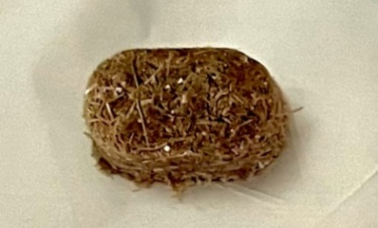
Fig. 1 Biofertilizers pellets prepared from eggshell, chitosan, and rice straw
2) Cellulose extraction from corn husk
Cellulose was extracted from corn husk by boiling the husk with 8% (w/v) sodium hydroxide and subsequent bleaching, yielding a light-yellow solid as shown in Figure 2, with a dry cellulose yield of 7.8 g.
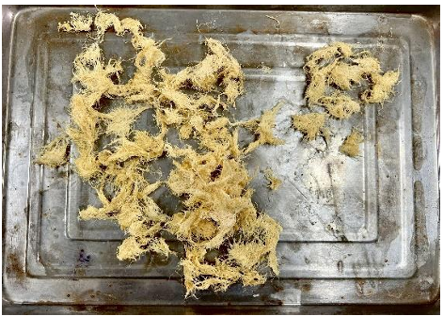
Fig. 2 Cellulose extraction from corn husk
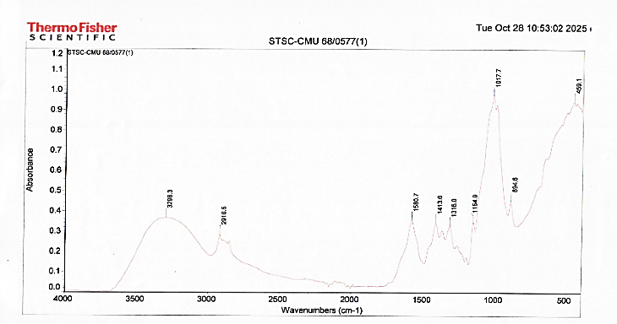
3) Characterization of CMC Synthesized from Corn Husk by FT-IR Spectroscopy
Fig. 3 FT-IR spectra of CMC from corn husk
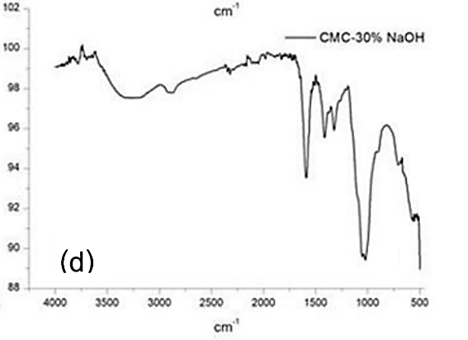
The synthesized CMC was characterized using Fourier Transform Infrared (FT-IR) spectroscopy. The FT-IR spectrum of synthesized CMC is shown in Figure 3.
Fig. 4 FT-IR spectrum of commercial CMC (Sanyant, S., & Patchareepon, J., 2021)
The FT-IR spectrum of the synthesized CMC was comparable to that of commercial CMC. Characteristic absorption bands corresponding to the carbonyl (C=O) group were observed at approximately 1,600–1,700 cm⁻¹, while the methylene (CH₂) group appeared at 1,400–1,450 cm⁻¹. In addition, the ether (C–O–C) stretching vibration was detected in the range of 1,000–1,200 cm⁻¹. The presence of these characteristic functional groups is consistent with the spectrum of commercial CMC and serves as a chemical fingerprint, confirming the successful carboxymethylation of cellulose extracted from corn husk.
These findings indicated that CMC was successfully synthesized.
4) Effect of CMC coating derived from corn husk cellulose on retarding phosphate release from phosphate-adsorbed biofertilizers
Table 1. Effect of CMC coating on phosphate concentration in DI water containing coated and uncoated biofertilizers.
Phosphate concentration in DI water containing CMC-coated and uncoated biofertilizers (mg/L)
Biofertilizers | Time (hours) |  |  |  |  | Average release [value]
Biofertilizers | 2 | 4 | 6 | 8 | 10
Uncoated Biofertilizers | 5.51 | 5.56 | 5.78 | 5.80 | 11.24 |  |  | 5.926
Coated Biofertilizers with CMC | 1.25 | 1.54 | 1.59 | 2.22 | 11.07 |  |  | 4.386
The phosphate release behavior of CMC-coated and uncoated biofertilizers immersed in DI water for 10 hours is presented in Table 1. The phosphate concentrations released from the CMC-coated biofertilizers at 2, 4, 6, 8, and 10 hours were 1.25, 1.54, 1.59, 2.22, and 11.07 mg/L, respectively, with an average concentration of 4.386 mg/L. In contrast, the phosphate concentrations released from the uncoated biofertilizers at the corresponding time intervals were 5.51, 5.56, 5.78, 5.80, and 11.24 mg/L, respectively, resulting in an average concentration of 5.926 mg/L.
The results indicated that the CMC-coated biofertilizers released significantly lower amounts of phosphate during the initial stages of the experiment than the uncoated biofertilizers. The lower average phosphate concentration observed for the coated samples suggested that the CMC coating effectively acted as a diffusion barrier, thereby slowing the release of phosphate into the surrounding medium. These findings demonstrated that coating the biofertilizers with CMC effectively enhanced the controlled release of phosphate compared with the uncoated biofertilizers.

Conclusions
Based on the results of this study, it can be concluded that the biofertilizers produced from eggshells, chitosan, and rice straw at a ratio of 1:1:1 was stable in water-insoluble and effectively adsorbed phosphate from synthetic wastewater. These findings demonstrated the potential of this material to recover phosphate and reuse it as a biofertilizers. Furthermore, coating the biofertilizers with carboxymethyl cellulose (CMC) derived from corn husks effectively delayed phosphate release. The coating exhibited the greatest controlled-release performance during the first 8 hours of the experiment. However, after 10 hours, the phosphate concentrations measured in the water from the coated and uncoated samples became similar, reaching 11.07 and 11.24 mg/L, respectively. This indicated that the CMC coating was effective in slowing phosphate release during the initial stage of the experiment, while the release rates of both coated and uncoated biofertilizers gradually converged over time.
Acknowledgments
We sincerely thank the Scientific and Technological Research Services Center and Central Laboratory, Chiang Mai University, for their support in sample analysis. We are deeply grateful to Mr. Natthawat Ai-kaew, Mrs. Thongpian Singchai, all advisors, and Miss Pimpawan Kanthakhiao, our English teacher, for their guidance and careful review of this article. We also gratefully acknowledge Princess Chulabhorn Science High School Chiang Rai for providing facilities and financial support.

References
Bilo, Fabjola, et al. (2018). A sustainable bioplastic obtained from rice straw. Journal of Cleaner Production, 200, 357-368.
Sanyant, S., & Patchareepon, J. (2021). Effect of Crosslinker Types on the Properties of Biodegradable Hydrogels Derived from Cassava Starch Grafted with Poly (Acrylic Acid)/Natural Rubber as Coating Material for Slow-release Urea Fertilizer. Faculty of Science, Ubon Ratchathani University.
Tikhamporn Chansuk, et al. (2019). Carboxymethyl cellulose from corn peel. in 16. KU-KPS National Conference. (p. 3022-3027). Kasetsart University. Kamphaeng Saen Campus, Nakhon Pathom (Thailand). Office of the Campus. Educational Administration and Student Affairs Division.

