Development and Characterization of Hydroxyapatite-Based Materials Derived from Waste Nile Tilapia Scales from Mekong River Cage-Farming Communities for a Targeted Drug Delivery System in Bone Infection Treatment

Patcharapron Sansom¹, Wadee Le ¹*
Thanaphat Tabthaisong¹, Wichuda Sanpakdee¹
¹¹Princess Chulabhorn Science High School Mukdahan No.281, Village No. 6, Bang Sai Yai, Mueang Mukdahan, Mukdahan. 49000 Thailand
*e-mail: 05944@pccm.ac.th

Abstract
This study focuses on the extraction and characterization of hydroxyapatite (HAp) derived from Nile tilapia scales to evaluate its quality and suitability as a drug delivery material for bone infection treatment. The fish scales were cleaned, soaked in NaOH solution, and calcined at 1,000 °C for 3 h. Five HAp formulations were prepared, four of which were further treated with KOH at concentrations of 1 M and 3 M for 1 and 5 hours. Chemical structure was analyzed using Fourier-transform infrared spectroscopy (FT-IR), porosity was determined by iodine number via iodometry, and surface characteristics were examined by field-emission scanning electron microscopy (FESEM). Gentamicin was used as the model antibiotic, and its release from HAp pellets was measured using spectrophotometry. Statistical analysis was performed using one-way ANOVA followed by Tukey’s HSD post hoc test (p < 0.01). The HAp appeared as a white powder containing P–O, P–OH, and CO₃²⁻ bonds. The surface exhibited porosity, and iodine number varied significantly among formulations (p < 0.01). HAp treated with 1M KOH for 5 hours showed the highest iodine number and encapsulated the most gentamicin. Pellets retained their shape for up to one day in fluid before disintegration. In simulated body fluid (SBF), Gentamicin release increased daily, with rapid release during days 1–4, while in distilled water, release increased quickly during days 1–3. The release rate and total amount decreased over time. The Higuchi model fit all formulations well (R² ≈ 1), and no significant differences in Gentamicin release were observed among pellets.
keywords : hydroxyapatite, tilapia scales, drug delivery system

Introduction
Osteomyelitis, an infection and inflammation of bone tissue, is a common medical condition that may lead to loss of organ function or even limb amputation if not treated promptly. A commonly used treatment for this condition is the administration of antibiotics via intravenous injection, which often requires high doses to ensure adequate drug penetration into the infected area. However, high-dose antibiotic therapy may cause undesirable side effects in the body (Phuttichat Khantee & Orsri Wittawatmongkol, 2016).
Currently, antibiotic drug delivery materials that can release drugs directly at the site of infection have been developed. These drug delivery systems are typically spherical beads strung together, which can be placed in the infected area to provide sustained antibiotic release. Nevertheless, a major drawback of these materials is that they are non-biodegradable, requiring surgical removal after treatment is completed (Ferreira et al., 2021).
Hydroxyapatite (HAP) is a material with properties similar to natural bone and is biodegradable within the body, eliminating the need for surgical removal after treatment. In addition, hydroxyapatite can be used as a drug delivery carrier, particularly for the treatment of bone infections, due to its porous structure, which allows for effective drug loading and sustained release. However, hydroxyapatite currently used in medical applications is relatively expensive due to complex production processes and high raw material costs (Wallapa Trakulwannachai, 2018).
To address this issue, the present study focuses on the extraction of hydroxyapatite from tilapia fish scales, which are inexpensive and abundantly available in the market. According to a study by Ikoma et al. (2003), calcium hydroxyapatite (Ca₁₀(PO₄)₆(OH)₂) is a constituent of fish scale structures. Therefore, it is expected that hydroxyapatite extracted from tilapia scales can reduce production costs while maintaining effective drug delivery properties and good bone integration comparable to hydroxyapatite produced through conventional synthetic methods.

Methodology
1) Materials
Tilapia fish scales were used as the raw material for hydroxyapatite (HAp) extraction. Sodium hydroxide (NaOH, 95% purity) and potassium hydroxide (KOH, 95% purity) were employed for organic removal and porosity enhancement, respectively. Gentamicin sulfate injection was used as the model antibiotic. Iodine solution (1% I₂), sodium thiosulfate (Na₂S₂O₃) and copper(II) chloride dihydrate (CuCl₂·2H₂O) were used for porosity analysis. All chemicals were used as received, and deionized water was used throughout the experiments. The instruments included a muffle furnace, shaker, tablet press, water bath, UV–Visible spectrophotometer (UV-1800, Shimadzu, Kyoto, Japan), and hot air oven.
2) Preparation and Porosity Activation of Hydroxyapatite
Fish scales were washed, boiled, and dried prior to chemical treatment. The cleaned scales were soaked in 3 mol/L NaOH for 24 hr. to remove organic components, rinsed until neutral pH, and calcined at 1,000 °C for 5 hr. The resulting hydroxyapatite was ground into powder.
Porosity activation was performed using KOH at different concentrations and durations: non-activated hydroxyapatite, 1 mol/L KOH for 1 h and 5 hr, and 3 mol/L KOH for 1 hr. and 5 hr. After activation, samples were washed and dried.
3) Characterization of Hydroxyapatite
Chemical composition was analyzed by Fourier-transform infrared spectroscopy (FT-IR) to confirm characteristic hydroxyapatite functional groups. Porosity was evaluated using the iodometry method. Surface morphology and pore structure were observed using field emission scanning electron microscopy (FESEM).
4) Gentamicin Loading and Pellet Formation
Hydroxyapatite powder was immersed in gentamicin solution and agitated for 30 min to allow drug adsorption. The loaded samples were filtered and dried at 30 °C. Pellets were prepared by compressing 0.5 g of gentamicin-loaded hydroxyapatite, and pellet dimensions were measured to ensure consistency.
5) In Vitro Drug Release Study
Pellets were immersed in 50 mL of distilled water or SBF and incubated at 37 °C for 7 days. Samples were collected daily, and gentamicin concentration was quantified by UV–visible spectrophotometry at 291 nm using a standard calibration curve
6) Release Kinetics and Statistical Analysis
Drug release data were fitted to zero-order, first-order, and Higuchi models to evaluate release mechanisms. Statistical analyses were conducted using one-way ANOVA followed by Tukey's HSD post hoc test for multiple comparisons and an independent-samples t-test for comparisons between two independent groups. A significance level of p < 0.01 was adopted throughout the study.
Result and Discussion
1) Morphology and Porosity Analysis
FT-IR analysis confirmed the successful extraction of HAp, showing characteristic functional groups in all samples (Figure 1). FESEM images (Figure 2) revealed that KOH activation significantly increased surface roughness and porosity compared to the non-activated control. These findings correlate with the iodine numbers presented in Table 1, where the 1 M KOH (5 hr.) formulation exhibited the highest adsorption capacity, indicating an optimal porous structure for drug loading.
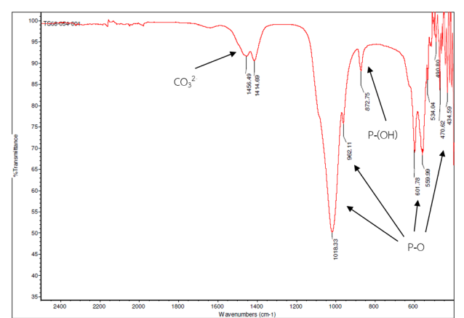
Fig. 1 FT-IR spectra of hydroxyapatite.
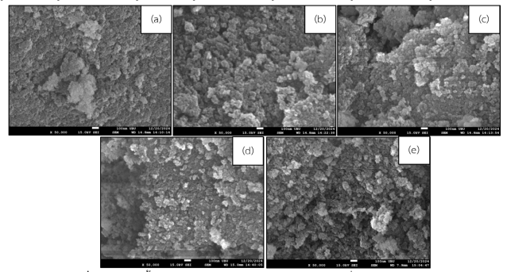
Fig. 2 FESEM images of hydroxyapatite surface at 50,000x magnification: (a) non-activated, (b) 1 M KOH 1 h, (c) 1 M KOH 5 h, (d) 3 M KOH 1 h, and (e) 3 M KOH 5 h.
Table 1. Iodine numbers of HAp formulations via iodometry.
Formulation | Iodine No. (mg/g) | Adsorption (%)
Non-activated | 46.3965 | 45.7000
1M 1hr. | 66.4982 | 65.5000
1M 5hr. | 80.8639 | 79.6500
3M 1hr. | 76.0922 | 74.9500
3M 5hr. | 80.1532 | 78.9500

2) Gentamicin Loading and Release Behavior
The loading efficiency of gentamicin was found to be directly proportional to the material’s porosity. The 1 M KOH (5 hr.) formulation encapsulated the highest amount of gentamicin, achieving an optimal balance between porosity enhancement and structural stability.
Table 2.Gentamicin encapsulation efficiency of HAp pellets.
Formulation | Amount Encapsulated per Pellet (mg) | Encapsulation Efficiency (%)
Non-activated | 0.3968 | 49.6009
1M 1hr. | 0.5401 | 67.5136
1M 5hr. | 0.6599 | 82.4924
3M 1hr. | 0.6094 | 76.1772
3M 5hr. | 0.6482 | 81.0276

In vitro studies demonstrated a significant burst release in both simulated body fluid (SBF) and distilled water during the initial 72–96 hours, followed by a sustained and gradual release phase. The release rate was slightly higher in distilled water than in SBF.

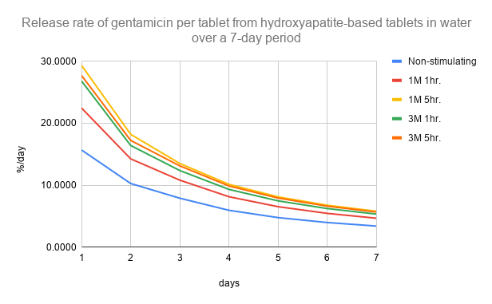Fig.3 The release rate of Gentamicin from a hydroxyapatite - base tablet in water per tablet over a period of 7 days.
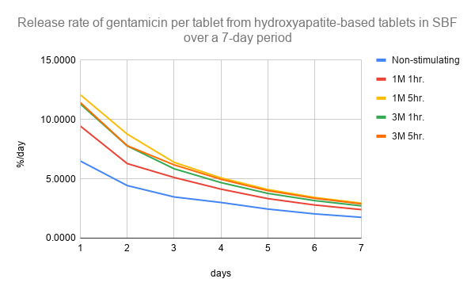
Fig. 4 The release rate of gentamicin from a single hydroxyapatite-base tablet in simulated body fluid (SBF) over a period of & days
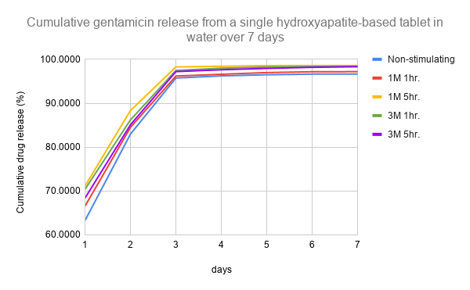Fig. 5 Percentage of cumulative gentamicin release from HAp pellets in distilled water over a 7-day period.
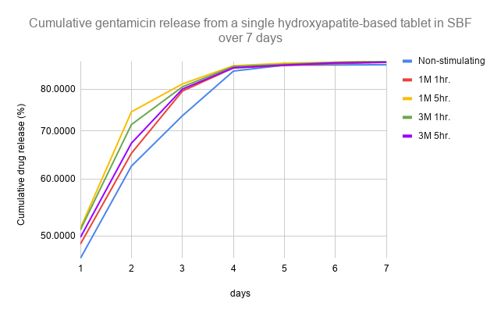Fig. 6 Percentage of cumulative gentamicin release from HAp pellets in distilled SBF over a 7-day period.
Mathematical fitting showed that the release behavior followed the Higuchi model (R² ≈ 1), indicating that gentamicin release was primarily controlled by diffusion through the porous hydroxyapatite matrix.

Conclusions
Porous hydroxyapatite (HAp) was successfully synthesized from tilapia scales and exhibited chemical and structural characteristics comparable to natural bone mineral. KOH activation significantly enhanced the porosity of HAp, resulting in improved gentamicin loading capacity and controlled drug release behavior. Among all formulations, HAp activated with 1 mol/L KOH for 5 hr. demonstrated the highest porosity, drug loading efficiency, and cumulative gentamicin release.
In vitro release studies revealed an initial burst followed by sustained drug release, with release kinetics well described by the Higuchi model, indicating a diffusion-controlled mechanism. Although the pellets partially disintegrated after immersion, this property may promote biodegradation and eliminate the need for surgical removal after treatment.
Overall, hydroxyapatite derived from tilapia scales represents a low-cost, biodegradable, and effective carrier for localized antibiotic delivery and shows strong potential for application in the treatment of bone infections. Future studies should focus on improving mechanical strength and evaluating in vivo performance.

Acknowledgments
The authors would like to express their sincere gratitude to Mr. Thanaphat Tabthaisong and Ms. Wichuda Sanpakdee for their invaluable guidance, encouragement, and continuous support throughout this research. The authors also gratefully acknowledge Princess Chulabhorn Science High School Mukdahan for providing laboratory facilities and research support, and the Scientific Instrument Center, Ubon Ratchathani University, for assistance with sample characterization and instrumental analysis. Their support and contributions were essential to the successful completion of this study.

References
Ferreira, M., et al. (2021).Liposomes as Antibiotic Delivery Systems: A Promising Nanotechnological Strategy against Antimicrobial Resistance. Molecules. 26(7): 2047.
Khantee, P., & Witthawatsamongkhon, O. (2016, November–December). Pediatric Acute Osteomyelitis. Focus Journal.
Kritsanamara,N.,Charoenphandhu, N., & Panupinthu, N. (2017). Research Project for the Development of Calcium and Collagen Supplement Products from Fish Scale Nanocomposites. Bangkok: Mahidol University.
Litsanan,S.,etal.(2017). Preparation, Characterization, and Study of Antibiotic Release via Geopolymers. RMUTP Research Journal. 11(2): 80–91.
Piukaew, N. (2018). Preparation of Hydroxyapatite-Based Antibiotic Delivery Pellets for Localized Bone Infection Treatment via Hydrothermal Process. (Master's Thesis). Bangkok:Chulalongkorn University.
Somjit, S., & Chompoosor, A. (2017). Drug Release Kinetics from Polydiacetylene Nanocapsules Coated with Gold Nanoparticles. In Proceedings of the National and International Graduate Research Conference. pp. 345–351. Khon Kaen: Khon Kaen University.
Trakulwannachai, W. (2018). Development of Hydroxyapatite Composites Prepared from Eggshells and Their Applications in Medical Technology. (Master's thesis). Bangkok: Thammasat University.

