AI-Based Cough Sound Analysis System for Preliminary Respiratory Disease Screening. (Cough Sense AI)

Kantapat Wattana¹, P.Potiwat Pattanasiripong^{1*} and Parid Khongtong¹
Thapanawat Chooklin¹, Pattiya Chanudom¹ and Boonchana Purahong²
¹Princess Chulabhorn Science High School Nakhon Si Thammarat No. 120 Moo 1, Sunonant Road, Bang Chak,
Mueang Nakhon Si Thammarat, Nakhon Si Thammarat, 80330 Thailand
²School of Engineering, King Mongkut's Institute of Technology Ladkrabang, Lat Krabang, Bangkok, 10520 Thailand
*e-mail: 6405676@pccnst.ac.th

Abstract
Respiratory diseases are among the leading causes of illness and mortality worldwide, making early screening essential for timely medical intervention. This study presents Cough Sense AI, an artificial intelligence-based cough sound analysis system developed for the preliminary screening of respiratory diseases. The proposed system employs Mel-Frequency Cepstral Coefficients (MFCCs) to extract acoustic features from cough recordings and utilizes a Convolutional Neural Network (CNN) for disease classification. Three CNN architectures, including a standard CNN, CNN with Dropout, and CNN with Global Average Pooling, were evaluated to determine the optimal model. Experimental results demonstrated that the CNN with Global Average Pooling architecture achieved the best performance, with an Accuracy of 83.22% and an F1-score of 79.71%, while showing strong classification performance for Healthy, Asthma, and Chronic Obstructive Pulmonary Disease (COPD). A web-based application was also developed, allowing users to upload or record cough sounds and receive real-time screening results together with a confidence score through an intuitive interface compatible with desktop and mobile devices. The proposed system provides a low-cost, non-invasive, and accessible approach to preliminary respiratory disease screening without requiring specialized medical equipment. Although it is intended as a screening tool rather than a clinical diagnostic system, the results demonstrate the potential of AI-assisted cough sound analysis to support early respiratory disease detection and improve access to healthcare, particularly in resource-limited communities.

keywords : Cough Sound Analysis, Respiratory Disease Screening, Mel Frequency Cepstral Coefficients,
Convolutional Neural Network, Decision Support System

Introduction
Respiratory diseases are among the most common health conditions affecting people in Thailand and worldwide. Following the global outbreak of Coronavirus Disease 2019 (COVID-19), public awareness of respiratory health has increased significantly. Respiratory infections caused by viruses or bacteria often present with a common early symptom—coughing. A cough is a key clinical indicator associated with numerous respiratory diseases, including COVID-19, sinusitis, asthma, chronic obstructive pulmonary disease (COPD), and lung cancer. According to global health statistics (World Health Organization, 2024), COPD and lung cancer ranked among the leading causes of death worldwide in 2021, highlighting the substantial public health burden posed by these diseases.
Despite its clinical importance, many individuals tend to overlook coughing, considering it a temporary symptom that will resolve without medical attention. Consequently, patients may delay seeking appropriate diagnosis and treatment, increasing the risk of disease progression and serious complications. This challenge is particularly evident in rural and underserved areas where access to healthcare professionals and advanced diagnostic equipment, such as chest X-ray and computed tomography (CT) scanners, is limited. The high cost of these diagnostic tools and delayed access to healthcare services further hinder early disease detection.
Recent advances in artificial intelligence (AI) have enabled the development of intelligent healthcare systems capable of assisting with disease diagnosis through automated analysis of medical data. Among these applications,
cough sound analysis has emerged as a promising, non-invasive approach for respiratory disease screening. Previous studies have demonstrated that cough sounds vary across different respiratory conditions in terms of temporal patterns, frequency characteristics, intensity, and acoustic features
(Ijaz et al, 2022). These distinctive characteristics can be effectively analyzed using AI and machine learning techniques to identify disease-specific patterns (Dunne et al., 2020).
Motivated by these developments, this study presents Cough Sense AI, an AI-based cough sound analysis system designed for the preliminary screening of respiratory diseases. The system enables users to record a cough using a standard smartphone, after which AI algorithms analyze the acoustic features and estimate the likelihood of respiratory diseases rapidly and accurately (Imran et al., 2020). Unlike conventional diagnostic methods, Cough Sense AI does not require expensive medical equipment or specialized clinical procedures, making it more accessible for routine health monitoring.
Beyond individual use, Cough Sense AI has the potential to support community-level healthcare services, including public health centers, schools, and childcare facilities, where it can be employed as a preliminary screening tool before referral for clinical examination. By providing an accessible, low-cost, and non-invasive screening solution, the proposed system aims to facilitate earlier detection of respiratory diseases, improve access to healthcare, and support timely medical intervention, ultimately contributing to better public health outcomes.

Methodology
1) Literature Review and Theoretical Framework A comprehensive literature review was conducted to establish the theoretical foundation of this study. Medical and scientific information related to respiratory diseases, including Chronic Obstructive Pulmonary Disease (COPD), asthma, and other respiratory disorders, was investigated to support cough sound analysis. In addition, the principles of Convolutional Neural Networks (CNNs), various deep learning techniques, and audio signal processing using Mel-Frequency Cepstral Coefficients (MFCCs) were studied to develop the AI model. The principles of website development and AI integration using the Flask Framework were also examined to support the implementation of the proposed web-based respiratory disease screening system.
2) Data Collection and Preparation
1. Search for a cough sound dataset from Kaggle, which contains cough sound samples from patients with various respiratory diseases specifically Chronic Obstructive Pulmonary Disease (COPD), asthma, and Covid-19 —utilizing a dataset of 401 audio files for COPD, 288 audio files for asthma and 224 audio files for Covid-19 as well as 1,207 normal cough sounds files. Organize the data into a format suitable for AI model input.
2. Download the dataset from Kaggle and store it in Google Drive so that it can be accessed from Google Colab.
3) AI Model Development and Training
1. Use Google Colab as the primary platform for AI model training because it provides GPU support for computation.
2. Develop a Convolutional Neural Network (CNN) model for cough sound classification, using MFCC features extracted from extracted from .wav audio files as the model input. 3. After training the AI model, a Confusion Matrix is generated. The information in the confusion matrix is then used to evaluate the performance of the AI model.
4) Website Design and Development
1. Develop a website using Java for the backend and HTML/CSS for the frontend.
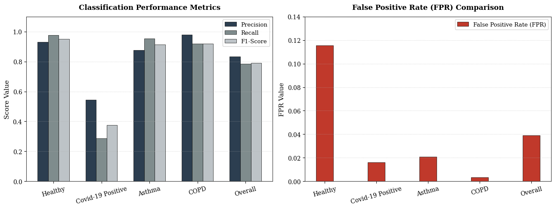
2. Design the website to allow users to upload an audio file or record their cough sound for analysis.
3. Integrate the trained AI model into the website and display the prediction results as text, such as "Normal Cough" or "Potential Respiratory Disease", together with the Confidence Score.
5) Prototype Testing and System Improvement
1. Test the AI model using cough sound recordings that are not included in the training dataset to verify its accuracy.
2. Evaluate the performance of both the AI model and the website interface. If any errors are found, incorporate additional data to improve both the AI model and the website structure based on the feedback, thereby enhancing the overall stability of the system.
Result and Discussion
1) Disease Classification Performance
The model achieved strong performance in classifying Healthy, Asthma, and COPD,
with F1-scores of 0.9519, 0.9130, and 0.9485, respectively, indicating that it successfully captured disease-specific cough characteristics. However, the performance for COVID-19 Positive was lower (Precision: 0.5455, Recall: 0.2857, F1-score: 0.3750), likely due to data imbalance and similarities between COVID-19 coughs and other respiratory diseases. Overall, the results demonstrate the feasibility of AI-assisted cough sound analysis as a non-invasive tool for preliminary respiratory disease screening.
Table 1 shows the performance of the AI ​​model in predicting cough sounds for various diseases.
Disease name | Performance Metrics of the AI Model
Disease name | Accuracy | Classification Error | Precision | Recall | False Positive Rate | F1-Score
Healthy | nan | nan | 0.9296 | 0.9754 | 0.1154 | 0.9519
Covid-19 Positive | nan | nan | 0.5455 | 0.2857 | 0.0160 | 0.3750
Asthma | nan | nan | 0.8750 | 0.9545 | 0.0208 | 0.9130
COPD | nan | nan | 0.9787 | 0.9200 | 0.0035 | 0.9185
Overall | 0.9159 | 0.0841 | 0.8322 | 0.7839 | 0.0389 | 0.7896
Fig.1 A chart showing the percentage survival rate of seagrass planted with different techniques.

Fig. 2 A chart showing the False Positive Rate (FPR) comparison for each diagnostic category.

2) Summary of the AI-Based Cough Sound Analysis System Evaluation
The experimental results show that CoughSense AI, which combines MFCC feature extraction with a CNN classifier, can effectively perform preliminary respiratory disease screening using cough sounds. Among the three evaluated architectures (CNN, CNN + Dropout, and CNN + Global Average Pooling), the CNN + Global Average Pooling model achieved the best performance, with an Accuracy of 0.8322 and a F1-score of 0.7971.
Table 2 shows the Accuracy and F1 Score values from AI models using different CNN techniques.
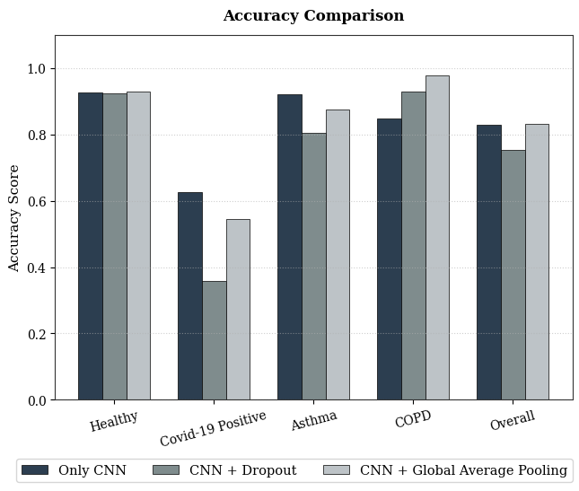
Fig. 3 A chart comparing the accuracy of three different AI model architectures across various conditions.

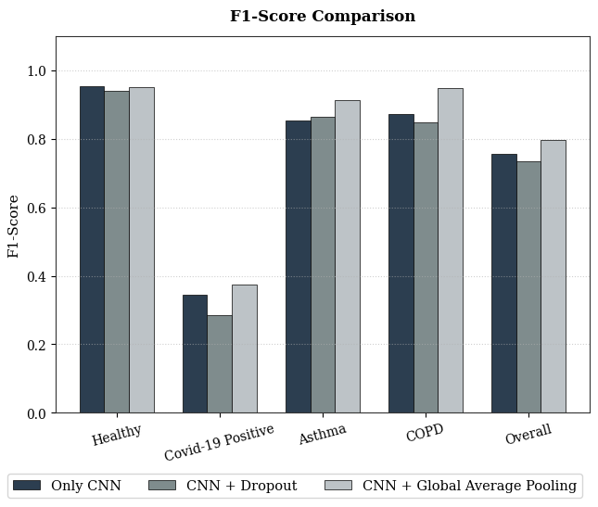
Fig. 4 A chart comparing the F1-Scores of three different AI model architectures across various conditions.

3) Summary of the Prototype Web Application Evaluation
Disease name | Techniques Used and AI Model Performance Metrics
Disease name | Only CNN |  | CNN + Dropout |  | CNN + Global Average Pooling
Disease name | Accuracy | F1-Score | Accuracy | F1-Score | Accuracy | F1-Score
Healthy | 0.9259 | 0.9547 | 0.9238 | 0.9395 | 0.9296 | 0.9519
Covid-19 Positive | 0.6250 | 0.3448 | 0.3571 | 0.2857 | 0.5455 | 0.3750
Asthma | 0.9211 | 0.8537 | 0.8039 | 0.8632 | 0.8750 | 0.9130
COPD | 0.8491 | 0.8738 | 0.9286 | 0.8478 | 0.9787 | 0.9485
Overall | 0.8303 | 0.7568 | 0.7534 | 0.7341 | 0.8322 | 0.7971
The Cough Sense AI Web Application successfully performed all intended functions, allowing users to upload or record cough sounds, process them using the trained AI model, and receive disease predictions with a Confidence Score. The website features a simple, user-friendly interface compatible with both desktop and mobile devices, providing an accessible and cost-effective solution for preliminary respiratory disease screening. Its ease of use and low infrastructure requirements make it suitable for deployment in hospitals, primary healthcare centers, schools, and other community healthcare settings.

Conclusions
This study successfully developed
Cough Sense AI, an artificial intelligence-based cough sound analysis system designed for the preliminary screening of respiratory diseases. The proposed system combines Mel-Frequency Cepstral Coefficients (MFCCs) for acoustic feature extraction with a Convolutional Neural Network (CNN) for cough sound classification. Experimental results demonstrated that the system can effectively distinguish cough sounds associated with several respiratory conditions. Among the three evaluated model architectures, CNN with Global Average Pooling achieved the best overall performance, obtaining an Accuracy of 83.22% and an F1-score of 79.71%, outperforming both the standard CNN and the CNN with Dropout model. The model showed strong classification performance for Healthy, Asthma, and Chronic Obstructive Pulmonary Disease (COPD), indicating that cough sounds contain distinctive acoustic characteristics that can be effectively learned using deep learning techniques. However, the classification performance for COVID-19 Positive remained comparatively lower, suggesting that additional training data and improved class balance are required to enhance the model's performance for diseases with similar cough characteristics.
In addition to the AI model, a web-based application was successfully developed to provide an accessible platform for respiratory disease screening. The application enables users to upload or record cough sounds through a web browser, automatically analyzes the audio using the trained AI model, and displays the predicted screening result together with a confidence score. Designed with a simple and user-friendly interface, the system is compatible with both desktop and mobile devices, making it convenient for everyday use. Since the proposed system requires only a smartphone or computer with a microphone and does not rely on expensive medical equipment, it has the potential to improve access to preliminary respiratory health screening, particularly in schools, community healthcare centers, and rural or resource-limited areas.
Although Cough Sense AI is intended as a screening tool rather than a clinical diagnostic system, the results demonstrate the potential of AI-assisted cough sound analysis as a practical, low-cost, and non-invasive approach for supporting early respiratory disease detection. Future work will focus on expanding and balancing the cough sound dataset, incorporating additional respiratory diseases, optimizing the deep learning architecture, and validating the system using larger real-world clinical datasets. These improvements are expected to enhance the accuracy, robustness, and reliability of the system, supporting its future application as an effective decision-support tool for preliminary respiratory disease screening.

Acknowledgments
Special thanks to Teachers for advice and data collection. We also thank Princess Chulabhorn Science High School, Nakhon Si Thammarat, for support in carrying out this study.

References
codernandan. (2022).
COVID-19 cough sounds [Data set]. Kaggle.
https://www.kaggle.com/datasets/pranayn andan63/covid-19-cough-sounds

Dunne, R., Morris, T., & Harper, S. (2020).
High accuracy classification of COVID-19 coughs using Mel-frequency cepstral coefficients and a convolutional neural network with a use case for smart home devices (Doctoral dissertation).
The University of Manchester. https://www.researchgate.net/publication/3 43376336
Dunne, R. (2020, August 20).
COVID-19 CNN MFCC classifier [Data set]. Mendeley Data. https://doi.org/10.17632/ww5dfy53cw.1
Ijaz, A., Nabeel, M., Masood, U., Mahmood, T., Posokhova, I., & Imran, A. (2022).
Towards using cough for respiratory disease diagnosis by leveraging artificial intelligence: A survey. Informatics in Medicine Unlocked, 29, 100832.
https://doi.org/10.1016/j.imu.
2021.100832
Imran, A., Posokhova, I., Qureshi, H. N., Masood, U., Riaz, M. S., Ali, K., John, C. N., Hussain, M. I., & Nabeel, M. (2020).
AI4COVID-19: AI enabled preliminary diagnosis for COVID- 19 from cough samples via an app. Informatics in Medicine Unlocked, 20, 100378. https://doi.org/10.1016/j.imu.2020 .100378
NATLADA MEEPHIW. (2022).
MFCC FEATURE NUMBERSELECTION FOR INFANT CRY CLASSIFICATION (Master’s thesis).
THAMMASAT UNIVERSITY. https://digital.library.tu.ac.th/tu_dc/frontend/Info/item/dc:303704

PENNAPA PHUKHOKWAI. (2023).
CONVOLUTIONAL NEURAL NETWORKS FOR COFFEE BEAN DEFECT CLASSIFICATION (Master’s thesis). Srinakharinwirot University
ithesis.swu.ac.th/dspace/handle/1 23456789/2753
Saeed, T., Ijaz, A., Sadiq, I., Qureshi, H. N., Rizwan, A., & Imran, A. (2024).
An AI-enabled bias- free respiratory disease diagnosis model using cough audio. Bioengineering, 11(1),55.
https://doi.org/10.3390/bioengine ering11010055
World Health Organization. (2024). Chronic obstructive pulmonary disease (COPD).
https://www.who.int/news- room/fact-sheets/detail/chronic- obstructive-pulmonary- disease-(copd)
World Health Organization. (2024).
The top 10 causes of death.
https://www.who.int/news- room/fact-sheets/detail/the-top- 10-causes-of-death

