Nanolignin for Eugenol Delivery: A Biological Alternative
for Sustainable Rice Blast Control

Natthakarn Chansamut¹*, Wipawee Srihanon¹, Pongtanawat Khemthong¹, Jakkapop Phanthasri¹,
Panot Krukkratoke¹ and Issaraporn Rakngam²
¹Princess Chulabhorn Science High School Lopburi, Huai Pong, Khok Samrong, Lopburi, 15120, Thailand
²National Nanotechnology Center, National Science and Technology Development Agency, Khlong Nueng, Khlong Luang, Pathum Thani, 12120, Thailand
*E-mail: 04799@pccl.ac.th

Abstract
This project was conducted to develop an environmentally friendly bioactive compound delivery system using lignin, a naturally biodegradable biomaterial, as a carrier for encapsulating eugenol. Eugenol is a natural compound with strong antimicrobial potential against plant pathogens. Therefore, this study investigated the release behavior of eugenol under different temperature conditions to evaluate the potential of the developed system for controlling Rice Blast Disease and reducing dependence on chemical pesticides in agriculture. Lignin nanoparticles encapsulating eugenol (LNPs-EUG) were synthesized and characterized. The prepared nanoparticles exhibited an average particle size of 67.57 nm and high stability, with a zeta potential of −43.2 mV. Chemical structure analysis using FTIR and XRD confirmed the successful encapsulation of eugenol within the amorphous lignin matrix. The release behavior was examined using UV–Vis spectrophotometry by determining the maximum absorbance wavelength, with analysis performed at 282 nm. The results showed that the developed delivery system provided sustained and controlled release for more than 20 hours, while release rates increased at higher temperatures. In conclusion, the developed lignin nanoparticles encapsulating eugenol demonstrate strong potential as a stable controlled-release bioactive delivery system. This system may improve the efficiency of natural bioactive compounds for sustainable agricultural applications while supporting environmentally friendly crop disease management and efficient natural resource utilization for future sustainable farming development worldwide.
keywords : Eugenol, Nanolignin, Encapsulation
Introduction
Rice is a major economic crop in Thailand and the Asian region; however, its production is significantly affected by Rice Blast Disease caused by Pyricularia oryzae, leading to severe yield losses [1]. Although synthetic fungicides are widely used for disease control, their environmental residues and potential health risks have raised concerns. Eugenol, a natural compound with strong antifungal activity, has gained attention as an alternative; however, its practical application is limited by high volatility and rapid degradation under heat and light exposure [5, 8].
Nano-encapsulation technology provides an effective strategy to enhance the stability and delivery efficiency of bioactive compounds [3, 4, 7]. In this study, lignin was selected as a natural carrier due to its amorphous structure, UV-shielding ability, and functional groups that support interactions with eugenol through hydrogen bonding and intermolecular forces [9–11]. The conversion of lignin into nanoparticles further improves surface area and adhesion properties, supporting controlled release under agricultural conditions [6, 10].
Therefore, this project aims to develop lignin nanoparticles for Eugenol encapsulation and investigate their encapsulation efficiency and temperature-dependent release behavior. This approach provides a sustainable delivery system for natural antifungal compounds, reducing reliance on synthetic fungicides and promoting environmentally friendly rice blast disease management.

Methodology
1. Preparation of Eugenol-Loaded Lignin Nanoparticles (LNPs-EUG)
Eugenol-loaded lignin nanoparticles (LNPs-EUG) were prepared using the nanoprecipitation method. Lignin powder 2 g was dissolved in 100 mL of ethanol under magnetic stirring at 200 rpm and 50°C for 2 hours. The obtained lignin solution was filtered to remove impurities, diluted to a concentration of 5 mg/mL, and transferred into a syringe. Eugenol (14.05 µL) was dissolved in 200 mL of deionized water, followed by gradual injection of 10 mL of lignin solution using a syringe pump under continuous stirring at 600 rpm and 25°C to form LNPs-EUG. The synthesized nanoparticle suspension was subsequently freeze-dried overnight to obtain dried LNPs-EUG powder for further characterization and release studies.
2. Release Kinetic Study of LNPs-EUG
The release behavior of Eugenol from LNPs-EUG was investigated by dispersing LNPs-EUG powder 0.01 g in 200 mL of deionized water. The suspension was sonicated using an ultrasonic cleaner for 30 minutes at 20°C to ensure uniform nanoparticle dispersion. Then, 10 mL of the suspension was transferred into three dialysis membranes. Each membrane was immersed in a 250 mL beaker containing 200 mL of deionized water under controlled temperatures of 25°C, 40°C, and 50°C using a magnetic stirrer with a hot plate. The beakers were sealed with parafilm to prevent evaporation, and samples were collected from the external solution at 1, 2, 3, 4, 5, 20, 24, and 48 hours to determine the amount of Eugenol released from the LNPs-EUG system.
3. Characterization of LNPs-EUG
The chemical and physical properties of LNPs-EUG were characterized using DLS, FT-IR, XRD, and UV-Vis Spectrophotometry. DLS was used to determine particle size, PDI, and nanoparticle stability. FT-IR and XRD were employed to analyze chemical interactions, functional groups, and structural properties after Eugenol encapsulation. UV-Vis Spectrophotometry was used to evaluate the loading capacity and encapsulation efficiency (%EE) based on the Eugenol calibration curve.

Result and Discussion
1. Particle Size and Polydispersity Index Analysis (DLS Result)
The particle size distribution, average particle size, and stability of LNPs-EUG were investigated using Dynamic Light Scattering (DLS). The obtained results are presented in Figure 1.1, Figure 1.2, and Table 1.1.
Figure 1.1 Particle size distribution of Eugenol-loaded lignin nanoparticles (LNPs-EUG)
Figure 1.2 Average hydrodynamic diameter of LNPs-EUG with standard deviation
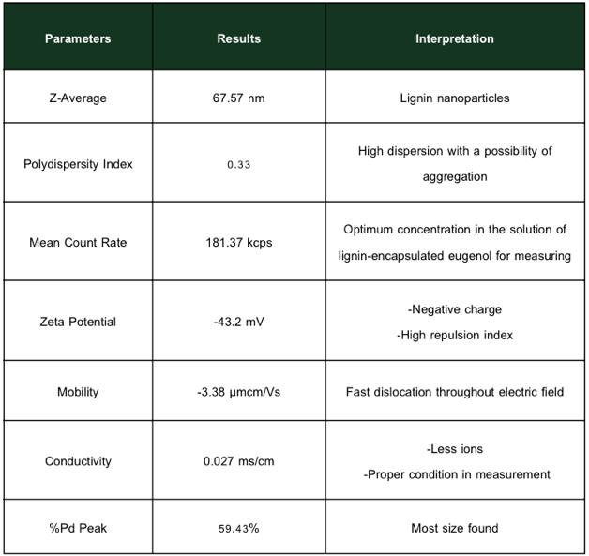
Table 1.1 Physical properties and surface charge of Eugenol-loaded lignin nanoparticles
The characterization results of LNPs-EUG showed an average particle size (Z-Average) of 67.57 nm with a PDI value of 0.33, confirming successful nanoparticle formation with moderate size distribution. The nanoparticles exhibited high physical stability, as indicated by the zeta potential value of -43.2 mV, which provided strong electrostatic repulsion and prevented particle aggregation. The particle mobility of -3.38 µm·cm/V·s under low conductivity conditions (0.027 mS/cm) further supported the stability of the LNPs-EUG system.
2. Chemical Functional Group Analysis (FT-IR Analysis)
The FT-IR spectra of commercial lignin and Eugenol-loaded lignin nanoparticles (LNPs-EUG) are presented in Figure 2.1.
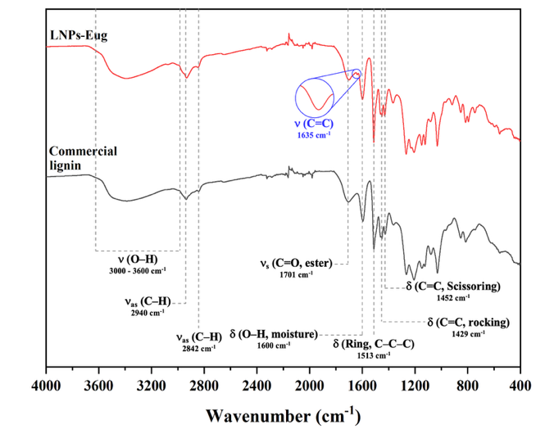
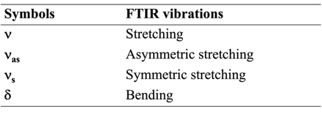
Figure 2.1 FT-IR spectra comparison between commercial lignin and Eugenol-loaded lignin nanoparticles (LNPs-EUG)
The FT-IR spectra of commercial lignin and LNPs-EUG revealed the characteristic functional groups and chemical interactions after Eugenol encapsulation. The LNPs-EUG spectrum retained the main lignin peaks, indicating that the original lignin structure was preserved. Additional absorption peaks corresponding to Eugenol confirmed its successful encapsulation into the lignin nanoparticle matrix. The overlapping signals suggested molecular interactions between lignin and Eugenol, such as hydrogen bonding, without significant changes to the fundamental chemical structure of lignin.
3. Structural Analysis Using X-Ray Diffraction (XRD)
The X-ray diffraction (XRD) patterns of commercial lignin and Eugenol-loaded lignin nanoparticles (LNPs-EUG) are presented in Figure 3.1.
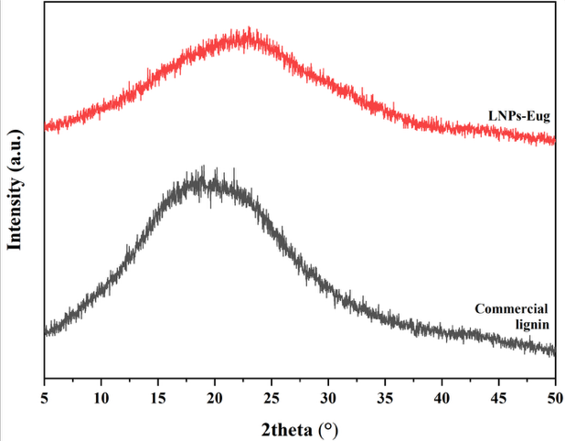
Figure 3.1 XRD patterns of commercial lignin and Eugenol-loaded lignin nanoparticles (LNPs-EUG)
The XRD analysis was performed to investigate the structural characteristics of lignin before and after Eugenol encapsulation. Both commercial lignin and LNPs-EUG exhibited a broad halo pattern within the 2θ range of 15°–30°, indicating the amorphous structure of lignin. No sharp diffraction peaks were observed after Eugenol encapsulation, confirming that Eugenol was uniformly distributed within the lignin nanoparticle matrix without forming crystalline structures. These results indicate that the encapsulation process maintained the original molecular structure of lignin and successfully formed the LNPs-EUG system.
4. Eugenol Release Study from Lignin Nanoparticles
The release behavior of Eugenol from LNPs-EUG was evaluated using UV-Vis Spectrophotometry. A calibration curve was established to correlate absorbance with Eugenol concentration, as shown in Figure 4.1.
Figure 4.1 Calibration curve showing the relationship between absorbance and Eugenol concentration measured by UV-Vis Spectrophotometry
The calibration curve showed a strong linear relationship between absorbance and Eugenol concentration, with the regression equation y = 0.0443x + 0.0232 and R² = 0.9778, indicating reliable quantification of Eugenol during the release study.
The Eugenol release profiles of LNPs-EUG at different temperatures (25°C, 40°C, and 50°C) are shown in Figure 4.2. Temperature significantly affected the release behavior. At 25°C, LNPs-EUG exhibited sustained release, while 40°Cresulted in moderate release with slight initial burst release followed by prolonged release. At 50°C, a pronounced burst release and the highest Eugenol release were observed.
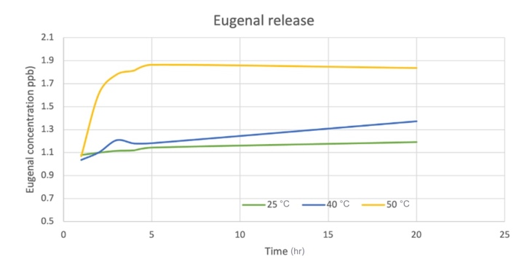
Figure 4.2 Eugenol release profile from LNPs-EUG at different temperatures (25°C, 40°C, and 50°C)
The cumulative release ratio (C/C₀) shown in Figure 4.3 increased continuously with release time, indicating the diffusion-controlled release of Eugenol from the amorphous lignin nanoparticle matrix. Higher temperatures accelerated molecular diffusion, causing the C/C₀ ratio to reach equilibrium faster. These results demonstrate that LNPs-EUG effectively encapsulated Eugenol and provided a controlled-release system.
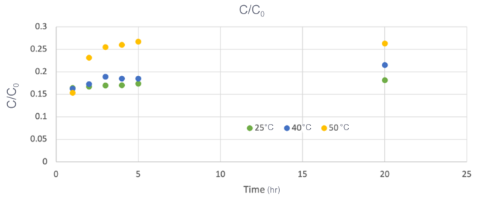
Figure 4.3 Cumulative release ratio (C/C₀) of Eugenol from LNPs-EUG under different temperature conditions

Conclusions
This study successfully developed Eugenol-loaded lignin nanoparticles (LNPs-EUG) as a potential sustainable biocontrol system for rice blast disease management. The nanoparticles exhibited suitable properties with an average particle size of 67.57 nm and high stability indicated by a zeta potential of -43.2 mV, preventing particle aggregation and maintaining dispersion stability.
FT-IR and XRD analyses confirmed the successful encapsulation of Eugenol within the amorphous lignin matrix without significant changes to lignin’s chemical structure. The release study showed that temperature influenced Eugenol release behavior, with higher temperatures accelerating release and 50°C causing an initial burst release, while lower temperatures provided sustained release for more than 20 hours. Overall, LNPs-EUG demonstrated potential as an effective carrier for stabilizing Eugenol and enabling controlled release, supporting the development of environmentally friendly biocontrol products for long-term rice blast disease management.

Acknowledgments
The project “Nanolignin for Eugenol Delivery: A Biological Alternative for Sustainable Rice Blast Control” was successfully completed with the support of many individuals and organizations. The authors sincerely thank Ms. Wipawi Srihanon for her guidance and support, as well as the advisors from the National Nanotechnology Center (NANOTEC) for their valuable advice. Appreciation is also extended to NANOTEC and Princess Chulabhorn Science High School Lopburi for providing facilities and resources, and to their parents and friends for their continuous encouragement and support.
References
[1] Fernandez, J., & Orth, K. (2021). Rise of
a cereal killer: The molecular biology of Magnaporthe oryzae (syn. Pyricularia oryzae) infection. Nature Reviews Microbiology, 19(9), 582-597.
[2] Kamal, T., Ul-Islam, M., Khan, A., & Shah, S. M. H. (2025). Controlled release of bioactive compounds using lignin-based nanocarriers for sustainable agriculture applications. Journal of Agricultural and Food Chemistry, 73(2), 456–468.
[3] Khemthong, P., et al. (2023). Effect of the ethanol-to-water ratio on the properties of silica–carbon core–shell materials for prolonged antibacterial activity of thymol. Applied Surface Science, 635, 157716.
[4] Lu, T., et al. (2024). Recent advances in lignin-based nanoparticles for controlled release of bioactive molecules in agriculture. International Journal of Biological Macromolecules, 258, 128915.
[5] Morales-Cerrada, R., García-Seco, D., & Gutiérrez, S. (2023). Antifungal and antimicrobial activity of eugenol: Recent advances and applications in agriculture. Applied Microbiology and Biotechnology, 107(15), 6201–6215.
[6] Santos, A. C., et al. (2021). Ultrasonic-assisted synthesis of lignin nanoparticles: Effects of process parameters on particle size and stability. Ultrasonics Sonochemistry, 73, 105518.
[7] Sosa, N., et al. (2023). Unraveling the adsorption behavior of thymol on carbon and silica nanospheres for prolonged antibacterial activity: Experimental and DFT studies. ACS Applied Bio Materials, 6(10), 4240–4249.
[8] Taleb, M. H., et al. (2022). Eugenol:
A potent compound for the treatment of fungal infections and as a natural preservative. Molecules, 27(11), 3462.
[9] Viñas del Vero, J., et al. (2022). Lignin-chitosan nanocarriers for the encapsulation of natural bioactive compounds: Stability and controlled release studies. Nanomaterials, 12(15), 2560.
[10] Zhao, W., et al. (2023). Preparation and characterization of lignin nanoparticles as innovative carriers for essential oils delivery. Industrial Crops and Products, 192, 116062.
[11] Zheng, L., et al. (2023). Lignin as
a sustainable biopolymer for smart delivery systems: Physicochemical properties and applications. Green Chemistry, 25, 1200-1215.

