Development of 3D Printing Filament from Carboxymethyl Cellulose
Synthesized from Sugarcane Bagasse

Wanwalee Tangmongkhon¹ and Kanyaphat Jumprom¹
Chanunphat Khotewong^{1*} and Suparak Raksa^{1*}
¹Princess Chulabhorn Science High School Loei No. 129, Village No. 5, That, Chiang Khan, Loei, 42110 Thailand
*e-mail: chanunphat.kh@pcshsloei.ac.th

Abstract

This study aimed to develop a sustainable 3D-printing filament using carboxymethyl cellulose (CMC) synthesized from sugarcane bagasse and to evaluate its mechanical, thermal, and printability properties. The experimental procedure consisted of five main stages: (1) preparation and purification of sugarcane bagasse, (2) cellulose extraction, (3) CMC synthesis through alkalization and carboxymethylation, (4) blending of the synthesized CMC with polylactic acid (PLA) and maleic anhydride-grafted PLA (MA-g-PLA) as
a compatibilizer, and (5) filament extrusion using a mini twin-screw extruder. The synthesized CMC was characterized by Fourier Transform Infrared Spectroscopy (FTIR) in the mid-infrared region (4,000–400 cm⁻¹). FTIR analysis confirmed the successful synthesis of CMC, with a prominent absorption peak at 3270.36 cm⁻¹ corresponding to hydroxyl (–OH) stretching vibrations characteristic of cellulose derivatives. The fabricated filament exhibited a uniform average diameter of 2.15 ± 0.05 mm. Mechanical testing conducted according to ASTM D885-03 revealed a maximum tensile strength of 21.402 MPa and an elongation at break of 1.4%. Differential Scanning Calorimetry (DSC) analysis showed a glass transition temperature (Tg) between 50 and 55 °C, a recrystallization temperature (Tcc) between 90 and 110 °C, and a melting temperature (Tm) in the range of 150–170 °C. The incorporation of bagasse-derived CMC enhanced the thermal behavior and printability of the filament while maintaining compatibility with conventional FDM 3D printers. These findings demonstrate the potential of sugarcane bagasse as a renewable feedstock for producing value-added bio-based 3D-printing materials and contribute to the sustainable utilization of agricultural waste.

Keywords : Sugarcane Bagasse, Carboxymethyl Cellulose, 3D Printing Filament

Introduction
Sugarcane is considered one of the important crops widely cultivated. Generally, sugarcane is processed to produce sugar for sale. However, in addition to sugar production, sugarcane also offers other benefits, such as extracting juice from its stalks to make fresh sugarcane juice. This production process generates a leftover material known as bagasse, which is the fibrous residue remaining after the juice has been pressed out. Bagasse has often been regarded as a worthless material and is typically discarded or used merely as fuel in factories, representing an inefficient use of resources and contributing to waste problems in the industrial sector.
Therefore, in today's era, where the world places great importance on the concept of the circular economy and sustainable development, adding value to leftover biological materials has become an especially interesting issue-particularly the utilization of bagasse in 3D printing technology, also known as "Additive Manufacturing." This involves extracting high-quality Carboxymethyl Cellulose (CMC) from bagasse and incorporating it as part of the material used to form bio-based filaments.
This application helps reduce environmental impact by decreasing the amount of bagasse waste and reducing the use of Polylactic Acid (PLA) plastic, which has certain limitations such as brittleness and low heat resistance. The development of this filament involves improving the material-forming properties derived from bagasse, which can serve as a foundation for further research and the future development of this project.

Methodology
1) Preparation of Bagasse
1.1 The bagasse is washed with water three times, then dried in the sun for a period of 4–7 days until completely dry.
1.2 The dried bagasse is finely ground using
a grinder. The resulting bagasse powder is then sieved through a 60-mesh screen, repeating the sieving process twice.
2) Extraction of Cellulose from Bagasse
2.1 A 40-gram portion of bagasse powder is boiled together with a 25% (w/v) sodium hydroxide solution in 800 milliliters of water. The sodium hydroxide solution is heated to a temperature of 90°C, after which the bagasse powder is added, and the boiling process is timed for a duration of 2 hours.
2.2 The resulting solution separates into two layers: a dense liquid at the top and a yellow liquid at the bottom.
2.3 The solution obtained is filtered through
a filter cloth, and the resulting cellulose is washed with clean water until the pH reaches 7, or neutral. The cellulose is then wrung out to remove excess water until damp, spread evenly onto a tray, and dried in a hot-air oven at a temperature of 45°C for 5 hours.
2.4 The dried cellulose is weighed to calculate the percentage yield of cellulose pulp obtained from the bagasse powder, which has undergone a lignin removal process using sodium hydroxide, yielding approximately 43.3%. The dried cellulose is then finely ground and sieved through a 60-mesh screen, with the sieving process repeated until a fine powder is obtained. This powder is stored in a suitable, tightly sealed container for use in the synthesis of carboxymethyl cellulose (CMC) in the next step.
3) Synthesis of Carboxymethyl Cellulose
The synthesis of carboxymethyl cellulose from bagasse-derived cellulose powder consists of the following main steps:
1. Alkalization Reaction
The process begins by establishing alkaline conditions. A 40-gram portion of cellulose powder is prepared, to which 950 milliliters of isopropanol and a solution of 80% (w/v) sodium hydroxide in 100 milliliters of water are added. The mixture is then stirred for 30 minutes while being heated to a temperature of 40°C.

2. Carboxymethylation Reaction
1.Once the alkalization step is complete, 33.33 grams of chloroacetic acid is added, and the mixture is stirred for a further 15 minutes. The mouth of the beaker is then covered with foil.
2. The prepared beaker is placed in a hot-air oven for 2.5 hours at a temperature of 55°C.
3.After baking, the liquid in the beaker is poured out, and 400 milliliters of 70% (w/v) methanol solution is added. Then, 15 milliliters of 90% acetic acid is added dropwise to neutralize the pH.
4.The resulting carboxymethyl cellulose is filtered through a filter cloth, then washed with 100 milliliters of 70% ethanol, five times.
5. It is washed again with 400 milliliters of 95% ethanol, twice. The cellulose is then wrung out to remove excess water until damp, after which the resulting carboxymethyl cellulose is dried in a hot-air oven at a temperature of 55°C for 10 hours.
6.The resulting carboxymethyl cellulose is weighed for the first time, yielding approximately 57.77 grams, which represents a yield of approximately 144.43% of carboxymethyl cellulose relative to the cellulose used.
4) Mixing of Raw Materials
4.1 The following materials are weighed: 1,000 grams of polylactic acid pellets, 60 grams of carboxymethyl cellulose powder, 20 grams of rice bran wax, 10 grams of glycerol, 20 grams of polyethylene glycol, and 10 grams of lubricant.
4.2 The 1,000 grams of polylactic acid pellets are placed into a mixing bag, followed by the addition of 20 grams of rice bran wax and 10 grams of lubricant, in that order. Next, 10 grams of glycerol and 20 grams of polyethylene glycol are added gradually while mixing thoroughly until the raw materials are evenly combined. Once the mixture is uniform, 60 grams of carboxymethyl cellulose powder is added as a dry-mix component, and the mixture is blended for 10–20 minutes to ensure the powder is evenly distributed across the surface of the plastic pellets.
5) Filament Extrusion
A small-scale twin-screw extruder is divided into 4 temperature zones, allowing precise control of the melting and mixing processes of the material. The temperature of each zone is typically set to increase gradually from low to high, with a slight decrease near the die. Based on research related to bioplastic extrusion and natural fiber materials, the suitable temperature range for the extrusion process is approximately 150–200°C, particularly for similar materials such as plant-based polymers and natural fiber reinforcements. Therefore, the temperature settings for each zone in the filament-forming process can be defined as follows:
1) Zone 1 (Feeding Zone)
A temperature of approximately 80–150°C
is used to prevent the material from melting before entering the conveying and mixing process.
2) Zone 2 (Mixing Zone)
This is the area where heating begins to melt and mix the material together. The temperature should be set to approximately 150–170°C.
3) Zone 3 (Melting Zone)
To ensure the material is fully melted and has a viscosity suitable for extrusion, the temperature should be set to approximately 160–170°C.
4) Zone 4 (Die Zone)
To ensure the extruded filament is stable, not overly soft, and to prevent material degradation, the temperature should be set to approximately 170–175°C.

6. Performance Testing
1) Mechanical Properties Testing
Testing is conducted using a Universal Testing Machine (UTM) to measure the maximum tensile strength before material failure (Tensile Strength),
in order to assess whether the filament is sufficiently strong for practical use.
2) Thermal Analysis
Differential Scanning Calorimetry (DSC) is used to analyze the melting point, crystallization temperature, and the energy required for the melting process.
3) 3D Printability Test
Prototype pieces (such as a 20×20 mm cube or a small gear) are printed to evaluate: extrusion consistency, bed adhesion, the occurrence of stringing or surface defects, and the ability to print continuously without nozzle clogging.
4) Structural Analysis
Fourier-Transform Infrared Spectroscopy (FTIR) is used to analyze the chemical composition and functional groups present in the material, in order to assess whether any residual substances or undesirable chemical reactions are present.

Result and Discussion
1. Results of Compositional Analysis of Carboxymethyl Cellulose Synthesized from Bagasse
Graph 1 Fourier Transform Infrared Spectroscopy of Carboxymethyl Cellulose
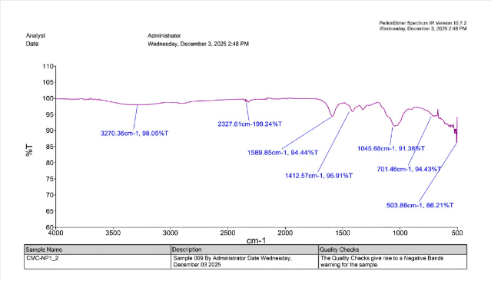

The composition of the carboxymethyl cellulose synthesized from bagasse was analyzed using the FTIR technique, a chemical analysis instrument that uses infrared (IR) light passed through a sample to study the vibrations of molecular bonds.
Table 1 FTIR Spectrum of Carboxymethyl Cellulose (CMC)
Wavenumber (cm⁻¹) | Assignment
3270.36 | O-H stretching
2327.61 | Stretching vibration of methine (C-H)
1589.85 | Region C=O (shown as CMC) Anti-symmetric stretching
1412.57 | Symmetric stretching vibration peak of COO-
1045.68 | C-O-C asymmetrical stretching of the bridge

The analysis was conducted in the mid-infrared (Mid-IR) region, at wavenumbers of approximately 4,000–400 cm⁻¹, or a wavelength range of 2–25 µm. The resulting spectrum showed an absorption peak at 3,270.36 cm⁻¹, corresponding to the vibration of the hydroxyl group (–OH), which is a characteristic feature of cellulose and its derivatives. In addition, the spectrum showed peaks corresponding to the carboxylate group (–COO⁻) and glycosidic bonds (C–O–C), both of which are important components of the carboxymethyl cellulose structure. The presence of the carboxylate group indicates that the cellulose structure was successfully modified with carboxymethyl groups, while the retention of the glycosidic bonds confirms that the fundamental polymer structure of the cellulose remained intact.
Table 2 Tensile Strength of Carboxymethyl Cellulose

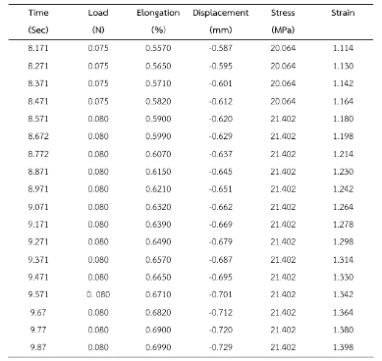

Mechanical property testing of the sample, conducted using a tensile testing machine in accordance with ASTM D885-03, showed that the stress–strain curve exhibited linear behavior in the early stage of testing. As tensile force was continuously increased, the material reached a maximum tensile strength of approximately 21.402 MPa, with an elongation at break of 1.4%. This behavior is consistent with that of biopolymer materials derived from bagasse-based carboxymethyl cellulose and can be used to assess the material's suitability for filament formation according to the ASTM D885-03 standard.
Graph 3 Heating and Cooling Cycles of the Filament

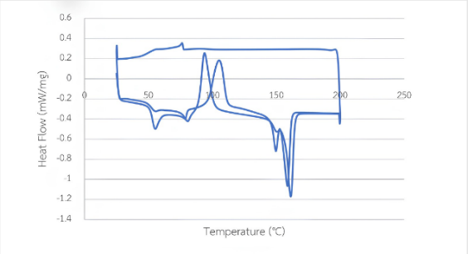

Thermal property testing of the sample was conducted using the DSC technique to analyze the melting point, crystallization temperature, and the energy required for the melting process. The resulting graph shows the relationship between temperature and heat flow, with the peaks divided into two categories: (1) endothermic peaks (heat absorption/melting) and (2) exothermic peaks (heat release/crystallization).
When the filament was heated, the following observations were made:
- 50–60°C (Tg – Glass Transition):
The curve showed a slight downward inflection, indicating the point at which the filament transitioned from a brittle solid to a flexible state.
- 70–80°C: A small peak was observed, indicating the melting of stearic acid and rice bran wax.
- 90–110°C (Tcc – Cold Crystallization):
A clear exothermic reaction was observed in this range, attributed to the CMC extracted from bagasse acting as a nucleating agent.
- 150–170°C (Tm – Melting Peak):
The melting peak was observed to have a double-peak shape, which may result from PLA crystals having differing stability, or from the material melting and immediately reforming new crystals.
When the temperature was lowered from 200°C down to the range of 90–100°C (Tc – Crystallization), another exothermic reaction was observed. This is the temperature at which the material begins to solidify and form crystals as it cools, which has a significant effect on the dimensional stability of the finished piece when printed using a 3D printer.

Conclusions
This study found that the chemical structure of carboxymethyl cellulose (CMC) synthesized from bagasse was confirmed using the FTIR technique, which showed a significant peak at
a wavenumber of 3,270.36 cm⁻¹, corresponding to the vibration of the hydroxyl group (–OH),
a characteristic feature of cellulose and its derivatives. The filament produced through the extrusion process using a twin-screw extruder exhibited a continuous physical structure, with an average diameter of 2.15 ± 0.05 millimeters. Testing results in accordance with the ASTM D885-03 standard showed that the composite material had a maximum tensile strength of approximately 21.402 MPa, with an elongation at break of 1.4%. The thermal property test results were consistent with the standards required for 3D printing, as indicated by the melting peak, which ended at approximately 170°C. The CMC derived from bagasse helped the printed piece set more quickly during extrusion. The addition of PEG 400 and glycerol helped increase the flexibility of the filament, preventing it from breaking during feeding into the printer, while the rice bran wax and stearic acid helped reduce friction within the nozzle. These test results are consistent with the hypothesis regarding formula improvement, in which the addition of plasticizers and glycerol helped increase the material's toughness, making it suitable for the printing process and practical application.

Acknowledgments
This project progressed through research, experimentation, analysis, and report writing. We are deeply grateful to our advisors, Teacher Chanunphat Khotewong and Teacher Suparak Raksa, for their continuous academic guidance, support, and patience throughout the project. We also thank all the books, websites, and research sources that informed our work. This project's success reflects not just our own effort, but the collective support of everyone who helped along the way.

References
Astro Instrument Co., Ltd. (2560). Tensile
(Compression) Testing Machine QC-505M2F (50 KN)https://www.astroinstrument.com/tensile-compression-testing-machine-50kn-qc- 505m2f/
Biopolymer Alternative from Sugarcane (Saccharum
officinarum L.) Leaves. Journal Sustainability, 16(6): 2352. https://www.mdpi.com/2071-1050/16/6/2352?hl=th-TH
Suriyatem, R., Noikang, N., Kankam, T.,
Jantanasakulwong, P. (2563/2020). Physical
Properties of Carboxymethyl Cellulose from Palm Bunch and Bagasse Agricultural
Wastes: Effect of Delignification with
Hydrogen Peroxide. Journal Polymers, 12(7): 1505. https://www.mdpi.com/20734360/12/7/150

Recommendations
The filament's rough surface and uneven diameter often clogged the printer nozzle—an issue for future improvement.
- Smooth out the filament's surface during production.
- Maintain a consistent diameter throughout the filament.
- Develop a surface treatment to prevent nozzle clogging.

