Intelligent Facial-Controlled Robotic Arm for Hemiplegic patient
Boonyawee Sujeerakulkrai^{1*}, Papungkorn Pitutecha¹ and Phakjira Damrongmukdatham¹
¹Princess Chulabhorn Science High School Chonburi No. 695, Village No. 3, Nong Chak, Ban Bueng, Chon Buri, 20170 Thailand
*e-mail: 6705611@pccchon.ac.th

Abstract

This project aims to develop an intelligent facial-controlled robotic arm as a prototype assistive device for individuals with hemiplegia, paralysis, and other mobility impairments. The system integrates facial movement detection using computer vision technology with robotic arm control through a microcontroller. The development process involved collecting and analyzing users' facial movement data, developing a facial detection program and a robotic arm control program, integrating both systems, and conducting performance testing at each stage.
The performance evaluation of the facial control system was conducted using six facial commands: turning the head left, turning the head right, looking up, looking down, opening the mouth, and closing the mouth. Each command was tested ten times, resulting in an average accuracy of 93.33%. The results demonstrate that the system can accurately and reliably detect facial movements and translate them into robotic arm commands. In addition, a user satisfaction survey involving ten participants evaluated the system in terms of control accuracy, response speed, movement flexibility, stability, and safety. The overall mean satisfaction score was 4.58 with a standard deviation of 0.57, indicating the highest level of user satisfaction.
Despite the promising results, the system still has limitations in movement flexibility under certain operating conditions. Future work will focus on enhancing the system's capabilities, improving stability and safety, and integrating advanced computer vision and artificial intelligence technologies to enable autonomous object detection and grasping. These improvements are expected to further enhance the robotic arm's practicality for assisting users in everyday activities.

keywords : Bamboo quadrat, Sugarcane pot, Traditional wooden stake, Seagrass

Introduction
At present, the number of individuals with hemiplegia, bedridden patients, and people with disabilities continues to increase. According to a report by Anamai Poll, an analysis of the dependency status of older adults in Thailand using descriptive statistics revealed a gradual increase in the proportion of dependent older adults between 2022 and 2024. Among male older adults, the proportion of bedridden individuals increased from 0.8% to 0.9%, while among females, it increased from 1.0% to 1.2%. Furthermore, the estimated prevalence of dependency is projected to rise from 1% to 5% every five years between 2021 and 2040. This represents a significant challenge for Thailand, which has been rapidly transitioning into an aging society, with the proportion of older adults exceeding 10% of the population since 2021 (Maliwan, 2024).

When patients become bedridden or are unable to perform daily activities independently, a wide range of challenges may arise. These include limitations in the caregiving environment, insufficient caregiver readiness, and increased caregiving burdens. In addition, such conditions may negatively affect patients’ psychological well-being, potentially leading to mental health issues such as depression (Ayuwat Nursing Home, 2023). Therefore, the development of assistive technologies that enhance independence and improve quality of life has become increasingly important for supporting patients with mobility impairments and reducing the burden on caregivers.

Therefore, the authors recognized the importance of addressing these challenges by developing an intelligent facial-controlled robotic arm that can be operated through facial movements. The proposed system is designed to assist patients in performing basic daily activities, such as feeding, taking medication, and sending signals to request assistance from caregivers. By enhancing patients' ability to perform essential tasks independently, the system has the potential to improve their quality of life while reducing the caregiving burden and long-term healthcare costs.
Methodology
1. Study the basic needs and physical limitations of hemiplegic patients to design an appropriate robotic arm.

The basic needs and physical limitations of the target users, particularly individuals with hemiplegia, were investigated. Information regarding their range of motion, motor impairments, and physical capabilities was collected to support the design of a facial-controlled robotic arm system. The data were obtained through consultations and interviews with a medical professional who directly cares for hemiplegic patients, ensuring that the system was developed to effectively meet users' needs.
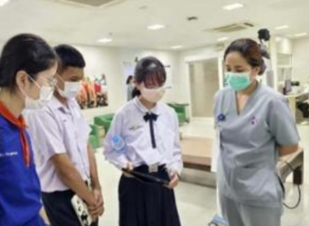
Fig 1. Interview with a physician specializing in the care of patients with hemiplegia and paralysis.

2. Select an appropriate robotic arm design from online resources, fabricate the components using a 3D printer, and assemble the prototype.
An appropriate robotic arm design was selected from publicly available online resources based on the user requirements identified in the previous stage. The selected design was then fabricated using a 3D printer. After all components had been printed, they were assembled to create the robotic arm prototype.
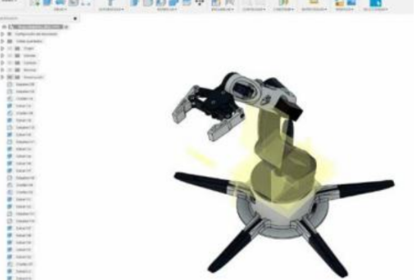
Fig 2. Three-dimensional (3D) model of the robotic arm.
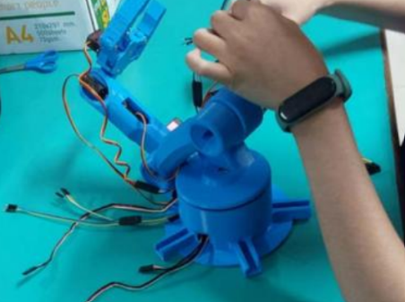
Fig 3. Assembly of the robotic arm.

3. Modify and optimize the robotic arm.
After assembling the robotic arm, several structural limitations were identified and improved to enhance its overall performance. These modifications included lowering the base of the robotic arm, reducing excessive friction caused by tightly fastened components, and decreasing the thickness of certain structural parts, such as the shoulder section. These improvements allowed the robotic arm to move more smoothly, increased its range of motion, and enhanced its overall operational efficiency. 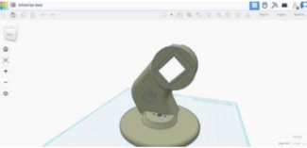
Fig 4. Modified three-dimensional (3D) design of the robotic arm.

4. Test Serial Communication Between the Computer and Arduino
A serial communication program was developed to enable the Arduino to receive commands from the computer via a USB serial connection. The Arduino was programmed to receive six servo angle values corresponding to the six servo motors of the robotic arm. Each servo motor was individually tested to verify its movement and response to the transmitted commands. Any errors identified during testing were corrected to ensure that all six servo motors could accurately receive commands and operate as intended.
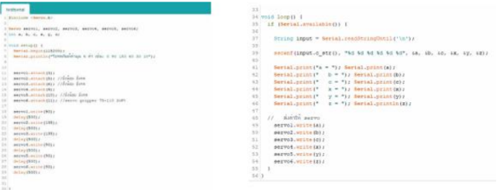Fig 5. Arduino program for receiving servo angle commands from the computer via serial communication.

5. Test the Facial Detection System
A facial detection and tracking program was developed in Visual Studio using the OpenCV library. The program captures images from a camera and processes facial movements in real time. The accuracy of the facial detection system was then evaluated to determine whether the detected facial movements were sufficiently accurate and reliable for controlling the robotic arm.
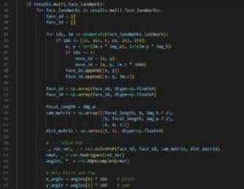
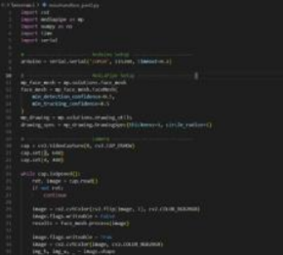
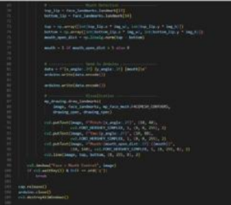

Fig 6. Facial movement detection program.

6. Test the Control Commands for Each Axis
After confirming that the servo angle values could be successfully transmitted to the robotic arm, a control program was developed to operate the robotic arm based on the user's facial movements. Facial movements were converted into three control parameters: Yaw, Pitch, and Mouth. The Yaw value was obtained from left and right head movements, Pitch from upward and downward head movements, and Mouth from opening and closing the mouth. These parameters were mapped to six robotic arm control commands. Each command was tested repeatedly, and the control algorithm was refined to improve the accuracy, responsiveness, and stability of the robotic arm.

Table 1. Relationship Between Robotic Arm Functions and Facial Movement Control Commands
Robotic Arm Function | Facial Movement
Arm rotates to the left | Turn head left
Arm rotates to the right | Turn head right
Arm moves upward | Look up
Arm moves downward | Look down
Gripper opens | Open mouth
Gripper closes | Close mouth
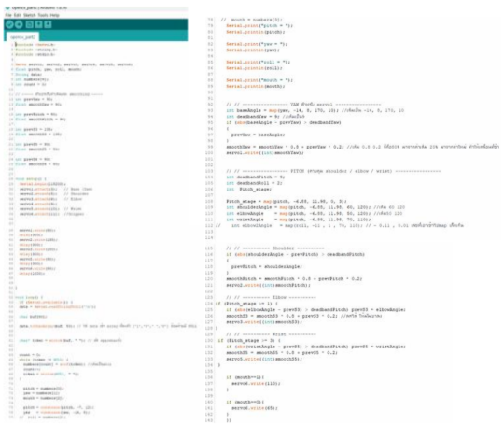
Fig 7. Robotic arm control program.

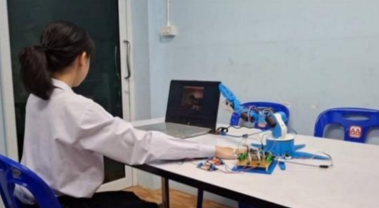
Fig 8. Performance testing of the robotic arm.
7. Design and Fabricate a Printed Circuit Board (PCB)
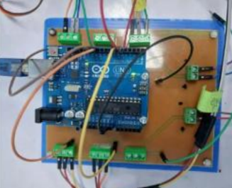
A Printed Circuit Board (PCB) was designed using EasyEDA to integrate the electronic components of the robotic arm control system. The PCB was then fabricated to reduce wiring complexity, improve the compactness of the system, and enhance the stability and reliability of the electrical circuits.
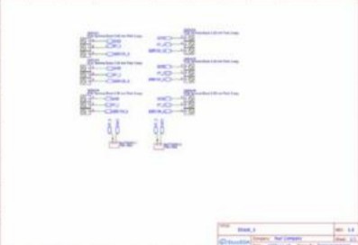
Fig 9. Printed Circuit Board (PCB) of the robotic arm control system.

Results and Discussion
1. Study of the Basic Needs and Physical Limitations of Hemiplegic Patients
The study of the basic needs of hemiplegic patients revealed that they require assistance with essential daily activities, including adequate nutrition, personal hygiene, medication administration according to medical prescriptions, and continuous monitoring of abnormal symptoms. In addition, patients require a safe environment to prevent accidents and adequate supervision to respond to emergency situations. These findings were used as guidelines for developing a facial-controlled robotic arm that better meets users' needs.

2. User Satisfaction Evaluation of the Robotic Arm
A user satisfaction evaluation was conducted with 10 participants after they had tested the robotic arm. The evaluation consisted of the following criteria:

Evaluation Criteria
Accuracy assessed by the ability of the robotic arm's end effector to reach the intended target as precisely as possible.
Response Speed assessed by the time required for the robotic arm to respond after the user initiates a facial movement command.
Movement Flexibility assessed by the robotic arm's ability to perform a wide range of movements.
Stability assessed by the robotic arm's ability to repeatedly perform the same task while producing consistent results.
Safety assessed based on the users' confidence and perceived safety while operating the robotic arm.
Rating Scale
Level 1: Very Low Satisfaction
Level 2: Low Satisfaction
Level 3: Moderate Satisfaction
Level 4: High Satisfaction
Level 5: Very High Satisfaction

Table 2. User Satisfaction Evaluation of the Robotic Arm by Ten Participants
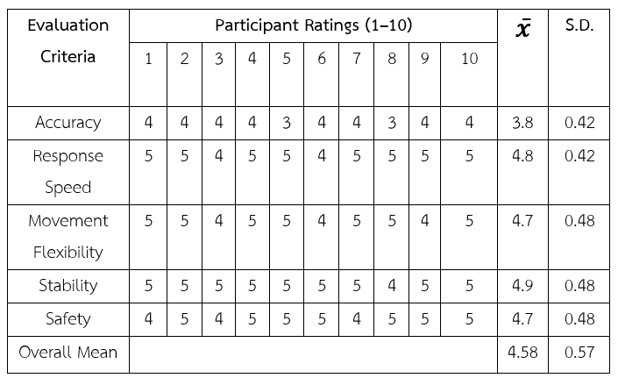
3. Performance Evaluation After System Development
The robotic arm was evaluated using six facial control commands: turning the head left, turning the head right, looking up, looking down, opening the mouth, and closing the mouth. Each command was tested ten times.

Table 3. Accuracy of the Robotic Arm Based on Facial Control Commands
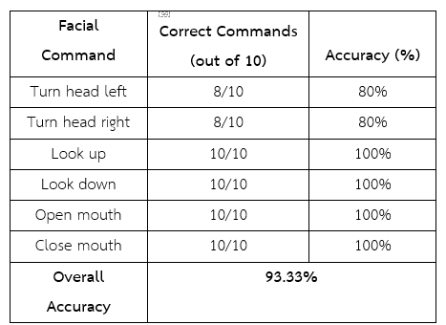

The experimental results demonstrated that the robotic arm and the facial detection system operated efficiently by accurately translating facial movements into robotic arm commands.

Conclusion
The intelligent facial-controlled robotic arm developed in this study demonstrates strong potential as an assistive device for individuals with hemiplegia and other mobility impairments. The system achieved an overall facial command recognition accuracy of 93.33% and received a high level of user satisfaction, with an overall mean score of 4.58. These results indicate that the system is capable of accurately translating facial movements into robotic arm commands while providing stable, responsive, and safe operation. Although improvements in movement accuracy and flexibility are still needed, the proposed prototype provides a promising foundation for future development of affordable assistive technology for daily living.
Acknowledgments
The authors would like to express their sincere gratitude to Dr. Taweesak Charoentia, Principal of the school, for generously providing the facilities and resources necessary for conducting this research and experimentation. The authors also extend their appreciation to Mr. Jaturat Phanthawat, Vice Principal for Academic Affairs, for his valuable guidance and encouragement throughout the project.
Special thanks are extended to Mr. Wichian Donraem and Mr. Kritsada Thongchuea, project advisors from the Science and Technology Department, for their continuous guidance, constructive suggestions, and the valuable reference materials they provided throughout the research process.
The authors also wish to thank the teachers of the Science and Technology Department for their assistance during the experiments and for providing the equipment and technical support required for this project. Finally, the authors sincerely appreciate their parents for their constant encouragement, guidance, and unwavering support throughout every stage of the project, from its inception to its successful completion.

References
Petcharavej Hospital. (2020).
9 Things You Should Know About Stroke and Paralysis.
https://www.petcharavejhospital.com/th/Article/article_detail/cerebrovascular_accident
Inc Connector. (2024).
Robot Arm: A Key Innovation for Industry 4.0.
https://incconnector.com/บทความ/robot-arm/

