A Study and Comparison of Andromeda Galaxy Mass Estimates Using Cepheid Variable Stars and Central Spectroscopic Analysis

Aekdanai Homsup¹ and Thanapat Siridol¹
Sornsanun Nontee^{1*}
¹Princess Chulabhron Science High School Loei No. 129, Village No. 5, Chiang Khan, Loei, 42110, Thailand
*e-mail: aekdanai05610@pcshsloei.ac.th

Abstract
The objective of this project is to 1) compare the effectiveness of studying the total mass of the Andromeda Galaxy (M31) by analyzing the Period-Luminosity Relation data of 9 Cepheid variable stars using the VStar program, together with constructing a Galaxy Rotation Curve graph and using the redshift of the spectrum at the galactic center to avoid interference from the internal rotation of disk galaxies, in order to obtain the distance modulus, which is then used with Hubble's Law to calculate distance, radius, and mass; 2) to develop a Python program for measuring the redshift of the spectrum; and 3) to determine the average total mass of this galaxy.
The analysis of the average period of the Cepheid variable stars found that the distance is approximately 796,000.7 parsecs, and the internal rotational velocity at this radius is 212.3 kilometers per second. Based on this variable, the mass of the Andromeda Galaxy was found to be approximately 2.417x10²⁷ kilograms. In the case of using the spectrum, the radial velocity was found to be approximately -414.0 kilometers per second, with an absolute distance of approximately 6.042x10⁶ parsecs. Since the radial velocity has a negative direction, it does not align with the theory of the expansion of the universe. This suggests that the Andromeda Galaxy is significantly affected by other factors. It can therefore be concluded that using the Cepheid variable star relation to study the mass of the Andromeda Galaxy is more appropriate than using the central spectrum.
keywords : Andromeda Galaxy, Cepheid variable stars, Spectrum
Introduction
Galaxies are large-scale structures in the universe made up of stars, gas, dust, and large amounts of dark matter. Studying the properties of galaxies, especially their mass, is essential for understanding how the universe forms and evolves. A galaxy's mass directly affects its internal gravity, its rate of star formation, and the motion of objects within it. It also influences how the galaxy interacts with other galaxies. The mass of a galaxy can be measured in several ways, depending on the type of data available. The Andromeda Galaxy (M31) is one of our nearby neighboring galaxies. This project focuses on comparing methods for measuring the mass of the Andromeda Galaxy by using photometry on Cepheid variable stars, which show a relationship between their pulsation period and true brightness, and by using spectroscopy on light from the galaxy's central region. This spectral data can be used to analyze the motion of the galaxy's central region and to calculate its dynamical mass through an analysis of the Doppler shift of spectral lines, applying Hubble's Law.

Methodology
1) Developing a Python Program to Measure Spectral Redshift
A Python program was written using the numpy, matplotlib, astropy and scipy libraries. Data were extracted from FITS files to generate a graph of wavelength versus intensity, which was then normalized to simplify analysis. Next, a reference template was created by simulating the hydrogen Brackett series and potassium lines. Cross-correlation was performed to determine the spectral redshift, and the radial velocity was calculated using the non-relativistic relation, according to the following equation
$$v=c\frac{λ-λ_{0}}{λ_{0}}$$
2) Determining Galactic Distance Using the Central Spectrum
Brightness-versus-wavelength data files from the APOGEE DR17 database were used to determine the radial velocity, using the Python program described in Section 1. The distance was then calculated from the resulting radial velocity by applying Hubble's Law
$$v=H_{0}d$$
3) Determining Galactic Distance Using Cepheid Variable Stars
Data from the AAVSO database were analyzed to determine the pulsation period using the AAVSO VStar program.
The absolute magnitude was then calculated based on Leavitt's Law.
$$M_{V}=\left(-2.38±0.06\right)\log_{10}P-\left(0.75±0.04\right)$$
The distance was subsequently calculated using the relationship between absolute magnitude and apparent magnitude.
$$M_{V}-m_{V}=5-5\log{d}$$
4) Constructing a Rotation Curve to Determine Rotational Velocity at Different Radii
Spectral data sets were selected along the radius of the galaxy at intervals of 2 arcminutes. These data were then analyzed using the program described in Section 2 and used to construct the rotation curve
5) Calculating and Comparing Mass
The radius was obtained by substituting the distance into the formula
$$r=θd$$
This radius was then compared with the rotation curve to determine the rotational velocity ($v_{rot}$) at the radius corresponding to each variable. All of the resulting data were then used in a calculation based on the relationship between gravitational force and centripetal force, giving
$$\frac{GMm}{r^{2}}=\frac{mv^{2}}{r}$$
$$M=\frac{v_{rot}^{2}r}{G}$$
Since the galaxy is inclined, we obtain
(1)
$$M=\frac{v_{obs}^{2}r}{G\sin^{2}i}$$

Result
1) Results of Data Analysis Based on the Cepheid Period-Luminosity Relationship
The analysis of data from the AAVSO database using the Cepheid period-luminosity relationship to determine distance, the average distance was found to be 796000.73 parsecs. The light curve of a sample star is shown in Figure 1
and the results of the data analysis are presented in Table 1.

Table 1 Results of Data Analysis Based on the Cepheid Period-Luminosity Relationship
ID | RA (hr) | Dec (°) | Period (day) | Apparent Mag. (m) | Absolute Mag. (M) | Distance(pc)
1 | 00 h 41 m 27.31 s | 41° 10′ 10.5″ | 31.460194 | 18.9488 | −5.4538 | 759,485.747
2 | 00 h 41 m 35.21 s | 41° 28′ 45.9″ | 32.391126 | 19.0976 | −5.4890 | 826,634.167
3 | 00 h 41 m 34.80 s | 41° 11′ 20.2″ | 28.882609 | 19.4125 | −5.3506 | 896,639.558
4 | 00 h 40 m 57.59 s | 41° 17′ 19.9″ | 35.155034 | 18.8703 | −5.5878 | 779,148.764
5 | 00 h 43 m 37.97 s | 41° 22′ 47.9″ | 36.692120 | 18.8754 | −5.6395 | 799,789.781
6 | 00 h 43 m 05.00 s | 41° 43′ 05.0″ | 34.730466 | 18.6999 | −5.5732 | 715,525.042
7 | 00 h 40 m 29.56 s | 40° 36′ 08.8″ | 33.515446 | 18.6291 | −5.5302 | 678,981.506
8 | 00 h 43 m 52.38 s | 41° 35′ 27.8″ | 32.701934 | 18.9740 | −5.5005 | 785,075.943
9 | 00 h 42 m 51.68 s | 41° 00′ 27.1″ | 41.033358 | 19.0508 | −5.7745 | 922,726.066

Fig.1 Sample light curves of Cepheid Variable Stars

ID | z | Radial Velocity  (km/s) | Distance  (pc)
1 | -0.00138 | -414.00 | 5914,285.714
2 | -0.00128 | -383.73 | 5,481,857.142
3 | -0.00131 | -392.72 | 5,610,285.714
4 | -0.00135 | -404.71 | 5,781,571.428
5 | -0.00138 | -413.71 | 5,910,142.857
6 | -0.00142 | -425.70 | 6,081,428.571
7 | -0.00145 | -434.70 | 6,209,900.000
8 | -0.00149 | -446.69 | 6,381,285.714
9 | -0.00152 | -455.68 | 6,366,857.143
10 | -0.00156 | -467.68 | 6,681,142.857
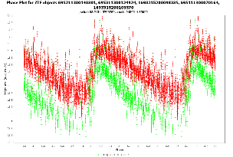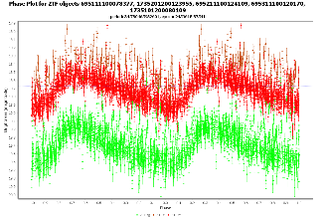
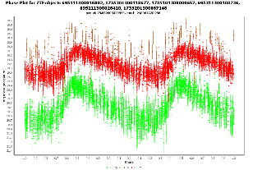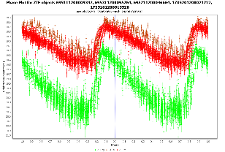
2) Results of Data Analysis from the Central Spectrum
Based on the analysis of data from the central spectrum using the APOGEE DR17 database to determine distance, the average distance was found to be 6041875.714 parsecs. The results of the data analysis are presented in Table 2, and a sample spectral line for which cross-correlation was performed at point ID 1 is shown in Figure 2.
Table 2 Results of Data Analysis from the Central Spectrum

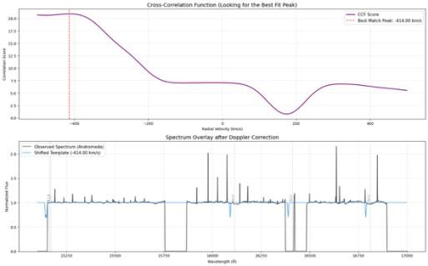
Fig.2 Sample spectral line for which cross-correlation was performed at point ID 1

3) Constructing the Rotation Curve and Determining the Radius
Selecting spectral line data sets along the radius of the galaxy and analyzing them to determine the radial velocity, the results in Table 3 and the rotation curve in Figure 3 were obtained.
Measuring the angular size of the image to determine the radius, the angular radius was found to be 1.11628 degrees, as shown in Figure 4. The radius was then calculated from the average distance obtained using Cepheid variable stars $r_{cep}=8.352×{10}^{15} m$ and from the average distance obtained using the central spectrum $r_{spec}=3.633×{10}^{21} m$

ID | RA  (deg) | DEC  (deg) | R  (kpc) | Velocity  (km s⁻¹) | error  (km s⁻¹)
1 | 10.7019 | 41.2910 | 0.357447326 | 177.333 | 0.784
2 | 10.7126 | 41.3048 | 0.579324214 | 221.82 | 0.907
3 | 10.7366 | 41.2942 | 0.646926742 | 223.289 | 0.813
4 | 10.754 | 41.3203 | 1.017854285 | 281.148 | 1.393
5 | 10.7717 | 41.3410 | 1.353430123 | 142.755 | 1.675
6 | 10.7813 | 41.3387 | 1.401229806 | 137.797 | 0.19
7 | 10.8081 | 41.3148 | 1.438159737 | 229.316 | 1.477
8 | 10.784 | 41.3541 | 1.574676276 | 221.515 | 0.436
9 | 10.8037 | 41.3595 | 1.769546885 | 215.178 | 1.448
10 | 10.8253 | 41.3716 | 2.151567855 | 299.932 | 2.757
11 | 10.879 | 41.3843 | 2.585710569 | 492.452 | 3.217
12 | 10.8893 | 41.4295 | 3.088753402 | 482.183 | 3.165
13 | 10.9303 | 41.4678 | 3.768807606 | 549.833 | 3.987
14 | 11.0266 | 41.5288 | 5.074720071 | 157.428 | 0.207
15 | 10.9267 | 41.5898 | 5.123613120 | 133.858 | 0.109
16 | 11.081 | 41.5097 | 5.429818118 | 282.813 | 1.386
17 | 11.1166 | 41.7361 | 7.897409038 | 111.351 | 0.148
18 | 11.1166 | 41.7361 | 7.968680664 | 111.351 | 0.148
19 | 11.2799 | 41.6753 | 8.384262552 | 212.272 | 2.053
20 | 11.4243 | 41.7593 | 10.27902555 | 221.41 | 0.101
21 | 11.3099 | 41.9613 | 11.60839884 | 361.818 | 0.755
Table 3 Results of Spectral Line Data Analysis Along the Radius

Table 3 Results of Spectral Line Data Analysis Along the Radius
ID | RA  (deg) | DEC  (deg) | R  (kpc) | Velocity  (km s⁻¹) | error  (km s⁻¹)
22 | 11.3891 | 42.0067 | 12.59447466 | 232.509 | 0.438
23 | 11.6125 | 42.0313 | 14.31782926 | 394.649 | 0.216
24 | 12.006 | 42.4258 | 21.18950261 | 265.989 | 0.349
25 | 11.7062 | 42.7463 | 23.12566347 | 273.323 | 0.489

Fig.3 Rotation curve of Andromeda galaxy
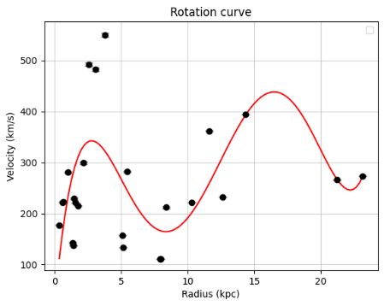
Fig.4 Angular radius of Andromeda galaxy
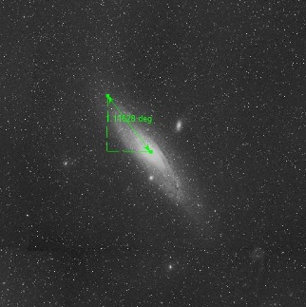

4) Determining the Mass of the Galaxy
By calculating Equation 1 using the galaxy's radial velocity from the rotation curve at the radius measured from the angular radius, with radial velocity is $v_{obs}= 428.239 km s^{-1}$ and the mass of the galaxy was found to be $M=2.417×{10}^{37} kg$

Conclusions
This study on the mass of the Andromeda Galaxy, based on the Cepheid period-luminosity relationship and the galaxy's central spectrum, found that the analysis using Cepheid variable stars yielded an average distance of 796000.73 parsecs. This result made the corresponding radius and mass more consistent with the angular size and apparent magnitude than the analysis using the galaxy's central spectrum, which yielded a much larger average distance of 6041875.714 parsecs. This larger value resulted from a high radial velocity with a negative direction, indicating that the object was moving toward the observer. This contradicts the expansion of the universe, which is the main factor explaining Hubble's Law.
It can therefore be concluded that the most suitable technique for studying the mass of the Andromeda Galaxy is analysis based on the Cepheid period-luminosity relationship.

Recommendation
- Increase the number of Cepheid variable stars analyzed to improve the accuracy of the distance and mass estimates.
- Use spectral data from multiple positions along the galaxy's radius to construct a more complete rotation curve and mass calculation.
- Systematically analyze and report calculation errors to increase the reliability of the results.

Acknowledgments
This project was completed successfully thanks to the advice and knowledge provided by the project advisor, Mr. Sornsanun Nontee of the Physics and Astronomy Department, Princess Chulabhorn Science High School Loei.

Appendix
QR Code linking to the appendix, including the table of recorded angular velocity versus radius, light curves, rotation curve, and spectra.


References
AAVSO. (n.d.). VStar: AAVSO’s variable star plotting and analysis software. Retrieved from https://www.aavso.org/vstar
Abhay Agarwal. (n.d.). Period-Luminosity Analysis of Cepheid Variables. https://ulab.studentorg.berkeley.edu/static/doc/posters/
Andrew Zimmerman Jones. (15 May 2025). Doppler Effect in Light: Red & Blue Shift. ThoughtCo. https://www.thoughtco.com/doppler-effect-in-light-red-shift-and-.
Caltech. (n.d.). Flux and Magnitude. https://sites.astro.caltech.edu/~george/ay21/.
Cosmos. (n.d.). Rotation Curve. https://astronomy.swin.edu.au/cosmos/.
มติพล ตั้งมติธรรม. (2563). คู่มือการศึกษาดาราศาสตร์เชิงปฏิบัติการ(พิมพ์ครั้งที่ 5). สถาบันวิจัยดาราศาสตร์แห่งชาติ(องค์การมหาชน). สืบค้นจาก https://www.narit.or.th

