MushTube : Innovative Oyster Mushroom Cultivation Tube Developed by Studying Factors Affecting Yield and Quality to Promote Community Enterprises

Phanrawee Kongkaew¹ and Arpaphat Srinamon¹
Wipa Arsingsamanun^{1*}
¹Princess Chulabhorn Science High School Phitsanulok, 86 M 4 86 M.4 Muang District, Phitsanulok, 65000, Thailand
*E-mail: phanrawee.kon@pccpl.ac.th
Abstract
Oyster mushrooms are an economically important crop whose growth and yield are strongly influenced by environmental factors. Conventional cultivation methods rely heavily on external weather conditions, resulting in inconsistent production, variable quality, and increased production costs. This study aimed to develop an oyster mushroom cultivation tube that can maintain optimal growing conditions regardless of the external climate. The system integrates evaporative cooling with the Internet of Things (IoT) technology, enabling real-time monitoring and control of temperature and humidity through a mobile application. The environmental conditions maintained by the system were established through optimization experiments to determine the optimal temperature, relative humidity, light color, and light intensity for oyster mushroom cultivation. Its tubular design also reduces space requirements and facilitates harvesting. The optimal cultivation conditions were 25°C, 71–80% relative humidity, and blue light at an intensity of 500 lux. Under the optimal conditions, mushrooms grown in the developed system achieved a significantly higher average fresh weight of 86.00 ± 3.31 g than mushrooms cultivated in a conventional greenhouse, which averaged 78.80 ± 2.95 g (p ≤ 0.05). They also exhibited larger cap diameters and longer stems. These findings demonstrate that the proposed cultivation system effectively improves mushroom yield and quality while reducing production costs and supporting sustainable cultivation.

Keywords: Oyster mushroom, Cultivation tube, Environmental control, Evaporative cooling, Internet of Things (IoT)

Introduction

Mushroom cultivation in Thailand is currently on the decline, as growers face high costs for raw materials and facility construction. Furthermore, most cultivation still relies on open-system structures, which fail to effectively control key growth factors such as temperature, relative humidity, and light intensity and spectrum. This results in compromised product quality and significant losses, particularly during the summer season. Although evaporative cooling systems can effectively regulate temperatures for cultivation, they still have limitations regarding relatively high installation, electricity, and maintenance costs.
From such problems, the researcher team saw the importance of studying environmental factors that affect the quantity and quality of oyster mushrooms, including temperature, humidity, and light intensity, to bring information as a guide to develop an oyster mushroom growing tube system with an evaporative cooling system. By focusing on the design of a system that can accurately control the environment, helping to reduce production costs, use of space, and payback period to raise the standard of oyster mushroom production to the same quality and quantity as large general greenhouses. Therefore, the purpose of this research is to 1) to study the appropriate physical factors for the growth of oyster mushrooms 2) to design and develop the best oyster mushroom cultivation tube system 3) to compare the quality of oyster mushroom inflorescences that grow, oyster mushroom cultivation system and general greenhouse to promote community enterprises of oyster mushroom farmers.

Methodology
The research process was systematically designed, with operations divided into three main parts 1) to study the appropriate physical factors for the growth of oyster mushrooms 2) to design and develop the best osyter mushroom cultivation tube system 3) to compare the quality of osyter mushroom inflorescences that grow, oyster mushroom cultivation system and general greenhouse to promote community enterprises of oyster mushroom farmers.
To study the appropriate physical factors for the growth of oyster mushrooms
The factors examined were: 1) temperature, with settings of 15°C, 25°C, and 35°C 2) relative humidity, with levels categorized as low (60–70%), medium (71–80%), and high (81–90%) and 3) light color and intensity, with varying settings for these parameters. These three factors were studied to observe mycelial growth duration, stem length, weight, and mushroom yield under various experimental conditions.
To design and develop the best osyter mushroom cultivation tube system
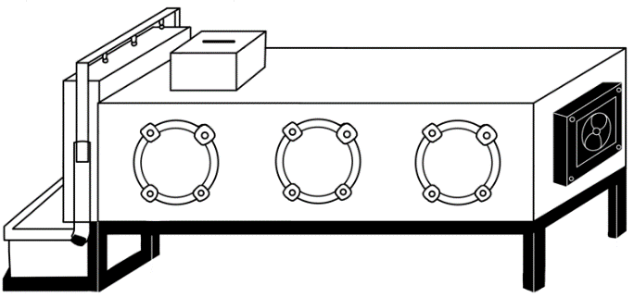
Data on farming challenges gathered from field visits underwent content analysis to design an optimal oyster mushroom cultivation system.
Figure 1: Design of the oyster mushroom cultivation tube (Model 1)
Development of the oyster mushroom cultivation tube with an evaporative cooling system (Model 1), performance testing and data recording. Then, refine the design of the innovation.
To compare the quality of osyter mushroom inflorescences that grow, oyster mushroom cultivation system and general greenhouse to promote community enterprises of angel mushroom farmers.
Mushroom quality was assessed by comparing the size and weight of fruiting bodies. Measurements and weighing were conducted over four days on oyster mushrooms grown in an oyster mushroom cultivation tube system and a general greenhouse. Random samples were measured using a vernier caliper, and the results were statistically analyzed by calculating the mean, standard deviation, and p-value. Cost-effectiveness was evaluated by comparing the cultivation and electricity costs of the oyster mushroom cultivation tube system with those of the general greenhouse.

Result and Discussion
The appropriate physical factors for the growth of oyster mushrooms
Analysis of physical factors, including temperature, relative humidity, and light color and intensity, revealed that these factors significantly affect the growth of oyster mushrooms.

Table 1 Results of the appropriate physical factors for the growth of oyster mushrooms.
Optimal Physical Factors | Optimal Values ​​for Growth
Temperature | 25 °C
Relative Humidity | 71-80 %
Light Color and Intensity | Blue light at an intensity of 500 lux
The optimal physical conditions for oyster mushroom growth were 25°C, 71–80% relative humidity, and 500 lux blue light (440–470 nm). At 25°C, lignocellulolytic enzymes exhibit high activity, enhancing substrate degradation and promoting rapid mycelial growth. Relative humidity of 71–80% maintains moisture balance and facilitates gas exchange, resulting in vigorous mycelial development while reducing contamination. Blue light at 500 lux stimulates photoreceptors and metabolic activity, increasing enzyme production without inducing photo-stress, whereas excessive light inhibits cell division and promotes premature pinning. These findings are consistent with Preuk et al. (2025), who reported that blue LED light significantly enhanced mycelial growth and produced the highest mycelial density in Hericium erinaceus.
Development of an Evaporative Cooling System for Oyster Mushroom Cultivation
Based on document analysis and target group interviews to provide crucial data for research development, it was found that the key factors directly affecting oyster mushroom cultivation are cost and weather conditions. From Wichuta Luxana (personal communication, 4 October 2024) said that this is because oyster mushrooms require suitable physical factors for efficient growth, but currently, most farmers are unable to control weather conditions effectively due to production cost limitations.
The developers synthesized the information to design a model of cultivation system. The results are as follows:
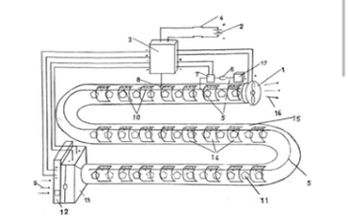
Model 1
Figure 3: Faults of the evaporative cooling system for oyster mushroom cultivation, Model 1.
Model 1 found that the pipes were round, making it impossible to place mushroom blocks.
- Solution: Change to square-shaped tubes.
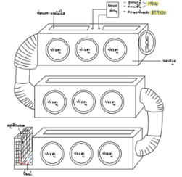
Model 2
Figure 4: Faults of the evaporative cooling system for oyster mushroom cultivation, Model 2.
Model 2 the aluminum foil air duct had air leaks.
- Solution: Use PVC pipes with the aluminum foil pipes.
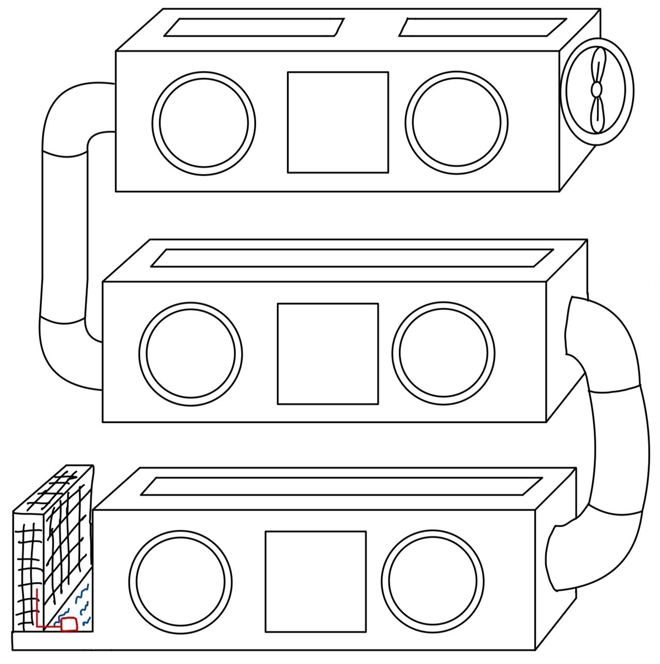
Model 3
Figure 5: Faults of the evaporative cooling system for oyster mushroom cultivation, Model 3.
Model 3 found that the door had problems opening and closing.
- Solutions: Change the door design
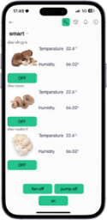
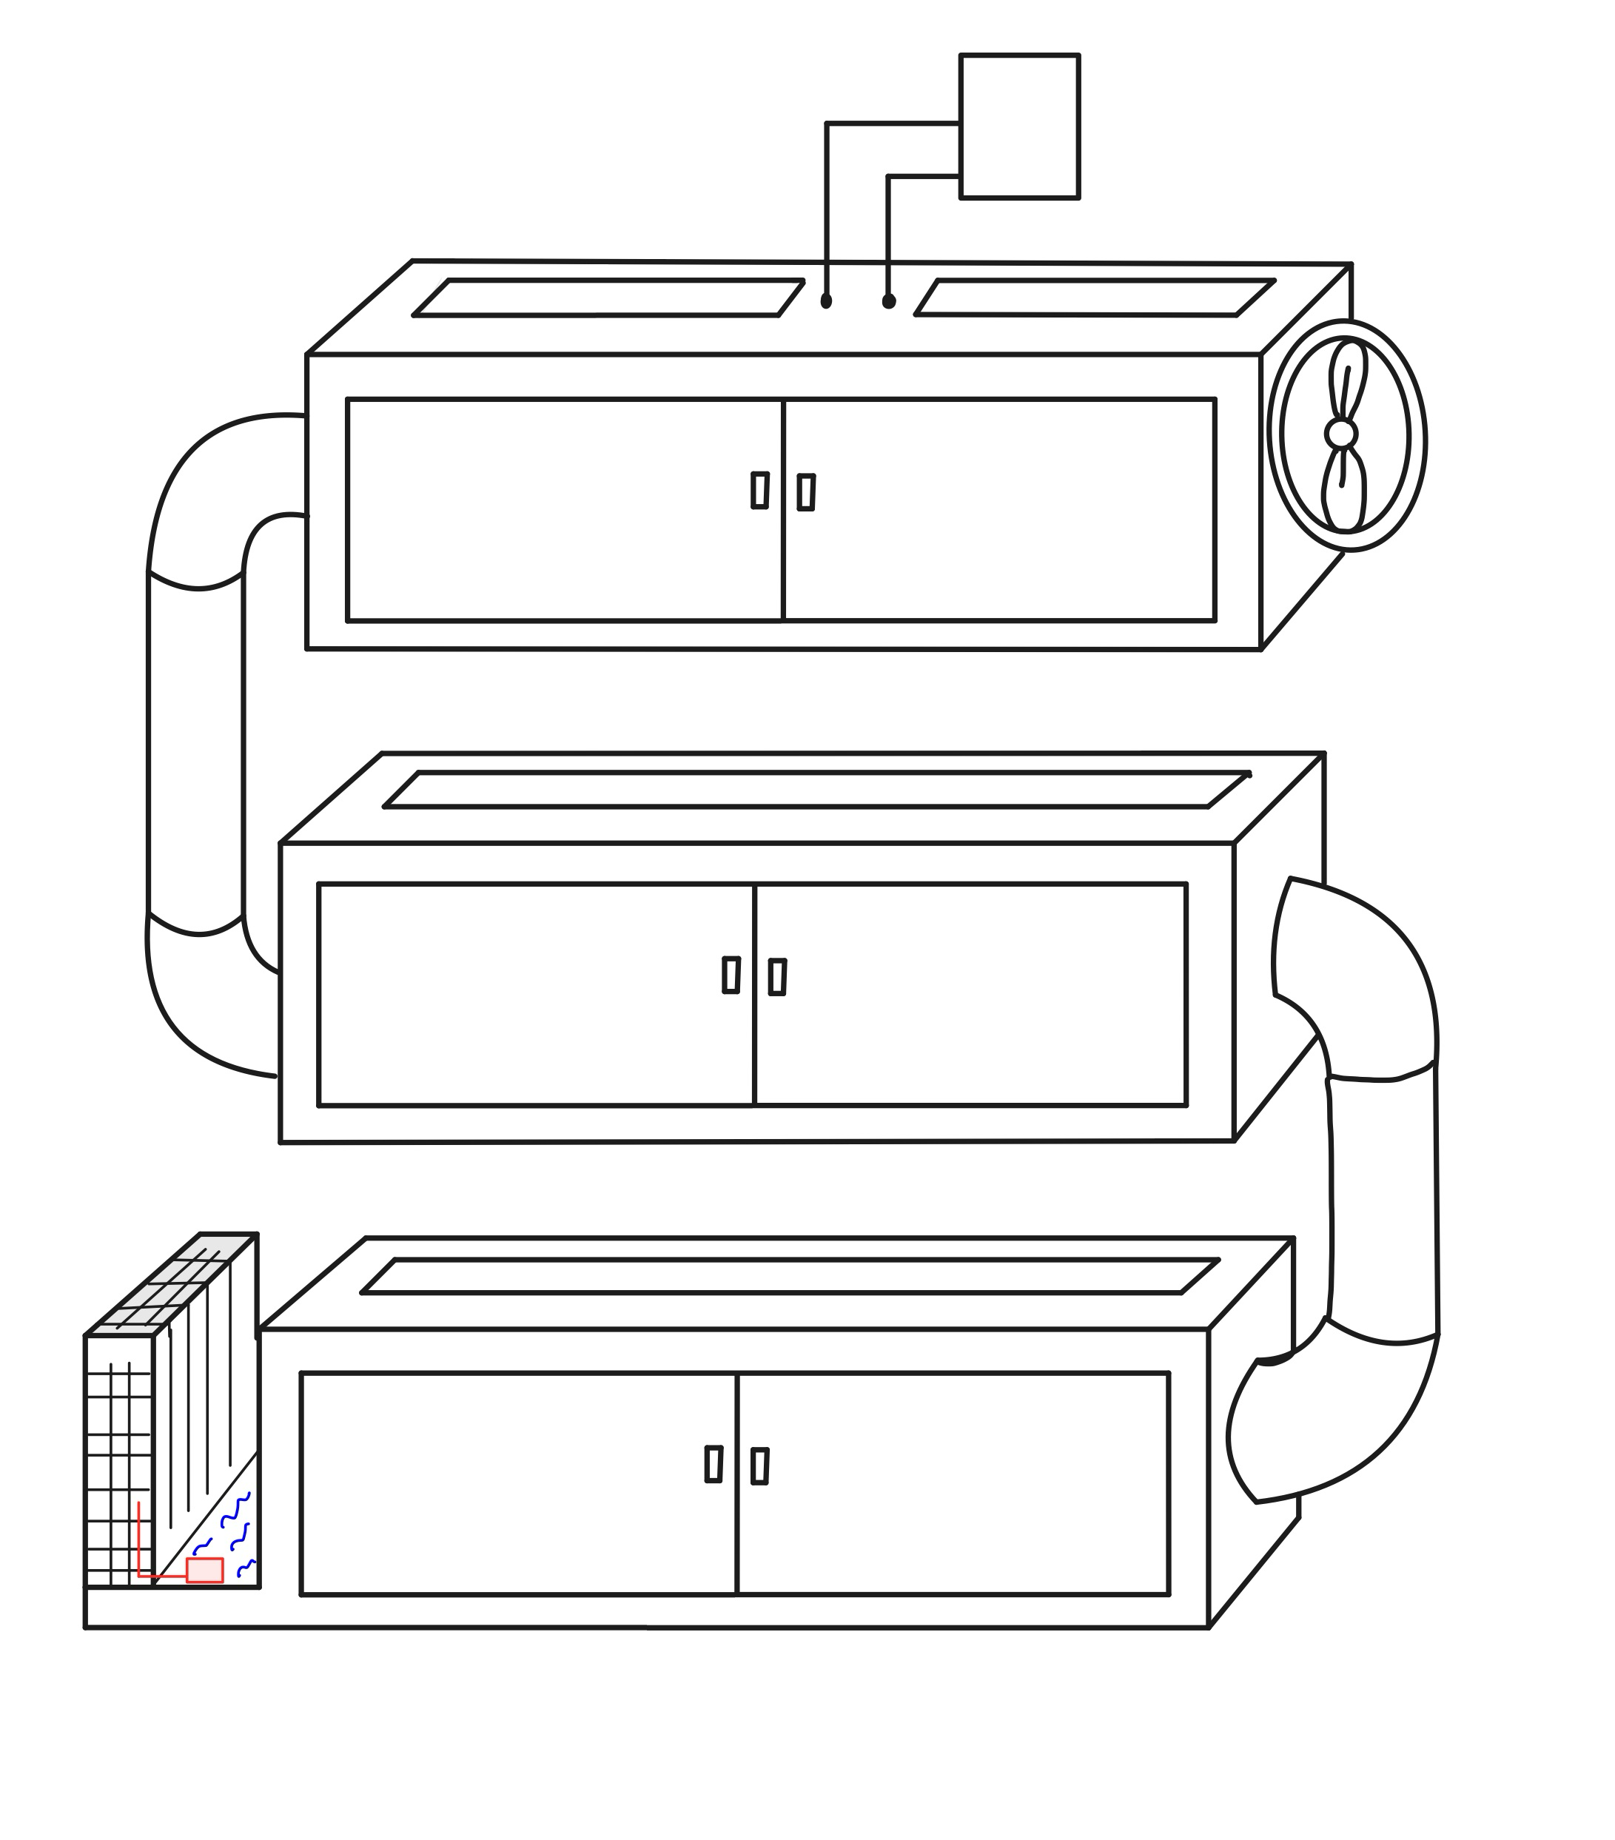
Model 4
Figure 6: Oyster mushroom cultivation tubes with evaporative cooling system, Model 4.
And an application for controlling temperature and humidity.
Model 4 shows no problems.
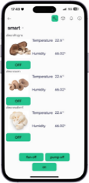
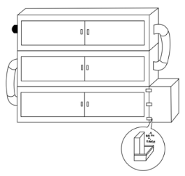
Model 5 for individuals interested in cultivating oyster mushroom
Figure 7: Oyster mushroom cultivation tubes with evaporative cooling system, Model 5.
And an application for controlling temperature and humidity.
Model 5 shows no problems.
The results showed that the Model 4 oyster mushroom cultivation system encountered no problems during performance testing and effectively controlled temperature and humidity through via the Internet of Things (IoT) within the Blynk application using an SHT45 temperature and humidity sensor and a BH1750 light intensity sensor on the IOXESP32 development board, the ESP32 is optimized for the growth of oyster mushrooms. The temperature is maintained at 25-28 degrees Celsius, the blue light intensity at 500 lux, and the humidity at 71-80 percent, ensuring optimal growth and quality of the mushrooms.
Comparison of the Efficiency of Oyster Mushroom Cultivation Systems Using Evaporative Cooling and Conventional Greenhouses
Analysis of the quality of oyster mushroom clusters showed that cultivation using oyster mushroom cultivation tubes resulted in significantly higher quality yields compared to conventional greenhouses.
Table 2 Comparison of the average weight of oyster mushroom clusters and the average size of oyster mushrooms cultivated in oyster mushroom cultivation tubes with an evaporative cooling system and conventional greenhouses.
Cultivation Area | Average (g) | Average Mushroom Size (cm)
Cultivation Area | Average (g) | Mushroom Cap | Mushroom Stem
Cultivation Tube | 86.00±3.31* | 7.74±1.15 | 9.06±3.44
General Greenhouse | 78.80±2.95 | 6.69±0.99 | 8.80±2.63
*p ≤ 0.05
Comparison of the average weight of oyster mushroom clusters showed a significant difference between cultivation tubes with an evaporative cooling system and conventional greenhouses, while mushroom size did not differ significantly. Maintaining optimal conditions, particularly air humidity and temperatures of 26–28°C, supports proper transpiration, nutrient absorption, flushing, and market-standard weights of 30–120 g. These findings are consistent with Sukanya Thongyothee et al. (2023), who reported that oyster mushrooms produced fruiting bodies most efficiently at 28°C using a temperature and relative humidity control system.
Table 3 Summarizes the cost-effectiveness and electricity costs of the innovative oyster mushroom growing tubes with an evaporative cooling system and conventional greenhouses.
Cost | Expenses (Baht)
Cost | Cultivation Tube | General Greenhouse
Cost | 7,889 | 15,000
Electricity | 54.11 | -
From the cost-effectiveness evaluation, the innovative oyster mushrooms growing tubes with an evaporative cooling system have a higher cost than a normal greenhouse by 7,811 baht but save energy with electricity costs of only 54 baht per month. From testing the cultivation of 108 mushroom blocks, it was found that the total yield was 34 kilograms, generating an income of 4,100 baht per cycle, allowing for the recouping of the difference within 3 cultivation cycles. The key advantage is the ability to maintain the stability of the yield in all seasons, especially during the summer when mushrooms are scarce in the market, the selling price of mushrooms is higher than before, resulting in farmers being able to generate more profit than using general greenhouses.

Conclusions
Achieving high yields in oyster mushroom cultivation requires optimal temperature and humidity control. To address this challenge, an oyster mushroom cultivation unit utilizing an evaporative cooling system managed via IoT was developed. The system uses the Blynk application with SHT45 temperature and humidity and BH1750 light intensity sensors on an IOXESP32 (ESP32) development board to maintain temperatures of 25–28°C, humidity of 71–80%, and blue light intensity of 500 lux, providing suitable conditions for oyster mushroom growth. Oyster mushrooms cultivated in the tube-based system with evaporative cooling had a significantly higher average cluster weight (86.00 ± 3.31 g) than those grown in a general greenhouse (78.80 ± 2.95 g). The average cap diameter and stalk length were 7.74 ± 1.15 cm and 9.06 ± 3.44 cm, respectively. Furthermore, the average harvest weight per flush was significantly higher than in the general greenhouse, enabling farmers to recover investments more quickly and increase profitability.

Acknowledgments
Special thanks to Miss Wipa Asingmanan, my project advisor, for her valuable guidance, knowledge, and support throughout this research.
We also thank Princess Chulabhorn Science High School Phitsanulok and the science laboratory staff for providing facilities, materials, and assistance essential to this project.

References
ECOEN. (2022). Evaporative Cooling System (EVAP). Search on 21
August 2024, https://www.ecoen.co.th
Kaley Todd. (2022). Mushrooms have a multitude of unique health benefits. Search on 21 August 2024, https://www.americanmushroom.org
Masterkool. (2023). Evaporative cooling systems in industrial plants. Search on 15 January 2025, https://www.masterkool.com
Chutimanukul, P., Sukdee, S., Phetkaew, P., Thepsilvisut, O., & Prajuabjinda, O. (2025). LED light spectra influence the stimulation of mycelial growth and anticancer activity in Hericium erinaceus mycelium. Frontiers in Fungal Biology, 6, Artical1684852. https://doi.org/10.3389/ffunb.2025.168485
Thongyothee, S., Dangton, W., Jeepetch, V., Wongniyom, A., Lomchangkum, C., & Thongyothee, C. (2023). Design of Temperature and Relative Humidity Test Kit for Grey Oyster Mushrooms Cultivation. Rajamangala University of Technology Tawan-ok Research Journal. 16(2), 24-34
Thaigreenagro. (2022). Temperature and humidity in the growing house are both important for mushroom growth. Search on 14 January 2025

