The Development of Water Filter Resin Quality Using Sodium Hydroxide

from Clam Shells

Napassawan Wongsudawan^{1*}, Kanoknart Raksason¹
Orawan Sritrirat¹, Thanchanok Sirirak² and Wanchai Wongsudawan³
¹Princess Chulabhorn Science High School Chonburi, Ban Bung, Chonburi 20170, Thailand
²Faculty of Pharmaceutical Sciences, Burapha University, Saen Suk, Mueang Chon Buri, Chon Buri 20000, Thailand
³The Institute of Marine Science, Burapha University, Saen Suk, Mueang Chon Buri, Chon Buri 20000, Thailand *E-mail:
*e-mail:6706400@pccchon.ac.th

Abstract
This research aimed to synthesize sodium hydroxide from cockle shells at different quantities to investigate its chemical properties, as well as to compare its effectiveness in regenerating ion exchange resin. The results showed that prior to regeneration, the ion exchange resin exhibited an ion removal efficiency of only 55.56 ± 0.00%. After regeneration with sodium hydroxide synthesized from cockle shells at various quantities, the ion removal efficiency of the resin significantly increased. Among all conditions, sodium hydroxide synthesized from 20 g of cockle shells, which provided the highest concentration (0.267 M), demonstrated the best regeneration performance, resulting in an ion removal efficiency of 91.67 ± 1.31%. In contrast, sodium hydroxide synthesized from 10 g and 30 g of cockle shells yielded lower ion removal efficiencies of 88.89 ± 3.70% and 81.48 ± 0.00%, respectively. These differences were statistically significant (p < 0.05). The observed results are consistent with the FTIR spectra of the synthesized sodium hydroxide compared with commercial sodium hydroxide. The sodium hydroxide synthesized from 30 g of cockle shells exhibited a higher level of impurities, which may interfere with access to the active sites of the resin or cause partial blockage on the resin surface. Although the sodium hydroxide synthesized from 10 g and 20 g of cockle shells contained fewer impurities, the concentration effect played a crucial role. The sodium hydroxide obtained from 20 g of cockle shells provided an optimal driving force, enabling effective activation of the resin’s active sites and leading to superior regeneration performance.
keywords : sodium hydroxide, ion-exchange resin regeneration, ion removal efficiency
Introduction
Water pollution is a critical environmental issue that directly affects living organisms because water is an essential resource for human consumption and daily activities. Effective water quality management is therefore essential to ensure water cleanliness and safety (Environmental and Pollution Control Office 13 (Chonburi), 2018).

Ion-exchange resin is widely used for water treatment because of its high efficiency in removing undesirable minerals and ions, including carbonates, which are the primary cause of water hardness, limescale formation, and urinary tract stones (Shala et al., 2021; Sadaf et al., 2020). However, ion-exchange resins have a service life of only 6–7 months and require regeneration to restore their performance. Regeneration generally uses synthetic chemicals, such as sodium hydroxide (NaOH), which are relatively expensive and whose production may adversely affect the environment (Jinglan et al., 2014).
Thailand is also facing increasing food industry waste, particularly discarded blood cockle shells, which are often disposed of without utilization (Pollution Control Department, Ministry of Natural Resources and Environment, 2023). These shells are rich in calcium carbonate (CaCO₃), which can be used as a raw material for sodium hydroxide synthesis.
This study therefore investigated the use of discarded blood cockle shells to produce sodium hydroxide for ion-exchange resin regeneration. This approach aims to reduce seafood industry waste, add value to discarded materials, reduce dependence on commercially available chemicals, and promote sustainable resource management.

Methodology
1. Preparation of Calcium Oxide (CaO) from Blood Cockle Shells
Blood cockle shells were washed with clean water and dried in an oven at 105 °C overnight to remove moisture. The dried shells were then calcined at 900 °C for 5 h to convert calcium carbonate (CaCO₃) into calcium oxide (CaO). The resulting product was ground, sieved through a 250-mesh sieve, and stored in a desiccator until use.
2. Synthesis and Characterization of Sodium Hydroxide (NaOH)
Calcium hydroxide [Ca(OH)₂] solution was prepared by adding 10, 20, and 30 g of CaO to distilled water. The solution was reacted with sodium carbonate (Na₂CO₃) at a 1:1 (v/v) ratio and shaken overnight. The mixture was vacuum-filtered to remove the calcium carbonate precipitate, yielding a NaOH solution. The NaOH concentration was determined by titration with 1 M HCl using phenolphthalein as the indicator. The solution was then freeze-dried for FTIR analysis, and the spectra were compared with those of standard NaOH.
3. Regeneration and Performance Evaluation of Ion-Exchange Resin
Thirty grams of spent ion-exchange resin were regenerated with 70 mL of the synthesized NaOH solution by stirring at 200 rpm for 60 min, then rinsed with deionized (DI) water until neutral pH was reached.
Ion-exchange performance was evaluated using 200 mL of a 5.4 mg/L⁻³ sulfide solution mixed with the regenerated resin in a closed batch system for 60 min. The residual sulfide concentration was analyzed, and the percentage removal was calculated (Stirarat, 2021). All experiments were performed in triplicate.

Result and Discussion
1. Analysis of the Synthesized Sodium Hydroxide
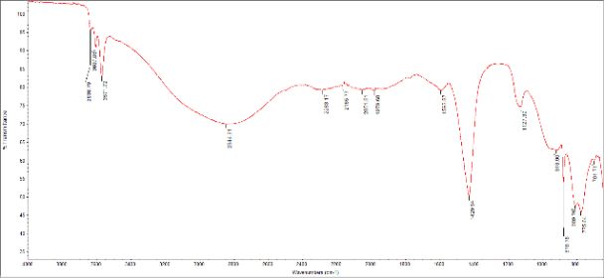
Fig. 1 FTIR spectrum of sodium hydroxide synthesized from 10 g of blood cockle shells.
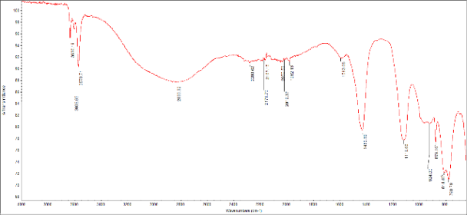
Fig. 2 FTIR spectrum of sodium hydroxide synthesized from 20 g of blood cockle shells.
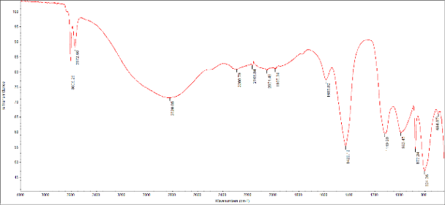
Fig. 3 FTIR spectrum of sodium hydroxide synthesized from 30 g of blood cockle shells.
Sharp peaks at 1100–800 cm⁻¹ were attributed to unreacted Ca(OH)₂, Na₂CO₃, and residual CaCO₃. These peaks were more pronounced in the 30 g sample than in the 10 and 20 g samples, indicating that smaller amounts of blood cockle shells resulted in a more complete causticization reaction.

Table 1 Concentration of sodium hydroxide synthesized from different amounts of blood cockle shells.
Blood cockle shells (g) | NaOH concentrations (Mol/L)
10 | 0.087
20 | 0.267
30 | 0.180
Table 2 pH of synthesized sodium hydroxide prepared from different amounts of blood cockle shells.
Blood cockle shells (g) | pH
10 | 12.33
20 | 12.40
30 | 12.44
The results showed that the amount of blood cockle shells used affected both the concentration and pH of the synthesized sodium hydroxide. The sample synthesized from 20 g of blood cockle shells exhibited the highest NaOH concentration (0.267 M), whereas the sample synthesized from 10 g exhibited the lowest concentration (0.087 M). In addition, the pH of the synthesized NaOH solution showed an increasing trend with increasing amounts of blood cockle shells, and the differences were statistically significant (p < 0.05).

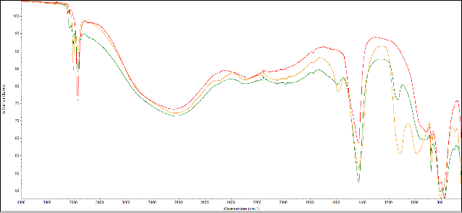
Fig 4. FTIR spectra of sodium hydroxide synthesized from 10 g and 30 g of blood cockle shells compared with analytical-grade sodium hydroxide.
As shown in Figure 4, a broad absorption band was observed within the wavenumber range of 3600–2400 cm⁻¹, corresponding to hydrogen-bonded O–H stretching. This broad band is due to the hygroscopic nature of sodium hydroxide. In addition, a peak at approximately 1429 cm⁻¹ was assigned to the carbonate (CO₃²⁻) functional group, resulting from carbonation caused by the rapid reaction of sodium hydroxide with atmospheric carbon dioxide (CO₂). A sharp peak was also observed at approximately 3572 cm⁻¹, corresponding to the free O–H stretching vibration, which is typically observed in the crystalline structure of sodium hydroxide.
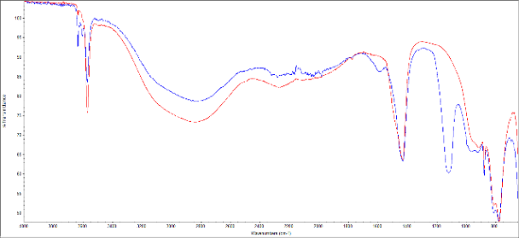
Fig 5. FTIR spectrum of sodium hydroxide synthesized from 20 g of blood cockle shells compared with analytical-grade sodium hydroxide.
The FTIR spectrum of NaOH synthesized from 20 g of blood cockle shells exhibited a broad O–H stretching band at 3600–2400 cm⁻¹ and a sharp free O–H stretching peak at approximately 3573 cm⁻¹, consistent with the crystalline structure of standard NaOH. A carbonate (CO₃²⁻) peak at approximately 1430 cm⁻¹ indicated carbonation caused by atmospheric CO₂, while a C–O stretching peak at approximately 1119 cm⁻¹ suggested the presence of residual starting materials from the causticization process.
NaOH from blood cockle shells (g) | Before regeneration (mg/L S²⁻) | After regeneration (mg/L S²⁻) | %error
10 | 2.40 | 0.60 | 33.33
20 | 2.40 | 0.45 | 12.48
30 | 2.40 | 1.00 | 0.00
Table 3 Residual sulfide concentration before and after regeneration of ion-exchange resin using NaOH synthesized from different amounts of blood cockle shells.
Before regeneration, the ion-exchange resin reduced the sulfide concentration from 5.4 to 2.40 mg L¹⁻ S²⁻, corresponding to an ion removal efficiency of 55.56 ± 0.00%. Regeneration with NaOH synthesized from 10, 20, and 30 g of blood cockle shells increased the ion removal efficiency to 88.89 ± 3.70%, 91.67 ± 1.31%, and 81.48 ± 0.00%, respectively (p < 0.05).
FTIR analysis confirmed that the synthesized NaOH exhibited functional groups consistent with standard NaOH. Carbonate (CO₃²⁻) peaks at 1430 and 1119 cm⁻¹ indicated residual CaCO₃, suggesting incomplete removal of the precipitate during filtration.
NaOH synthesized from 20 g of blood cockle shells provided the highest ion removal efficiency (91.67 ± 1.31%), whereas the 30 g sample showed the lowest efficiency (81.48 ± 0.00%, p < 0.05). The lower performance of the 30 g sample may be attributed to residual CaCO₃, which could hinder access to the active sites or partially block the resin surface. These results indicate that NaOH synthesized from blood cockle shells has properties comparable to standard NaOH and can be used to regenerate ion-exchange resin effectively.

Conclusions
- Blood cockle shells can be used to
synthesize sodium hydroxide. NaOH synthesized from 10 and 20 g of blood cockle shells showed greater similarity to standard NaOH than that synthesized from 30 g.
- The synthesized NaOH effectively
regenerated ion-exchange resin. NaOH synthesized from 20 g of blood cockle shells achieved the highest ion removal efficiency (91.67 ± 1.31%), whereas NaOH synthesized from 30 g showed the lowest efficiency (81.48 ± 0.00%).

Acknowledgments
The authors gratefully acknowledge the support of Mr. Taweesak Charoentia, Director of the school, for providing facilities for this study, and Mr. Jaturan Phanthawat, Vice Director of Academic Affairs, for his valuable guidance. The authors also thank Ms. Orawan Sritrirat, the project advisor, and the teachers of the Science and Technology Department for their guidance and support with laboratory equipment and experimental facilities. Finally, the authors sincerely thank their parents for their encouragement and continuous support throughout this project.

References
พรรนิภา พวันนา. (2023). เรซินแลกเปลี่ยน
ไอออนที่เป็นมิตรกับสิ่งแวดล้อมจากผักตบชวา. Life Sciences and Environment Journal, 24(2), 443–455.
มานิดา ทองรุณ, & ชลดา โกมินทรชาติ.
(2025). การปรับปรุงสมบัติเบสของแคลเซียมออกไซด์จากเปลือกหอยนางรมเพื่อเป็นตัวเร่งปฏิกิริยาในการผลิตไบโอดีเซล. วารสารวิชาการพระจอมเกล้าพระนครเหนือ, 35(3), 1–13.
กรมควบคุมมลพิษ. (2023). รายงาน
สถานการณ์มลพิษของประเทศไทย ปี 2566. Retrieved April 10, 2025, from
https://www.pcd.go.th/wpcontent/uploads/2024/06/pcdnew-2024-06-21_06-42-54_474054.pdf
สตรีรัตน์ พิทักษ์ฉนวน. (2021).ประสิทธิภาพ
การกำจัดซัลไฟด์ในสารละลายด้วยวัสดุแลกเปลี่ยนไอออนสังเคราะห์จากเปลือกกุ้งขาว (Litopenaeus vannamei). วารสารวิจัย มข. (ฉบับบัณฑิตศึกษา), 23(1), 244–255.
สำนักงานสิ่งแวดล้อมและควบคุมมลพิษที่ 13
(ชลบุรี). (2018). ปัญหามลพิษทางสิ่งแวดล้อมตลอดจนแนวทางการป้องกันแก้ไขที่ดี. Retrieved April 10, 2025, from https://epo13.pcd.go.th/th/news/detail/9373
Ali, A., Sadia, M., Azeem, M., Ahmad,
M. Z., Umar, M., & Abbas, Z. U. (2023). Ion exchange resins and their applications in water treatment removal from environment: A review. Futuristic Biotechnology, 3(3), 12–19.
Contreras, R. R., Almarza, J., Rincón, L.,
& Ruiz, C. (2024). Green sodium
hydroxide for industrial purposes: A
short review. Journal of Environmental
Chemical Engineering, 13(1), 114972.
Hong, J., Chen, W., Wang, Y., Xu, C., &
Xu, X. (2014). Life cycle assessment of
caustic soda production: A case study
in China. Journal of Cleaner
Production, 66, 113–120.
Jasim, A. Q., & Ajjam, S. K. (2024).
Removal of heavy metal ions from wastewater using ion exchange resin in a batch process with kinetic isotherm. South African Journal of Chemical Engineering, 49, 43–54.
Lanlang. (2020). วิธีการฟื้นฟูเรซินแลกเปลี่ยนไอออน.
Retrieved February 14, 2025, from
https://th.waterfiltermediasupplier.com/info/how-to-regenerate-ion-exchange-resin-49953214.html
Pinelli, D., Bovina, S., Rubertelli, G.,
Martinelli, A., Guida, S., Soares, A., & Frascari, D. (2022). Regeneration and modelling of phosphorus removal and recovery by hybrid ion exchange resin after long-term operation with municipal wastewater. Chemosphere, 286, Article 131***. (Verify article number.)
PubChem. (2025). Sodium hydroxide.
Retrieved February 14, 2025, from https://pubchem.ncbi.nlm.nih.gov/compound/Sodium-hydroxide
Sadeghi, S., Abbasi, M., Osfouri, S.,
Dianat, M. J., & Khodaveisi, J. (2021). Application of ion exchange resins to reduce hardness and scaling of drinking water: Experimental and modeling. Membrane and Water Treatment, 12(6). (Verify page numbers.)
Standard Methods Committee of
American Public Health Association, American Water Works Association, & Water
Environment Federation. (2018). Standard
Methods for the Examination of Water and Wastewater (23rd ed.). Washington, DC: American Public Health Association.
Zhang, J., Luo, H., Wu, H., Qian, Y.,
Tang, Z., Wang, J., Li, Z., Zheng, H., Tang, F., & He, Z. (2025). The association between domestic water hardness and kidney stone disease: A prospective cohort study from the UK Biobank. International Journal of Surgery, 111(2), 1957–1967.

