The Development of a Board Game Integrating Mathematical Logic and Online Game Mechanics to Enhance Computational and Analytical Thinking

Phossathon kesornsri, Wanwadee meedee
Tanongkiat Phonchaiya, Wipapon Chatthong
¹Princess Chulabhorn Science High School Loei No.129,Village No.5, Huai Phot-Phu Bo Bit Road, That Subdistrict, Chiang Khan District, Loei Province 42110
*e-mail: phossathon04860@pcshsloei.ac.th

Abstract
This project aimed to develop an educational card game that integrates propositional logic with gameplay elements inspired by popular online trading card games.
The project began with a comprehensive study of the concepts, mechanics, and gameplay features of online games that emphasize analytical thinking and logical decision-making. The knowledge gained was then applied to the design and development of a logic-based card game consisting of problem cards, truth-value cards, and gameplay mechanics that encourage systematic reasoning. Players are required to analyze logical statements, explain their reasoning, and apply propositional logic concepts through engaging and easy-to-understand gameplay.
To improve the quality of the game, participant satisfaction and qualitative feedback were collected during the testing phase and used to refine subsequent versions of the prototype.
The results indicated that integrating propositional logic with game-based learning principles successfully produced an educational card game that was both enjoyable and well received by participants. Feedback from playtesters also contributed significantly to improving the game's design, clarity, and overall learning experience.
keywords : card game, logic

Introduction
Mathematics is essential for developing cognition and solving real-world problems (Ministry of Education, 2008; Amporn Makanong, 2010). However, Grade 10 students at Princess Chulabhorn Science High School Loei exhibit relatively low achievement in "Mathematical Logic" because the content is complex and conventional instruction overemphasizes rote memorization rather than analytical thinking, which diminishes student learning motivation (Jintana Sawasdee, 2022). Consequently, the developers surveyed student preferences and found that the majority of students prefer playing games over reading textbooks in their free time. This inspired the concept of creating a game that offers both entertainment and a means of academic review. Board games, particularly Tactical Card Games (TCGs), are widely recognized as effective 21st-century educational tools that foster analytical thinking, problem-solving, and rational decision-making. Therefore, this project aims to study and develop an educational tactical card board game by adapting gameplay mechanics from popular titles—including Genshin Impact TCG, Yu-Gi-Oh!, and Hearthstone. This game serves as an interactive learning medium to improve mathematical logic and cognitive skills in a fun, accessible, and highly engaging social environment

Methodology
The development of the logic card game followed the four stages of the PDCA (Plan–Do–Check–Act) cycle: Planning, Implementation, Evaluation, and Revision.
3.1.1 Planning
The planning stage began with identifying the learning difficulties experienced by Grade 10 (Matthayom 4) students in mathematics, particularly in the topic of propositional logic. In addition, students were surveyed regarding their leisure activities and personal interests to ensure that the instructional media would be engaging and accessible to the target audience. The collected data were analyzed and used as the basis for designing the educational card game.
3.1.2 Implementation
During the implementation stage, the researchers conducted a comprehensive review of the upper secondary school propositional logic curriculum. The game mechanics of several popular trading card games, including Genshin Impact Genius Invokation TCG, Yu-Gi-Oh!, and Hearthstone, were also analyzed to identify engaging gameplay elements suitable for educational purposes. Based on this analysis, a prototype of the logic card game was developed.
The game cards, accessories, and instruction manual were designed using Canva, while three-dimensional game components, including True/False tokens and health point counters, were modeled using Tinkercad and produced with a 3D printer.
3.1.3 Evaluation
The prototype was evaluated by Grade 11 (Matthayom 5) students, who participated in gameplay sessions and subsequently completed a satisfaction questionnaire. Participants were also encouraged to provide suggestions and identify any limitations or issues encountered during gameplay. The collected feedback was analyzed to guide further improvements. In addition, the project's progress was regularly presented to the research advisor, whose recommendations were incorporated to refine and improve the game.
3.1.4 Revision
Following the evaluation phase, the prototype was revised based on the results of a satisfaction survey completed by 62 participants. Statistical findings and qualitative feedback were analyzed to identify areas requiring improvement.
Overall Satisfaction
Participants rated the overall enjoyment and attractiveness of the game at an average of 4.25 out of 5, indicating a high to very high level of satisfaction. The incorporation of gameplay mechanics inspired by popular online trading card games was reported to enhance students' engagement and motivation.
Identified Issues
Despite the positive overall evaluation, 51.6% of respondents (32 out of 62 participants) indicated that the wording used on the problem cards required improvement. Three primary issues were identified:
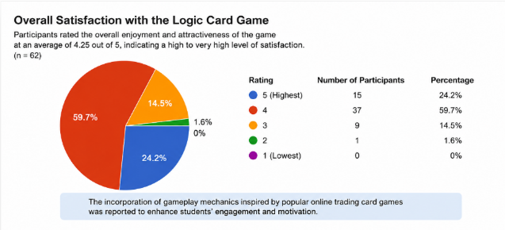

- Ambiguous logic statements: Some propositional logic questions contained insufficient contextual information, allowing multiple interpretations and occasionally leading to disagreements among players.
- Unnatural language usage: Certain cards combined formal mathematical terminology (e.g., proposition and tautology) with terminology commonly used in trading card games, resulting in awkward sentence structures that reduced readability.
- Excessive linguistic complexity: Several cards contained multiple nested negations (e.g., double negatives), making the statements unnecessarily difficult to interpret. This increased the time required for logical reasoning and disrupted the pace of gameplay.
Revision Process
Based on these findings, the prototype was revised through the following improvements:
Text refinement: All logic statements were rewritten to improve clarity and eliminate ambiguity. Unnecessary wording was removed, and conditional ("if...then") and logical connective ("and"/"or") expressions were standardized to ensure consistent interpretation.
Glossary development: A glossary explaining terminology adapted from online trading card games (e.g., combo, rare card, and continuous effect) was added to the game manual. This allowed players with no prior experience in trading card games to understand the terminology before gameplay.
Card layout improvement: The visual design of the cards was revised in Canva by increasing the font size of instructional text and adjusting the layout to improve readability and enable players to process information more efficiently.

Result and Discussion
The project developers analyzed online game mechanics to design an educational card game aimed at enhancing conceptual understanding and logical problem-solving skills among upper-secondary students at Princess Chulabhorn Science High School Loei. The game focuses on accelerating cognitive processing regarding logical connectives, truth tables, and tautologies.
1) Card Game Components and Mechanics
1. Game Components: The developed game consists of three primary elements: Problem Cards, Hit Points (HP) tracking, and Truth Value Tokens representing T (True) and F (False).
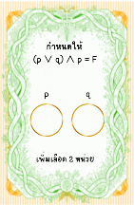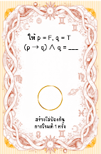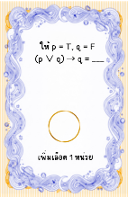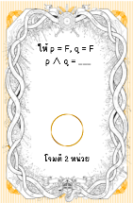



2. Gameplay Core: Players engage with mathematical logic by using their hand cards and truth value tokens to execute strategic in-game actions: Attacking, Defending, Healing, and Regenerating.
3. Action Execution: To successfully play a card, the active player must verbally explain the displayed logic problem and provide the correct solution. Upon a successful solution, the player can chain subsequent cards continuously until resources are depleted, which then concludes their turn.
2) Problem Design and Analytical Training To systematically train students' analytical thinking skills
the problems embedded within the cards were structured with progressive complexity
1. Compound Propositions: Cards feature tasks requiring students to determine the truth value of compound propositions.
2. Variable Operations: The problems mandate evaluating complex logical operations involving 2 to 4 distinct truth value variables

Conclusions
From recording the results and collecting data from the participants, it indicates that online game concepts can be used to create a mathematical logic card game to help promote knowledge and understanding of mathematical logic. Students showed a 10% improvement in their mathematical logic learning development after playing this board game. Furthermore, the majority of the students expressed satisfaction with learning mathematics through the logic card game, making the learning process more interesting and efficient.
1) Conclusion
From implementing this project The card game can be created from online games that is fun and provides knowledge from mathematical logic that can actually be utilized in learning upper-secondary school mathematical logic. It also yields good learning development, promoting an engaging learning environment and reducing students' screen time.
2) Discussion
Playing the card game allows students to have more fun learning mathematical logic in the classroom and also enables them to understand the lesson content better. While students play the card game, it reduces their screen time and allows them to practice focusing on the gameplay, which enhances the players' concentration and mindfulness. This also benefits the learning of other subjects.
3) Suggestions
This project demonstrates that we can learn mathematics in a fun, engaging, and efficient way through playing a card game. Content in other subjects can also be developed into fun activities like this to improve learners as well. Design the card game rules to accommodate more players, as the current version of the card game can only be played by 2 people per game at a time.

Acknowledgments
We would like to express our sincere gratitude to our project advisor, Mr. Tanongkiat Phonchaiya, for his guidance, valuable advice, and continuous support throughout this project. We also thank all the teachers in the Mathematics Department for their encouragement and helpful suggestions, which contributed greatly to the completion of this project.
Special thanks are extended to all student participants for their cooperation during the experiment, including the card game activities, pre-tests, and post-tests. Their participation provided the data necessary for this study.
Finally, we appreciate everyone who contributed to the success of this project. Any educational value gained from this work is dedicated to our teachers for their support and encouragement.

References
Kaewcharoennet, P. (2022).
Classroom action research to enhance mathematical concepts and problem-solving abilities on application of exponential and logarithmic functions of grade 10 students using online learning based on real-world connected mathematics education (Master's thesis).
Naresuan University, Phitsanulok. Lester, F. K. (1994).
Musings about mathematical problem solving research: 1970-1994. Journal for Research in Mathematics Education, 25(6), 660–675. Makanong, A. (2003). Mathematics: Teaching and learning. Chulalongkorn University Press.
Makanong, A. (2010).
Mathematical skills and processes: Development for improvement. Academic Textbook and Document Center, Faculty of Education, Chulalongkorn University.
Ministry of Education. (2008).
The Basic Education Core Curriculum B.E. 2551 (A.D. 2008). The Agricultural Co-operative Federation of Thailand Printing House.
The Institute for the Promotion of Teaching Science and Technology. (2009).
Learning management manual for the mathematics learning substance group. Express Transportation Organization of Thailand (E.T.O.).

