Development of a Phase Change Film with Eggshell-Based Microcapsules
for Efficient Nocturnal Heat Release in Quail Chick Farms

Nanthin Lertwannavit^{1*} and Peerawat Pengnaree¹
Khunthong Klaythong¹ and Amorn Chaiyasat²
¹Princess Chulabhorn Science High School Pathum Thani,
51 Village No. 6, Bo Ngoen Sub-district,Lat Lum Kaeo District, Pathum Thani 12140, Thailand
²Rajamangala University of Technology Thanyaburi
39 Village No, Rangsit-Nakhon Nayok Road, Khlong Hok, Khlong Luang, Pathum Thani 12120, Thailand
*e-mail: nanthinlertwannavit@gmail.com

Abstract
Quail are economically important poultry raised primarily for meat and egg production. During the early post-hatch stage, quail chicks are highly susceptible to temperature fluctuations due to their sparse feather coverage and limited ability to regulate body temperature. This project aimed to develop a temperature-regulating film incorporating phase change materials (PCMs) through microencapsulation technology reinforced with eggshell powder. The developed film was designed to absorb thermal energy during the daytime and gradually release stored heat at night, thereby maintaining the brooding environment within the optimal temperature range of 32–35°C. During material fabrication, the ratio of methyl methacrylate (MMA) to ethylene glycol dimethacrylate (EGDMA) was systematically optimized. Experimental results demonstrated that an MMA ratio of 25:75 provided the highest microencapsulation efficiency for the phase change material. The resulting film exhibited effective thermal energy storage and controlled heat release, reducing the diurnal temperature fluctuation within the brooding environment to only 0.81°C. The improved thermal stability significantly alleviated physiological stress in quail chicks, allowing metabolic energy to be preferentially allocated toward growth rather than thermoregulation. Consequently, chicks exhibited significantly greater body weight gain and a higher survival rate compared with conventional brooding conditions. Furthermore, the incorporation of waste eggshell powder as a bio-based reinforcing material enhances the sustainability of the system by valorizing agricultural waste while reducing dependence on external energy sources. Overall, the developed temperature-regulating film represents an environmentally sustainable approach to brooding management that is consistent with the biological and developmental requirements of newly hatched quail chicks.

keywords : temperature-regulating film, phase change materials (PCMs) , microencapsulation,
eggshell powder, quail chicks

Introduction
Quail are economically important poultry widely raised for meat and egg production because of their rapid growth and high commercial value (Zhang et al., 2017). During the brooding period, newly hatched chicks are highly sensitive to low temperatures due to their limited thermoregulatory ability, making stable nighttime temperature control essential for survival and healthy growth (Yahav et al., 2001). Conventional heating systems, such as infrared lamps and ventilation equipment, consume considerable energy and often fail to maintain a consistent thermal environment throughout the night (Ayo et al., 2011; Abd El-Wahab et al., 2020).
Phase change materials (PCMs) provide a promising passive thermal management solution by storing heat during the day and releasing it as temperatures decrease (Li et al., 2016). However, conventional PCMs are prone to leakage during phase transitions. To address this limitation, this study developed a temperature-regulating film incorporating microencapsulated PCMs reinforced with waste eggshell powder, improving thermal stability while promoting agricultural waste utilization and circular economy principles (Memon, 2014; Kumar et al., 2020).
The developed film was designed to maintain a stable brooding temperature during nighttime, thereby reducing thermal stress, enhancing chick growth and survival, lowering electricity consumption, and supporting sustainable livestock production in line with the BCG Economy Model and the United Nations Sustainable Development Goals (SDGs).

Methodology
1. Determination of the Optimal Brooding Temperature
Newly hatched quail chicks were reared at 30°C, 35°C, and 40°C for 14 days. Body weight, body length, and survival rate were recorded to determine the optimal brooding temperature.
2. Development of PCM Microcapsules
- Optimization of Capric Acid–Eggshell Ratio
Capric acid and eggshell powder were mixed at ratios of 1:1, 1:1.5, and 1:2. Thermal properties were analyzed to identify the optimum PCM formulation.
- Optimization of MMA Ratio
PCM microcapsules were synthesized by micro-suspension polymerization using different MMA ratios. Encapsulation efficiency was evaluated by TGA.
- Optimization of PCM-to-Monomer Ratio
Various PCM-to-monomer ratios were investigated to maximize encapsulation efficiency, minimize leakage, and improve thermal storage performance.
3. Film Fabrication and Material Characterization
- Thermal Performance Evaluation
The developed film, a commercial infrared-reflective film, and a control were compared by monitoring cage temperature every 4 h for 7 days.
- Mechanical Property Test
Tensile strength and elongation were evaluated using a Universal Testing Machine following ASTM D638-22.
- Accelerated Weathering Test
Film durability under repeated UV exposure and humidity was assessed using a QUV chamber according to ASTM G154-16.
4. Biological Performance Evaluation
Quail chicks were raised under the three treatments for 14 days. Growth, survival, and fecal corticosterone levels (ELISA) were analyzed to evaluate physiological responses.

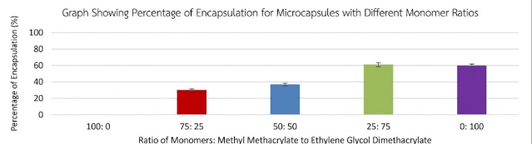
Result and Discussion
1. Optimal Brooding Temperature
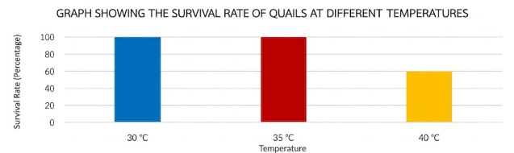
Quail chicks were reared at 30°C, 35°C, and 40°C for 14 days. 35°C produced the highest growth (30%) with 100% survival, while survival decreased to 60% at 40°C.
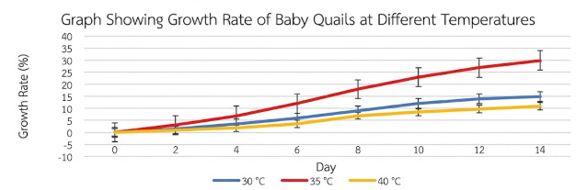
Graph 1 Survival rate of quail chicks reared under different temperature conditions after 14 days.
Graph 2 Growth of quail chicks reared under different temperature conditions after 14 days.

2. Development of PCM and Microcapsules
(1) Optimization of Capric Acid Ratio
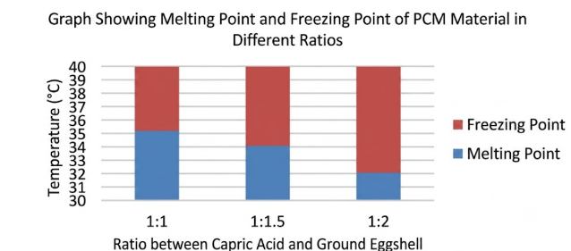
A 1:1.5 capric acid-to-eggshell ratio exhibited the most suitable thermal properties, maintaining a stable phase transition at 33–35°C.
Graph 3 Melting and solidification temperatures of phase change materials (PCMs) prepared with different capric acid-to-eggshell ratios.
(2) Optimization of MMA Ratio
Among five formulations, an MMA ratio of 25:75 achieved the highest encapsulation efficiency (61.20 ± 0.65%) and was selected for subsequent experiments.
Graph 4 Encapsulation efficiency (%) of microcapsules prepared with five different MMA:EGDMA monomer ratios.
(3) Optimization of PCM Ratio
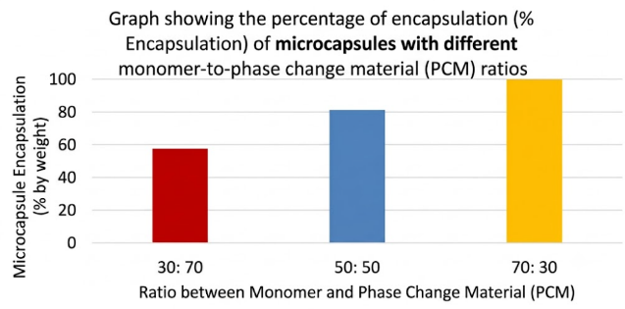
A PCM ratio of 30:70 (monomer = 70:30) provided complete encapsulation (100%) with excellent structural stability.
Graph 5 Encapsulation efficiency (%) of microcapsules prepared with different PCM-to-monomer ratios

- Film Fabrication and Characterization
(1) Temperature Regulation
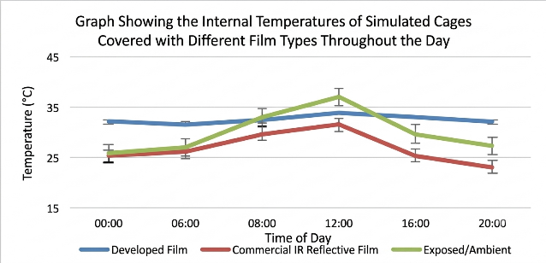
The developed film showed the lowest daily temperature fluctuation (0.81°C), outperforming the commercial IR film (3.15°C) and the control (4.24°C).
Graph 6 Temperature profiles of model brooding cages covered with different films and the uncovered control throughout the day.

(2) Mechanical Properties
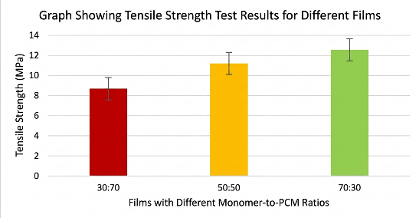
The 70:30 monomer formulation exhibited the highest tensile strength (12.54 ± 0.88 MPa) and satisfied ASTM D638-22 requirements.
Graph 7 Tensile strength of the three film formulations.

(3) Accelerated Weathering
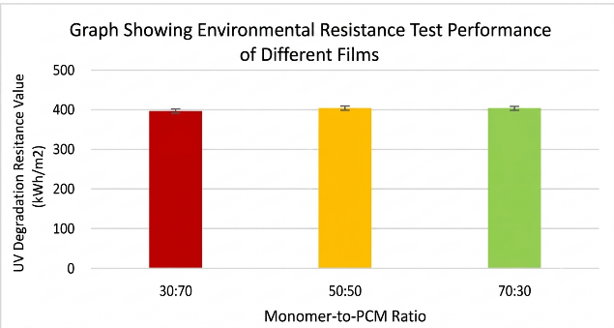
All films demonstrated acceptable durability after ASTM G154-16 testing, with the 50:50 formulation showing the highest UV-weathering resistance (404 ± 3.40 kWh/m²).
Graph 8 Weathering resistance of films prepared with three different PCM-to-monomer ratios.

4. Biological Performance
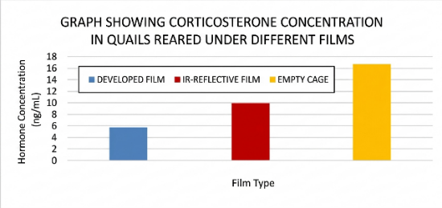
Quail chicks raised under the developed film exhibited the lowest corticosterone level (5.8 ± 0.43), together with the greatest body length (92 ± 1 mm) and body weight (61.3 ± 3.5 g), indicating reduced thermal stress and improved growth.
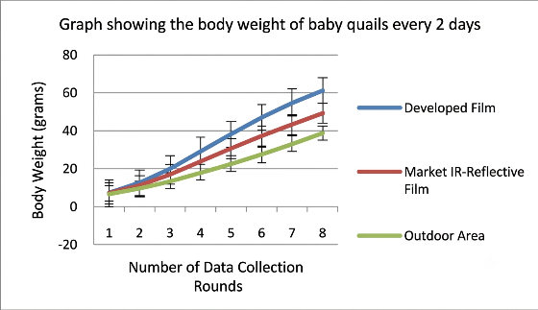
Graph 9 Corticosterone concentrations in quail chicks reared under different film treatments.
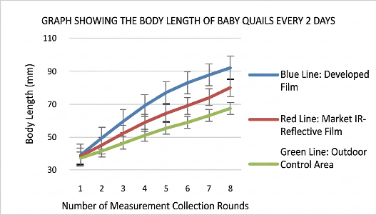
Graph 10 Body weight of quail chicks reared under three different brooding conditions.
Graph 11 Body length of quail chicks under three different film treatments.
Conclusions
The development of an eggshell-reinforced phase change material (PCM) microencapsulated film for nighttime thermal regulation in quail chick farms was conducted through the optimization of biological temperature requirements, PCM formulation, microencapsulation conditions, and film performance evaluation. The optimal brooding temperature for newly hatched quail chicks was determined to be 35°C, which provided the highest growth rate of 30% with a survival rate of 100%. Maintaining chicks within the thermoneutral zone reduced energy expenditure for thermoregulation, allowing more metabolic energy to be directed toward growth and physiological development.
The PCM formulation was optimized by incorporating capric acid with eggshell powder, where the 1:1.5 ratio exhibited suitable phase transition properties within the desired temperature range of 33–35°C. The microencapsulation process demonstrated that the MMA ratio of 25:75 achieved the highest encapsulation efficiency (61.20 ± 0.65%) due to the formation of a stable cross-linked polymer shell that minimized PCM leakage. Furthermore, optimization of the PCM-to-monomer ratio revealed that the 70:30 ratio provided the highest encapsulation performance (100%) and enhanced thermal storage capability, allowing the microcapsules to effectively function as thermal buffers.
The fabricated PCM film demonstrated superior temperature regulation compared with commercial infrared-reflective film and the uncovered control. The developed film reduced daily temperature fluctuation to 0.81°C, compared with 3.15°C and 4.24°C for the commercial film and control, respectively. Mechanical and environmental durability tests confirmed that the developed film maintained adequate tensile strength and resistance to repeated UV exposure and humidity according to ASTM D638-22 and ASTM G154-16 standards, indicating its potential for long-term application in agricultural environments.
Biological evaluation revealed that quail chicks raised under the developed PCM film exhibited the lowest corticosterone concentration (5.8 ± 0.43), indicating reduced physiological stress compared with other treatments. In addition, these chicks showed the highest growth performance, reaching a body length of 92 ± 1 mm and body weight of 61.3 ± 3.5 g after 14 days. This improvement was attributed to the stable microclimate created by the PCM film, which reduced thermal stress and enabled more efficient energy allocation toward growth rather than heat regulation.
Overall, the developed eggshell-reinforced PCM microencapsulated film provides an effective and sustainable approach for temperature management in quail chick farming. By utilizing agricultural waste as a functional material, the innovation reduces dependence on external energy sources, improves animal welfare, and supports sustainable livestock production in accordance with the BCG Economy Model and the Sustainable Development Goals (SDGs).

Acknowledgments
The authors gratefully acknowledge the 28th Young Scientist Competition (YSC 2026), supported by the National Science and Technology Development Agency (NSTDA) and the National Research Council of Thailand (NRCT), for awarding a research grant that financially supported this project. This funding enabled the procurement of research materials, the execution of experiments, and the successful completion of the study. The Department of Applied Chemistry, Rajamangala University of Technology Thanyaburi, for providing laboratory facilities, technical support, and research assistance And Princess Chulabhorn Science High School Pathum Thani, for supporting the project and facilitating research activities. Appreciation is also extended to Mr. Nakarin Thadsri, owner of Nakarin Quail Farm, for providing experimental facilities and assistance during the biological study.

References
นฤภร ประทีปมณีรักษ์. นวัตกรรมนาโนแคปซูลหลาย หน้าที่สำหรับผ้าปรับสภาพความร้อนและ ต้านเชื้อจุลชีพ(Doctoral dissertation มหาวิทยาลัยเทคโนโลยีราชมงคลธัญบุรี. วิทยาศาสตร์และเทคโนโลยี.สาขาวิชา เคมี ประยุกต์. ขวา อำเภอกาญจนดิษฐ์ จังหวัดสุ ราษฎร์ธานี.
ลิมปธนโชติ, & พสธร. (2021). ไมโครแคปซูลวัสดุ เปลี่ยนเฟสสำหรับสีทากล่องโฟมเพื่อ รักษาอุณหภูมิเกล็ดเลือด.
Ben Aribia, W., Trigui, A., Alshammari, N. K., & Abdelmoleh, M. (2024). Development of phase change eco-composite materials from eggshell waste. Green Chemistry Letters and Reviews,
Choi, J.-W., & Lee, J. H. (2020). Selectively UV- blocking and visibly transparent adhesive films embedded with TiO2/PMMA hybrid nanoparticles for displays. Materials, 13(22), 5273.
Fang, G., Li, H., Chen, Z., & Liu, X. (2010). Preparation and characterization of nano-encapsulated n-tetradecane as phase change material for thermal energy storage. Chemical Engineering Journal, 153(1–3), 217–221. https://doi.org/10.1016/j.cej.2009.06.036
Puvadolpirod, S., & Thaxton, J. P. (2000). Model of physiological stress in chickens 1. Response parameters. Poultry Science, 79(3), 363–369. https://doi.org/10.1093/ps/79.3.363
Moberg, G. P. (2000). Biological response to stress: Implications for animal welfare. In G. P. Moberg & J. A. Mench (Eds.), The biology of animal stress: Basic principles and implications for animal welfare (pp. 1–21).
CABI Publishing.
Sahin, K., & Küçük, O. (2003). Heat stress and dietary vitamin supplementation of poultry diets. Nutrition Abstracts and Reviews, 73(7), 41–50
Sánchez, L., Barrio, M., Gascón, P., Pardo, L. C., & Royo, F. M. (2010). Thermal energy storage using PCM microcapsules:
A review. Renewable Energy, 35(4), 818–826. https://doi.org/10.1016/j.renene.2009.10.025
Yang, D., Tu, S., Chen, J., Zhang, H., Chen, W., Hu, D., & Lin, J. (2023). Phase change composite
microcapsules with low-dimensional thermally conductive nanofillers: Preparation,
performance, and applications. Polymers, 15(6), 1562. https://doi.org/10.3390/polym15061562
Zhang, H., Wang, X., & Wu, D. (2010). Silica encapsulation of n-octadecane via sol–gel process: A novel
microencapsulated phase change material with enhanced thermal conductivity and stability. Energy,
35(12), 5306–5312. https://doi.org/10.1016/j.energy.2010.08.041

