Development of an Eucalyptus Leaf Extract Spray Film to Prevent Marine Barnacle Fouling

Lalitphat Srithep¹
Chareef Surinrach^{1*}
Princess Chulabhorn Science High School 138 Moo. 12 Chalung, Mueang, Satun 91140
E-mail: Lalitphat.s@pccst.ac.th

Abstract
Barnacle fouling on the surfaces of ships, piers, and underwater structures is a major problem in the marine industry because it directly affects vessel performance, increases fuel consumption, and shortens the service life of materials such as commercial ships, fishing boats, docks, and offshore structures. A common solution used by fishermen is the application of antifouling paint to the hulls of their boats. However, conventional antifouling paints contain hazardous chemicals and heavy metals that can adversely affect marine ecosystems.

Therefore, this study aimed to develop a metal coating spray film containing eucalyptus leaf extract as an environmentally friendly alternative for preventing barnacle attachment in marine environments. The eucalyptus leaf extract was obtained using the Soxhlet extraction method before being mixed with suitable solvents and film-forming agents to produce a spray capable of forming a uniform and durable thin film on metal surfaces. The resulting film was evaluated for its flexibility, adhesion, water resistance, and antifouling performance against barnacle attachment.

The developed eucalyptus leaf extract spray film successfully formed a uniform coating with good breathability and moisture permeability while maintaining durability under marine conditions. It effectively reduced barnacle attachment and demonstrated good resistance to seawater exposure. Moreover, the spray film provides an environmentally friendly and safe antifouling solution for marine organisms, making it a promising alternative for sustainable applications in coastal communities and the marine industry.
keywords : Terpenoids,Eucalyptus,Spray Coating,Anti-Barnacle Attachment
- Introduction
The attachment of barnacles and other marine organisms to the surfaces of ships, piers, and underwater structures is a major challenge in the marine industry. Biofouling increases hydrodynamic drag, reduces fuel efficiency, and shortens the service life of marine materials and infrastructure, including commercial vessels, fishing boats, docks, and offshore structures. Conventional antifouling coatings containing hazardous chemicals and heavy metals, such as copper-based compounds and tributyltin (TBT), have been widely used to prevent barnacle attachment. Although these coatings are highly effective, they cause marine pollution, disrupt aquatic ecosystems, and accumulate in marine organisms that are consumed by humans.

To minimize these environmental impacts and develop a safer alternative, this study focuses on the development of a waterproof spray film containing terpenoids extracted from eucalyptus leaves. Eucalyptus leaves are rich in bioactive compounds with antifouling properties, particularly eucalyptol and flavonoids, which have been reported to interfere with the settlement and attachment of barnacle larvae without causing harmful effects on the marine environment.

The spray film offers several practical advantages, particularly its convenience and ease of application. Users can simply spray a thin coating directly onto the surfaces of boats or underwater structures without requiring specialized equipment or complex technical procedures. After application, the coating forms a thin protective film that continuously inhibits the attachment of barnacles and other fouling organisms, thereby reducing material deterioration, simplifying maintenance, and lowering the costs associated with frequent cleaning and repair. Furthermore, developing a spray film from eucalyptus leaf extract reduces dependence on hazardous synthetic chemicals while promoting the sustainable utilization of plant-based biological resources. The coating can be applied to a wide range of marine environments, including fishing vessels, cargo ships, and underwater structures, to improve operational efficiency, reduce energy consumption, and minimize long-term environmental impacts.

With its antifouling effectiveness, ease of application, and environmental compatibility, the eucalyptus leaf terpenoid spray film has strong potential as a sustainable alternative for the marine industry. Furthermore, this technology provides a promising foundation for the future development of safe, effective, and environmentally friendly commercial antifouling products.

- Methodology
2.1 Preparation of Crude Eucalyptus Leaf Extract
2.1.1 Preparation of Dried Eucalyptus Leaf Powder
2.1.1.1 Fresh eucalyptus leaves (10 kg) were cut into thin pieces and sun-dried for 1 day.
2.1.1.2 The leaves were further dried in a hot-air oven at 60°C for 12 hours.
2.1.1.3 The dried leaves were ground into a fine powder using a laboratory grinder.
2.1.1.4 The eucalyptus leaf powder was weighed, and the final weight was recorded.
2.1.2 Soxhlet Extraction of Eucalyptus Leaf Extract
2.1.2.1 Approximately 20 g of eucalyptus leaf powder was placed into a 1-L round-bottom flask.
2.1.2.2 350 mL of ethanol was added as the extraction solvent.

2.1.2.3 The extraction was carried out using a Soxhlet extraction system at 45°C for 12 hours.
After extraction, the ethanol extract was concentrated to dryness using a rotary evaporator to obtain the crude eucalyptus leaf extract.
2.2 Preparation and Characterization of Eucalyptus Leaf Extract Spray Film
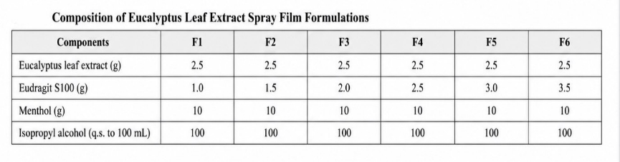
The crude eucalyptus leaf extract obtained from the Soxhlet extraction was subsequently used for the preparation of the spray film formulation. The physical properties and film-forming characteristics of the spray film were evaluated in subsequent experiments.

2.2.1 Optimization of the Polymer Ratio for the Eucalyptus Leaf Extract Spray Film
2.2.1.1 An equal amount of eucalyptus leaf extract was used in all six formulations.
2.2.1.2 Eudragit S100 polymer was dissolved in isopropyl alcohol until a clear, homogeneous solution was obtained.
2.2.1.3 The dissolved polymer solution was added to the eucalyptus leaf extract and mixed thoroughly until a uniform solution was formed.
2.2.1.4 Menthol was used as the plasticizer, and its concentration was adjusted to obtain the optimum formulation.
2.2.1.5 The film-forming properties were evaluated by casting the formulations onto aluminum foil and glass Petri dishes.
2.2.1.6 The physical characteristics of the resulting films were observed and recorded.
2.2.2 Optimization of the Eucalyptus Leaf Extract Concentration in the Spray Film

2.2.2.1 The concentration of the eucalyptus leaf extract was adjusted to determine the optimum formulation.
2.2.2.2 The physical properties of the films were evaluated by casting the formulations onto aluminum foil and glass Petri dishes.
2.2.2.3 The characteristics of the films were observed and recorded.
2.3 Evaluation of the Optimum Concentration of Eucalyptus Leaf Extract for the Prevention of Barnacle Attachment.
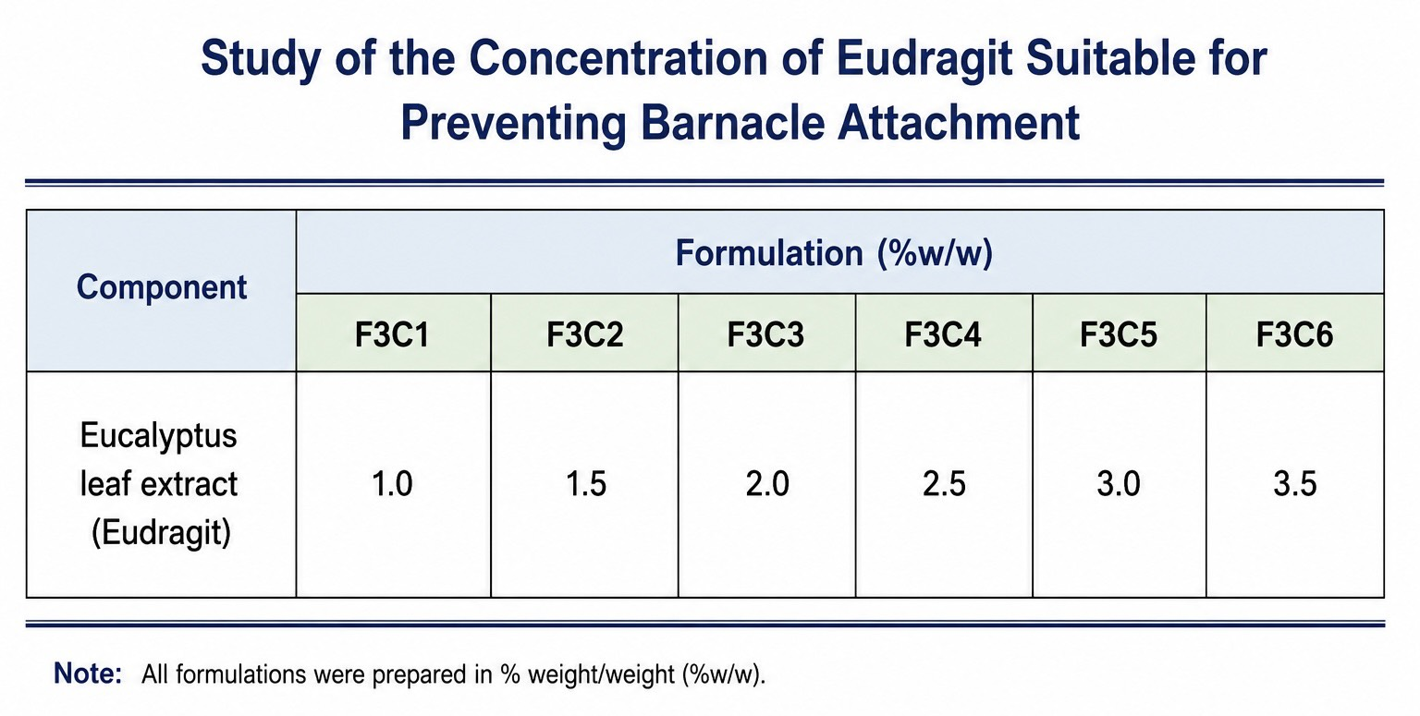

2.3.1 Seven culture tanks were prepared under identical environmental conditions and water quality. Each tank contained a metal plate of the same dimensions to serve as the substrate for barnacle attachment.
2.3.2 The metal plate in Tank 1 was coated with the F3C1 eucalyptus leaf extract spray film.
2.3.3 The metal plate in Tank 2 was coated with the F3C2 eucalyptus leaf extract spray film.
2.3.4 The metal plate in Tank 3 was coated with the F3C3 eucalyptus leaf extract spray film.
2.3.5 The metal plate in Tank 4 was coated with the F3C4 eucalyptus leaf extract spray film.
2.3.6 The metal plate in Tank 5 was coated with the F3C5 eucalyptus leaf extract spray film.
2.3.7 The metal plate in Tank 6 was coated with the F3C6 eucalyptus leaf extract spray film.
2.3.8 Tank 7 (C7) served as the control group, and its metal plate was left uncoated without spray film application.

2.3.9 The number of barnacles attached to each metal plate was observed and recorded using a light microscope.

3. Results and Discussion

The quality of six eucalyptus leaf extract spray film formulations (F1–F6), prepared with varying concentrations of the polymer Eudragit S100, was evaluated. The results showed that:
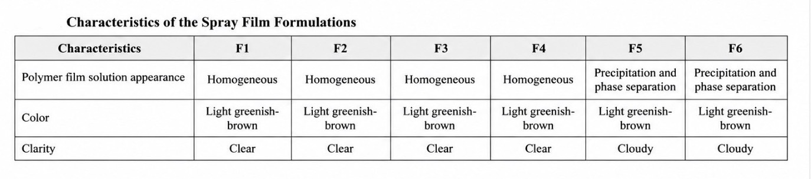

Table 1. Characteristics of the Film-Forming Solutions
Appearance of the Film-Forming Solutions Before Film Formation
Formulations F1–F4 were homogeneous and showed no phase separation. In contrast, F5 and F6 exhibited sedimentation and phase separation. All formulations were light greenish-brown in color. Regarding clarity, formulations F1–F4 were clear, whereas F5–F6 appeared cloudy.

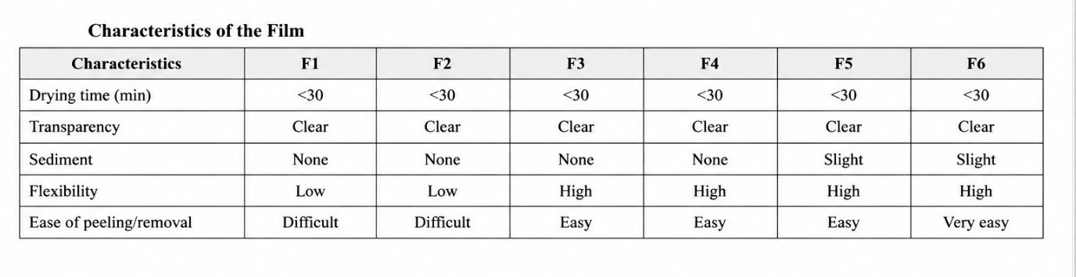

Table 2. Characteristics of the Spray Film After Drying
The drying time of all formulations was less than 30 minutes. All dried films were transparent. No sedimentation was observed in formulations F1–F4, whereas F5–F6 showed slight sedimentation.

Regarding film flexibility, formulations F1–F2 exhibited low flexibility, while formulations F3–F6 demonstrated high flexibility.
For peelability, the films prepared from F1–F2 were difficult to remove, whereas those from F3–F6 could be peeled off easily.
Overall, F3 and F4 exhibited the most desirable physical properties, including excellent transparency, high flexibility, and easy peelability, without any evidence of sedimentation. Since F3 also had the lowest production cost, it was selected as the optimal formulation for subsequent studies.
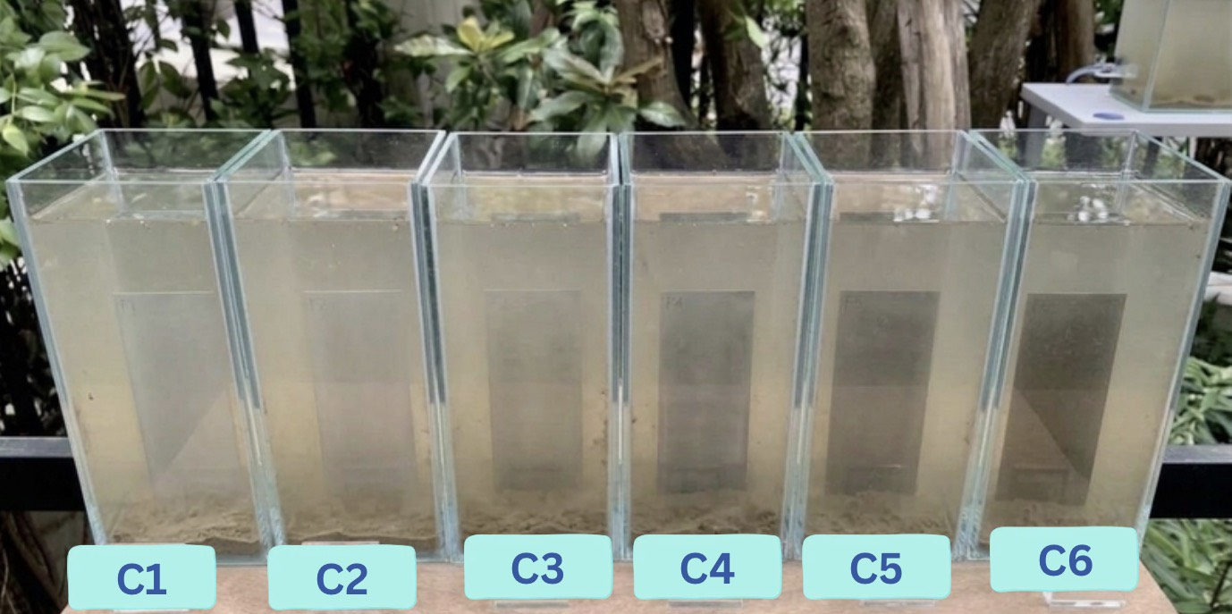
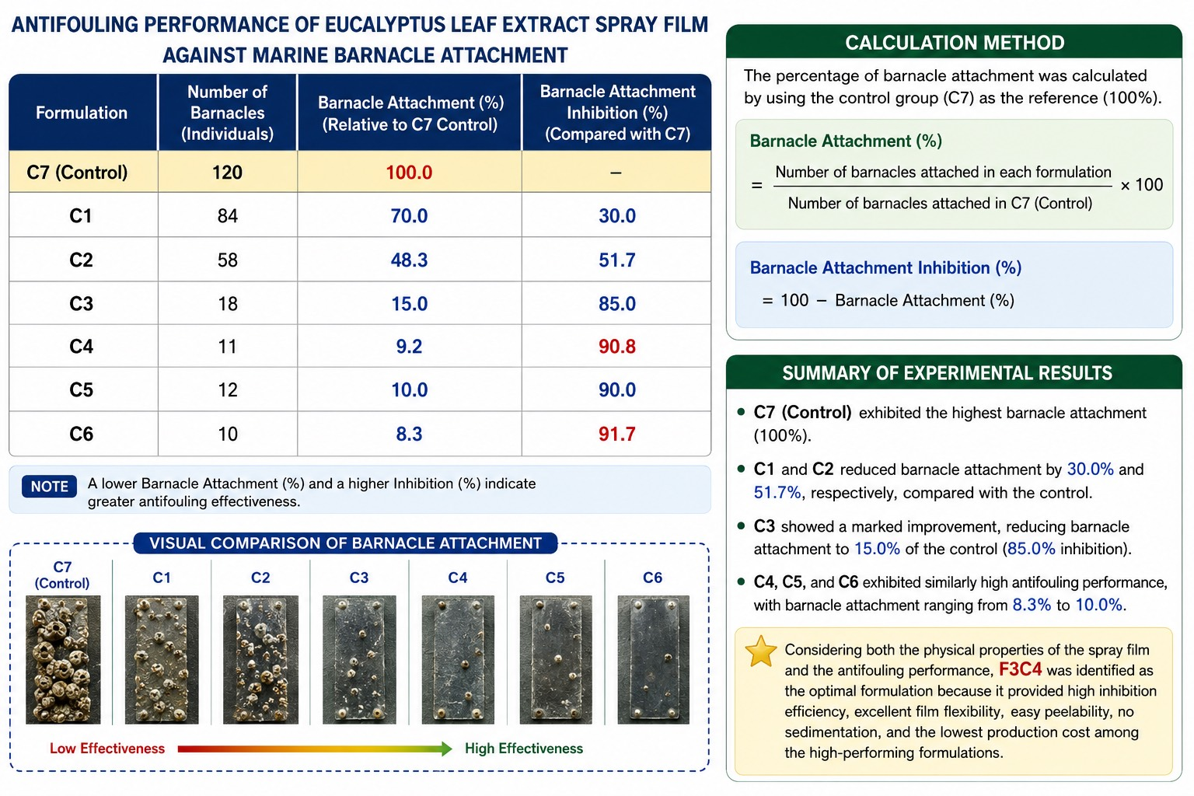

Figure 3. Antifouling Performance of the Eucalyptus Leaf Extract Spray Film Against Barnacle Attachment
The experimental results demonstrated that formulation C4 was the most suitable formulation, achieving 90.8% inhibition of barnacle attachment. Its antifouling performance was comparable to that of C5 (90.0%) and C6 (91.7%), while requiring a lower concentration of active materials. Consequently, C4 had a lower production cost while maintaining physical film properties comparable to those of C5 and C6.
Therefore, C4 was identified as the most cost-effective formulation, providing excellent antifouling performance against barnacle attachment while maintaining desirable film characteristics. These results suggest that C4 is the most promising candidate for further development and practical applications in marine antifouling systems.

4.Conclusions
The evaluation of the physical properties of the spray film formulations showed that F3 and F4 exhibited the most desirable characteristics. Both formulations produced homogeneous solutions without phase separation or sedimentation. The resulting films were transparent, dried within 30 minutes, exhibited high flexibility, and could be peeled off easily. Since F3 had a lower production cost than F4, it was considered the more suitable formulation for use as an antifouling coating.
The antifouling evaluation further demonstrated that C4 achieved 90.8% inhibition of barnacle attachment, showing performance comparable to C5 (90.0%) and C6 (91.7%), while requiring a lower concentration of active materials. As a result, C4 offered a lower production cost without compromising its high antifouling efficiency.
Overall, considering the physical properties, antifouling performance, and production cost, the combined formulation F3C4 was identified as the optimal formulation. It produced a high-quality spray film with excellent resistance to barnacle attachment while remaining cost-effective, making it a promising candidate for further development and practical applications in environmentally friendly marine antifouling coatings.
5.Acknowledgments
The research project entitled “Development of an Eucalyptus Leaf Extract Spray Film to Prevent Marine Barnacle Fouling” was successfully completed through the invaluable guidance, support, and encouragement of Mr. Chareef Surinrach, the project advisor. The authors would like to express their sincere gratitude for his continuous supervision, constructive suggestions, careful review, and valuable comments, all of which greatly contributed to the completion and improvement of this research.
The authors also wish to extend their heartfelt appreciation to everyone who generously shared their knowledge, experience, and expertise throughout the course of this study. Their support, guidance, and assistance in data collection and research development were instrumental in the successful completion of this project.
Finally, the authors would like to thank all individuals whose encouragement and contributions, whether direct or indirect, made this research possible.

References
Baumann, D., & Baumann, K.//(2014).//Reliable estimation of prediction errors for QSAR models under model uncertainty using double cross-validation.//Journal of Cheminformatics.//6(1):/47.

Preuer, K., Lewis, R. P., Hochreiter, S., Bender, A., Bulusu, K. C., & Klambauer, G.//(2018).//DeepSynergy: Predicting anti-cancer drug synergy with deep learning.//Bioinformatics.//34(9):/1538–1546.

Wang, J., Liu, X., Shen, S., Deng, L., & Liu, H.//(2022).//DeepDDS: Deep graph neural network with attention mechanism to predict synergistic drug combinations.//Briefings in Bioinformatics.//23(1):/bbab390.

