Performance Assessment of Chitosan- Coated Bamboo Fiber Filters
Integrated with Bamboo-Based Biochar for Waterborne Bacteria Removal.

Laksika Mangkorn¹*, Thassaneeya Oy-aree¹ and Chartchai Changsen²
¹Princess Chulabhorn Science High School Lopburi , Huai Pong, Khok Samrong, Lopburi, 15120 Thailand
² Mahidol University, 272 Rama VI Road, Thung Phaya Thai, Ratchathewi, Bangkok 10400, Thailand
*E-mail: 05451@pccl.ac.th

Abstract

Water pollution caused by Escherichia coli (E. coli) is a major public health concern, while conventional water treatment methods are often expensive and may leave chemical residues. This project developed an eco-friendly bio-based water filtration membrane by coating bamboo fibers with a chitosan–bamboo biochar composite to improve bacterial removal. The approach also supports the circular economy by converting agricultural waste into value-added materials. A biochar suspension was prepared in a chitosan solution dissolved in acetic acid. Bamboo fiber sheets were coated using the dip-coating method and dried at 60°C to form a stable filtration layer. Filtration performance was evaluated using water samples contaminated with E. coli at an initial concentration of 10⁸ CFU/mL. The experiment was conducted in triplicate. The coated bamboo fiber filter achieved a 95.8% reduction in bacterial contamination, significantly outperforming uncoated bamboo fiber filters. This performance resulted from the combined effects of physical trapping by the porous structure of bamboo fibers and biochar and the antimicrobial activity of positively charged chitosan, which disrupts bacterial cell walls. These findings demonstrate the potential of the developed composite filter as a low-cost, efficient, and environmentally friendly solution for reducing bacterial contamination in water.

Keywords: Bamboo fiber filter, Chitotan, Biochar, Waterbome bacteria

Introduction
Water pollution from bacteria is a widely addressed problem today. Bacteria such as Escherichia coli are an indicator of water contamination and have a direct impact on human health (World Health Organization, 2017). Traditional water treatment methods, such as synthetic membranes or chemical disinfectants, while effective, have limitations in terms of high cost and the risk of residual chemicals (Shannon et al., 2008).
Due to these problems, there has been a search for low-cost, environmentally friendly alternatives that can be produced from natural materials. One approach that has garnered attention is the application of biomaterials as water filters, particularly the use of chitosan, a biopolymer derived from shrimp and crab shells with positively charged amino groups that can effectively bind to bacterial cell walls (Rinaudo, 2006), and bamboo biochar, a porous material with a high surface area suitable for absorbing a wide variety of contaminants (Lehmann & Joseph, 2015). When these two materials are coated onto bamboo fiber fabric, which is strong and easily biodegradable, And locally available materials can be used to create a biofilter coated with Chitosan–Biochar Composite, which has the potential to remove bacteria from water in a single step. Furthermore,
it reduces production costs and environmental problems caused by the use of synthetic materials (Crini & Badot, 2008).
Therefore, the project team developed and tested the efficiency of such a filter to evaluate its ability to reduce bacterial contamination in water, with the hope of gaining new knowledge that can be further developed into a prototype for inexpensive, easy-to-use, and environmentally friendly water filtration.
Methodology
1) How to prepare a filter
The preparation of the biofilter begins with preparing a chitosan solution. Weigh 2 grams of chitosan powder and dissolve it in 100 milliliters of 1% acetic acid. Stir continuously with a magnetic stirrer until a clear and homogeneous solution is obtained. The acetic acid helps to dissolve the chitosan, as it is soluble in weakly acidic conditions.
Once the chitosan solution is obtained, add 3 grams of biochar powder and continue stirring until a homogeneous biochar–chitosan suspension is formed. This ensures that the biochar particles are evenly distributed in the chitosan solution, increasing the surface area and improving the efficiency of bacterial adsorption. Next, 6 cm diameter bamboo fiber sheets are cleaned once with distilled water (DI water) and dried at 60°C for 1 hour to remove moisture and initial contaminants.
Afterward, the bamboo fiber sheets are immersed in a biochar-chitosan solution for 1–2 minutes to allow the coating to penetrate the fiber structure.
They are then hung vertically to allow excess material to drain off and left for approximately 30 minutes.
This coating process is repeated 2–3 times to increase the uniform thickness of the coating layer and improve the adhesion of the coating to the fiber surface. Finally, the coated filter sheets are baked at 60°C for 12 hours until completely dry, resulting in biochar-chitosan filter sheets ready for performance testing.
2) How to performance
2.1 Bacterial Removal Test
Prepare an Escherichia coli bacterial suspension with a concentration of 10⁸ CFU/mL to be used as a contaminated water sample for the experiment. Then, install the prepared filter plate, with a diameter of 6 centimeters, into the vacuum filtration unit, ensuring it is tightly fitted to the support base and preventing any gaps that might allow water to bypass the filter.
Once the system is properly installed, pour the bacterial suspension into the filter funnel and activate the vacuum system to create negative pressure, causing water to flow through the filter at a consistent rate under controlled conditions, maintaining consistency in all experimental sets. This ensures the accuracy and comparability of the experimental results. During filtration, water samples were collected before and after filtration for bacterial quantification analysis. Bacteria were cultured on Tryptic Soy Agar (TSA) and incubated at 37 degrees Celsius for 24 hours. After the time limit, the number of bacterial colonies that had grown was counted. And the results are reported in Colony Forming Units per milliliter (CFU/mL).
2.2 Experimental Measurement
Experimental measurements were performed by analyzing the efficiency of bacterial removal from the number of colonies reported in Colony Forming Units per milliliter (CFU/mL) both before and after filtration.
The values ​​obtained from cultivation were averaged from multiple repeated experiments to reduce errors and increase data reliability. Then, the number of bacteria before and after filtration was compared to evaluate the efficiency of the filter in reducing microbial counts. The percentage of bacterial removal was calculated from the difference between the two time periods, which reflects the ability of the biochar–chitosan coating material to capture and reduce the amount of microorganisms in water. All experimental results were systematically recorded and summarized in a table to clearly show the trend of changes in bacterial counts. This data was then used to discuss the results and conclude the overall efficiency of the developed filter.

Result and Discussion
From testing the filtration efficiency of E. coli bacteria, starting with a result of 6.0 times 10⁷ CFU/mL, different filter types were found to yield different bacterial counts.
Table 1 A comparison of bacterial counts before and after filtration using different types of filters.

Sample | Before (CFU/mL) | After  (CFU/mL) | Reduction  (%)
Uncoated bamboo fiber filter | 6.0\times 10⁷ | 4.9\times 10⁷ | 18.3
Membrane filter (0.45μm) | 6.0\times 10⁷ | 0 | 100
Chitosan-biochar coated babboo fiber filter | 6.0\times 10⁷ | 0.25\times 10⁷ | 95.8
Note: It was found that uncoated bamboo fiber filters could only reduce the number of bacteria by 18.3%, demonstrating that the bamboo fiber structure alone has a limited ability to trap bacteria, which may be due solely to the physical trapping of the fibers.
In contrast, a standard membrane filter a pore size of 0.45 micrometers could remove all bacteria, with no colonies detected after filtration, representing a 100% reduction, indicating the highest efficiency in bacterial filtration.
For bamboo fiber filters coated with chitosan combined with bamboo biochar, it was found that the number of bacteria could be reduced from 6.0 times 10⁷ CFU/mL to only 0.25 times 10⁷ CFU/mL, or a reduction of 95.8%.
This is significantly more efficient than the uncoated bamboo fiber filter and similar in efficiency to the standard membrane filter.

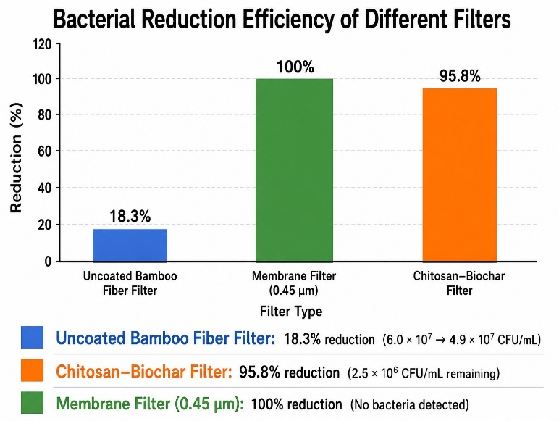

Fig.1 A chart showing the percentage reduction of bacterial counts achieved by different filtration materials and methods.
Comparative analysis of filter performance
Experimental results show that coating bamboo fibers with chitosan in combination with biochar significantly enhances bacterial removal efficiency. This increased efficiency can be explained by the synergistic mechanism of the two materials: biochar's porous structure and high surface area aid in physical bacterial capture, while chitosan's positively charged amino groups can generate electrostatic attraction with the negatively charged bacterial cell walls, resulting in bacterial inhibition or destruction.
Therefore, bamboo fiber filter sheets coated with chitosan and biochar show potential as a highly effective biological water filtration material, capable of effectively reducing bacterial populations in water, and may be developed into a cost-effective and environmentally friendly water filtration system in the future.

Conclusions
The development of a chitosan-coated bamboo fiber filter combined with bamboo biochar aimed to study its efficiency in removing Escherichia coli bacteria from water. The developed filter was then compared to an uncoated bamboo fiber filter and a standard membrane filter.
The filtration efficiency test, performed in three repetitions, showed that the chitosan-coated bamboo fiber filter combined with biochar effectively reduced the bacterial count by 95.8%, significantly higher than the uncoated bamboo fiber filter.
Compared to a standard 0.45 µm pore-sized membrane filter, which could remove all bacteria, the developed filter was slightly less efficient but still considered highly effective and suitable for practical applications.
The study found that chitosan-coated bamboo fiber filters combined with bamboo biochar can significantly improve bacterial removal efficiency compared to conventional bamboo fiber filters. This is due to chitosan's antimicrobial properties, and the biochar's porous structure that helps trap bacteria, resulting in an effective reduction of bacteria in the water.
However, the developed filter cannot remove all bacteria like standard membrane filters. This may be due to the filter's structure or the unsuitable amount of coating material. Therefore, further development is needed to improve its efficiency.
Acknowledgments
Special thanks to Assistant Professor Dr. Chatchai Changsen for his valuable advice and guidance throughout this project. We also thank Princess Chulabhorn Science High School Lopburi, our teachers, and our parents for their support and encouragement.

References
Agrafioti, E. et al. (2020).
Biochar technology in wastewater treatment: A critical review.
Chemosphere, 252, 126539.
https://doi.org/10.1016/j.chemosphere.2020.126539
Chen, D. et al. (2014).
Influence of pyrolysis temperature on characteristics and heavy metal adsorptive performance of biochar.
International Journal of Environmental Science and Technology.
https://link.springer.com/article/10.1007/s13762-013-0400-3
Kumkum, P., & Kumar, S. (2024).
A review on biochar as an adsorbent for Pb(II) removal from water.
Geomaterials.
https://www.scirp.org/journal/paperinformation?paperid=131198
Thongsamer, T. et al. (2022).
Chitosan impregnation of coconut husk biochar pellets improves their nutrient removal from eutrophic surface water.
Sustainable Environment Research, 32(39).
https://sustainevironres.biomedcentral.com/articles/10.1186/s42834-022-00153-2

