Efficiency Evaluation of Electrical Conductivity of Simple PCB Copper-based Microheaters

Thanchanok Thongmak¹, Paphanin Promchat¹, Sirikhwan Musika¹* and Siripong Srisuwan¹

¹Princess Chulabhorn Science High School Nakhon Si Thammarat, Bang Chak, Mueang Nakhon Si Thammarat, Nakhon Si Thammarat 80330, Thailand
*e-mail: 6706376@pccnst.ac.th

Abstract

This project aimed to investigate the electrical conductivity performance of a copper printed circuit board (PCB) microheater fabricated with a serpentine geometry. The voltage divider method was employed to characterize the electrical properties of the microheater because direct resistance measurement was impractical. In the experimental setup, the microheater was connected in series with a reference resistor and powered by a constant voltage source. The measured voltages were used to calculate the current, resistance, and power dissipation of the microheater. The effects of three geometric parameters, line width, line length and copper thickness were systematically investigated. The results showed that Increasing the line width or copper thickness decreased the power electrical power, with the narrowest width and the thinnest line producing the highest electrical power. increasing the line length increased the power dissipation, with the longest microheater exhibiting the highest power output. These results demonstrate that the electrical performance of the microheater is strongly influenced by its geometry. A microheater with a narrow line width, long line length, and thin copper layer provides the highest power dissipation and consequently, the greatest heating capability. Moreover, the voltage divider method offers a reliable and practical approach for characterizing microheaters when direct resistance measurement is not feasible.

Keywords: Microheater, copper PCB, Serpentine Geometry, Voltage Divider

Introduction
Currently, microheaters have garnered widespread attention across various sectors, including manufacturing, medicine, nanotechnology research, and embedded systems. The definitive advantage of microheaters is their ability to efficiently convert electrical energy into thermal energy within a localized, small-scale area, combined with precise temperature control and a rapid response time. Consequently, research on microheaters has progressed continuously, exploring diverse materials, structural configurations, and fabrication processes such as thin-film metals, aluminum oxide, silicon, and conductive polymers. However, many of these conventional materials suffer from high costs, fabrication complexities, or limited feasibility for general applications.
To address these limitations, this study investigates microheaters fabricated from copper layers on Printed Circuit Boards (PCBs). PCBs are readily available, cost-effective, and exhibit excellent electrical and thermal conductivity. Crucially, they allow for flexible circuit pattern design through the etching process a technique easily accessible in standard laboratory environments or school workshops. This project specifically focuses on analyzing various circuit layouts of microheaters on copper PCBs by comparing different configurations of the widely used 'Serpentine geometry.' This pattern is intentionally designed to elongate the electrical current path within a confined area, thereby increasing electrical resistance and generating higher thermal output under a constant voltage supply. Comparing the electrical performance and heat distribution efficiency of each pattern will provide a clearer understanding of microheater operating mechanisms. The insights gained from this research can be further utilized to develop or optimize applications in micro-electronics, robotics, sensors, or medical devices requiring localized thermal control in the future.

Methodology
1) Theoretical
To evaluate the electrical efficiency of the fabricated microheaters, fundamental electrical principles were applied. Since the internal resistance of the copper trace on the Printed Circuit Board is exceedingly low and cannot be accurately measured directly using a standard digital multimeter, a voltage divider circuit configuration was implemented. The unknown resistance of the microheater can be calculated using the voltage divider equation

 | $V_{1}= \frac{R_{1}}{R_{1}+R_{2}}E$ | (1)

Where $V_{1}$ represents the voltage drop across the reference resistor $R_{1}$, $R_{2}$ is the electrical resistance of the microheater, and $E$ is the total supply voltage.
Furthermore, the electrical characteristics and thermal power generation of the system were analyzed using Ohm's Law and the electrical power formula:

 | $$V=IR$$ | (2)

 | $$P=\frac{V^{2}}{R}$$ | (3)

Where $I$ is current, $R$ is resistance, and $P$ is power. The theoretical resistance of the geometric patterns can also be verified through the relationship between material properties and dimensions:

 | $R=ρ\frac{L}{A}$ | (4)

Where $ρ$ is the electrical resistivity of copper, $L$ is the total length of the trace, and $A$ is the cross-sectional area of the copper layer.
2) Microheater Fabrication Process
The fabrication process initiated with the preparation of copper-clad PCB substrates, sized proportionally to accommodate the designated number of turns for each Serpentine geometry configuration. The copper surfaces were mechanically polished with fine-grit sandpaper to eliminate surface contaminants and oxide layers, followed by thorough drying.
Circuit patterning was executed by applying custom-cut, chemical-resistant adhesive masks onto the copper surfaces. The masked substrates were subsequently immersed in a ferric chloride ($Fe{Cl}_{3}$) etching solution, diluted with water at a 1:5 ratio (etchant to water), for approximately 20 minutes or until the exposed, unprotected copper was completely dissolved. Post-etching, the boards were rinsed thoroughly with clean water, and the adhesive masks were removed to reveal the copper traces. A visual inspection was conducted to verify circuit integrity; any minor trace discontinuities were repaired using a conductive/permanent marker to ensure absolute electrical continuity.
Once the finalized microheater circuits were verified, lead wires were soldered onto the designated terminal pads. Soldering iron tip cleanliness and terminal surface preparations were strictly controlled to minimize contact resistance and ensure high-quality, robust electrical connections. The completed microheater assembly was then connected to a direct current (DC) power supply to verify circuit functionality as showed in Fig.1.

Trace Width  (a) | 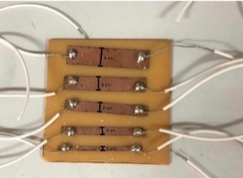
Number  of Turns  (Total Length) (b) | 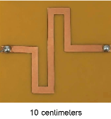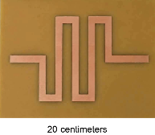
(b) | 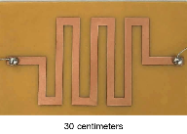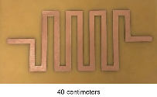
 | 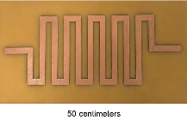
Copper Layer Thickness (c) | 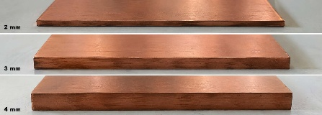
Fig. 1 Shows all the experimental setups used in this study as (a) Trace Width (b) Number of Turns (Total Length) and (c) Copper Layer Thickness

3.) Experimental Setup and Parametric Testing
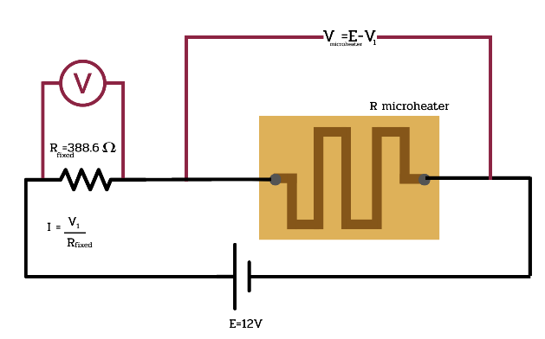
Fig. 2 Electrical Performance Measurement Circuit
After the circuit was connected as shown in Figure 2, the electrical and thermal performance of the microheaters was systematically evaluated based on three primary geometric variables:
3.1 Trace Width: Tested at 1, 3, 5, 7, and 9 centimeters. The width is defined as shown in Figure 3.
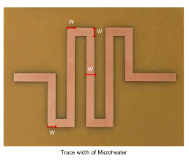
Fig. 3 Microheater trace width for electrical performance measurement.
3.2 Number of Turns (Total Length): Tested at 10, 20, 30, 40, and 50 centimeters. The length is defined as shown in Figure 4.
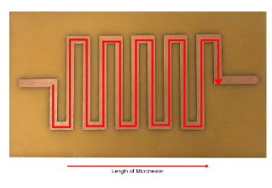
Fig. 4 Microheater trace length for electrical performance measurement.
3.3 Copper Layer Thickness: Tested at 2, 3, and 4 millimeters. The thickness is defined as shown in Figure 5

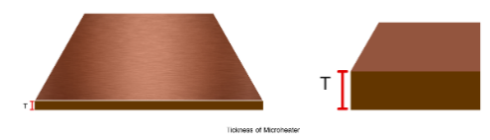
Fig. 5 Measurement of the microheater thickness for electrical performance measurement.

Result and Discussion
The electrical performance of the PCB-based microheaters was evaluated by varying their geometric parameters under a constant input voltage of 12 Volt and a fixed resistor.
4.1 Effect of Trace Width
Increasing the trace width from 1-9 centimeters. decreased the microheater's resistance from 9.00-7.00 Ohm. Within the voltage divider configuration, this lower resistance reduced the voltage drop across the microheater from 0.27-0.22 Volt. Consequently, the calculated electrical power output as shown in Eq. (3) dropped from 8.1 to 6.3 milliwatts.

Table 1 shows the voltage, current, and resistance measured at different micro-heater trace widths.

Micro- heater trace width  (cm) | Voltage across fixed resistor R1 (V) | Current in  circuit (mA) | Voltage across micro-  heater (V) | Resistance of micro-  heater (Ω)
1 | 11.73 | 30.19 | 0.27 | 9.00
3 | 11.75 | 30.24 | 0.25 | 8.33
5 | 11.76 | 30.26 | 0.24 | 8.00
7 | 11.77 | 30.29 | 0.23 | 7.67
9 | 11.78 | 30.31 | 0.22 | 7.00

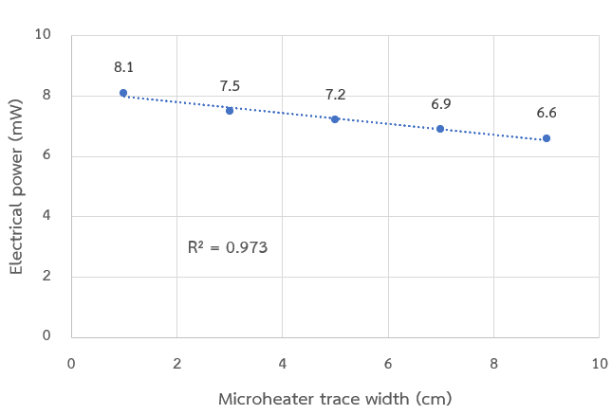
Fig. 6 Relationship between microheater trace width and electrical power output.
4.2 Effect of Trace Length
Increasing the trace length from 10-50 centimeters. expanded the microheater's resistance from 5.33-22.00 Ohm. Within the voltage divider framework, this higher resistance raised the voltage drop across the microheater from 0.16-0.66 Volt, substantially enhancing the generated electrical power output from 4.8-19.8 milliwatts.

Table 2 shows the voltage, current, and resistance measured at different micro-heater trace lengths.

Micro-  heater wire (cm) | Voltage across fixed resistor R1 (V) | Current in circuit (mA) | Voltage across micro-  heater (V) | Resistance of micro-  heater (Ω)
10 | 11.84 | 30.47 | 0.16 | 5.33
20 | 11.69 | 30.08 | 0.31 | 10.33
30 | 11.58 | 29.80 | 0.42 | 14.00
40 | 11.44 | 29.44 | 0.56 | 18.67
50 | 11.34 | 29.18 | 0.66 | 22.00

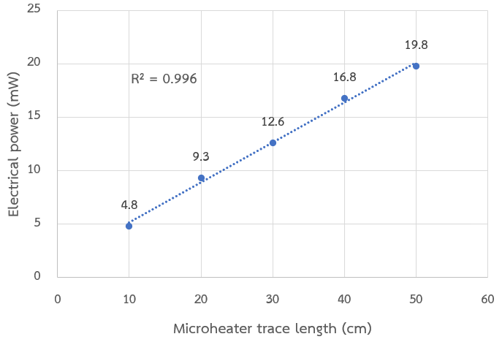
Fig. 7 Relationship between microheater trace Length and electrical power output.
4.3 Effect of Trace Thickness
Increasing the trace thickness from 2-4 millimeters. reduced the resistance from 7.67-3.00 Ohm. This lower resistance decreased the voltage drop across the microheater at 0.23-0.09 Volt, causing the electrical power output to decline from 6.8-2.7 milliwatts.
Table 3 shows the voltage, current, and resistance measured at different micro-heater trace thickness.

PCB copper thickness (mm) | Voltage across fixed resistor R1 (V) | Current in  circuit (A) | Voltage across micro-  heater (V) | Resistance of micro  -heater (Ω)
2 | 11.77 | 30.29 | 0.23 | 7.67
3 | 11.86 | 30.52 | 0.14 | 4.67
4 | 11.91 | 30.65 | 0.09 | 3.00

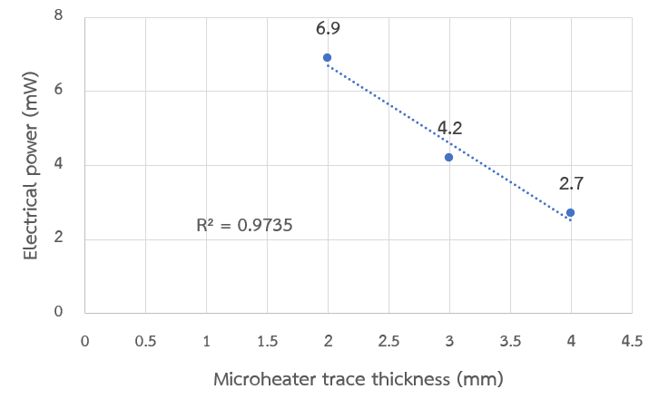
Fig. 8 Relationship between microheater trace thickness and electrical power output.
4.4 Discussion
To maximize the output power of the copper-based PCB microheater within a voltage divider circuit, the copper trace must be designed as narrow, long, and thin as possible to increase its internal resistance. Compared to the direct-writing silver conductive ink microheater, which successfully maintained stable temperatures above 60°C for biological applications (Jiang et al., 2023), our PCB-based method offers a significantly simpler and lower-cost fabrication process that requires no high-precision printing equipment. However, because copper has exceptionally high electrical conductivity, the total resistance of our device remains low. This limits the voltage drop across the microheater, restricting the output power to the milliwatt range and resulting in lower heating efficiency than the silver-ink system. Nevertheless, the key advantage of our study lies in its absolute simplicity and the successful application and integration of a voltage divider circuit to govern the system. For future developments, we highly recommend utilizing alternative materials with much higher electrical resistance, such as nichrome wire, while maintaining this straightforward fabrication approach and the voltage divider circuit framework to achieve superior thermal efficiency.

Conclusions
In this present study, we systematically investigated how geometric parameters specifically trace width, length, and thickness affect the electrical performance and power generation of PCB-based microheaters within a voltage divider configuration. From our experimental results, we found that increasing the trace width decreases the electrical power output, which directly results from the reduction in the microheater's internal resistance. Conversely, we found that increasing the trace length significantly enhances the power output. Under a voltage divider circuit, a higher resistance allows for a greater voltage drop across the microheater, thereby amplifying the generated electrical power. Furthermore, we found that an increase in trace thickness causes a decline in power output, driven by a corresponding reduction in resistance. Based on these parametric evaluations, we conclude that an optimized microheater design requires a narrow trace width, an extended length, and a minimal thickness to maximize electrical resistance. However, we observed a critical limitation: the absolute electrical resistance achieved by the copper-clad PCB traces remained exceptionally low. Consequently, we found that the maximum power output was insufficient to achieve elevated operating temperatures, indicating that further material or structural modifications are necessary for high-temperature applications.

Acknowledgments
Special thanks to Princess Chulabhorn Science High School, Nakhon Si Thammarat, for providing the research funding and laboratory support that made this study possible. We would also like to express our gratitude to our project advisor and friends for their invaluable advice, and continuous encouragement throughout this research. Lastly, our deepest appreciation goes to our parents for their unwavering support, care, and inspiration.

References
Qingrui Jiang et al. Direct Writing of Microheater for Studying Plant Thermal Biology. Volume 35, Supplement, 2023, Pages 725-731
Lienhard, J. H. A Heat Transfer Textbook. Cambridge, Massachusetts: Phlogiston Press, 2020.
K. Puangphet. Fundamentals of Electrical Circuit Analysis and Ohm's Law. https://ice04electric.blogspot.com/2018/04/blog-post_26.html , 2025.
Zhang, Y., & Tadigadapa, S. Design and Fabrication of a Microheater for Gas Sensing Applications. IEEE Sensors Journal. 2008.

