Physical Therapy Gloves For Muscle Rehabilitation In Rheumatoid Arthritis

Nantita Noirit¹, Praewa Mankhong¹ and Phloenchit Kittiyongwiwat¹ *
¹Princess Chulabhorn Science High School Satun, Chalung, Mueang Satun, Satun , 91140 Thailand
*E-mail: pccst@pccst.ac.th

Abstract

This project aims to develop a rehabilitation therapy glove for muscle function recovery in patients with rheumatoid arthritis. Rheumatoid arthritis primarily affects the joints, particularly in the hands and fingers, causing pain and discomfort. Patients often experience limited mobility due to pain, which impacts daily activities such as reduced grip strength and finger stiffness. The proposed rehabilitation therapy glove is equipped with small motors that control finger movements through a web-based application, enabling effective interaction between the therapist and patient. All treatment data is automatically recorded in the web application, which displays the progress and trends of the patient’s physical therapy treatment. Additionally, a point accumulation system is integrated to provide motivation for consistent daily practice. The design and development of this glove aims to enable rheumatoid arthritis patients to conduct physical therapy independently and conveniently, reducing the need for frequent hospital visits. This approach helps save both time and costs while ensuring consistent treatment, improving the chances of effective muscle function recovery. The adjustable intensity levels enhance treatment accuracy and safety. Continuous monitoring of treatment data enables physicians to develop personalized treatment plans for each patient and contributes to more modern and accessible healthcare solutions for all.
Keywords: Rheumatoid Arthritis, Hand Physical Therapy, Arthritis, Glove
Introduction
Rheumatoid Arthritis (RA) is a chronic autoimmune disease that causes long-term inflammation in the joints, especially in the wrists and fingers. More than 18 million people worldwide are affected by this disease, which often causes pain, swelling, and joint stiffness that make daily activities difficult. Although medication can help reduce inflammation and slow the progression of the disease, physical therapy is still an important part of treatment
because it helps improve joint flexibility and restore hand movement. However, current physical therapy still has several limitations, including high treatment costs, frequent hospital visits, and the lack of tools for continuous and accurate progress monitoring.
To address these challenges, this project developed a Smart Rehabilitation Glove for patients with Rheumatoid Arthritis. The system uses servo motors to control the movement and bending angle of each finger through a web application. This innovation allows patients to perform rehabilitation exercises safely and conveniently at home while recording their rehabilitation data for progress tracking. The collected data can also be used in the future to support Artificial Intelligence (AI) in analyzing rehabilitation progress and assisting healthcare professionals in making more accurate clinical decisions. In addition, the knowledge gained from combining biomedical engineering with modern technology can be further applied to develop rehabilitation devices for stroke patients, older adults, and other people with hand movement impairments, helping improve their quality of life and support better healthcare services in the future.

2. Methodology
1) Study of Concepts and Information Collection
The project began with a review of relevant literature and physical therapy guidelines for patients with Rheumatoid Arthritis (RA). This information was used to understand the proper movement of the wrist and fingers and to determine appropriate finger bending angles and movement speeds for safe and effective rehabilitation.
2) Circuit Design and Software Development
The electronic circuit was designed using Fritzing to define the connections between the ESP32 board and other hardware components before assembly. The control system and RARA Rehab web application were then developed to enable users to control the rehabilitation glove, record rehabilitation data, and monitor training progress in real time.
3) Communication and IoT Integration
The system was developed based on Internet of Things (IoT) technology by connecting the ESP32 board to a Wi-Fi network for communication with the RARA Rehab web application. This allows real-time data exchange and device control, enabling users to operate the glove, record rehabilitation sessions, and track their rehabilitation progress through the online platform.
4) Device Assembly and Performance Testing
After completing the hardware and software development, the electronic system was assembled with the rehabilitation glove. The prototype was then evaluated using measuring tools such as a protractor and a stopwatch. The performance tests included response time, finger bending angle, finger extension, and air leakage to ensure that the device operated accurately, safely, and effectively.

3. Result and Discussion
3.1) Performance Testing Results
The performance testing results are summarized in the table, including the response time, finger bending angle, air leakage test, and web application performance, such as real-time data recording, command response, and system stability.

Tested Finger | Bending Angle (Open/Close) | Air Leakage |  |  | Response Time
Thumb  Index  Middle  Ring  Pinky | 45°/0°  85°/2°  82°/0°  78°/5°  70°/0° | No  No  No  Yes  No |  | 1.5  1.8  1.9  2.1  2.3
Experimental Results

3.2 ) Analysis of Experimental Results
The experimental results showed that the Smart Rehabilitation Glove controlled through the RARA Rehab web application successfully achieved its intended objectives. The device effectively controlled finger movements, allowing finger bending angles of approximately 70–85 degrees, which is suitable for hand rehabilitation. The thumb showed a slightly smaller bending angle than the other fingers due to its unique anatomical structure.
Although a small amount of air leakage was observed at some tubing connections during testing, it had only a minor effect on finger movement and did not significantly affect the overall rehabilitation performance. Therefore, the developed system has strong potential for use as a rehabilitation device for patients with Rheumatoid Arthritis in both clinical and home settings, with opportunities for further development in the future.
3.3 ) Prototype Development Results
The project team successfully designed and developed a prototype of a Smart Rehabilitation Glove for Patients with Rheumatoid Arthritis. The system uses an ESP32 microcontroller as the main processing unit, connected to servo motors to control the movement of each finger. It also integrates with the RARA Rehab web application through the Internet of Things (IoT). Users can control the glove via the web application while recording rehabilitation data and monitoring their progress in real time. In addition, the system includes a Daily Streak feature to encourage patients to perform rehabilitation exercises consistently and stay motivated throughout their recovery.
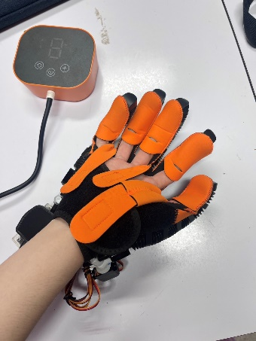

Fig 1. Palmar View of the Smart Rehabilitation Glove
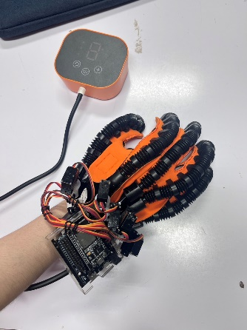

Fig 2. Dorsal View of the Smart Rehabilitation Glove

4. Conclusions
The results indicate that the Smart Rehabilitation Glove successfully achieved its intended objectives through the effective integration of hardware and software. By combining the ESP32 microcontroller with the RARA Rehab web application, the system provides stable wireless communication and real-time control. Users can operate the glove, record rehabilitation data, and monitor their progress continuously, making rehabilitation more convenient and accessible.
The device achieved finger bending angles of approximately 70–85 degrees, which are suitable for hand rehabilitation. Although the thumb showed a smaller range of motion than the other fingers due to its anatomical structure, this did not significantly affect the overall rehabilitation performance. Minor air leakage was observed at some tubing connections during testing, but it had little impact on the overall operation of the device.
In addition, the web application includes three rehabilitation levels, real-time data recording, and a Daily Streak system to encourage regular rehabilitation exercises. These features help improve patient motivation while providing valuable rehabilitation data that can support future AI-based analysis and personalized rehabilitation programs.
The Smart Rehabilitation Glove for Patients with Rheumatoid Arthritis successfully met the project objectives. The system effectively controls the rehabilitation glove through the RARA Rehab web application using IoT technology and the ESP32 microcontroller. The device achieved finger bending angles of 70–85 degrees with an average response time of 1.5–2.5 seconds, making it suitable for rehabilitation exercises. In addition, the system supports real-time data recording and a Daily Streak feature to encourage continuous rehabilitation. The developed system also has strong potential for future development in rehabilitation technology and healthcare data analysis.

Acknowledgments
This science project, "Smart Rehabilitation Glove for Patients with Rheumatoid Arthritis," was successfully completed with the invaluable guidance and support of Mrs. Phloenjit Kittiyongwiwat, the project advisor. The authors would like to express their sincere gratitude for her dedication, encouragement, and valuable advice throughout every stage of this project.
The authors also wish to thank their classmates, parents, and everyone who contributed their support and assistance, making this project possible and successfully completed.

References
[1] Thai Rheumatism Association. (2024). Clinical Practice Guidelines for the Management of Rheumatoid Arthritis (2024 Revised Edition). Retrieved February 10, 2026, from https://thairheumatology.org/
[2] Institute for Health Metrics and Evaluation (IHME). (2024). Global Health Data Exchange: Rheumatoid Arthritis Trends and Projections, 1990–2050. University of Washington. Retrieved February 14, 2026, from https://www.healthdata.org/

