BurnWatch AI An AI-Based Open Burning Risk Prediction System for PM2.5 Monitoring

Pannathorn Worawongkoopt^{1*} and Suvapich Mueanritthichoat¹
Khunthong Klaythong¹ and Sirimongkon Senanorit¹
¹Princess Chulabhorn Science High School Pathum Thani,
51 Village No. 6, Bo Ngoen Sub-district,Lat Lum Kaeo District, Pathum Thani 12140, Thailand
*E-mail: worapanna@gmail.com

Abstract

PM2.5 air pollution is a serious environmental and public health problem in Thailand, especially during the dry season. One important cause of PM2.5 pollution is open burning from agricultural areas and forest fires. Most existing air quality platforms mainly report current PM2.5 concentrations, but they do not clearly identify possible pollution sources or predict high-risk areas in advance. This project proposes BurnWatch AI, an AI-based open burning risk prediction system for PM2.5 monitoring. The system integrates satellite hotspot data, PM2.5 monitoring data, weather data, and geographic information to analyze risk factors such as hotspot density, wind direction, wind speed, humidity, rainfall, temperature, and air pollution trends. The processed data are used to calculate a burn risk score and display high-risk areas through an interactive map and dashboard. The system is expected to help users identify fire hotspot locations, predict areas that may be affected by PM2.5 pollution, and support early warning for schools, communities, and local authorities. This project demonstrates the use of artificial intelligence, geospatial analysis, and data visualization for environmental monitoring and public health protection.

Keywords: PM2.5, Artificial Intelligence, Open Burning, Satellite Data, Risk Prediction

Introduction
PM2.5 air pollution is one of the most serious environmental and public health problems in Thailand. PM2.5 refers to fine particulate matter with a diameter of 2.5 micrometers or smaller, which is small enough to enter the respiratory system and may affect human health. Long-term or repeated exposure to high PM2.5 concentrations can increase the risk of respiratory problems, eye irritation, reduced visibility, and other health impacts, especially among children, elderly people, and people with underlying diseases. In Thailand, this problem becomes more severe during the dry season, when air circulation is limited and pollution can accumulate in the atmosphere for several days.
One major source of PM2.5 pollution is open burning from agricultural areas and forest fires. Burning crop residues, biomass, and forest areas can release large amounts of smoke and fine particulate matter into the air. These pollutants can spread from the burning area to nearby communities or even across provinces depending on wind direction, wind speed, humidity, rainfall, temperature, and other weather conditions. Therefore, PM2.5 pollution is not only a local problem but also a regional environmental issue that requires continuous monitoring and early warning.
At present, many air quality monitoring platforms are available to report PM2.5 levels in different areas. However, most of these platforms mainly provide current air quality information. They often show how polluted an area is at the present time, but they do not clearly identify possible pollution sources or predict which areas may become risky in advance. As a result, schools, communities, and local authorities may not have enough time to prepare suitable preventive measures, such as avoiding outdoor activities, preparing protective masks, closing windows, or issuing health.
BurnWatch AI is proposed as an artificial intelligence-based system for monitoring and predicting open burning risk related to PM2.5 pollution. The system integrates multiple types of data, including satellite hotspot data, PM2.5 monitoring data, weather data, and geographic information. These data are processed and analyzed to identify important risk factors such as hotspot density, wind direction, wind speed, humidity, rainfall, temperature, and PM2.5 trends.
The system then calculates a burn risk score and visualizes high-risk areas through an interactive map and dashboard.
The main objective of this project is to develop a prototype web application that can help users identify fire hotspot locations, analyze open burning risk, and predict areas that may be affected by PM2.5 pollution. The system is expected to support early warning and decision-making for schools, communities, and local authorities.
This project demonstrates the application of computer science, artificial intelligence, geospatial analysis, data processing, and data visualization to solve a real environmental problem and reduce the impact of PM2.5 pollution on public health.
Methodology
1) Study Area Determination
The study area of this project focuses on regions in Thailand that are frequently affected by PM2.5 pollution and open burning, especially during the dry season. These areas may include agricultural zones, forest areas, and nearby communities where fire hotspots and high PM2.5 levels are often reported. The study area is divided by administrative boundaries such as provinces or districts in order to compare risk levels and display the results clearly on a map.
2) Data collection
This project uses data from online open databases and public data sources. The main data include satellite hotspot data, PM2.5 monitoring data, weather data, and geographic data. Satellite hotspot data are used to identify possible open burning locations. PM2.5 data are used to monitor air pollution levels. Weather data, such as wind direction, wind speed, humidity, rainfall, and temperature, are collected because they affect the movement and accumulation of smoke. Geographic data, such as provincial boundaries, forest areas, agricultural areas, and community locations, are used for spatial analysis and map visualization.
3) Data Preparation and Processing
After collecting the data, all datasets are cleaned and prepared before analysis. Incomplete, duplicate, or incorrect records are removed. The date, time, and location formats are adjusted so that hotspot data, PM2.5 data, and weather data can be compared together. Fire hotspot coordinates are matched with provinces or districts using latitude and longitude. PM2.5 and weather data are also linked to the same area and time period. This process allows the system to analyze the relationship between open burning, weather conditions, and PM2.5 pollution.
4) Burn Risk Calculation
A burn risk score is created to estimate the level of open burning risk in each area. The score is calculated from important factors, including the number of fire hotspots, hotspot density, PM2.5 concentration, wind direction, wind speed, humidity, rainfall, and temperature. Areas with many hotspots, high PM2.5 levels, low humidity, low rainfall, and wind conditions that may carry smoke toward communities receive higher risk scores.
The final score is classified into risk levels such as low, moderate, high, and very high, making the results easier for users to understand.
5) AI-Based Risk Prediction
An artificial intelligence model is used to predict areas that may have a high risk of open burning or PM2.5 impact. The input data include hotspot density, PM2.5 concentration, weather conditions, and geographic information. The dataset is divided into training and testing sets to develop and evaluate the model. Machine learning techniques are used to learn patterns from historical data and predict future risk levels. The model performance can be evaluated using accuracy, precision, recall, F1-score, or error values, depending on the type of prediction.
6) System Development
BurnWatch AI is developed as a prototype web application. The system consists of data processing, AI analysis, database management, and user interface components. The main interface is an interactive map that displays fire hotspot locations, PM2.5 levels, and risk areas. A dashboard is also created to summarize important information, such as the number of hotspots, current PM2.5 level, burn risk score, and warning status. The system is designed to be easy to understand for students, teachers, communities, and local authorities.
7) System Testing and Evaluation
The system is tested using historical hotspot, PM2.5, and weather data.The predicted risk levels are compared with actual PM2.5 trends and hotspot records to evaluate the accuracy of the system. The usability of the web application is also considered by checking whether users can understand the map, dashboard, and warning information easily.
The testing results are used to improve the risk score, prediction model, and data visualization.

Result and Discussion

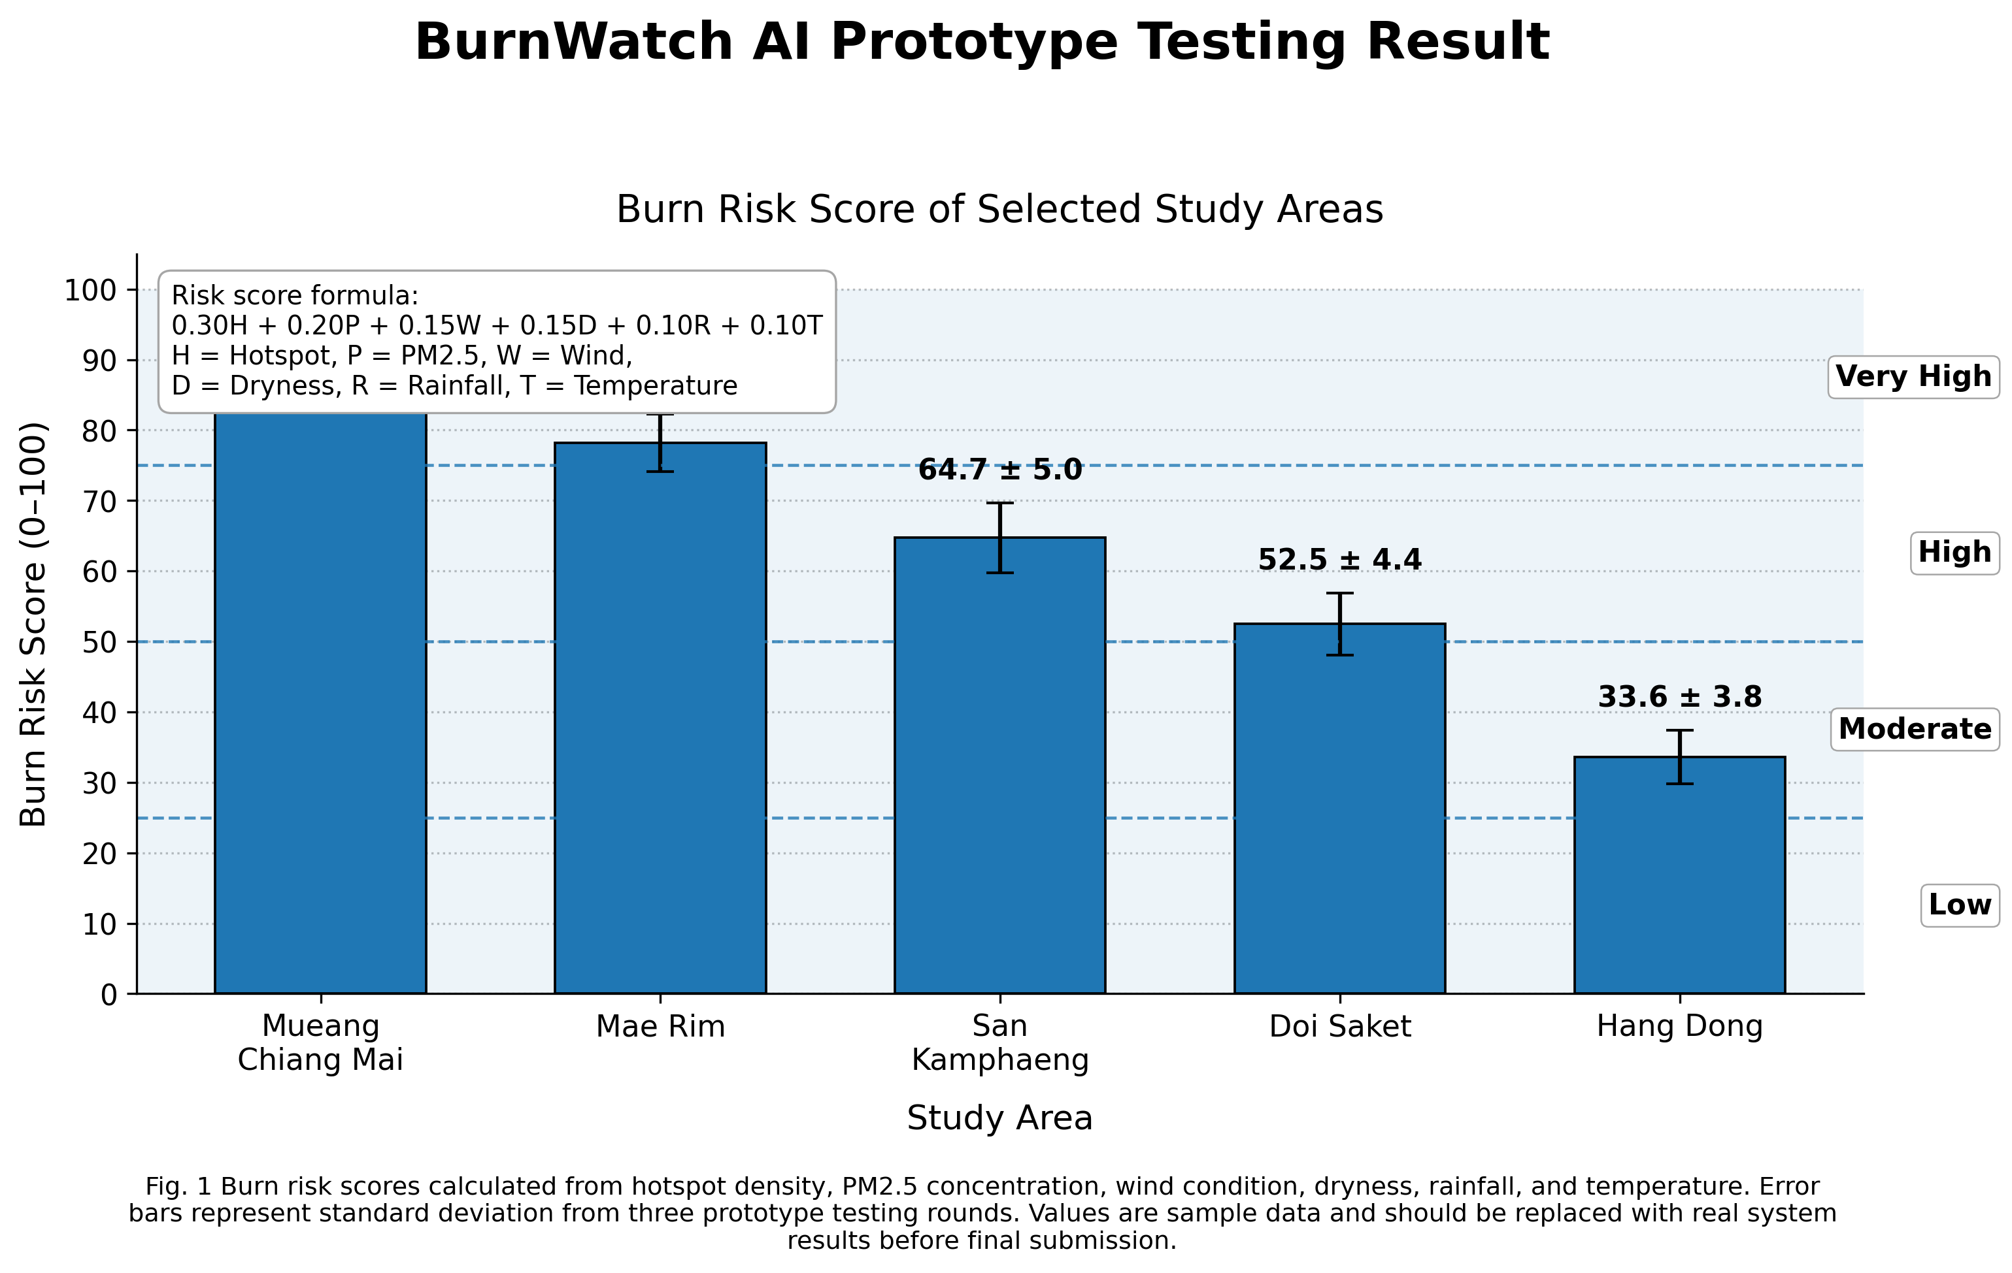
The BurnWatch AI prototype was tested by calculating the burn risk score of five selected study areas: Mueang Chiang Mai, Mae Rim, San Kamphaeng, Doi Saket, and Hang Dong. The burn risk score was calculated from six environmental factors, including hotspot density, PM2.5 concentration, wind condition, dryness, rainfall, and temperature. The final score was classified into four risk levels: low, moderate, high, and very high.
As shown in Fig. 1, Mueang Chiang Mai had the highest burn risk score at 86.4 ± 3.2, which was classified as very high risk. Mae Rim had the second highest score at 78.2 ± 4.1, also classified as very high risk. These results suggest that both areas had high open burning risk, which may be related to high hotspot density, elevated PM2.5 concentration, dry weather conditions, and wind patterns that could transport smoke into populated areas.
San Kamphaeng and Doi Saket had burn risk scores of 64.7 ± 5.0 and 52.5 ± 4.4, respectively. Both areas were classified as high risk.
Although their risk scores were lower than those of Mueang Chiang Mai and Mae Rim, the values were still above the high-risk threshold. This indicates that these areas still require monitoring, especially during periods of low rainfall, low humidity, and increasing PM2.5 levels.
Hang Dong had the lowest burn risk score at 33.6 ± 3.8, which was classified as moderate risk. This result may indicate lower hotspot density, lower PM2.5 concentration, or more favorable weather conditions compared with the other study areas. However, the score still suggests that the area should be monitored because changes in weather or hotspot activity could increase the risk level.
The error bars in Fig. 1 represent the standard deviation from three prototype testing rounds. The relatively small standard deviation values show that the calculated burn risk scores were consistent across repeated tests. This suggests that the BurnWatch AI scoring method can provide stable and understandable risk classification for selected areas.
Overall, the results indicate that BurnWatch AI can transform multiple environmental data sources into a single burn risk score that is easy to interpret. The system can help users compare risk levels among areas and identify locations that may require early warning or closer monitoring. However, the values shown in this figure are sample data used for prototype testing.
In the final system evaluation, these values should be replaced with real-time or historical data collected from actual data sources.

Conclusions
BurnWatch AI was developed as a prototype system for monitoring and predicting open burning risk related to PM2.5 pollution. The system integrated satellite hotspot data, PM2.5 monitoring data, weather data, and geographic information to analyze environmental risk factors and calculate a burn risk score for selected study areas.
The results showed that the proposed scoring method could classify areas into different risk levels, including moderate, high, and very high risk. Areas with higher hotspot density, higher PM2.5 concentration, dry weather conditions, and wind conditions that may transport smoke tended to receive higher burn risk scores.
The prototype testing results indicated that BurnWatch AI can transform complex environmental data into an easy-to-understand risk level through an interactive map and dashboard. This can support early warning and decision-making for schools, communities, and local authorities. The system can help users identify high-risk areas, monitor possible pollution sources, and prepare preventive measures before PM2.5 pollution becomes severe.
Overall, this project demonstrates the application of artificial intelligence, geospatial analysis, data processing, and data visualization in solving an environmental problem. BurnWatch AI has the potential to be further developed into a real-time decision-support system for PM2.5 monitoring and open burning risk prediction. However, further improvement should include the use of real-time data, larger historical datasets, and additional validation with actual PM2.5 events to improve the accuracy and reliability of the system.
Acknowledgments
Special thanks Princess Chulabhorn Science High School Pathum Thani, for support the project and carrying out this study.
References
Air4Thai. (n.d.). Air4Thai: Air quality monitoring
system. Pollution Control Department. Retrieved July 15, 2026, from https://air4thai.pcd.go.th/
Geo-Informatics and Space Technology
Development Agency. (n.d.). PM2.5 monitoring system. Retrieved July 15, 2026, from https://pm25.gistda.or.th/

Leaflet. (n.d.). Leaflet: An open-source
JavaScript library for mobile-friendly interactive maps. Retrieved July 15, 2026, from https://leafletjs.com/
NASA Fire Information for Resource Management
System. (n.d.). FIRMS: Fire Information for Resource Management System. National Aeronautics and Space Administration. Retrieved July 15, 2026, from https://firms.modaps.eosdis.nasa.gov/
NASA Fire Information for Resource Management
System. (n.d.). Active fire data. National Aeronautics and Space Administration. Retrieved July 15, 2026, from https://firms.modaps.eosdis.nasa.gov/active_fire/
Open-Meteo. (n.d.). Historical weather API.
Retrieved July 15, 2026, from https://open-meteo.com/en/docs/historical-weather-api

