Comparative Study on the Physical Properties of Bone Scaffolds from Hydroxyapatite and Natural Polymers

Natteera Podaet¹ and Sisiraphat Thongsai¹
Namthip Srikaew^{1*}
¹Princess Chulabhorn Science High School Loei No. 129, Village No. 5, Huai Phod, Chiang Khan, Loei, 42110 Thailand
*e-mail: natteera04941@pcshsloei.ac.th

Abstract

Comparative Study on the Physical Properties of Bone Scaffolds from Hydroxyapatite and Natural Polymers was conducted to investigate the physical properties of bone scaffolds from hydroxyapatite combined with natural polymers at different ratios, analyze their mechanical strength and porous structures, and evaluate their potential for bone substitute applications. Hydroxyapatite was synthesized from bovine bone and characterized using Fourier-transform infrared spectroscopy (FT-IR). Ten scaffold formulations were fabricated using the freeze-drying technique and evaluated for compressive mechanical properties, volumetric porosity using the liquid displacement method, and area porosity and pore size through scanning electron microscopy (SEM) combined with ImageJ analysis. The results confirmed the successful synthesis of hydroxyapatite, with characteristic functional groups consistent with reference data. All scaffold formulations exhibited comparable compressive strength, while their elastic modulus values were within the range of human cancellous bone. The composition and ratio of polymers significantly influenced scaffold porosity and pore size. Among all formulations, Formulation 7, consisting of 5 g hydroxyapatite, 1 g chitosan, and 4 g gelatin, demonstrated the most favorable overall properties, with a volumetric porosity of 61.11 ± 9.62%, an area porosity of 18.33%, and an average pore size of 101.18 ± 39.28 µm, providing a suitable environment for bone cell infiltration, attachment, and growth. These findings indicate the potential of this scaffold for further development as a bone substitute material for tissue engineering applications.

keywords: Bone Scaffold, Hydroxyapatite, Natural Polymers, Biomaterials, Tissue Engineering

Introduction
Bone is an essential structure of the human body, providing mechanical support, enabling movement, and contributing to the function of various body systems. In general, bone tissue has the ability to repair and regenerate itself after injury. However, when bone loss occurs over a large area or a critical-sized defect is formed between bone ends, the natural repair process may be insufficient to achieve complete bone union (Sukit Rungapinun, 1991). Therefore, bone substitute materials have been extensively studied to fill bone defects, provide structural support, and promote new bone formation.
Hydroxyapatite (HA) is a widely used biomaterial for bone substitute applications due to its chemical composition similar to the mineral phase of human bone, high biocompatibility, and ability to promote bone tissue formation. In addition, its porous structure and high surface area enhance cell attachment and nutrient exchange (Hamed Ghomi, 2011). When combined with biopolymers, hydroxyapatite can form a three-dimensional structure suitable for bone tissue growth and regeneration.
This study focuses on the investigation and comparison of the physical properties of bone scaffolds fabricated from hydroxyapatite combined with natural polymers, including gelatin, chitosan, and carboxymethyl cellulose (CMC). The scaffolds were prepared using different material ratios and fabricated through freezing and freeze-drying techniques to create porous structures within the materials. This study aims to identify the formulation with suitable porosity and mechanical properties for bone tissue growth and provide a guideline for the development of natural-source bone substitute materials for future tissue engineering applications.

Methodology
1. Synthesis of Hydroxyapatite from Bovine Bone
Bovine bone was treated to remove proteins and lipids by boiling for 5 days, followed by ethanol immersion, drying, and calcination at 900°C for 3 hours. The obtained powder was ground, sieved through a 100-mesh sieve, and characterized using Fourier-transform infrared spectroscopy (FT-IR) to confirm the presence of phosphate and hydroxyl functional groups.
2. Fabrication of Bone Scaffold
Ten scaffold formulations were prepared using hydroxyapatite and natural polymers at different ratios. The mixtures were molded, frozen at −20°C for 24 hours, and freeze-dried at −50°C under 0.1 mbar for 48 hours to create porous structures.
3. Mechanical Property Evaluation
The scaffold specimens were trimmed into cylindrical shapes with a diameter of 12 mm and a height of 20–30 mm. The compressive properties were evaluated using a Universal Testing Machine at a crosshead speed of 5 mm/min until specimen fracture or collapse occurred. The obtained data were used to calculate compressive strength, strain, and elastic modulus.
4. Physical Property Evaluation
The volumetric porosity of the scaffolds was evaluated using the liquid displacement method, with ethanol used as the displacement liquid to infiltrate the porous structure. The porosity value was calculated based on the differences in volume before and after liquid infiltration.

Result and Discussion
1. Characterization of Hydroxyapatite Synthesized from Bovine Bone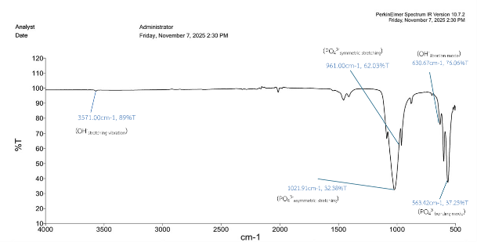
Fig. 1 FT-IR spectrum of hydroxyapatite synthesized from bovine bone

Table 1 Comparison of FT-IR spectra of synthesized hydroxyapatite and reference hydroxyapatite.
Functional group | FT-IR vibration
Functional group | HA  (cm⁻¹) | HA Ref.  (cm⁻¹)
OH⁻_{stretching} | 3571.00 | 3570
OH⁻_{libration} | 630.67 | 630
PO₄³⁻_{symmetric} | 961.00 | 960
PO₄³⁻_{asymmetric} | 1021.91 | 1020-1100
PO₄³⁻_{bending} | 563.42 | 560-600

FT-IR analysis revealed that the wavenumber positions of hydroxyl and phosphate groups were closely matched with the reference hydroxyapatite data, indicating the successful synthesis of hydroxyapatite from bovine bone.

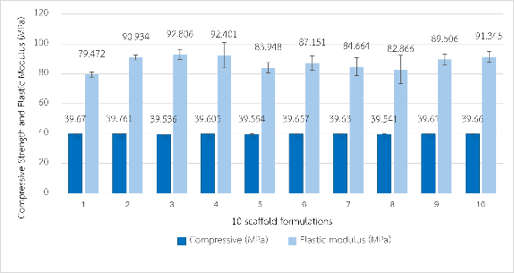
2. Mechanical Property Analysis
Fig. 2 Compressive strength and elastic modulus of the 10 scaffold formulations.

The results showed that all scaffold formulations exhibited comparable compressive strength values, and their elastic modulus values were within the range of human cancellous bone.

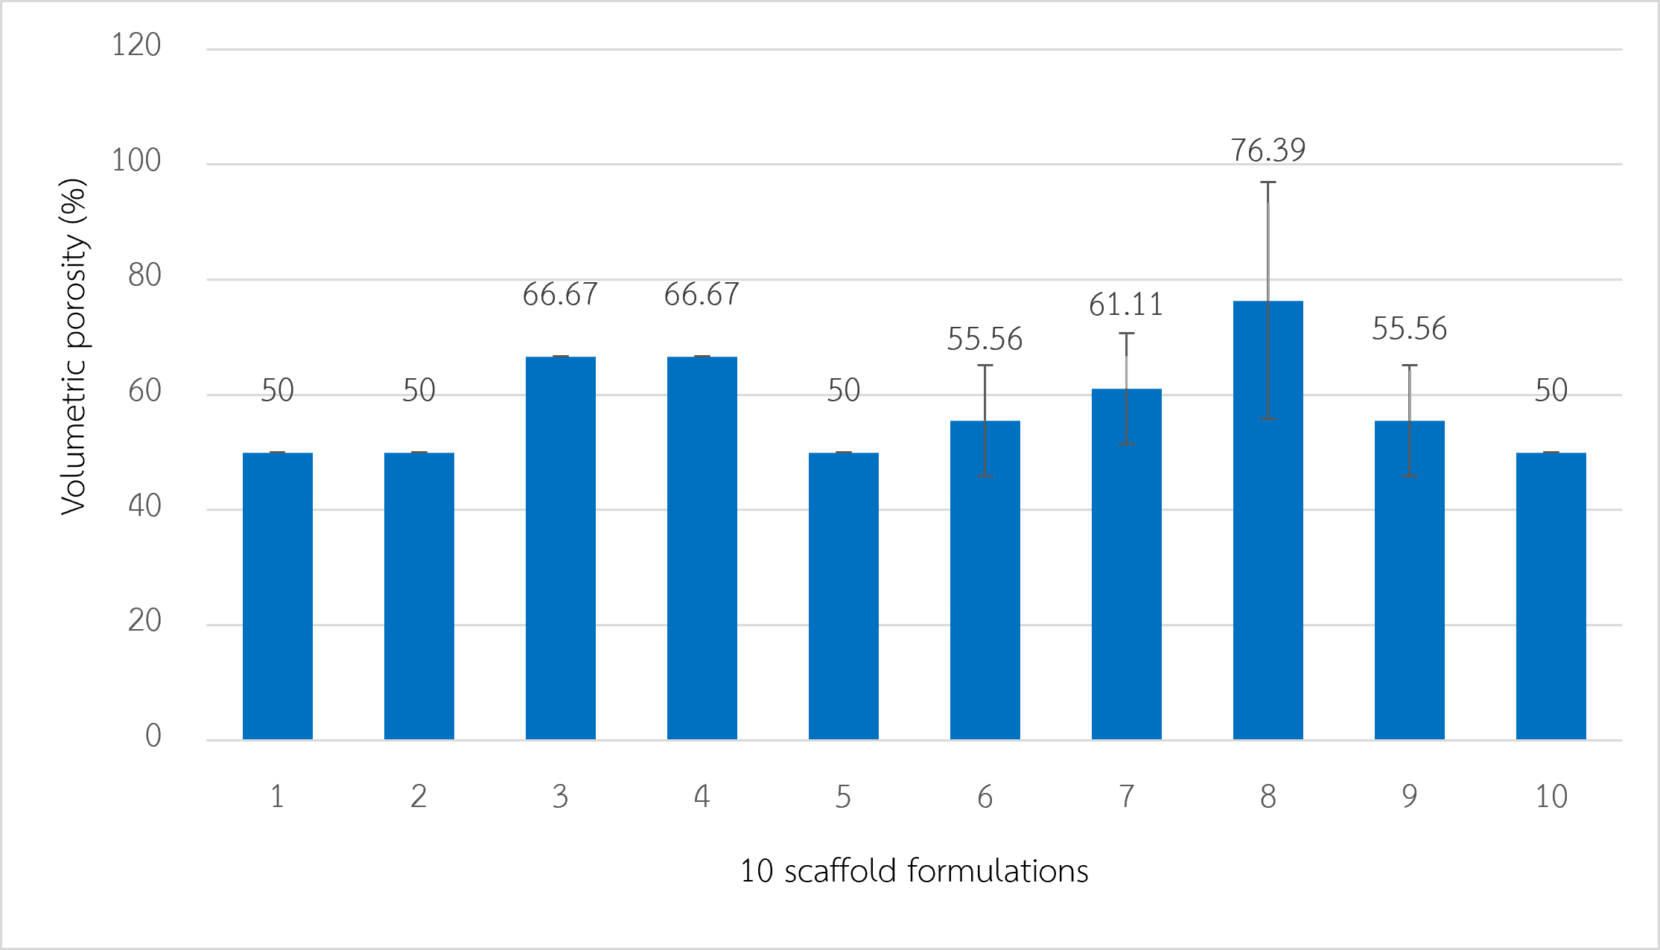
3. Volumetric Porosity Analysis Using the Liquid Displacement Method
Fig. 3 Volumetric porosity of the 10 scaffold formulations.

The volumetric porosity analysis revealed that Formulations 3, 4, 7, and 8 exhibited porosity values greater than 60%, which is considered suitable for cell infiltration and nutrient transport within the scaffold structure.

4. Analysis of Area Porosity and Pore Size Using SEM
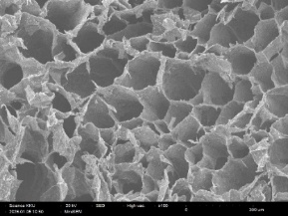  1 | 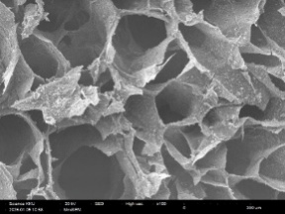  2
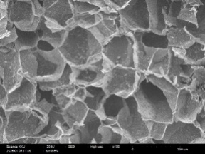  3 | 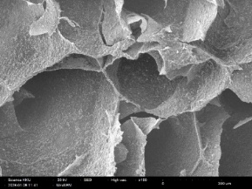  4
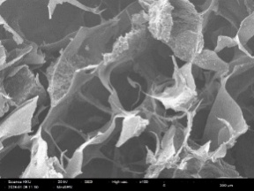  5 | 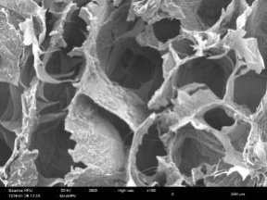  6
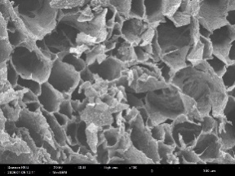  7 | 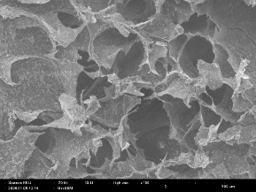  8
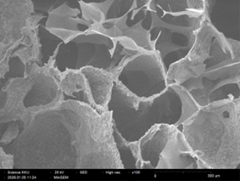  9 | 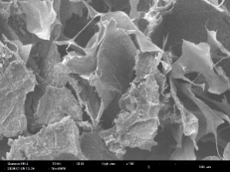  10
Fig. 4 SEM images of the 10 scaffold formulations.

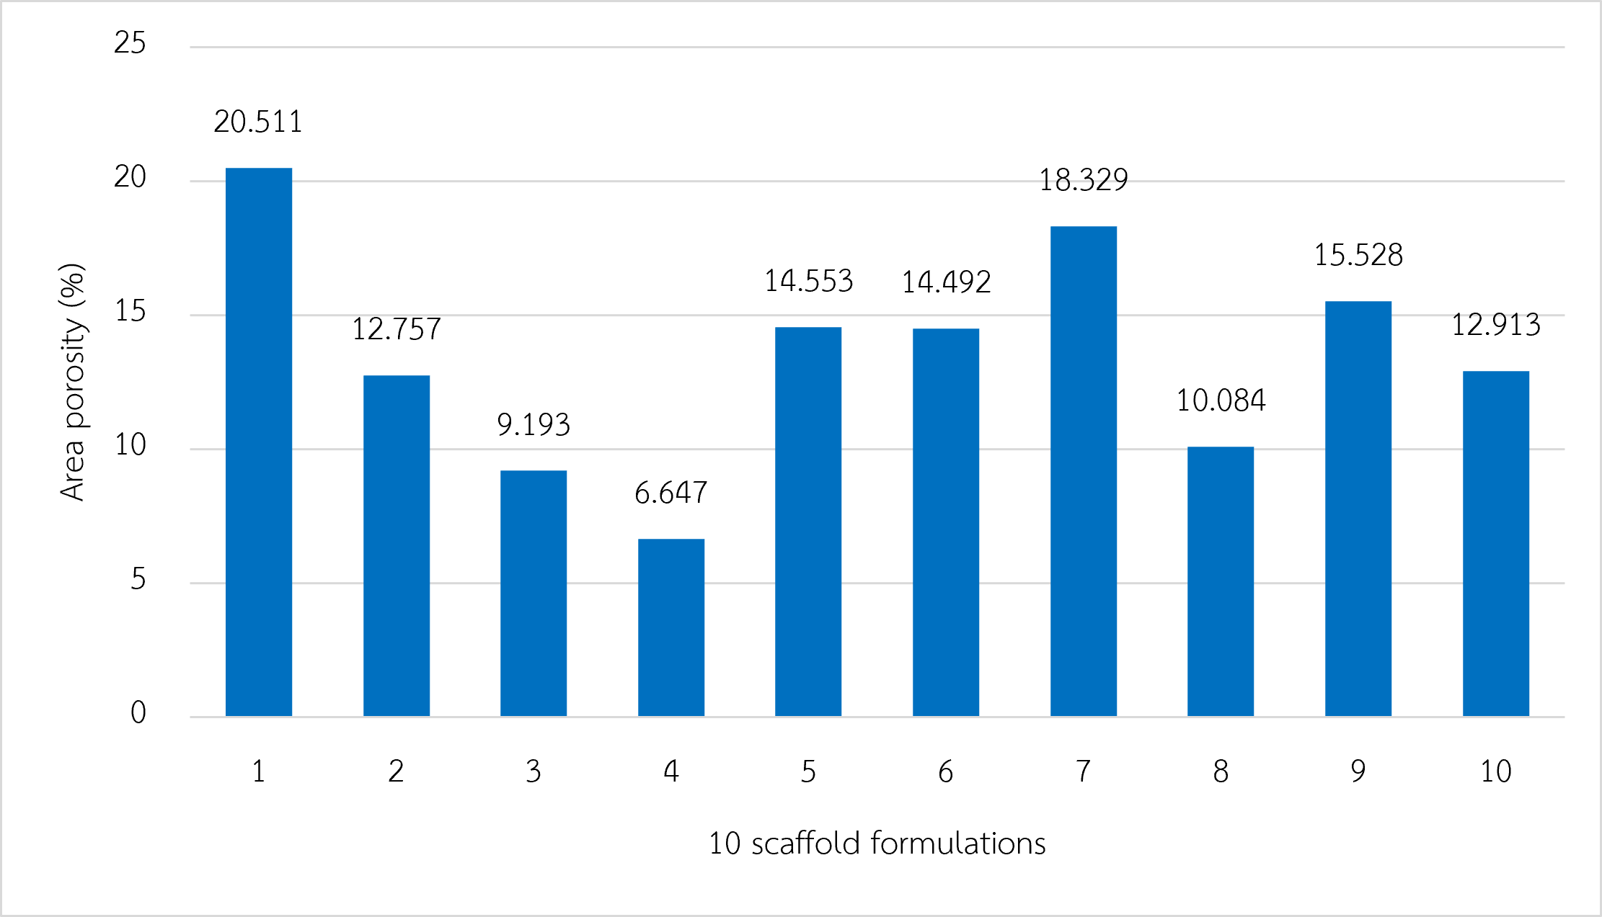
Fig. 5 Area porosity of the 10 scaffold formulations.

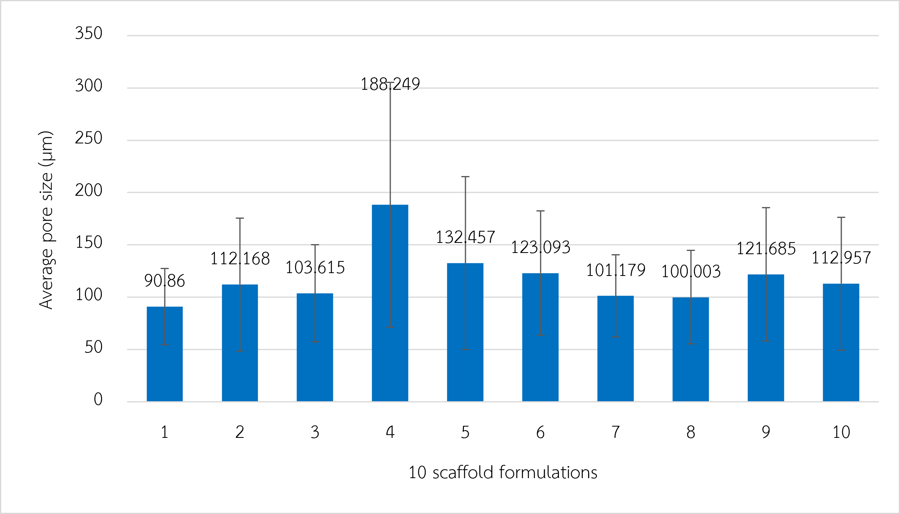
Fig. 6 Average pore size (µm) of the 10 scaffold formulations.

Image analysis of the SEM micrographs using ImageJ showed that Formulation 7 exhibited an area porosity of 18.33% and an average pore size of 101.18 ± 39.28 µm, which falls within the reported optimal range for bone cell infiltration, attachment, and proliferation.

Conclusions
The comparative study on the physical properties of bone scaffolds fabricated from bovine bone-derived hydroxyapatite combined with natural polymers evaluated ten scaffold formulations with different compositions of hydroxyapatite, chitosan, gelatin, and carboxymethyl cellulose (CMC). The results demonstrated that hydroxyapatite was successfully synthesized from bovine bone, as confirmed by FT-IR analysis, which showed characteristic hydroxyl and phosphate functional groups corresponding to reference hydroxyapatite.
All scaffold formulations exhibited similar compressive strength values, while their elastic modulus values were within the range of human cancellous bone. Among all formulations, Formulation 7 (5 g hydroxyapatite, 1 g chitosan, and 4 g gelatin) showed the most suitable overall properties, with a compressive strength of 39.657 ± 0.145 MPa, an elastic modulus of 88.896 ± 2.649 MPa, a volumetric porosity of 61.11 ± 9.62%, an area porosity of 18.33%, and an average pore size of 101.18 ± 39.28 µm.
The appropriate balance between mechanical strength and porous structure in Formulation 7 may result from the synergistic effects of hydroxyapatite and natural polymers. Hydroxyapatite provided structural reinforcement, while chitosan and gelatin contributed to polymer network formation, improving structural stability and maintaining the porous architecture. The pore characteristics of this formulation are suitable for supporting bone cell infiltration, attachment, and nutrient transport, which are essential factors for bone tissue regeneration.
Therefore, the selected scaffold formulation demonstrates potential for further development as a bone substitute material for tissue engineering applications. Further studies on biological properties, including cell attachment, cell proliferation, biodegradation behavior, and long-term structural stability, are recommended to evaluate its applicability in future clinical applications.

Acknowledgments
Special thanks to Teacher Namthip Srikhaew for valuable guidance and advice throughout this research. We also thank Princess Chulabhorn Science High School Loei, Director Kittichai Kruaythong, and the science teachers for providing research facilities, equipment, and support in carrying out this study.

References
Aaddouz, M., et al. (2023). Cheminformatics-
based design and synthesis of hydroxyapatite/collagen nanocomposites for biomedical applications. Polymers, 16(1), 85. https://doi.org/10.3390/polym16010085
Jiao, J., et al. (2023). Influence of porosity
on osteogenesis, bone growth and osteointegration in trabecular tantalum scaffolds fabricated by additive manufacturing. Frontiers in Bioengineering and Biotechnology, 11, 1117954. https://doi.org/10.3389/fbioe.2023.1117954
Sun, Q., et al. (2022). A novel gelatin/
carboxymethyl chitosan /nano-hydroxyapatite/β-tricalcium phosphate biomimetic nanocomposite scaffold for bone tissue engineering applications. Frontiers in Chemistry, 10, 958420. https://doi.org/10.3389/fchem.2022.958420

