Investigation and Comparative Study of Zinc Oxide Nanoparticles Synthesized via Green Chemistry and Sol–Gel Methods for Textile Coating and Photocatalytic Degradation of Methylene Blue

Chatrnichanan Naidan¹, Sirawan Kwangkhwang¹ and Sutthida Netsawang^{1*}
Teerapat Khanjai¹
¹Princess Chulabhorn Science High School Chiang Rai, 345 Moo 2 Rob Wiang Subdistrict, Muang District,Chiang Rai 57000, Thailand
*e-mail: 05855sutthida@pcccr.ac.th

Abstract
This project aims to study the green synthesis of zinc oxide nanoparticles and to evaluate their performance in cotton fabric coating and methylene blue degradation. Zinc oxide nanoparticles were synthesized using coriander leaf extract and the sol–gel method. The nanoparticles were applied to cotton fabric by dipcoating and spray-coating, and water contact angles were measured. The green-synthesized TEM image shows size of nanoparticles at about 100-150 nm, while sol–gel nanoparticles at 5–20 nm. Cotton coated with sol–gel nanoparticles showed a higher water contact angle at 79.23° compared to 74.00° from the green method, maintaining hydrophobicity after 15 washing cycles; spray-coating also performed better than dip-coating. In methylene blue degradation, sol–gel ZnO showed the highest efficiency at 56.5%, whereas the green method achieved 40.58%. These findings indicated that the sol–gel method provided better particle size control and dispersion, resulting in higher surface area and improved photocatalytic properties
keywords : ZnO NPs, green synthesis, sol–gel, coated fabric, photocatalysis

Introduction
Nanotechnology has revolutionized the textile industry by creating "nanotextiles" with enhanced physical, chemical, and biological properties (Kaewtrakulpong, 2020). By incorporating materials at the 1–100 nm scale, functional benefits are gained, significantly increasing the economic value of textile products (Thailand Textile Institute, 2022).
Zinc Oxide Nanoparticles (ZnO NPs) are typically synthesized via physical or chemical methods, such as Chemical Vapor Deposition (CVD), which often involve toxic reagents. Consequently, Green Chemistry has emerged as a sustainable alternative, utilizing natural plant extracts as eco-friendly, safe, and cost-effective reducing and stabilizing agents (Pimolsri et al., 2021). The resulting ZnO NPs function as potent photocatalysts. Under light activation, they generate high-energy free radicals that degrade stable organic pollutants, such as Methylene Blue (MB), into non-toxic substances (Yawong & Chiaranaisilalak, 2019). Additionally, the production of hydrogen peroxide (H₂O₂) during this process disrupts bacterial cell walls, providing antimicrobial properties suitable for medical textiles and sportswear (Liuveha et al., 2020). Regarding the enhancement of functional properties in textiles, coating fabrics with ZnO NPs also improves water repellency and reduces the accumulation of dirt on the fabric surface. The adhesion efficiency of nanoparticles on fibers depends on their interaction with functional groups, such as ⁻OH, ⁻COOH, or ⁻NH₂, on the fiber surface, which can form chemical bonds (Khamsawat et al., 2020). Selecting appropriate techniques, such as Dip Coating for uniform distribution or Spray Coating for precise quantity control, is a crucial factor for the washing durability of the coating (Chansuwan, 2018).
This project aims to synthesize Zinc Oxide Nanoparticles using the green chemistry method to characterize and analyze the resulting particle sizes. It further investigates cotton coating methods using dip and spray techniques to compare the adhesion efficiency of ZnO NPs on cotton fabrics. Additionally, the study evaluates the methylene blue degradation efficiency of ZnO NPs synthesized through different methods, emphasizing the use of eco-friendly materials and processes to reduce the release of hazardous chemicals and minimize impacts on health and the environment.

Methodology
- Preparation of Coriander Leaf Extract
Fresh coriander leaves were chopped and boiled in distilled water (50 g/200 mL) at 60°C for 30–45 minutes. The solution was vacuum filtered through Whatman No. 1 paper and stored at 4°C. The extract was characterized using UV-Vis spectrophotometry (190–1,000 nm).

2) Green Synthesis of ZnO NPs
20 mL of extract was added dropwise to 0.1 M zinc acetate (100 mL). The pH was adjusted to 12 using 2 M NaOH. The mixture was stirred at 1,000 rpm for 2 hours. The resulting precipitate was centrifuged, washed with distilled water and 95% ethanol, dried at 100°C for 8 hours, and calcined at 550°C for 3 hours.
3) Sol-Gel Synthesis of ZnO NPs
Zinc acetate and NaOH were dissolved separately in ethanol, chilled in an ice bath, and then mixed dropwise. Distilled water was added under continuous stirring. The mixture was centrifuged, and the precipitate was dried at 120°C for 3 hours. Both synthesis methods (Green and Sol–Gel) were characterized via TEM.
4) Preparation of Coating Solution
Coating Solution: 0.5 g of ZnO NPs was dispersed in PVA solution (20%) at 80–90°C for 1 hour.
5) Preparation of Fabric Pre-treatment
Cotton fabrics (4 × 5 cm) were scoured in a boiling alkaline detergent solution, rinsed to neutral pH, and dried.
6) Fabric Coating and Testing
For the dip-coating process, fabrics were immersed for 30 minutes, padded, dried at 70°C, and then cured at 150°C for 10 minutes. For spray coating, the fabric were sprayed at a 90°, followed by drying and curing under identical conditions. Finally, the hydrophobicity of the treated fabrics was evaluated via water contact angle measurements.
7) Photocatalytic Degradation of Methylene Blue (MB)
0.06 g of ZnO NPs was added to 100 mL of 10 µM MB. The mixture reached adsorption equilibrium in darkness for 30 minutes before being irradiated under UV light for 30 minutes. The solution was centrifuged, and its absorbance was measured at 664 nm to calculate degradation efficiency:
% Degradation = $\left(\frac{A_{0}-A}{A_{0}}\right)×100$

Result and Discussion
1) Characterization of ZnO NPs via TEM
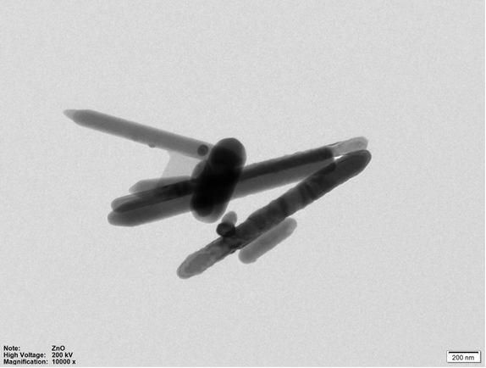
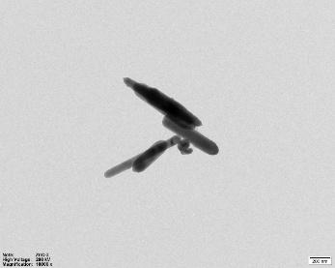
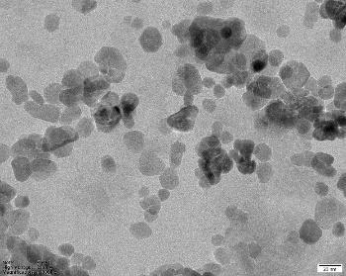
The morphology and particle size of the synthesized Zinc Oxide Nanoparticles (ZnO NPs) were characterized using Transmission Electron Microscopy (TEM).
(a)
(b)
(c)
Fig. 1 TEM image of the synthesis ZnO (a) ZnO, (b) ZnO NPs with Green, (c) ZnO NPs with Sol Gel

The analysis revealed distinct structural differences between the synthesis methods. The commercial ZnO (Fig. 1a) exhibited a rod-like morphology with a size range of 100–250 nm, while the green-synthesized ZnO NPs (Fig. 1b) showed a similar rod-like structure but with a more refined size of 100–150 nm. In contrast, the sol–gel synthesized ZnO NPs (Fig. 1c) displayed a significantly different morphology, appearing as small spherical particles with a diameter of only 5–20 nm. This reduction in size and shift in shape suggest that the sol–gel process provides superior control over nucleation and growth kinetics compared to the green synthesis method used in this study.

2) Hydrophobicity and Water Contact Angle
The sol–gel synthesized ZnO NPs exhibited the highest water repellency, particularly when applied via spray coating, achieving a contact angle of 79.23 ± 1.80° after 15 washes. This significantly outperformed the green-synthesized particles. The enhanced hydrophobicity is attributed to the small, spherical nanoparticles creating a high surface roughness, which traps air and minimizes the solid-liquid contact area (Cassie-Baxter state). Additionally, spray coating proved superior to dip coating, likely due to a more uniform and dense particle distribution, resulting in better durability and adhesion on the fabric surface.
Test Fabric |  | Contact Angle (°) / Washing Cycle (No.)
 |  | 0 | 5 | 10 | 15
Control Fabric |  | 64.30 ± 2.65 | 63.75 ± 1.00 | 64.67 ± 1.53 | 62.25 ± 1.00
ZnO-Nps-Green | dip-coating | 92.33 ± 1.15 | 76.9 ± 1.83 | 74.73 ± 3.50 | 66.13 ± 2.42
ZnO-Nps-Green | spraying | 101.17 ± 2.35 | 80.57±2.25 | 76.10 ± 1.85 | 74.00 ± 1.20
ZnO-Nps-Sol-Gel | dip-coating | 86.30 ± 2.98 | 81.50 ± 4.76 | 77.60 ± 1.31 | 76.80 ± 0.36
ZnO-Nps-Sol-Gel | spraying | 101.87 ± 0.80 | 87.93 ± 0.31 | 85.37 ± 0.90 | 79.23 ± 1.80
Table 1 Comparison of water contact angle values of ZnO-coated fabric synthesized via green and sol-gel methods after 15 washes.
3) Photocatalytic Performance against Methylene Blue
The photocatalytic efficiency of the synthesized nanoparticles was evaluated through the degradation of Methylene Blue (MB) dye under UV irradiation. The results indicated that both synthesized ZnO NPs possessed significantly higher catalytic activity than commercial ZnO. The sol–gel synthesized ZnO NPs demonstrated the highest efficiency, with a degradation rate of 56.50%, while the green-synthesized ZnO NPs achieved 40.58%. The superior performance of the sol–gel particles is directly linked to their smaller size (5–20 nm) as observed in the TEM analysis. This smaller size provides a substantially larger surface-area-to-volume ratio, increasing the number of active sites available for light absorption and the generation of reactive oxygen species. Consequently, this leads to a more rapid and effective breakdown of the organic dye molecules compared to the larger rod-shaped particles.
Table 2 Methylene Blue degradation efficiency of zinc oxide nanoparticles synthesized by different methods under UV light every 30 minutes for 150 minutes.

Conclusions
This study successfully demonstrated the synthesis of Zinc Oxide Nanoparticles (ZnO NPs) using both green chemistry and sol–gel methods, each yielding distinct morphological characteristics. The green synthesis produced rod-shaped particles (100–150 nm), while the sol–gel method resulted in significantly smaller, spherical particles (5–20 nm).
In textile applications, the sol–gel synthesized ZnO NPs exhibited superior performance, particularly in enhancing hydrophobicity. Fabrics treated with these particles via spray coating maintained a high water contact angle of 79.23 ± 1.80° even after 15 washing cycles, outperforming both the green-synthesized and dip-coated samples. Furthermore, both synthesis methods produced nanoparticles with higher photocatalytic activity than commercial ZnO. The sol–gel ZnO NPs achieved the highest Methylene Blue degradation efficiency at 56.50%, compared to 40.58% for the green-synthesized version.
These findings suggest that the sol–gel method is highly effective for producing high-surface-area nanoparticles suitable for multifunctional textiles. Meanwhile, the green synthesis approach offers a viable, eco-friendly alternative with significant catalytic potential. The integration of these nanoparticles into textiles via spray coating presents a promising pathway for developing self-cleaning, water-repellent, and antimicrobial fabrics for medical and industrial use.
Type of ZnO Nanoparticles | % Degradationat a Specific Time Duration Under UV Light (minutes)
Type of ZnO Nanoparticles | 30 | 90 | 120 | 150
Commercial ZnO | 15.86 | 26.50 | 37.52 | 40.03
ZnO-Green | 16.66 | 23.19 | 28.62 | 40.58
ZnO-Sol Gel | 32.17 | 41.16 | 50.30 | 56.50

Acknowledgments
Special thanks to Mr. Teerapat Khanjai, our project advisor, for his invaluable guidance and continuous support throughout this study. We also sincerely thank Princess Chulabhorn Science High School Chiang Rai for providing laboratory facilities and research support. Finally, we are grateful to all teachers, our families, and friends for their encouragement and assistance during this project.

References
Chansuwan, W. (2018).
Nano-coating Technology for the Modern Textile Industry. Rajamangala University of Technology Phra Nakhon Press, Bangkok.
Kaewtrakulpong, P. (2020).
Electrospinning Technology for Nanofibers Production in Technical Textiles. Kasetsart University Press, Bangkok.
Khamsawat, N., Klangpraphan, P., and Noisorn, W. (2020).
Surface Modification of Textiles with Nanoparticles to Enhance Water Repellency and Washing Durability. Journal of Science and Technology Innovation Research and Development, 2(1), 12–25.
Liuveha, T., Chianamwong, P., and Attachot, O. (2020).
Mechanism of Free Radical Generation from Zinc Oxide Nanoparticles under UV Light for Organic Matter Degradation. KMUTT Research and Development Journal, 43(2), 155–168.
Pimolsri, S., Tassanawiroj, N., and Sakultong, K. (2021).
Green Synthesis of Zinc Oxide Nanoparticles Using Plant Extracts and Their Antibacterial Applications. Journal of Science and Technology, 29(4), 612–625.
Thailand Textile Institute. (2022).
Report on the Textile Industry Situation and Adaptation to Nanotextile Innovation. Ministry of Industry, Bangkok.
Yawong, K., and Chiaranaisilalak, S. (2019).
Synthesis of Zinc Oxide Nanoparticles for Use as Photocatalysts in Methylene Blue Degradation and Antibacterial Activity. Thammasat University Journal of Science and Technology, 27(5), 842–856.

