Development of Bacterial Cellulose Sheets from Agricultural Waste Materials Using Acetobacter xylinum.

Chotika Sibtute¹ and Pavitrapond Surapipit¹
Suparat Kromsaeng^{1*}
1Princess Chulabhorn Science High School Chonburi, Nong Chak, Ban Bueng, Chonburi, 20170 Thailand
^{*E-mail: 6706399@pccchon.ac.th}
Abstract

This study investigated the production of bacterial cellulose sheets from watermelon peel waste using Acetobacter xylinum as a sustainable alternative to synthetic leather. The research aimed to convert agricultural waste into a value-added biomaterial with environmentally friendly properties. Watermelon peel waste was used as the cultivation substrate, and the resulting bacterial cellulose sheets were evaluated for their physical and mechanical properties. The findings showed that the sheets exhibited good flexibility, elasticity, and mechanical strength comparable to synthetic leather, demonstrating their potential for practical applications. Moreover, surface treatment with beeswax effectively improved water resistance. Furthermore, dyeing with sappanwood extract resulted in good color absorption and satisfactory color durability. Overall, the results suggest that bacterial cellulose derived from watermelon peel waste is a promising, eco-friendly alternative to synthetic leather and highlights the potential of agricultural waste as a sustainable resource for developing high-performance biomaterials.
Keywords: Acetobacter xylinum, bacterial cellulose, agricultural waste, synthetic leather, sustainable biomaterials.
Introduction
In recent years, the fashion industry has increasingly shifted from the use of animal leather to synthetic leather in response to growing concerns regarding animal welfare. Most commercially available synthetic leather is manufactured from petroleum-based polymers such as polyurethane (PU) and polyvinyl chloride (PVC). Although these materials reduce the demand for animal-derived leather, they
contribute significantly to environmental pollution due to their non-biodegradable nature, prolonged degradation time, and the generation of plastic waste and microplastics. Consequently, there is an increasing demand for sustainable, biodegradable, and environmentally friendly alternatives to conventional synthetic leather.
Bacterial cellulose has emerged as a promising biomaterial owing to its unique structural and mechanical properties. Produced by cellulose-synthesizing bacteria, bacterial cellulose consists of an ultrafine three-dimensional nanofiber network that exhibits high mechanical strength, flexibility, water-holding capacity, and biodegradability. These characteristics make bacterial cellulose an attractive candidate for applications in sustainable materials, including leather substitutes. Among cellulose-producing bacteria, Acetobacter xylinum is widely employed because it is a non-pathogenic, Gram-negative, aerobic bacterium capable of producing high-purity cellulose with excellent structural integrity. Furthermore, the bacterium is readily available, relatively inexpensive to cultivate, and has long been utilized in the production of nata de coco.
The production of bacterial cellulose generally requires culture media containing high concentrations of carbon sources, such as glucose or sucrose, which can increase production costs. To improve the economic feasibility and sustainability of bacterial cellulose production, agricultural waste has attracted considerable attention as an alternative nutrient source. Thailand, as an agricultural country, generates large quantities of agricultural residues, including watermelon peels, which retain appreciable amounts of sugars and nutrients after fruit processing. These residual nutrients make watermelon peel waste a suitable substrate for bacterial cellulose production while simultaneously reducing organic waste. In addition, molasses, a by-product of the sugar industry rich in sucrose and other fermentable sugars, can be incorporated into the culture medium to enhance bacterial growth and cellulose biosynthesis.
Despite its excellent mechanical properties, bacterial cellulose requires further modification to satisfy the performance requirements of leather-like materials. Dry bacterial cellulose sheets typically exhibit a brownish appearance and limited water resistance, which may restrict their commercial applications. Therefore, natural dyeing with sappanwood (Caesalpinia sappan) extract was employed to enhance the aesthetic properties of the material. Sappanwood produces a deep red natural dye with good environmental compatibility and has the potential to provide durable coloration. In addition, surface coating with beeswax to improve water resistance.
Therefore, this study aimed to develop bacterial cellulose sheets from watermelon peel waste using Acetobacter xylinum as a sustainable alternative to synthetic leather. The study also evaluated the effects of glycerol, beeswax coating, and natural dyeing with sappanwood extract on the physical and mechanical properties of the resulting bacterial cellulose sheets. The findings of this research are expected to demonstrate the potential of converting agricultural waste into value-added, high-performance biomaterials and to contribute to the development of environmentally sustainable materials for future industrial applications.

Methodology

1) Preparation and Production of Bacterial Cellulose
1.1 Culture Medium Preparation
Watermelon peel waste was used as the main substrate for bacterial cellulose production. The peels were blended with distilled water and filtered to obtain the extract. The culture medium was prepared by adding sucrose, ammonium sulfate, acetic acid, and L-arginine, with the pH adjusted to approximately 4.5.
1.2 Bacterial Cellulose Cultivation and Purification
The prepared medium was inoculated with Acetobacter xylinum and incubated at room temperature (28 ± 2°C) for 10–14 days. The obtained bacterial cellulose sheets were purified using distilled water and sodium hydroxide treatment, followed by washing and drying.
2) Modification of Bacterial Cellulose Sheets
2.1 Natural Dyeing and Beeswax Coating
Sappanwood (Caesalpinia sappan) extract was prepared as a natural dye. The bacterial cellulose sheets were treated with alum and tannin before dyeing and drying at 50°C. Beeswax was then applied to the surface of the sheets to improve water resistance.
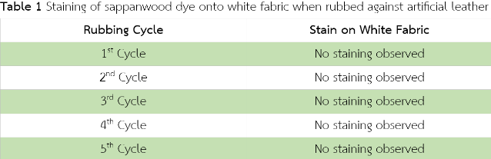

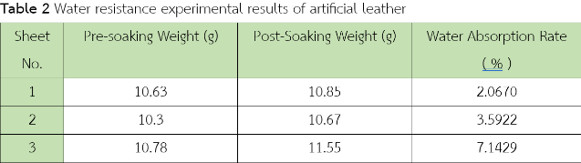

3) Evaluation of Bacterial Cellulose Properties
The physical and mechanical properties of the bacterial cellulose sheets were evaluated. Tensile strength, stress, strain, and Young’s modulus were measured using a tensile testing machine. Water absorption, color fastness, and fiber morphology were also examined.
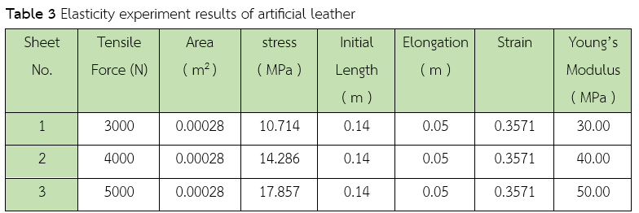

The experimental results were analyzed to determine the effects of sappanwood dyeing and beeswax coating on the properties of bacterial cellulose sheets and their potential as a sustainable alternative to synthetic leather.

Conclusions
The development of bacterial cellulose-based synthetic leather from agricultural waste using Acetobacter xylinum was successfully demonstrated in this study. Watermelon peel waste was utilized as a substrate for bacterial cellulose production, while sappanwood extract and beeswax coating were applied to enhance the aesthetic properties and water resistance of the developed material.
The results demonstrated that bacterial cellulose sheets were successfully produced from watermelon peel extract. The obtained sheets exhibited a flexible and slightly elastic texture. Tensile testing showed that the Young’s modulus values ranged from approximately 0.022–0.028 MPa, indicating that the material could withstand tensile stress to some extent; however, its mechanical strength remained lower than that of commercial synthetic leather.
Regarding water resistance, beeswax coating effectively reduced water absorption of the bacterial cellulose sheets, with absorption values ranging from 2.067–7.1429%. The coated sheets maintained their structural integrity and did not deteriorate after water immersion, indicating improved suitability for practical applications.
Furthermore, dyeing with sappanwood extract combined with alum and tannin treatments provided good color fixation and durability. The color fastness test showed no visible dye transfer onto white fabric after rubbing, demonstrating that the natural dye effectively adhered to the bacterial cellulose fibers.
In conclusion, bacterial cellulose derived from watermelon peel waste shows potential as an environmentally friendly alternative material for synthetic leather applications. The properties of the material can be improved through beeswax coating and natural dyeing methods, enhancing both water resistance and aesthetic appearance. However, further optimization of the production process is required to improve the mechanical strength and flexibility of the material for future practical applications.

Acknowledgments
We sincerely thank Ms. Suparat Kromsaeng for her valuable guidance, advice, and support throughout this project. We also appreciate all teachers in the Science Department and our parents for their knowledge, encouragement, and support, which contributed to the successful completion of this work.

References
Ashjaran, A., Yazdanshenas, M. E., Rashidi, A.,
Khajavi, R., & Kulivand, A. (2013). Adsorption of natural dyes onto bacterial cellulose. Journal of the Textile Institute. 104(3): 254-261.
Binma-ae, H. (2023). Production of bacterial
cellulose sheets from agricultural wastes for the development of biodegradable pots. Bachelor’s Thesis (Science or related field). Narathiwat: Princess of Naradhiwas University. Mimeographed.
Boonaek, P. (2024). 'Disappearing seagrass'
degradation Impact on the ecosystem. Bangkok. Bangkokbiznews. Retrieved March 9, 2024, https://www.bangkokbiznews.com/environment/1116955
Bureau of Animal Nutrition Development. (2017).
Molasses: Properties and utilization in agricultural industry. Bangkok: Department of Livestock Development.
Charoonpong, K. (2018). Optimization of
bacterial cellulose production from Acetobacter xylinum using local fruit juices. Thammasat International Journal of Science and Technology. 26(1): 88-102.
Chindawut, S. (2018). Dyeing of natural
fibers with Sappanwood extract and mordants. Journal of Textile and Apparel Technology. 4(1): 22-35.
Chonborideechaloemrung, B., Chaiwarit, T., &
Jantrawut, P. (2022). Development of
bacterial cellulose composite with alginate and pectin hydrogels for pharmaceutical applications. Isan Journal of Pharmaceutical Sciences. 18(2): 45-58.
Koneplee, S., & Panesri, P. (2022). Utilization of
agricultural waste for bacterial cellulose production. Journal of Agricultural Innovation. 15(2): 112–125.
Neha, K., & Sumathi, S. (2016). Statistical
optimization of bacterial cellulose production using industrial waste as carbon source. International Journal of ChemTech Research. 9(5): 458-466.
Viswanathan, S. S. (2020). Wax-based
artificial superhydrophobic surfaces and coatings. Colloids and Surfaces A: Physicochemical and Engineering Aspects. 602: 125132.
Zhang, X., et al. (2014). Laser-drilled micro-
hole arrays on polyurethane synthetic leather for improvement of water vapor permeability. Applied Surface Science. 305: 1–8.

