Development of Resin Composite for Dental Restoration and Recurrent Caries Prevention Using Fish Scale-Derived Calcium Powder Reinforced with Nanocellulose Fibers and Fluoride Release as Fluorapatite

Aiwarin Eaemraksa¹, Dalaya Kosol¹
Natpassorn Laonet ², Piyanan Boonphayak²
Princess Chulabhorn Science High School Phitsanulok, Makham Sung, Mueang, Phitsanulok 65000
*E-mail: ai.aiwarin.ai@gmail.com

Abstract

Dental caries is an important public health problem in Thailand across all age groups. To address the limitations of current resin composites regarding durability and secondary caries, this research developed an enhanced resin composite. The team utilized hydroxyapatite powder extracted from Nile tilapia fish scales, a natural material structurally like human teeth and bones, combined with fluoride to form fluorapatite, and reinforced with nanocellulose fibers. X-ray diffraction (XRD) analysis confirmed that both the extracted hydroxyapatite and prepared fluorapatite powders exhibited crystal structures consistent with standard databases. The formulation containing 5 wt% fluorapatite provided the best mechanical properties, yielding a stress of 52 MPa. This achieved the same level as the optimal hydroxyapatite content but required a lower filler amount, thanks to stronger bonding strength and appropriate particle dispersion assisted by ultrasonic sonication. Furthermore, fluorapatite demonstrated the ability to continuously release fluoride during the short-term study period at 0, 6, 12, 24, and 72 hours. When nanocellulose fibers were added at 0.25 wt%, the compressive strength of the resin composite reached its highest level, increasing the yield stress to 61 MPa with relatively uniform filler dispersion. In contrast, adding higher contents of nanocellulose fibers resulted in particle agglomeration and a subsequent reduction in mechanical properties.

Keywords: resin-composite, hydroxyapatite, fluorapatite, fluoride releasing, mechanical properties.

Introduction
According to the 8th National Oral Health Survey of Thailand (2017), dental caries affected 91.8% of the working-age population, with 43.3% of cases untreated, while 53% of three-year-old children had dental caries, more than half of which were untreated. These conditions contribute to tooth loss and poor oral health. Although resin composites are widely used as restorative materials, recurrent caries at the tooth–restoration interface remains a major challenge due to bacterial accumulation. Therefore, restorative materials with improved mechanical properties and resistance to recurrent caries are needed. Fish scales are abundant biowaste that can be converted into hydroxyapatite, a biomaterial with a crystal structure similar to that of human teeth and bone. However, its limited mechanical strength restricts its application. Therefore, this study developed a resin composite reinforced with fish scale-derived fluorapatite and nanocellulose fibers to improve mechanical performance, provide sustained fluoride release for recurrent caries prevention, and promote the sustainable utilization of natural waste resources.
Methodology
The study consisted of three parts: (1) investigation of the effect of hydroxyapatite (HAp) content on particle dispersion and the mechanical properties of resin composites; (2) evaluation of fluoride release from fluorapatite (FAp) and its mechanical properties; and (3) investigation of the effect of nanocellulose fiber content on the mechanical properties of resin composites.
Extraction of Hydroxyapatite from Nile Tilapia Fish Scale.
Nile tilapia (Oreochromis niloticus) fish scales were boiled for 30 min, dried, ground, treated with 0.1 M HCl for 4 h, neutralized with 0.1 M NaOH (pH 7), dried again, and sieved through a 120-mesh sieve. The extracted HAp was characterized using X-ray diffraction (XRD).

Preparation of Resin Composites
Epoxy resin Part A (20 g) was mixed with HAp powder (0, 1.5, 3.0, 4.5, and 6.0 g) and sonicated to ensure homogeneous dispersion. After adding 10 g of epoxy resin Part B, the mixtures were cast into 1 × 1 × 1 cm³ molds and cured at room temperature. Particle dispersion was evaluated by laser scattering using a digital microscope, and compressive strength was measured with a Universal Testing Machine at a crosshead speed of 2.0 mm/min.

Preparation of Fluorapatite
The extracted HAp was dispersed in distilled water and reacted with a fluoride solution in phosphoric acid under continuous stirring for 30 min. The suspension was aged at 80°C for 24 h, dried, ground, sieved (120 mesh), and characterized by XRD.

Fluoride Release Test
Fluoride release was evaluated using a calibration curve prepared from ammonium fluoride standard solutions with Zirconium–Alizarin reagent and acetate buffer (pH 4.5). FAp powder (0.1 g) was immersed in 10 mL of distilled water, and samples were collected at 0, 6, 24, and 72 h. Fluoride concentration was measured using a UV–Vis spectrophotometer at 530 nm, and fluoride release, the limit of detection (LOD), and the limit of quantification (LOQ) were calculated. The optimum FAp content was then incorporated into the resin composite.

Incorporation of Nanocellulose Fibers
Nanocellulose fibers (0, 0.075, 0.150, 0.225, and 0.300 g) were incorporated into the optimum resin composite formulation. Particle dispersion and compressive strength were evaluated under the same conditions to determine the reinforcing effect of nanocellulose fibers.

Result and Discussion
Characterization of Hydroxyapatite Powder Figure 1. X-ray diffraction (XRD) pattern of the extracted hydroxyapatite powder.
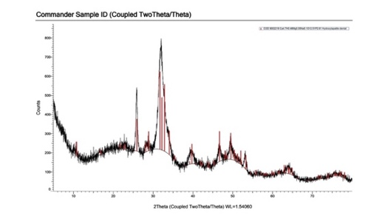

The XRD analysis confirmed the successful formation of hydroxyapatite. The diffraction peaks observed at 2θ values of approximately 26° and 31–35° corresponded well with the standard reference patterns (COD 9001878 and JCPDS No. 01-074-9772).
Evaluation of Particle Dispersion by Laser Scattering
Table 1. Comparison of laser beam characteristics observed through resin composites (Formulations A1–A5).
Resin formulation | Laser beam characteristics
A1 | Highest clarity and continuity
A2 | Clear and continuous beam
A3 | Slight light scattering observed
A4 | Noticeable light scattering
A5 | Significant light scattering with non-uniform dispersion
As shown in Table 1, increasing the hydroxyapatite content resulted in greater light scattering due to particle agglomeration within the resin matrix. The formation of particle clusters increased light scattering, indicatingreduced dispersion uniformity at higher filler loadings.
Compressive Strength
The compressive strength of the resin composites increased with increasing hydroxyapatite content up to the optimum concentration. The control formulation (A1) exhibited a compressive strength of approximately 44 MPa, while formulations A2 and A3 showed improved strengths of 48 and 49 MPa, respectively, indicating that an appropriate amount of hydroxyapatite effectively reinforced the resin matrix. The highest compressive strength was obtained for formulation A4 (52 MPa). However, a further increase in filler content (A5) reduced the compressive strength to 43 MPa. This decrease can be attributed to particle agglomeration, which created stress concentration sites and weakened the overall mechanical performance of the composite.
Characterization of FluorapatiteFigure 2.
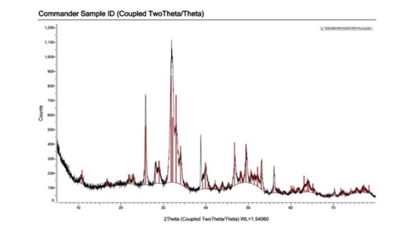
X-ray diffraction (XRD) pattern of the synthesized fluorapatite
The XRD analysis confirmed the successful synthesis of fluorapatite. The diffraction peaks were in good agreement with the standard reference patterns (COD 9001878 and JCPDS No. 01-084-1998), with the characteristic reflections observed at the (002), (211), (112), and (300) crystal planes. The presence of these characteristic diffraction peaks indicates that the substitution of hydroxyl (OH⁻) groups by fluoride (F⁻) ions within the hydroxyapatite crystal lattice occurred successfully, confirming the formation of fluorapatite.

Fluoride Release
Figure 3. Fluoride release profile of fluorapatite at different immersion times.
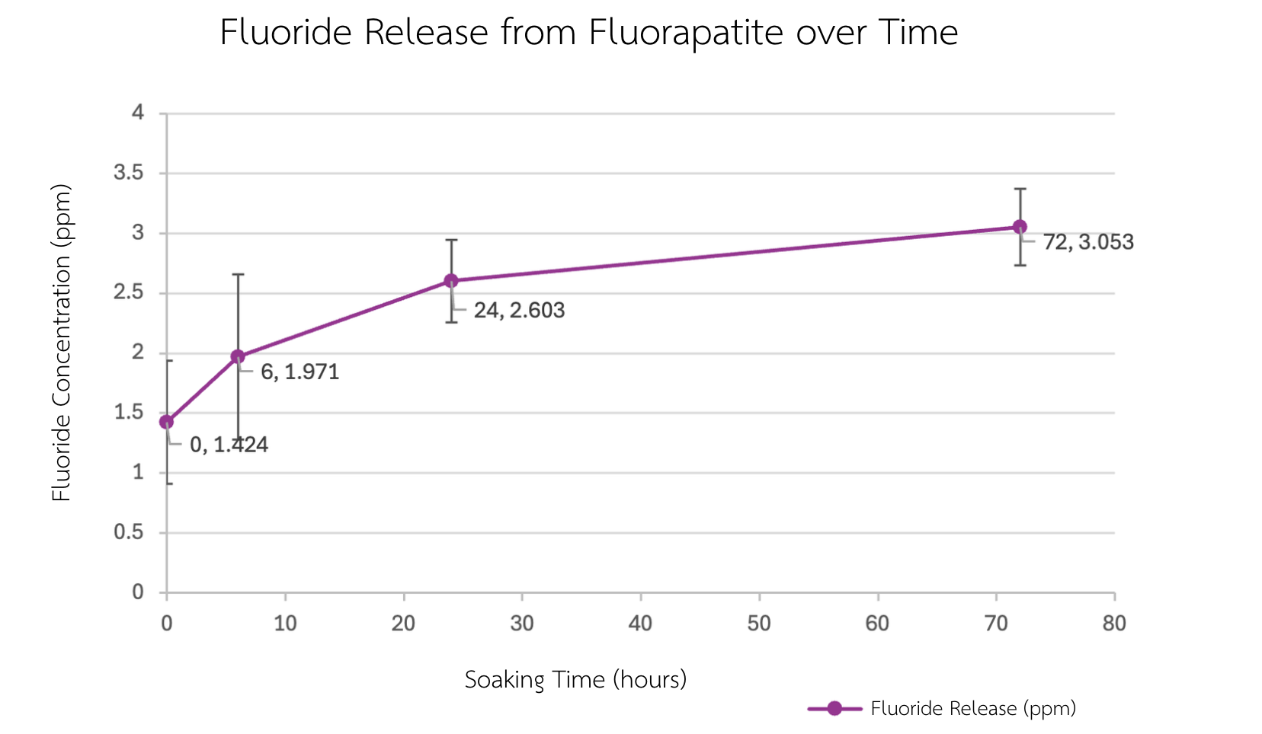
The fluoride release test demonstrated a time-dependent increase in fluoride concentration. An initial rapid release was observed during the early immersion period, followed by a gradual increase over time. At 24 and 72 h, the cumulative fluoride concentrations reached 2.603 and 3.053 ppm, respectively, both exceeding the limit of quantification (LOQ, 2.34 ppm). These results indicate a sustained fluoride release behavior, suggesting that the synthesized fluorapatite is capable of continuously storing and releasing fluoride ions over time. Such sustained fluoride release may contribute to the prevention of recurrent caries by promoting remineralization and inhibiting demineralization at the tooth–restoration interface.

Evaluation of Particle Dispersion by Laser Scattering
Table 2. Comparison of laser beam characteristics observed through resin composites (Formulations B1–B5).
Resin formulation | Laser beam characteristics
B1 | Highest clarity and continuity
B2 | Slight light scattering while maintaining beam continuity
B3 | Moderate light scattering with overall uniform dispersion
B4 | Pronounced light scattering with non-uniform dispersion
B5 | Severe light scattering with the most non-uniform dispersion
As shown in Table 2, increasing the fluorapatite content resulted in progressively greater light scattering. This behavior is attributed to particle agglomeration within the resin matrix, which reduced the uniformity of particle dispersion and increased light scattering.
Compressive Strength
The compressive strength results of formulations B1–B5 showed that formulation B2 exhibited the highest compressive strength (52 MPa), followed by B4 (49 MPa) and B3 (48 MPa). In contrast, formulations B1 and B5 exhibited compressive strengths of 44 and 42 MPa, respectively. These findings indicate that an appropriate fluorapatite content effectively reinforced the resin composite, whereas excessive filler loading promoted particle agglomeration, resulting in stress concentration and deterioration of the overall mechanical properties.

Evaluation of Particle Dispersion by Laser Scattering
Table 3. Comparison of laser beam characteristics observed through resin composites (Formulations C1–C5).
 | Laser beam characteristics
  Resin formulation
C1 | Highest clarity and continuity
C2 | Clear beam with minimal light scattering
C3 | Initial light scattering observed
C4 | Pronounced light scattering
C5 | Severe light scattering with the most non-uniform dispersion
As shown in Table 3, increasing the nanocellulose fiber content resulted in greater light scattering than that observed in the previous resin formulations. This phenomenon is attributed to the increased tendency of nanocellulose fibers to agglomerate at higher concentrations, leading to reduced dispersion uniformity within the resin matrix.

Compressive Strength
The compressive strength of formulation C1 was 44 MPa, while the incorporation of nanocellulose fibers in C2 significantly increased the value to 61 MPa (p < 0.05), the highest among all formulations. This result is consistent with the laser scattering observations, where C2 exhibited a clear laser beam with minimal scattering, indicating homogeneous particle dispersion. The improved dispersion enhanced stress transfer between the resin matrix and reinforcing fillers, resulting in superior mechanical performance.

Conclusions
In summary, the X-ray diffraction (XRD) analysis confirmed that the powder extracted from Nile tilapia fish scales was hydroxyapatite (HAp) with a hexagonal crystal structure comparable to that of the hydroxyapatite naturally found in human teeth and bone. The synthesized fluorapatite (FAp) also exhibited a crystal structure consistent with that of standard fluorapatite. Owing to its greater chemical stability and stronger crystal bonding, the incorporation of 5 wt% FAp provided mechanical strength comparable to that achieved with 15 wt% HAp in the resin composite. Furthermore, the addition of nanocellulose fibers enhanced stress transfer and interfacial adhesion between the reinforcing fillers and the resin matrix. The optimum nanocellulose content (0.25 wt%) yielded the highest compressive yield strength of 61 MPa, whereas excessive nanocellulose loading led to particle agglomeration and a reduction in mechanical properties. In addition, the developed composite exhibited sustained fluoride release, with a cumulative concentration of 3.053 ppm, demonstrating its potential as a restorative dental material with enhanced mechanical performance and the ability to reduce the risk of recurrent caries after restoration.

Acknowledgments
The authors sincerely thank Ms. Nattapatsorn Laonet and Asst. Prof. Dr. Piyanan Boonyapyak, the project advisors, for their valuable guidance and continuous support throughout this research. The author salso acknowledge the laboratory staff of the school and the Science Laboratory Center, Naresuan University, for providing research facilities and technical assistance. Finally, the authors are grateful to their parents and guardians for their encouragement and support throughout this study.

References
Nateetip Krishnamra. (2017).
Characterization and development of calcium- and collagen-rich biomedical products and related nancomposites from fish scales. TSRI Outstanding Research Project Report in Physiology. (Project Code DPG5780004). Thailand Science Research and Innovation (TSRI).

Pimpagee Pancharat. (2023).
of modifying hydroxyapatite powder with fluoride and transition metals on optical properties. Chulalongkorn University Theses and Dissertations (Chula E TD) . 11722. https://digital.car.chula.ac.th/chulaetd/11722

