GrilleFlowPiezoGen: Design and Development of a Prototype Vehicle Grille for Piezoelectric Power Generation from Airflow

Cailina Siengkasem Balmaceda ¹ and Rarintarn Arjtunyakorn^{1*}
Kanokporn Wilaisin¹
¹Princess Chulabhorn Science High School Phetchaburi No. 428, Village No. 7, Khao-Yai, Cha-am, Phetchaburi, 76120 Thailand
*e-mail: 64rarintarn.arj@pccphet.ac.th

Abstract

Renewable energy plays a crucial role in mitigating environmental pollution and addressing potential energy crises. One promising approach is harvesting ambient kinetic energy and converting it into electrical energy using piezoelectric materials. This project utilizes the airflow-induced vibration generated during vehicle motion as an alternative energy source. The primary objective was to design, fabricate, and evaluate a prototype vehicle grille integrated with piezoelectric elements to harvest electrical energy from incoming airflow.
Initially, aerodynamic simulations were conducted using SolidWorks to determine the optimal grille geometry for piezoelectric installation. The simulation results revealed that a rounded-edge grille design with a maximized cross-sectional area achieved the highest Reynolds number (34,291.20), indicating a robust turbulent flow ideal for energy harvesting. Based on these insights, a full-scale grille prototype was fabricated using 3D printing. Piezoelectric elements were integrated with an electrical circuit, and impact plates were installed to mechanically transfer the airflow-induced vibrations. Preliminary testing demonstrated that the prototype successfully generated an electrical output of approximately 0.2 mV per impact. These findings validate the feasibility of capturing lost kinetic energy from moving vehicles and provide a foundation for developing energy-harvesting automotive components.

Keywords: renewable energy, vehicle grille, piezoelectricity, 3D printing

Introduction
Energy is an essential resource for modern society, and its demand is expected to continue increasing in the future. Although fossil fuels, such as petroleum and coal, remain the primary energy sources, their extensive consumption has led to serious environmental problems, including global warming, air pollution, and ecosystem degradation. Consequently, renewable energy technologies have become increasingly important as sustainable and environmentally friendly alternatives. Besides conventional renewable energy sources such as solar, wind, hydro, and biomass, piezoelectric technology has attracted considerable attention due to its ability to convert mechanical energy into electrical energy.
During vehicle operation, a continuous airflow passes through the front grille. While the grille primarily facilitates airflow for cooling and ventilation, the kinetic energy contained in this airflow is generally not utilized. Harvesting this otherwise wasted energy could improve overall energy efficiency without requiring an additional external energy source.
Although piezoelectric energy harvesting has been widely investigated in applications such as pavements, wearable devices, and structural vibration monitoring, its integration into a vehicle front grille to utilize airflow-induced vibration has received limited attention. This presents an opportunity to develop an energy harvesting system that can be integrated into an existing vehicle component while maintaining its original function.

To address this challenge, this study proposes GrilleFlow PiezoGen, a prototype vehicle grille integrated with piezoelectric elements and flexible airflow receivers. Airflow passing through the grille causes the flexible receivers to vibrate and transfer mechanical force to the piezoelectric elements, generating electrical energy. The grille was first designed and analyzed using SolidWorks Flow Simulation to investigate airflow behavior and identify suitable locations for piezoelectric installation. The optimized design was then fabricated using 3D printing technology and experimentally evaluated. This study aims to demonstrate the feasibility of integrating piezoelectric energy harvesting into a conventional vehicle grille, providing a potential supplementary power source for low-power automotive electronics in both conventional and electric vehicles.

Methodology
1) Vehicle Grille Prototype Design
Six hexagonal vehicle grille models were designed using SolidWorks based on the dimensions and structural characteristics of an actual vehicle grille. The models consisted of sharp-edged and rounded-edged geometries with small, medium, and large cross-sectional areas to investigate the influence of grille geometry on airflow behavior.
2) Airflow Simulation
Airflow simulations were performed using SolidWorks Flow Simulation at airflow velocities of 30, 60, and 90 km/h. Air velocity, pressure distribution, flow direction, vortex formation, and Reynolds number were analyzed to determine the most suitable grille geometry for piezoelectric installation.
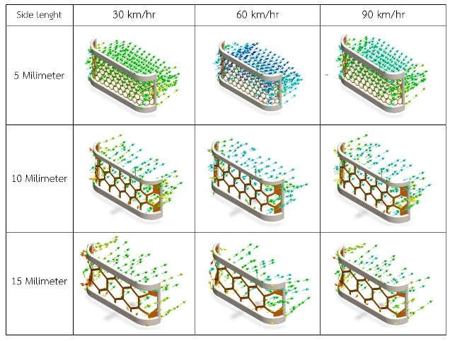
Table 1 Sharp-edge flow simulation.
Table 2 Rounded-edge flow simulation.
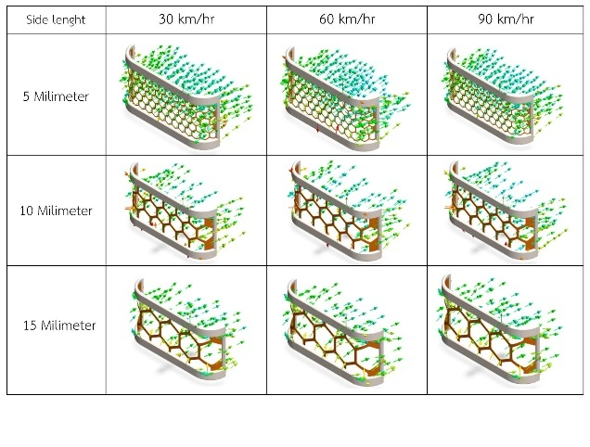
3) Scaled Prototype Fabrication by 3D Printing
The optimal grille design obtained from the simulation was fabricated as a scaled prototype using a 3D printer. The prototype was designed with designated positions for piezoelectric elements and an impact mechanism to prepare for airflow-induced electrical energy generation experiments.

4) Installation of the Energy Harvesting System
Piezoelectric elements were installed at the center of the grille openings and connected to an energy harvesting and storage circuit. An impact plate was mounted with one end fixed to the front side of the grille while the opposite end remained free to vibrate. This mechanism transferred airflow-induced vibrations into repeated mechanical impacts on the piezoelectric elements, enabling electrical energy generation.
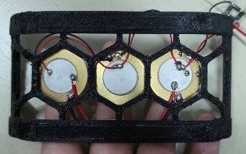

Fig.1 Piezoelectric-Circuit Grille Prototype
5) Electrical Energy Generation Test
A blower was used to generate airflow at different velocities through the grille prototype to replicate the airflow experienced by a moving vehicle. The electrical voltage generated by the piezoelectric elements was measured and recorded for performance evaluation.
6) Data Analysis
The simulation and experimental results were analyzed and compared to evaluate the relationship between grille geometry, airflow characteristics, and electrical energy generation performance. The findings were then used to identify the most effective grille design for piezoelectric energy harvesting.

Result and Discussion
1) Development of a Piezoelectric-Integrated Vehicle Grille for Airflow Energy Harvesting
1.1 Reynolds Number Analysis of the Sharp-Edged Vehicle Grille :
The airflow characteristics of the vehicle grille were analyzed using SolidWorks Flow Simulation. The Reynolds numbers of the sharp-edged and rounded-edged grille designs were calculated at airflow velocities of 30, 60, and 90 km/h to evaluate their airflow characteristics.

Table 3 presents the calculated Reynolds numbers of both grille designs at an airflow velocity of 30 km/h.
Side Length | Grille Design
Side Length | Sharp-edged | Fillet-edged
5 mm | 465.63 | 644.61
10 mm | 4139.28 | 1812.46
15 mm | 8838.27 | 11031.09

At an airflow velocity of 60 km/h, the calculated Reynolds number increased with the side length of the hexagonal grille opening. The sharp-edged grille with a side length of 15 mm exhibited the highest Reynolds number, as shown in Table 4. At an airflow velocity of 60 km/h, the calculated Reynolds number increased with the side length of the hexagonal grille opening. The sharp-edged grille with a side length of 15 mm exhibited the highest Reynolds number, as shown in Table 4.

Table 4 presents the calculated Reynolds numbers of both grille designs at an airflow velocity of 60 km/h.
Side Length | Grille Design
Side Length | Sharp-edged | Fillet-edged
5 mm | 2030.39 | 1395.55
10 mm | 14769.03 | 14862.43
15 mm | 24244.84 | 21731.23

At an airflow velocity of 90 km/h, the rounded-edged grille with a side length of 15 mm exhibited the highest Reynolds number. It also produced the highest Reynolds number among all airflow velocities investigated, as shown in Table 5.

Table 5 presents the calculated Reynolds numbers of both grille designs at an airflow velocity of 60 km/h
Side Length | Grille Design
Side Length | Sharp-edged | Fillet-edged
5 mm | 2825.62 | 2026.87
10 mm | 10395.58 | 6341.57
15 mm | 24569.71 | 34291.20

Airflow Performance Analysis for Piezoelectric Energy Harvesting in Vehicle Grilles
The airflow simulation conducted in SolidWorks Flow Simulation showed that the Reynolds number generally increased with increasing airflow velocity and grille side length. The highest Reynolds number, 34,291.20, was obtained from the rounded-edged grille with a 15 mm side length at an airflow velocity of 90 km/h, indicating turbulent flow, as the Reynolds number exceeded 4,000. In comparison, Reynolds numbers between 2,000 and 4,000 represent transitional flow, while values below 2,000 indicate laminar flow.
Although the sharp-edged grille with a 15 mm side length also produced a relatively high Reynolds number (24,569.71) at 90 km/h, sharp edges tend to create flow separation and dead zones, resulting in less stable airflow. In contrast, the rounded-edged grille promoted smoother and more uniform airflow while maintaining a high level of turbulence. This airflow characteristic is expected to produce more consistent vibration of the airflow receiver, thereby improving the potential performance of the piezoelectric energy harvesting system.
1.2 Experimental Evaluation of the Piezoelectric-Integrated Vehicle Grille
The optimized hexagonal grille with filleted edges, identified through the airflow simulation, was fabricated using 3D printing technology. Piezoelectric elements were installed behind the grille together with a flexible airflow receiver to convert airflow-induced vibrations into electrical energy. The prototype was then tested to evaluate its electrical output.
The experimental results demonstrated that the prototype was capable of generating electrical energy, producing a maximum output voltage of approximately 0.2 mV. Although the generated voltage was relatively low, the findings demonstrate the feasibility of integrating a piezoelectric energy harvesting system into a conventional vehicle grille. Further optimization of the airflow receiver, piezoelectric configuration, and electrical circuit could improve the electrical output in future studies

Conclusion
This study proposed GrilleFlow PiezoGen, a piezoelectric-integrated vehicle grille designed to harvest electrical energy from airflow generated during vehicle movement. Airflow simulations using SolidWorks Flow Simulation showed that the filleted-edge hexagonal grille provided more favorable airflow characteristics than the sharp-edged design, with the highest Reynolds number obtained at an airflow velocity of 90 km/h, indicating strong turbulent flow suitable for inducing vibration.
Based on the simulation results, a prototype was fabricated using 3D printing technology and experimentally evaluated. The prototype successfully generated electrical energy, producing a maximum output voltage of approximately 0.2 mV, demonstrating the feasibility of integrating piezoelectric energy harvesting into a conventional vehicle grille.
Although the electrical output remains limited, this study confirms the potential of utilizing airflow around a moving vehicle as a supplementary renewable energy source. Future work will focus on optimizing the airflow receiver, piezoelectric arrangement, and energy harvesting circuit to improve power generation efficiency and support low-power automotive electronics in both conventional and electric vehicles.

Acknowledgments
Special thanks to Teacher Kanokporn Wilaisin for valuable advice, guidance, and support throughout this study. We also thank Princess Chulabhorn Science High School Phetchaburi, for providing facilities and support in carrying out this study.

References

Kim C, Park CM, Yoon JY, Park SY. (20 November 2020).
Piezoelectric Polymer Energy Harvesting System Fluctuating in High-Speed Wind Flow Around a Running Electric Vehicle.
https://research.knu.ac.kr/en/publications/piezoelectric-polymer-energy-harvesting-system-fluctuating-in-a-h/
Koo BG, Shin DJ, Lim DH, Kim MS, Kim IS,Jeong SJ. (13 August 2021).
Properties of Car-Embedded Vibrating Type Piezoelectric Harvesting System.
https://www.mdpi.com/2076-3417/11/16/7449
An X, Song B, Tian W, Ma C. (24 August 2018).
Design and CFD Simulations of a Vortex-Induced Piezoelectric Energy Converter (VIPEC) for Underwater Environment.
https://www.mdpi.com/1996-1073/11/9/2329
Vo TVK, Lubecki TM, Chow WT, Gupta A, Li KHH. (22 July 2021).
Large-Scale Piezoelectric-Based Systems for More Electric Aircraft Applications.
https://www.mdpi.com/2072-666X/12/8/832

