Assistive Device for Walking Support and Physical Therapy in Foot Drop Patients

Ubaidillah Waaryita Bulkis Satirak
Sirachuch Juntongpoon
¹Princess Chulabhorn Science High School Satun, Chalung, Mueang Satun, Satun 91140, Thailand
*e-mail: Sirachuch.j@pccst.ac.th

Abstract
This project aims to apply the principles of mechanics to the design and development of the proposed assistive device for walking support and physical therapy for patients with foot drop. The device employs a linear actuator to transmit force and generate torque about the ankle joint, enabling dorsiflexion and plantarflexion movements that closely resemble natural ankle motion. The system is controlled through a web application. The device was designed with consideration of force transmission and actuator positioning to achieve appropriate torque generation and improve the stability of ankle movement. Its performance was evaluated through load-bearing tests, ankle range of motion (ROM) measurements, and gait motion analysis using the Tracker software. The experimental results showed that the device could support loads of up to 4 kg, with optimal performance in the range of 0.5–3.5 kg. The device achieved an ankle range of motion of approximately 20°, and gait analysis demonstrated that ankle movement while wearing the device was closer to natural walking than without the device. These findings indicate that the application of mechanical principles can effectively contribute to the design of assistive devices for walking support and rehabilitation. The developed device has the potential for use in hospitals, rehabilitation centers, and home-based rehabilitation to promote functional recovery, reduce the risk of tripping, and improve the quality of life of patients with foot drop.
keywords: Foot Drop, Mechanics, Torque, Linear Actuator

Introduction
Foot drop is a condition characterized by the inability to dorsiflex the foot due to weakness or paralysis of the muscles responsible for lifting the foot. It is commonly observed in patients with stroke, spinal cord injuries, and peripheral nerve disorders. As a result, patients are unable to lift the forefoot adequately during the swing phase of gait, causing the toes to drag on the ground and increasing the risk of tripping and falling. This condition significantly limits mobility and reduces the quality of life of affected individuals.
From the perspective of physics, ankle movement during walking is governed by the principles of mechanics. Dorsiflexion and plantarflexion occur when a force generated by the muscles is transmitted through the tendons, producing torque about the ankle joint and causing rotational motion of the foot. When the generated torque is insufficient, normal ankle motion cannot be achieved, resulting in abnormal gait patterns. Therefore, the restoration of ankle movement can be understood and addressed through the application of mechanical principles, particularly force transmission, torque generation, and rotational motion.
Conventional assistive devices, such as ankle-foot orthoses (AFOs) or foot slings, primarily provide passive support to maintain the ankle in a functional position during walking. However, most of these devices do not actively assist ankle movement for rehabilitation. In contrast, robotic rehabilitation systems capable of generating ankle motion are often expensive, bulky, and limited to use in hospitals or rehabilitation centers, making continuous rehabilitation at home difficult for many patients.
To address these limitations, this project applies the principles of mechanics to the design and development of an assistive device for walking support and physical therapy for patients with foot drop. The device utilizes a linear actuator to transmit force and generate torque about the ankle joint, enabling dorsiflexion and plantarflexion movements that closely resemble natural ankle motion. The actuator position was designed by considering force transmission and torque generation to improve ankle movement while minimizing undesirable lateral torque. The performance of the device was evaluated through load-bearing tests, ankle range of motion measurements, and gait motion analysis using the Tracker software. This study demonstrates how fundamental principles of mechanics, including force, force transmission, torque, and rotational motion, can be integrated into the design of a medical rehabilitation device. The proposed device has the potential to support rehabilitation in hospitals, rehabilitation centers, and home environments, thereby promoting functional recovery and improving the quality of life of patients with foot drop.

Methodology
2.1 Design Procedure
2.1.1 Device Design
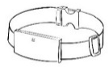
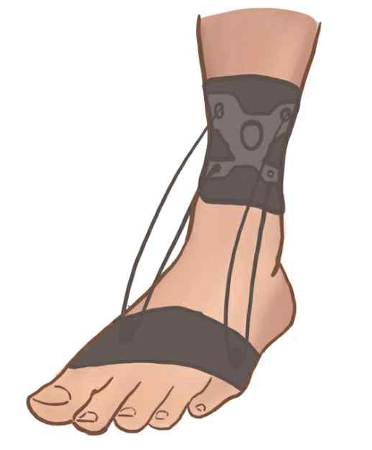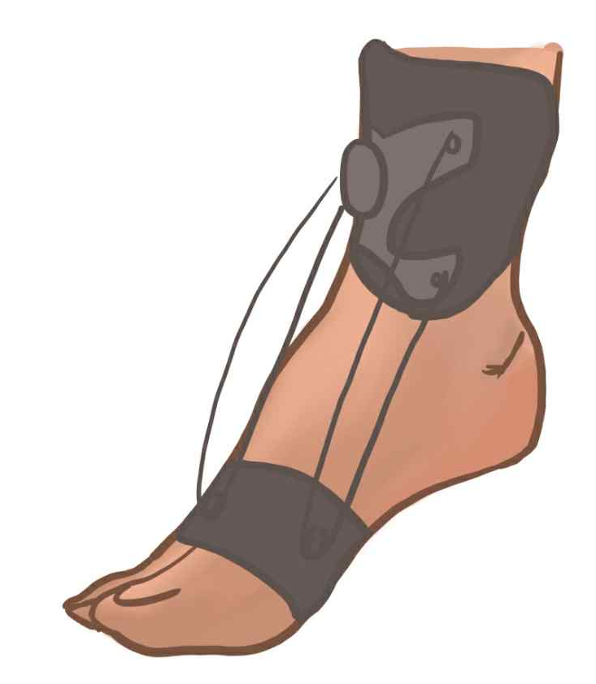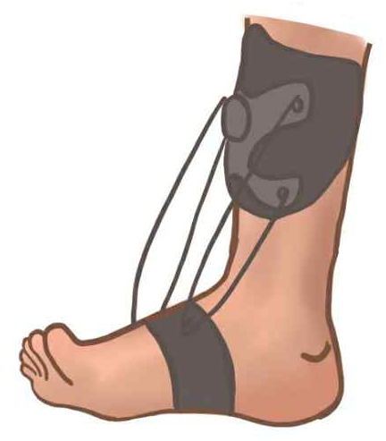
Figure 1. Conceptual Design of the Developed Device
2.1.2 Circuit Design
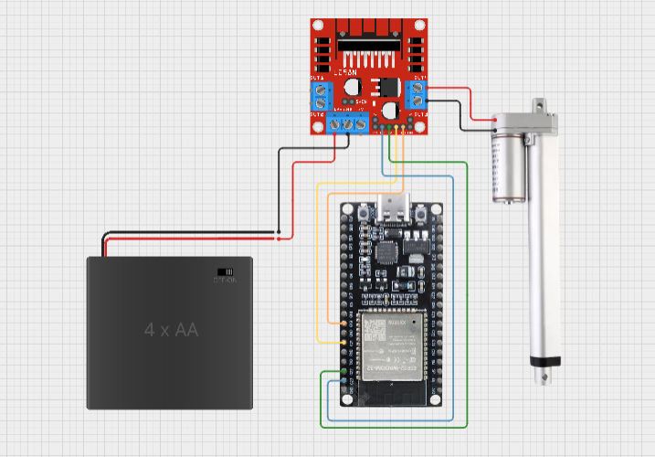
Figure 2. Circuit Diagram Designed Using Cirkit Designer
2.2 Device Development
2.2.1 Software Development
1. Configure the ESP32 GPIO pins for controlling the L298N Motor Driver by assigning IN1 = D23, IN2 = D22, IN3 = D21, and IN4 = D19. The ENA and ENB pins of the L298N were jumpered to enable the motor to operate at full power.
2. Configure the Bluetooth Low Energy (BLE) system in the setup() function by creating one BLE Service and two BLE Characteristics: a Command (CMD) characteristic for receiving the commands EXTEND, RETRACT, and STOP, and a Position (POS) characteristic for transmitting the actuator position to the web application.
3. Develop the control functions for the linear actuator, including extendActuator(), retractActuator(), and stopMotor(), by assigning HIGH and LOW logic levels to the IN1–IN4 pins to control the actuator movement direction.
4. Implement the loop() function to estimate the actuator position (0–100%) based on the operating time and transmit the position data to the application via BLE Notify every 100 ms.
5. Verify and compile the program using Arduino IDE version 2.3.2, then upload the firmware to the ESP32 board via a USB connection. Finally, test the BLE communication and the operation of the linear actuator together with the electronic circuit.
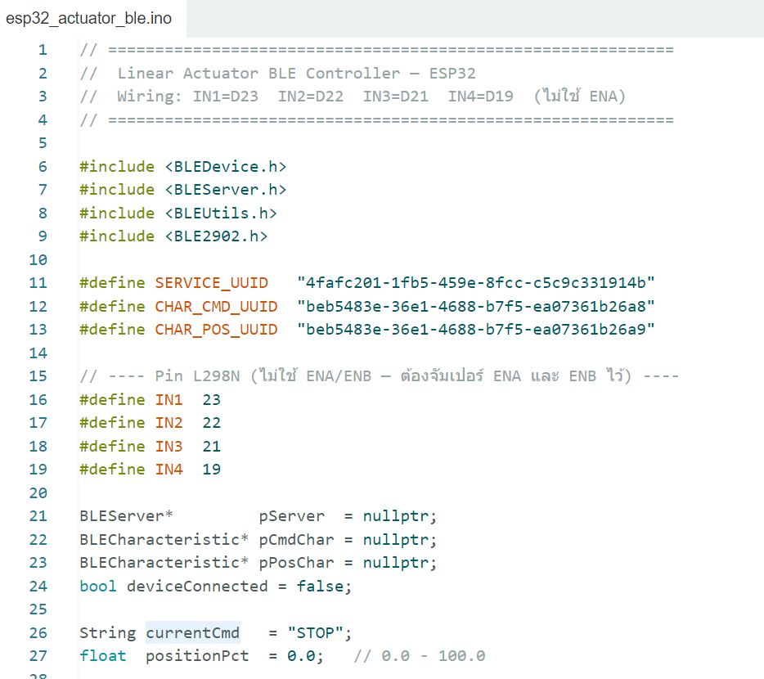
Figure 3. Example of the Programming Code.
2.2.2 Circuit Assembly
1. Design the electronic circuit using Cirkit Designer and prepare the required components, including one linear actuator, one ESP32 development board, one L298N motor driver module, four AA batteries, and jumper wires.
2. Connect the wires from the linear actuator to the output terminals of the L298N motor driver.
3. Connect the IN1–IN4 input pins of the L298N motor driver to the D23, D22, D21, and D19 GPIO pins of the ESP32 board, respectively.
4. Connect the VCC and GND terminals from the 4 × AA battery pack to the 12V and GND terminals of the L298N motor driver, respectively. Connect the GND terminal of the motor driver to the GND pin of the ESP32 to establish a common ground.
5. Connect the 5V output of the L298N motor driver to the 5V input pin of the ESP32 to supply power to the board.
2.2.3 Device Assembly
1. Prepare the main structure of the device, including the soft ankle brace and the assembled electronic circuit.
2. Place the electronic circuit inside a waterproof enclosure, then securely attach the enclosure to the soft ankle brace.
3. Install the linear actuator onto the device and securely fasten all components to complete the assembly.
2.3 Testing Procedure
2.3.1 Load-Bearing Capacity Test
1. Secure the device by suspending it vertically from the upper fastening strap to simulate the actual wearing condition.
2. Place sandbags on the foot support section of the device to simulate the weight of a user's foot.
3. Increase the applied load incrementally (0.5 kg, 1.0 kg, 1.5 kg, ...) until the maximum load is reached.
4. Observe and record the load at which the device begins to deform or malfunction. The performance was evaluated based on the actuator operating time for one complete cycle and any abnormal operating behavior.
2.3.2 Ankle Range of Motion (ROM) Test
1. Have the participant wear the device properly and sit in a position where the lateral side of the ankle is clearly visible.

mass | Time per Cycle (s) |  |  |  |  |  | Notes
(kg) | 1 | 2 | 3 | 4 | 5 | Average | Notes
0.5 | 20.21 | 20.17 | 20.06 | 20.08 | 20.17 | 20.14
1 | 20.24 | 20.28 | 20.16 | 20.06 | 20.03 | 20.15
1.5 | 20.28 | 20.12 | 20.14 | 20.05 | 20.03 | 20.12
2 | 20.17 | 20 | 20.04 | 20.04 | 20.23 | 20.1
2.5 | 20.13 | 20.37 | 20.37 | 20.25 | 20.18 | 20.26
3 | 21.02 | 20.94 | 20.87 | 21.09 | 20.95 | 20.97
3.5 | 20.95 | 20.93 | 20.73 | 20.86 | 21.03 | 20.95
4 | 21.18 | 21.05 | 20.92 | 21.24 | 21.16 | 21.11 | Abnormal motor noise.
2. Operate the linear actuator to raise the forefoot to its maximum dorsiflexion position and lower it to its maximum plantarflexion position. Capture images at both positions.
3. Import the images into the Tracker software to measure the ankle joint angle.
4. Calculate the difference between the maximum dorsiflexion and plantarflexion angles to determine the total ankle range of motion (ROM). Compare the measured ROM with the recommended range required for physical rehabilitation.
2.3.3 Gait Performance Test
1. Have the participant walk along a predetermined distance under two conditions: without the device and while wearing the device. Record videos from the lateral view to ensure that the ankle joint is clearly visible throughout the walking trial.
2. Import both video recordings into the Tracker software and track the positions of the forefoot and ankle joint during each gait cycle.
3. Compare the toe clearance, forefoot elevation, and overall gait kinematics between the walking trials performed with and without the device.
4. Analyze whether wearing the device improves gait performance by producing a walking pattern that more closely resembles normal gait.

Results and Discussion
3.1 Results of the Load-Bearing Capacity Test

Table 1. Load-Bearing Capacity of the Developed Device
As shown in Table 1, the developed device was able to support loads ranging from 0.5 to 4.0 kg, with an average operating time of approximately 20.10–21.11 s, indicating consistent performance throughout the test. However, when the applied load reached 4.0 kg, the linear actuator produced abnormal operating noise, suggesting that the actuator was operating near its maximum load capacity. Therefore, based on the experimental results, the optimal operating load range of the device was determined to be 0.5–3.5 kg.
3.2 Results of the Ankle Range of Motion (ROM) Test
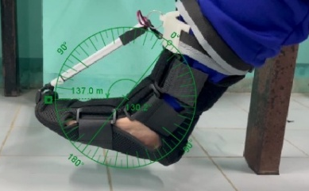
Figure 4. Ankle Angle in the Maximum Dorsiflexion Position

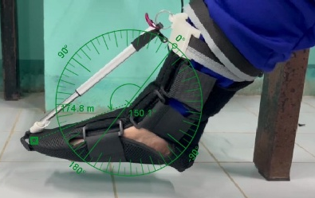
Figure 5. Ankle Angle in the Maximum Plantarflexion Position
The experimental results showed that the device achieved an ankle angle of approximately 130.2° in the maximum dorsiflexion position and 150.1° in the maximum plantarflexion position. Therefore, the total ankle range of motion (ROM) was approximately 19.9° (approximately 20°). These results demonstrate that the developed device is capable of producing sufficient dorsiflexion of the foot, enabling users to perform ankle rehabilitation exercises with a range of motion that more closely resembles natural ankle movement.
3.3 Results of the Gait Performance Test
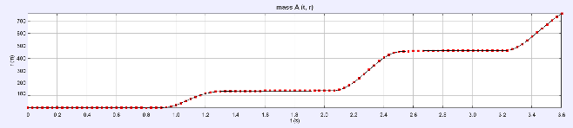
Figure 6. Motion Trajectory of the Forefoot While Wearing the Device
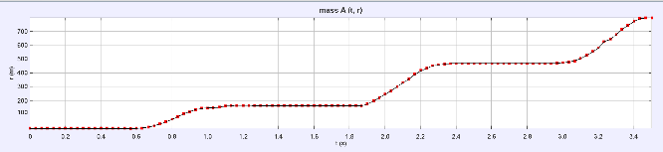
Figure 7. Motion Trajectory of the Forefoot Without the Device
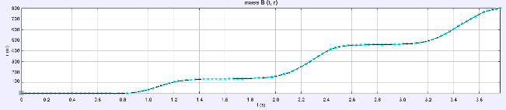
Figure 8. Motion Trajectory of the Lower Leg While Wearing the Device

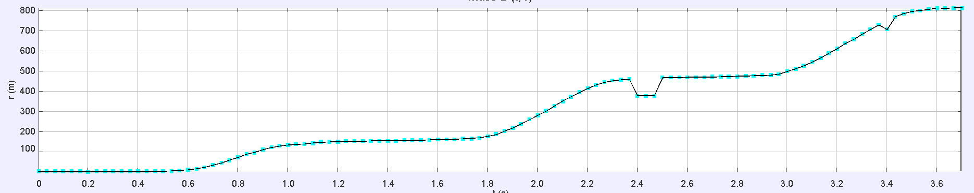
Figure 9. Motion Trajectory of the Lower Leg Without the Device
The gait analysis results showed that the motion trajectories of both the forefoot and the lower leg while wearing the device were comparable to those observed without the device. This indicates that the developed device did not interfere with the natural movement of the ankle joint while providing adequate support and guidance during walking. As a result, the participant was able to maintain a stable and natural gait pattern while using the device.
Only minor differences were observed between the two walking conditions, suggesting that the device was designed to accommodate the user's natural biomechanics without excessively restricting ankle motion. These findings indicate that the device has the potential to support safe gait rehabilitation by maintaining natural joint movement while reducing the risk of abnormal gait patterns and movement-related injuries.

Conclusions
This project, entitled "Assistive Device for Walking Support and Physical Therapy in Foot Drop Patients" aimed to develop a device that combines walking assistance and physical rehabilitation in a single system. The device uses a linear actuator to control ankle dorsiflexion and plantarflexion through a web-based application.
The results showed that the device effectively supported foot loads of up to 3.5 kg and provided approximately 20° of ankle range of motion, helping improve foot lifting and maintain a gait pattern closer to natural walking. The lightweight and portable prototype is suitable for use in hospitals, rehabilitation centers, and home environments.
Although the device shows promising performance, its load capacity is limited by the linear actuator, and long-term clinical evaluation has not yet been conducted. Overall, the prototype demonstrates strong potential for further development as an assistive and rehabilitation device for patients with foot drop.

Acknowledgments
The authors would like to express their sincere gratitude to Mr. Sirachuch Juntongpoon, the project advisor, for his invaluable guidance and support throughout this project. The authors also thank Ms. Anutida Sangabankhok, a physical therapist, for her professional advice and valuable recommendations on the rehabilitation of patients with foot drop. Finally, the authors sincerely appreciate everyone who contributed to the successful completion of this study.

References
Kitsiricharoenchai, T. (2019). Passive Walking
Assistive Device for Patients with Foot Drop (Master's thesis, Department of Mechanical Engineering, Chulalongkorn University). Retrieved from https://digital .car.chula.ac.th/cgi/viewcontent.cgi?article=10575&context=chulaetd
First Physio Co., Ltd. (2017). Various Types of Foot
Drop Orthoses. Retrieved July 12, 2025, from https://www.firstphysioclinics.com /article /257/
Office of Vocational Education Research and
Development. (2021). Physical Therapy Device for Foot Drop Rehabilitation. Retrieved July 18, 2025, from https://www.thailandinnovationportal.com/info/innovation/item/34087
Rungsaiwattana, S. (2018). Foot Drop and Its
Impact on Daily Living. Retrieved July 12, 2025, from https://www.rama.mahidol.ac .th/ramachannel/article/2002
Mayo Clinic Staff. (2025). Foot drop. Retrieved July
18, 2025, from https://www.mayoclinic. org/diseases-conditions/foot-drop/ diagnosis-treatment/drc-20372633
National Institutes of Health (NIH). (2024). Foot
Drop Syndrome. Retrieved July 18, 2025, from https://www.ninds.nih.gov/health-information/disorders/foot-drop-syndrome
ReBRAIN Specialized Physical Therapy Team.
(2021). Foot Drop in Stroke Patients. Retrieved July 13, 2025, from https:// www.rebrain-physio.com
ReBRAIN Specialized Physical Therapy Team.
(2022). What Is a Foot Sling? How Is It Used, What Is It For, and Is It Necessary or Beneficial for Stroke Patients? Retrieved July 18, 2025, from https:// www.rebrain-physio.com/foot-sling/

