The Application of Geometry in Finding the Appropriate Area and Angle of Sunshade Model for Enhancing the Usage of Natural Light and Reducing the Temperature Inside the Building in Architecture Fields

Pimnada Kwanakarapat¹ and Kodchaphorn Kupratumsiri¹
Khunthong Klaythong¹* and Ratchanikorn Chonchaiya²

¹Princess Chulabhorn Science High School Pathum Thani,
51 Village No.6 Bo Ngoen, Lat Lum Kaeo, Pathum Thani 12140, Thailand
²Department of Mathematics, Faculty of Science, King Mongkut’s University of Technology Thonburi,
Bangmod Subdistrict, Thung Khru District, Bangkok 10140, Thailand
*E-mail: khunthong.kla@gmail.com

Abstract
Sunshade is one of the most popular solutions for controlling a building’s interior light intensity and temperature, as natural sunlight is an important energy resource for Earth’s living beings. However, excessive sunlight may negatively affect human health. This project aimed to research and calculate the appropriate angle and size of sunshades by applying geometry alongside modern technology to calculate the solar incidence angle on different days of the year and design sunshades suitable for Thailand’s geographical conditions. The results showed that the sunshade with a size of 10.8 × 10.8 cm² and an angle of 0° was the most efficient in controlling light intensity and temperature, with reduction rates of 31.87% and 14.45%, respectively. For the regression equation study, polynomial regression was the most effective in predicting light intensity and temperature control rates, with R² values of 0.6831 and 0.8299, respectively. The same sunshade also demonstrated high efficiency under actual sunlight, achieving a light intensity reduction rate of 35.9 ± 1.79% and a temperature reduction rate of 7.06 ± 0.35%. These findings indicate that the selected sunshade sizes and angles enabled accurate regression predictions of light intensity and temperature control rates. The proposed design can serve as a prototype for architectural applications, helping reduce energy consumption and improve the quality of life for building occupants.

Keywords: Sunshade, Applied Geometry, Architecture, Usage of Natural Light, Temperature Reduction

Introduction
Sunlight is a vital energy source, but excessive exposure in hot, humid climates like Thailand spikes indoor temperatures, UV risks, and air conditioning demands (Aranya Jutwiboonsuk, 2015; Kumjan Chanchit & Atirat Maksuwan, 2024). Globally, buildings generate 36% of energy consumption and 39% of greenhouse gas emissions, underscoring the urgent need for efficient architecture (United Nations, 2022).
Sun-shading devices mitigate solar heat gain while preserving daylight, but their efficacy relies heavily on optimized dimensions and tilt angles; flawed designs either fail to block heat or block useful daylight (Lv et al., 2024). While automated adaptive shading systems resolve this, their high implementation costs limit widespread use (Srisak Phattanawasin & Prittiporn Lopkerd, 2016).
Solar geometry offers a scientific foundation to map the sun's path and optimize shading (Aejaz & Yasmeen, 2023; Vincenzo De Risi, 2015), with proper designs proven to lower indoor temperatures by 3–5°C and reduce electricity loads (Szokolay, 2014; Olgyay, 2015). Consequently, this study applies geometric analysis to find the optimal shading configuration for Thailand's climate, aiming to improve daylighting, lower indoor heat, provide practical building guidelines, and support the BCG Economy model alongside SDGs 7, 11, and 13.

Methodology
1) Study of Solar Incidence Angles at Different Times and Seasons in the Climatic Context of Thailand
The solar altitude and azimuth angles were investigated, as they depend on Thailand’s latitude, solar declination angle, and time of day. These angles were calculated at three representative times (09:00, 12:00, and 15:00) on four key astronomical dates representing seasonal variations: the March Equinox, June Solstice, September Equinox, and December Solstice. The corresponding solar incidence angles were then calculated and recorded using the following formulas:
$$\sin\left(α_{s}\right)=\cos{(ϕ)\cos{(δ)\cos{(ω)}}}+\sin{(ϕ)}\sin{(δ)}$$

$$cos⁡(γ_{s})=\frac{cosθ_{z} sinϕ-sinδ}{sinθ_{z}cosϕ}$$

$cos(θ) =\cos{θ_{z}\cos{β}}+\sin{θ_{z}\sin{βcos}\left(γ_{s}-γ\right)}$
Given that α_{s} is the altitude angle of the sun
ϕ is the latitude angle
δ is the declination angle
ω is the hour angle (15° × (Time – Right Ascension))
γ_{s} is the azimuth angle of the sun
$θ_{z}$ is 90° - α_{s}
θ is the incidence angle of the sunlight
β is the declination angle of the surface
γ is the surface azimuth angle
These data served as reference values for subsequent experiments and were used to analyze the variation in solar incidence angles across different seasons and times of day.

2) Analysis of the Effectiveness of Sun-Shading Device Dimensions and Tilt Angles in Controlling Indoor Light Intensity and Temperature
2.1 Construction of the Building and Sun-Shading Device Models
Three-dimensional models of the building and sun-shading devices were created using SketchUp. The building model measured 18 × 18 × 28.8 cm³ and contained a square opening measuring 10.8 × 10.8 cm² on one side. A total of 25 sun-shading device configurations were designed by combining five panel dimensions (3.6 × 3.6, 3.6 × 7.2, 3.6 × 10.8, 7.2 × 10.8, and 10.8 × 10.8 cm²) with five tilt angles (0°, 15°, 30°, 45°, and 60°). After the digital models were completed, they were fabricated using a 3D printer for use in the subsequent experiments.

2.2 Evaluation of the Effectiveness of Sun-Shading Device Dimensions and Tilt Angles
1. The building model was placed inside a black foam-board enclosure to minimize external interference. A halogen lamp, serving as an artificial sunlight source, illuminated the model for 7.5 minutes from a distance of 1.0 m and a height of 70 cm above the horizontal plane. Once turned off, indoor illuminance and surface temperature were measured using a lux meter and an infrared thermometer, with data recorded in Microsoft Excel as baseline values. A 5–10-minute cooling period was observed between trials to restore initial conditions. Next, a 3.6×3.6 cm² sun-shading device with a 0° tilt angle was installed over the opening, and the step was repeated three times. After each cooling interval, the tilt angle was changed sequentially to 15°, 30°, 45°, and 60° using the same panel dimensions. This entire procedure was then repeated for the remaining panel sizes made in the procedure from 2.1.
2. Compare the measured illuminance and temperature values obtained with each sun-shading device with those obtained from the building model without a shading device. The percentage reduction in illuminance (% Lux Reduction) and percentage reduction in temperature (% Temperature Reduction) were then calculated using the following formulas:
$$\% Lux reduction= \frac{Lux_{0}-Lux_{1}}{Lux_{0}}×100\%$$

$$\% Temperature reduction= \frac{Temp_{0}-Tⅇ{mp}_{1}}{Temp_{0}}×100\%$$

Given that Lux₀ is the light intensity indoors
without the sunshade model
Lux₁ is the light intensity indoors with
the sunshade model
Temp₀ is the light intensity indoors
without the sunshade model
Temp₁ is the light intensity indoors with
the sunshade model
Trend graphs were generated in Microsoft Excel, and Linear, Polynomial, and Exponential Regression models were developed in Google Colab to predict temperature and illuminance reduction separately. The model with the highest coefficient of determination (R²) was selected to identify the optimal combination of panel dimensions and tilt angle based on the predicted % Temperature Reduction and % Lux Reduction.

3) Comparison and Error Analysis of the Performance of the Model and Conditions in Reality
An experimental site was scaled and aligned using similarity principles and trigonometry to replicate laboratory dimensions and solar angles. To minimize error, variables like measurement height, testing period, solar direction, and weather conditions were tracked while indoor ventilation was maintained at a 27°C baseline. Illuminance and temperature were measured before and after 7.5 minutes of direct sunlight exposure, with the room allowed to reset to initial conditions between trials.
This procedure was repeated using the highest-performing sun-shading device to measure indoor illuminance and temperature under natural sunlight. These field results were compared with laboratory predictions to calculate the percentage error. Finally, potential sources of experimental error, which include solar spectrum variations, differences between the halogen lamp and natural sunlight, weather conditions, and reflected light from the surroundings, were analyzed.

Result and Discussion
1) Results in the Analysis of the Effectiveness of Sun-Shading Device Dimensions and Tilt Angles in Controlling Indoor Light Intensity and Temperature
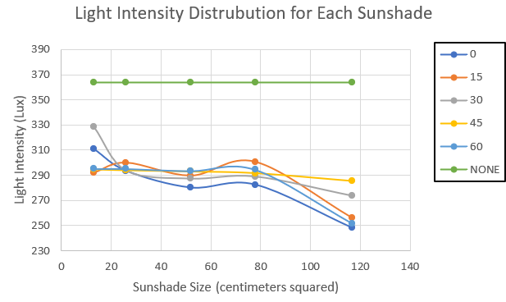
1.1 Results of the Evaluation of the Effectiveness of Sun-Shading Device Tilt Angles and Dimensions in Controlling Indoor Illuminance and Temperature in the Building Model
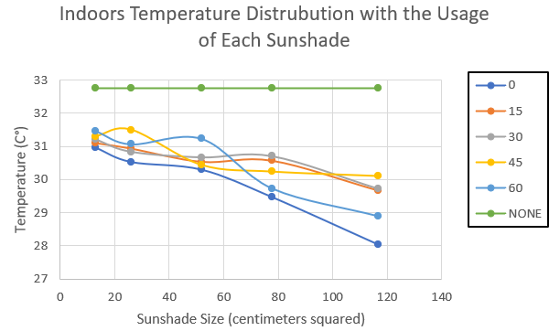
Fig 1. A graph showing the trendlines of the indoor illuminances
Fig 2. A graph showing the trendlines of the indoor temperature
Figures 1 and 2 illustrate indoor illuminance and temperature across various sun-shading dimensions x-axis and tilt angles (colored lines, with green representing the baseline without a device). Generally, both illuminance and temperature decreased as device dimensions increased. The optimal configuration was the 10.8×10.8 cm² device at a 0° tilt angle, yielding the lowest averages of 248 Lux and 28.03°C. Additionally, the greatest fluctuations occurred at a 15° tilt angle for illuminance and a 60° tilt angle for temperature.
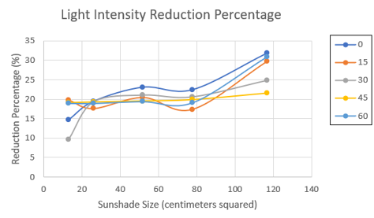
1.2 Results of the Calculation of the Percentage Reduction in Indoor Illuminance and Temperature in the Building Model
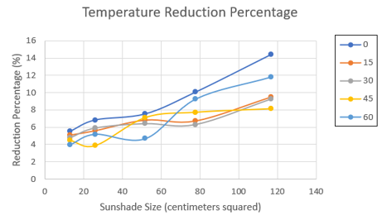
Fig 3. A graph showing the trendlines of the illuminance reduction percentage
Fig 4. A graph showing the trendlines of the indoor temperature reduction percentage
Figures 3 and 4 show that indoor illuminance and temperature reductions generally increased with larger sun-shading dimensions. The optimal 10.8 × 10.8 cm² configuration at a 0° tilt angle achieved the highest performance, reducing illuminance by 31.87% and temperature by 14.45%. Additionally, the greatest data fluctuation occurred at a 15° tilt angle for illuminance and a 60° tilt angle for temperature.
Model | Light Intensity
Model | Equation | R²
Linear  Regression | $$f\left(x,y\right)= 15.9445+0.0937x -0.0184y$$ | 0.5757
Polynomial Regression | $$f\left(x,y\right)= 17.480864+ 0.000730x^{2}+ 0.028703x- 0.000976xy - 0.124304y + 0.002692y^{2}$$ | 0.6831
Exponential Regression | $$f\left(x,y\right)={10}^{2.7730 + 0.0044x -0.0006y}$$ | 0.5912
1.3 Results of Developing Predictive Regression Models for Sun-Shading Device Performance Using Linear, Polynomial, and Exponential Regression
Table 1 shows the created regression equations predicting the indoor illuminance, along with their respective R-squared values

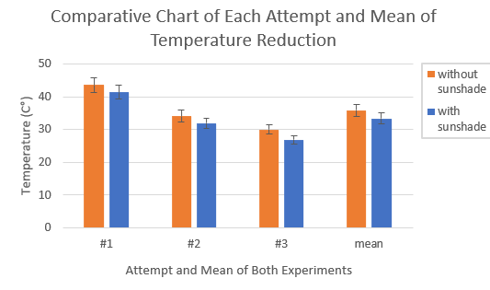
Table 2 shows the created regression equations predicting the indoor temperature, along with their respective R-squared values
Model | Temperature
Model | Equation | R²
Linear  Regression | $$f\left(x,y\right)=4.7492+0.0557x-0.0283y$$ | 0.7504
Polynomial Regression | $$f\left(x,y\right)= 5.919133+ 0.000171x^{2}+ 0.035409x - 0.00006xy- 0.132264y+ 0.001789y^{2}$$ | 0.8299
Exponential Regression | $$f\left(x,y\right)={10}^{1.6002 + 0.0075x-0.0042y}$$ | 0.7599

Among the three regression models developed—where the x-value represents device area cm² and the y-value represents tilt angle (°)—Polynomial Regression performed best, yielding R² values of 0.8299 for temperature and 0.6831 for illuminance. The Exponential model ranked second (R² = 0.7599 temperature, 0.5912 illuminance), closely followed by the Linear model (R² = 0.7504 temperature, 0.5757 illuminance).
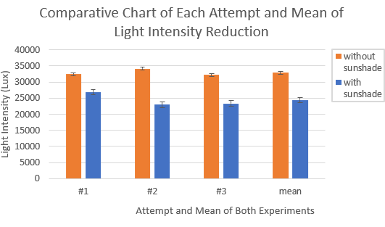
2) Evaluation of the Performance of the Sun-Shading Device in Controlling Indoor Illuminance and Temperature in the Building Model Under Natural Sunlight
Fig 5 A chart displaying the comparison of indoor illuminance in the building model with and without the sun-shading device
Fig 6 A chart displaying the comparison of indoor temperature in the building model with and without the sun-shading device
Figures 5 and 6 plot indoor illuminance and temperature, respectively, against the number of experimental trials and overall averages. Without a sun-shading device, baseline averages were 32,924 ± 1,316.9 lux and 35.9 ± 1.79°C. Installing the device significantly reduced these metrics, lowering the average indoor illuminance to 24,406 ± 976.30 lux (a 25.9 ± 1.29% reduction) and the average indoor temperature to 33.4 ± 1.67°C (a 7.06 ± 0.353% reduction).
Conclusions
The evaluation of the sun-shading device models demonstrated that the 10.8 × 10.8 cm² configuration with a 0° tilt angle achieved the highest performance, resulting in the lowest average indoor illuminance (248 lux) and temperature (28.03°C), with peak reductions of 31.87% and 14.45%, respectively. Among the developed predictive models, the Polynomial Regression model provided the highest accuracy, yielding $R^2$ values of 0.6831 for illuminance and 0.8299 for temperature. Performance evaluation under natural sunlight further validated these results, as this optimal panel configuration reduced baseline indoor illuminance by 25.86 ± 1.293% and indoor temperature by 7.06 ± 0.353%.

Acknowledgments
We would like to express our sincere gratitude to our advisors, Mr. Khunthong Klaythong and Mr. Ratchanikorn Chonchaiya, for providing invaluable insights and guidance, and to our school’s principal, Dr. Samorn Pato, for creating an environment that fostered experimental activities, which helped shape our project into its current form. We would also like to appreciate the 28th Young Scientist Competition for providing financial support to our project.

References
Guoyuan Li (2006). Solar Altitude and Azimuth
Angle Calculation. The University of
Georgia.
Lv, S., Sun, X., Zhang, B., Lai, Y., & Yang, J. (2024).
Research on the influence and
optimization of sunshade effect on
radiative cooling performance.
https://doi.org/10.1016/j.energy.2024
.131172
Steven V. Szokolay (2014). Introduction to
Architectural Science: The Basis of
Sustainable Design. (3rd ed.).
https://doi.org/10.4324/9781315852409
Victor Olgyay (2015). Design with Climate:
Bioclimatic Approach to Architectural
Regionalism New and expanded
Edition. (Rev ed.). Princeton University
Press

