Innovative Black Soldier Fly Life-Cycle Box for Organic Waste Management

Piyachet Saengchan^{1*}, Kamolchanok Thamat¹, and Pornpawee Sriwongniam¹
Advisors: Nawamin Wongchai¹, Jirawat Varophas¹, and Nopphasul Sirijant¹
¹Princess Chulabhorn Science High School Chiang Rai, Rob Wiang, Mueang Chiang Rai, Chiang Rai 57000, Thailand
*E-mail: Piyachet.barnaby@gmail.com

Abstract
Thailand generated approximately 26.95 million metric tons of municipal solid waste in 2023, with food and garden waste forming a major fraction. This project developed an enclosed black soldier fly (BSF; Hermetia illucens) life-cycle box for household organic-waste treatment. During a 21-day pilot trial, mixed food waste was supplied in portions of up to 1 kg day−1. Waste input and residue, processing time, larval biomass, frass, temperature, and relative humidity were recorded. Mean waste reduction was 68.1%, with a maximum weekly value of 82.8%. Three processing runs required 18–22 days (20 ± 2 days). Internal temperature and relative humidity averaged 29.5°C and 65.2%, respectively. Mean weekly yields were 0.26 kg of fresh larvae and 0.58 kg of frass. The prototype therefore showed technical feasibility for small-scale waste treatment and resource recovery. Replicated seasonal trials and nutritional and safety analyses are required before wider household or community deployment.
Keywords: black soldier fly, closed system, food waste, organic waste, waste bioconversion

Introduction
Thailand generated 26.95 million metric tons of municipal solid waste in 2023, of which 47.84% was food and garden waste. Improper disposal of this biodegradable fraction creates odor, leachate, and greenhouse-gas emissions; methane traps substantially more heat than carbon dioxide over a 100-year period (Department of Climate Change and Environment [DCCE], 2025). Source-level biological treatment is therefore important for reducing the amount of wet organic waste transported to disposal sites.
Black soldier fly larvae (BSFL; Hermetia illucens) can consume diverse organic substrates and convert part of the material into larval biomass while leaving a compost-like residue. Treatment performance depends on feed characteristics, feeding rate, larval density, and environmental conditions (Diener et al., 2009; Gold et al., 2018; Lalander et al., 2019). The resulting larvae and frass may be reused, subject to nutritional and safety assessment. This project developed an enclosed, two-compartment life-cycle box and evaluated its pilot-scale organic-waste reduction, processing time, product yields, temperature, and relative humidity.

Methodology
Prototype design. The prototype comprised a larval feeding compartment connected to a screened adult compartment. Main components included two plastic boxes, white mesh, PVC tubes, wooden supports and egg-laying strips, LED lamps, water-moistened foam, a temperature-relative-humidity sensor, and a digital balance. The enclosed layout was designed to limit external insect entry while providing ventilation and separate areas for feeding, pupation, adult emergence, mating, and oviposition.
Culture and feeding. A 1-g batch of BSF eggs was placed on dry leaves above 0.50 kg of fruit and vegetable waste. After hatching on approximately days 3–5, mixed household food waste was supplied in portions of up to 1 kg day⁻¹. For performance evaluation, 3.50 kg of waste was tracked in each weekly interval during the 21-day trial. Feeding ceased when larvae entered the prepupal stage. Prepupae migrated toward a dry zone and subsequently entered the adult compartment, which contained water-moistened foam, vegetation, lighting, and wooden oviposition strips.
Measurements and analysis. Waste input (W₀) and residual waste (W_{r}) were weighed for each interval. Waste reduction was calculated as WR (%) = [(W₀ − W_{r})/W₀] × 100. Processing time was recorded in three runs. Fresh larvae and frass were weighed weekly. Internal temperature and relative humidity were measured with the installed sensor and summarized by week. Owing to the pilot design, results were analyzed descriptively; mean and sample standard deviation (SD) were reported where repeated-run data were available.
Results and Discussion
Table 1. Weekly organic-waste reduction in the prototype
Week | Input (kg) | Residue (kg) | WR (%)
1 | 3.50 | 2.80 | 20.0
2 | 3.50 | 1.00 | 71.4
3 | 3.50 | 0.60 | 82.8
Mean | 3.50 | 1.47 | 68.1

Waste reduction increased from 20.0% in week 1 to 82.8% in week 3, with a three-week mean of 68.1% (Table 1; Fig. 1). The progressive increase is consistent with rising consumption as the larvae developed and their biomass increased. Because the weekly observations represent different stages of the same pilot cycle, they should not be treated as independent experimental replicates.
Across three processing runs, treatment required 18, 20, and 22 days, giving a mean of 20 ± 2 days (mean ± SD). The system produced 0.10, 0.25, and 0.42 kg of fresh larvae per week (mean 0.26 kg week⁻¹) and 0.25, 0.40, and 1.10 kg of frass (mean 0.58 kg week⁻¹). These products demonstrate resource recovery, but feed or fertilizer use should follow compositional and microbiological testing.
Weekly internal temperatures were 29.0, 30.5, and 28.9°C (29.5 ± 0.9°C), while relative humidity values were 65.0, 67.2, and 63.5% (65.2 ± 1.9%). The narrow ranges indicate that the enclosure maintained comparatively stable conditions during the observation period. Feedstock composition and total volatile solids are known to influence both larval development and conversion efficiency; therefore, the observed reduction cannot be attributed to the box design alone (Lalander et al., 2019).

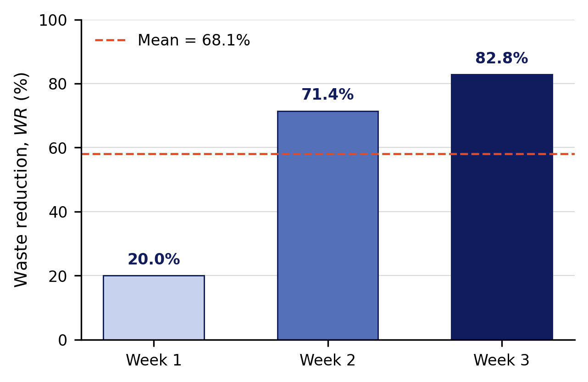
Fig. 1. Weekly organic-waste reduction; the dashed line shows the overall mean.
The mean reduction was comparable with the broad range reported for BSFL treatment, although direct comparison is limited by differences in feed, loading rate, larval density, and measurement basis (Gold et al., 2018). The design also offers practical separation of larval and adult zones within one enclosure, which may simplify small-scale operation and reduce dependence on colonization by wild flies.
Study limitations. This pilot lacked an untreated control and did not include replicated boxes or seasonal repetition. Weekly means also do not capture short-term temperature and humidity fluctuations. Moreover, the reported waste reduction represents the difference between feed input and recovered residue; it does not quantify how the removed mass was partitioned among larval biomass, carbon dioxide, water loss, leachate, and material retained on the box. Consequently, the results support feasibility, not a definitive claim of superiority over other treatment methods.
Further work should employ multiple identical boxes and a no-larvae control, standardize feed composition and moisture, record environmental data continuously, and report a complete wet- and dry-mass balance. Nutrient composition, pathogens, heavy metals, and maturity indicators should be assessed before larvae or frass are used in agriculture.

Conclusions
The enclosed BSF life-cycle box achieved a mean organic-waste reduction of 68.1% during a 21-day pilot trial and reached its highest weekly reduction of 82.8%. Processing required 20 ± 2 days, while the internal environment averaged 29.5°C and 65.2% relative humidity. The system also generated fresh larvae and frass, indicating the potential to recover useful biological products from household food waste.
The prototype is therefore a promising small-scale proof of concept, but the evidence is not yet sufficient to establish long-term performance or product safety. Replicated controlled trials, seasonal testing, complete mass-balance analysis, and nutritional and microbiological evaluation are necessary before household or community deployment.
Acknowledgments
The authors gratefully acknowledge Nawamin Wongchai and Jirawat Varophas for their project supervision and constructive guidance, and Nopphasul Sirijant for specialized academic advice. The authors also thank Princess Chulabhorn Science High School Chiang Rai for facilities and institutional support, and their families and classmates for assistance and encouragement throughout the project.

References
Department of Climate Change and Environment. (2025). Thailand Taxonomy: Waste Management Sector. https://www.dcce.go.th/wp-content/uploads/2025/06/06_EN_Thailand_Taxonomy-Waste_Management_Sector-1.pdf
Diener, S., Zurbrügg, C., & Tockner, K. (2009). Conversion of organic material by black soldier fly larvae: Establishing optimal feeding rates. Waste Management & Research, 27(6), 603–610. https://doi.org/10.1177/0734242X09103838
Gold, M., Tomberlin, J. K., Diener, S., Zurbrügg, C., & Mathys, A. (2018). Decomposition of biowaste macronutrients, microbes, and chemicals in black soldier fly larval treatment: A review. Waste Management, 82, 302–318. https://doi.org/10.1016/j.wasman.2018.10.022
- Kim, C.-H., Ryu, J., Lee, J., Ko, K., Lee, J.-Y., Park, K. Y., & Chung, H. (2021). Use of black soldier fly larvae for food waste treatment and energy production in Asian countries: A review. Processes, 9(1), 161. https://doi.org/10.3390/pr9010161
Lalander, C., Diener, S., Zurbrügg, C., & Vinnerås, B. (2019). Effects of feedstock on larval development and process efficiency in waste treatment with black soldier fly (Hermetia illucens). Journal of Cleaner Production, 208, 211–219. https://doi.org/10.1016/j.jclepro.2018.10.017

