Empowering Innovation, Technology and Artificial Intelligence For a Sustainable Future

*Chawin Khurukitkumchorn¹ and Vivit Suravatevongpas¹
Makabhumi Chumponwong^{1*}
¹Princess Chulabhorn Science High School Buriram No. 299, Village No. 2, Satuek, Satuek, Buriram, 31150 Thailand
*e-mail: 467wiwitsurawatewongpas@pcshsbr.ac.th

Abstract

This science project aims to investigate the mechanical behavior and endurance limits of material bundles subjected to external forces, with a specific focus on analyzing the influence of twisting on the generation of Maximum Shear Stress in a bundle of spaghetti. Spaghetti was selected as the representative material for this experiment due to its distinctively brittle nature, which allows for the precise observation of structural failure phenomena once the stress reaches a critical point.
The study applies the principles of mechanics of materials in conjunction with Helix Geometry to explain the redirection of forces and the accumulation of shear stress within the bundle at varying twist angles. The findings indicate that twisting directly contributes to an increase in shear stress within individual spaghetti strands, serving as the primary factor that leads to sudden fracture. This theoretical data was compared with empirical experimental results to determine the critical stress at which the spaghetti bundle loses its structural integrity. Ultimately, these findings provide a crucial foundation for understanding the engineering limitations of cable- and rope-like materials.
keywords : Torsion, Maximum Shear Stress, Modulus of Rigidity, Mechanics of Materials, Spaghetti Bundle

Introduction
In structural engineering analysis, a comprehensive understanding of the mechanical behavior of materials subjected to torsion is fundamental for determining their strength limitations and overall durability. Typically, cylindrical rods or shafts exhibit varying capacities to resist torsional forces, which are dictated by both the inherent properties of the material and the specific geometry of their cross-sections. According to the principles of mechanics of materials, this torsional behavior is described through fundamental equations that establish the relationship between the angle of twist ($θ$), the applied twisting moment or torque ($T$), and the geometric resistance parameter known as the polar moment of inertia ($J$). Furthermore, to accurately assess material safety and structural integrity, it is essential to calculate the maximum shear stress that develops within the specimen under loading.
Building upon these foundational engineering theories, this project utilizes a bundle of spaghetti as a simulated material rod to investigate its structural response under torsional loads. The primary objective is to evaluate the mechanical properties of this bundled configuration by applying physical principles to determine the material's shear modulus ($G$), which represents its overall rigidity. Specifically, the study aims to observe how the spaghetti bundle responds to incrementally increasing twisting moments ($T$) and to identify the precise critical maximum shear stress at which structural failure or fracture occurs. By doing so, the project seeks to evaluate the shear modulus of a bundled material system and compare these empirical findings with standard theoretical models.
To achieve these objectives, the scope of the study is carefully controlled, focusing exclusively on spaghetti bundles arranged in a uniform cylindrical shape without any initial twisting. The experimental design involves manipulating independent variables, namely the size of the bundle—defined by the number of individual strands—and the magnitude of the twisting moment applied to the structure. Correspondingly, the study will measure the dependent variables, which include the actual resulting angle of twist ($θ$) and the ultimate shear stress the material can withstand before failure.
Ultimately, this research is expected to yield valuable engineering data regarding the rigidity and shear stress limits of bundled materials. Furthermore, it will provide deeper insights into the practical application of mechanics of materials equations in small-scale structural research, facilitating a broader understanding of how fibrous or bundled materials behave when subjected to complex torsional forces.

Methodology
1. Material and Apparatus Preparation
1.1. Spaghetti Bundle: Arrange the spaghetti strands to a constant quantity as defined in the scope of the study. This ensures a uniform bundle radius ($r$) for the experiment.
1.2. Experimental Setup: Install a steel frame or stand capable of securely clamping one end of the spaghetti bundle. Suspend a container (e.g., a bucket) from the opposite end to serve as a receptacle for incremental weight application.
2. Definition of Variables
2.1. Angle of Twist ($θ$): Apply a predetermined twist angle to the spaghetti bundle (e.g., 0, 30, or 60 degrees), utilizing a protractor to ensure precise measurements.
2.2. Length ($L$): Maintain a constant length of the spaghetti bundle across all experimental trials.
2.3. Radius ($r$): Verify and record the radius of the bundle, which is essential for calculating the polar moment of inertia ($J$).
3. Testing Procedure
3.1. Secure one end of the spaghetti bundle to a fixed pivot point and attach the free end to the load-bearing container.
3.2. Gradually and steadily add weight (e.g., sand) into the container to induce a twisting moment ($T$) and stress upon the spaghetti strands.
3.3. Record the critical mass of the applied weight at the exact moment the spaghetti bundle undergoes structural failure or fracture.

4. Calculation and Data Analysis
4.1. Upon obtaining the critical mass that causes fracture, calculate the maximum shear stress ($τ_{\text{max}}$) utilizing the standard torsion formula.
The analytical parameters are defined as follows:
$$θ=\frac{TL}{JG}$$
$$τ_{max}=\frac{Tr}{J}$$
$$G=\frac{Fl_{0}}{AΔl}$$

$θ$ = Angle of twist of the shaft (Radians)
$T$ = Twisting moment or torque (N·m) (Note: Torque is measured in Newton-meters)
$J$ = Polar moment of inertia (mm$^4$)
$L$ = Length of the shaft (mm)
$r$ = Radius to the point of interest (mm)
$τ_{\text{max}}$ = Maximum shear stress

Result and Discussion
1) Angle of Twist
The findings indicate that an initial increase in the angle of twist enhances the load-bearing capacity of the spaghetti bundle. However, once the applied twist reaches a critical threshold where the brittle nature of the spaghetti strands dominates, the bundle's ability to withstand external forces significantly decreases.
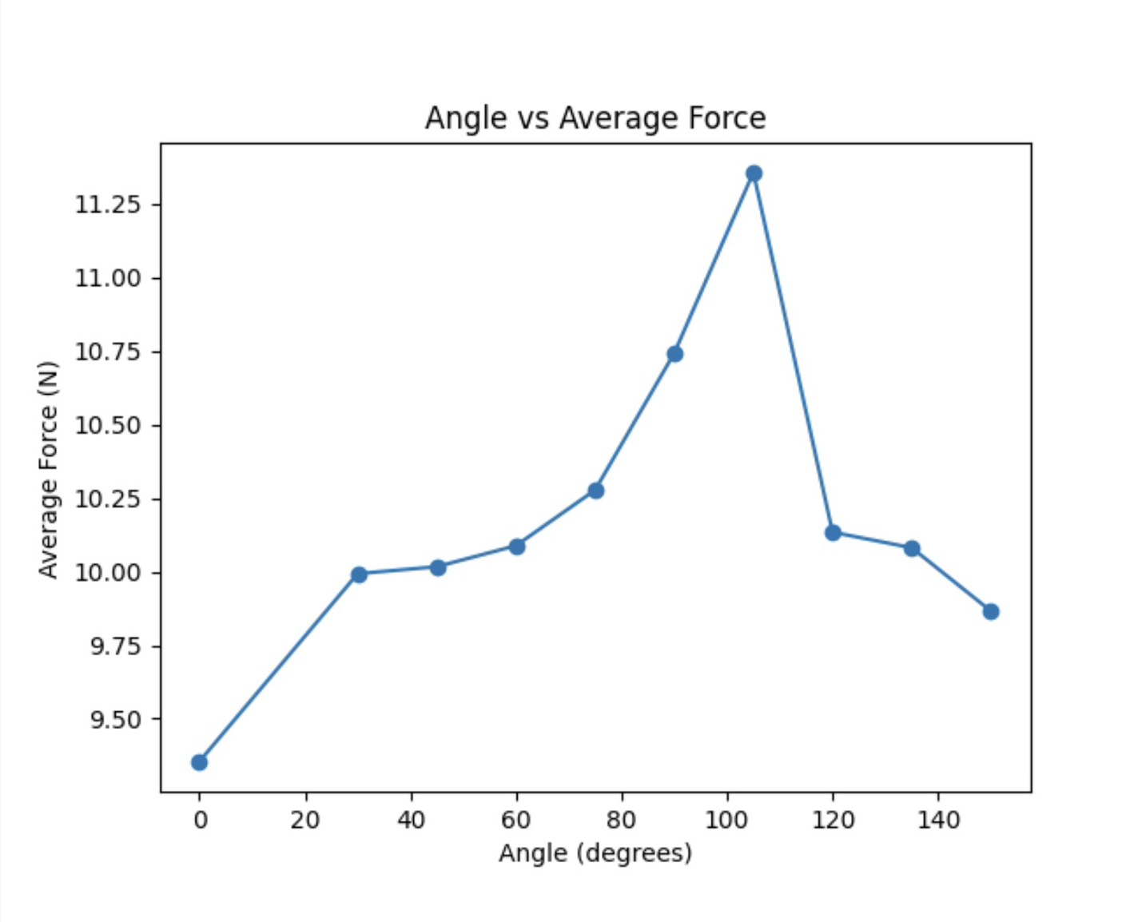
2) Bundle Length
It was observed that a greater measured length of the bundle inversely affects its load-bearing capacity, resulting in lower structural resistance. This phenomenon occurs because the applied moment increases while the deformation or change in length ($Δl$) decreases.
(Note: The variable $G$ mentioned in your text represents the Shear Modulus, measured in GN/m²)
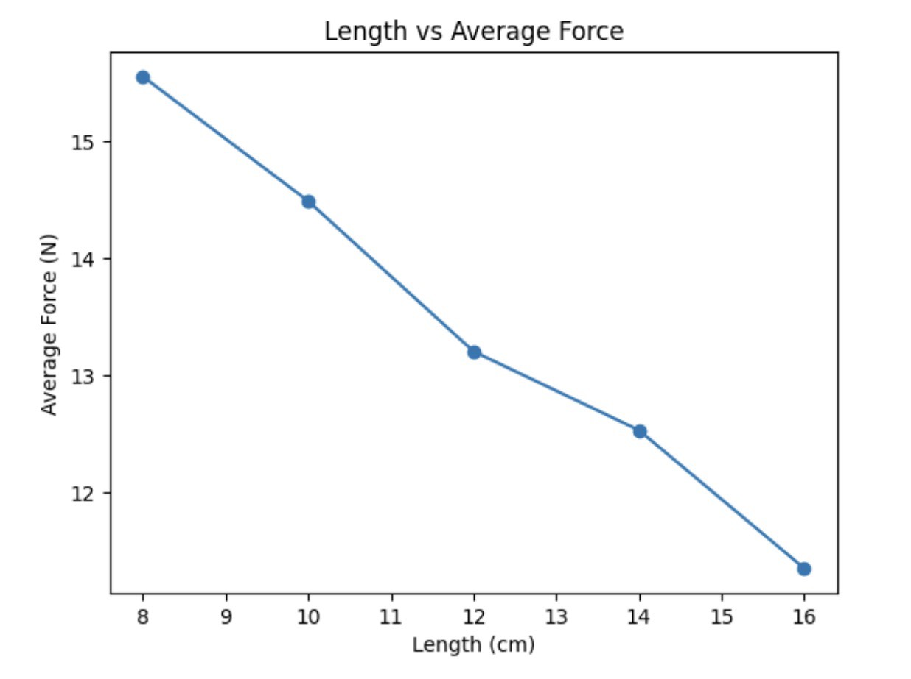
3) Bundle Radius
The results demonstrate that a larger cross-sectional area directly correlates with a higher load-bearing capacity. This enhanced resistance is attributed to the increased number of individual strands within the bundle, which generates greater internal friction among the spaghetti strands during torsion.
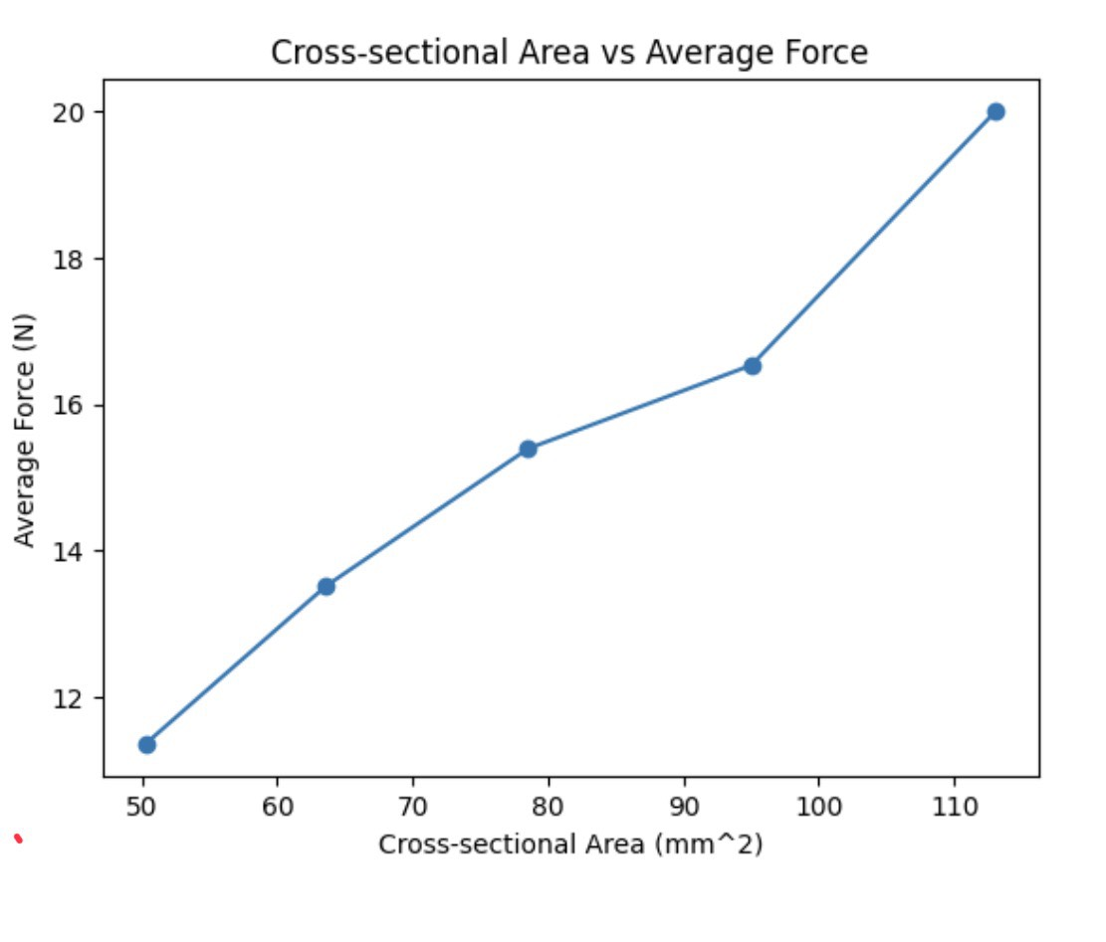

Conclusions
Based on the study of the twisting phenomenon in spaghetti bundles to enhance resistance against transverse stress, the experimental results conclude that twisting the bundle directly impacts its capacity to withstand the maximum shear stress. This relationship does not increase linearly with the angle of twist; rather, there exists an "Optimal Twist Angle" at which the spaghetti bundle can sustain the maximum load prior to structural failure. Furthermore, it was observed that bundles twisted at this optimal angle exhibit collective failure, which distinctly contrasts with untwisted bundles that are more susceptible to strand separation or slippage.
In discussing these results through the lens of the mechanics of materials, the initial increase in structural strength can be explained by the equations presented in the experimental methodology. The twisting of the fiber bundle generates a radial compressive force, which subsequently increases the static friction between the contact surfaces until the bundle exhibits a pseudo-solid behavior. Consequently, the polar moment of inertia ($J$) becomes more efficient in distributing the twisting moment ($T$) across the entire cross-section compared to a standard parallel alignment.
However, once the twist angle exceeds the optimal point, the structural strength inversely declines. As explained by the previously established relationships, excessive twisting induces an internal pre-stress (tensile stress) that accumulates within each individual strand due to its geometric rearrangement. This acts as an initial structural load applied to the material, thereby reducing its remaining capacity to absorb additional external torsional forces before reaching the critical limit, in accordance with the principle of stress superposition.
In conclusion, the application of torsion theory to a simulated brittle material bundle like spaghetti demonstrates that the mechanical properties of bundled materials rely heavily on maintaining an equilibrium between the binding forces generated by twisting and the internal stresses accumulated from the twisting geometry itself. The analytical data derived from these engineering equations serves as empirical evidence that designing an efficient fibrous bundle structure necessitates the careful consideration of the optimal twist angle. This ensures that the system's maximum shear stress ($τ_{\text{max}}$) capacity is maximized before the accumulation of internal stresses inevitably leads to material failure.

Acknowledgments
Here is the academic English translation for your acknowledgments section, matching the formal tone of your project:
Acknowledgments
The science project titled "A Study on the Torsion of Spaghetti Bundles for Maximum Transverse Stress Resistance" was brought to successful completion through the kindness, guidance, and support of various individuals. The project team would like to express our sincere gratitude to everyone who provided consultation and assistance throughout this endeavor.
We extend our deepest gratitude to Makaphum Chumphonwong, our project advisor, who generously dedicated his time to provide invaluable consultation and guidance regarding the underlying physics principles and the design of the experimental setup. We are also highly appreciative of his meticulous review of the content and his expert advice in troubleshooting issues encountered during the execution phase, all of which significantly enhanced the completeness and systematic rigor of this project.
Finally, the project team sincerely hopes that this study will be beneficial and serve as a valuable resource for those interested in this field. Should there be any errors or shortcomings within this document, we humbly accept full responsibility and offer our sincere apologies.

References
Beer, F. P., Johnston, E. R., DeWolf, J. T., & Mazurek, D. F. (2015). Mechanics of Materials (7th ed.). New York, NY: McGraw Hill Education.
Callister, W. D., & Rethwisch, D. G. (2018). Materials Science and Engineering: An Introduction (10th ed.). Hoboken, NJ: Wiley.
Chulalongkorn University. (2011). ENME20954ST Mechanics of Materials – Chapter 2: Stress and Strain. Retrieved from https://archive.lib.cmu.ac.th/full/T/2554/e nme20954st_ch2.pdf
Gere, J. M., & Goodno, B. J. (2013). Mechanics of Materials (8th ed.). Stamford, CT: Cengage Learning.
Hibbeler, R. C. (2017). Mechanics of Materials (10th ed.). Pearson Education.

