Development of a Sustainable Plant-Based Bio-Mordant from Agricultural Waste for Enhanced Mud Dyeing of Silk Fibers

Rachalop Junjuntuk¹, Peerapat Sanglai¹
Watcharaporn Saenna¹*
¹Princess Chulabhorn Science High School Buriram, Satuek, Satuek, Buriram, 31150 Thailand
e-mail: rachalopjunjuntuk@pcshsbr.ac.th

Abstract
The textile industry requires environmentally sustainable alternatives to synthetic mordants, which generate hazardous waste and environmental concerns. This study developed an eco-friendly bio-mordant from pomegranate (Punica granatum) peel extract, rice husk ash alkaline solution, and local natural mud to improve mud-assisted natural dyeing of silk fibers. Six bio-mordant formulations (100:0:0, 100:0:20, 100:10:20, 100:20:20, 100:30:20, and 100:40:20 mL) were evaluated prior to dyeing with sappanwood (Caesalpinia sappan) extract. Color properties were measured using the CIELAB color system, while washing fastness was assessed through three washing cycles. EDS, FTIR, UV–Visible spectroscopy, and SEM were employed to characterize the materials and support the proposed dyeing mechanism. The formulation containing 100 mL mud, 30 mL pomegranate extract, and 20 mL rice husk ash solution exhibited the highest color saturation (Chroma = 8.95) and the lowest color loss (0.36%) after repeated washing. The enhanced performance is attributed to coordination interactions among tannin-derived phenolic compounds, naturally occurring metal ions in the mud, and silk fibroin, resulting in a stable dye–metal–fiber coordination network. The findings demonstrate that agricultural wastes can be transformed into an effective bio-mordant capable of improving traditional mud-assisted silk dyeing while reducing dependence on synthetic mordants and supporting sustainable textile production under the Bio-Circular-Green (BCG) Economy Model.
keywords: Bio-mordant, Coordination complex, Mud dyeing, Silk fiber, BCG Model
Introduction
The growing environmental impact of textile manufacturing has increased interest in sustainable alternatives to synthetic mordants, which improve dye fixation but generate hazardous wastewater and environmental pollution. Natural dyes are environmentally friendly; however, their commercial application remains limited because of poor color fixation
Sappanwood (Caesalpinia sappan), a traditional natural dye widely used in Southeast Asia, contains brazilin, which is readily oxidized to the red pigment brazilein during dyeing. Traditional mud-assisted dyeing partially improves color fixation through naturally occurring mineral ions in the mud, although variations in mineral composition often result in inconsistent dyeing performance. Plant-derived tannins have recently attracted attention as eco-friendly mordants because of their strong metal-chelating ability. Pomegranate (Punica granatum) peel is an abundant agricultural by-product rich in hydrolyzable tannins, while rice husk ash provides a mild alkaline medium that promotes phenolic ionization and metal coordination. Combining these agricultural wastes with natural mud may enhance dye fixation while adding value to local resources within the Bio-Circular-Green (BCG) Economy framework.
Therefore, this study developed a bio-mordant consisting of pomegranate peel extract, rice husk ash alkaline solution, and local natural mud for mud-assisted dyeing of silk fibers. Different formulations were evaluated using the CIELAB color system and washing fastness tests to determine the optimum composition. The proposed bio-mordant is expected to improve dye fixation through coordination interactions among tannins, naturally occurring metal ions, and silk fibroin, providing a sustainable alternative to synthetic mordants.

Methodology
1)Materials
Local natural mud was collected from a traditional mud-dyeing community in Buriram Province, Thailand. Dried pomegranate (Punica granatum) peels, rice husk ash (RHA), sappanwood (Caesalpinia sappan) heartwood, degummed silk fibers, and distilled water were used throughout the study.
2) Preparation of Bio-Mordant Components Pomegranate peel extract was prepared by boiling 50 g of dried peel in 500 mL distilled water at 90°C for 60 min, followed by filtration. Rice husk ash alkaline solution was prepared by soaking 50 g of ash in 500 mL distilled water for 24 h before filtration. Local mud was sieved to remove coarse particles and homogenized with distilled water prior to bio-mordant preparation.
3) Preparation of Bio-Mordant Formulations
Six bio-mordant formulations were prepared by varying the volume of pomegranate peel extract while maintaining constant mud and rice husk ash solution volumes.
4) Mordanting and Dyeing Procedure Silk fibers were immersed in each bio-mordant formulation for 60 min at room temperature before dyeing with sappanwood extract at 80–85°C for 60 min. The dyed samples were rinsed with distilled water and air-dried under ambient conditions.
5) Color Measurement and Washing Fastness
Color properties were evaluated using the CIELAB color system by measuring L*, a*, and b* values. Color saturation (Chroma, C*) was calculated using
\
Washing fastness was evaluated through three consecutive washing cycles. After each cycle, the silk samples were dried, and their color parameters were re-measured to determine color retention.
6) Physicochemical Characterization Natural mud was characterized using Energy Dispersive X-ray Spectroscopy (EDS), while surface morphology before and after bio-mordant treatment was examined using Scanning Electron Microscopy (SEM). Fourier Transform Infrared Spectroscopy (FTIR) and UV–Visible spectroscopy was employed to identify functional groups and verify the presence of tannin-related compounds supporting the proposed dyeing mechanism.
7) Statistical Analysis All experiments were performed in triplicate (n = 3). Results are presented as mean ± standard deviation (SD). The optimum formulation was selected based on the highest Chroma (C*) and the lowest percentage color loss after three washing cycles.
Result and Discussion
1) Physicochemical Characterization of Natural Materials.
1.1 Elemental Composition of Local Natural Mud
The elemental composition of natural mud collected from Buriram Province was determined using Energy Dispersive X-ray Spectroscopy
Table 1 shows the elemental composition of
the natural mud.
Element | % element composite in mud
Oxygen (O) | 37.99
Silicon (Si) | 37.04
Aluminum (Al) | 11.69
Iron (Fe) | 8.79
Potassium (K) | 2.03
Magnesium (Mg) | 0.93
Calcium (Ca) | 0.77
Titanium (Ti) | 0.76

Among these elements, Fe and Al are particularly important because they can serve as multivalent coordination centers for phenolic ligands. Their presence supports the proposed role of natural mud as an inorganic matrix capable of enhancing dye fixation through coordination bonding. Nevertheless, because the mineral composition of natural mud varies with geographical origin, incorporation of plant-derived tannins is expected to provide a more stable and reproducible mordant system.
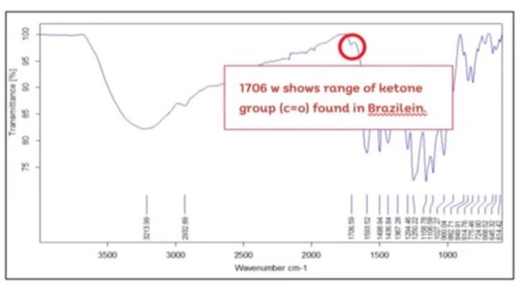
1.2 FTIR Analysis of Sappanwood Extract
Fig.2 presents the FTIR spectrum of the extracted dye.
A characteristic absorption band was observed at approximately 1706 cm⁻¹, corresponding to the stretching vibration of carbonyl (C=O) groups. This peak indicates oxidation of brazilin to brazilein during extraction.
Formation of brazilein increases molecular conjugation and provides phenolic functional groups capable of coordinating with multivalent metal ions. Under mildly alkaline
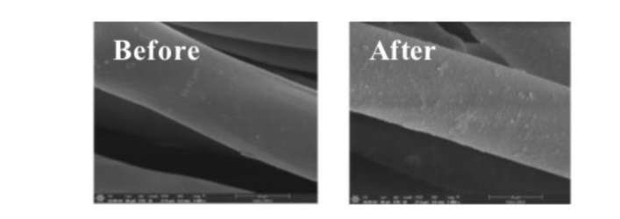
conditions provided by rice husk ash solution, partial deprotonation of phenolic groups further enhances metal coordination, supporting the proposed dye–metal–fiber 1.3 Surface Morphology of Natural Mud
Fig.3 presents the SEM micrographs of the natural mud before and after bio-mordant preparation. The untreated mud exhibited a relatively smooth and compact surface with limited visible deposits. After preparation with the bio-mordant components, the mud surface became noticeably rougher and was covered with fine particulate aggregates. These morphological changes suggest that plant-derived organic compounds were deposited onto the mineral surface, increasing the available contact area for dye adsorption. The modified surface is therefore expected to facilitate stronger interactions among tannins, naturally occurring metal ions, and silk fibers, contributing to improved dye fixation. 1.4 Verification of Tannin Content in Pomegranate Peel Extract
Table 2 Total tannin concentration of pomegranate peel extract determined by UV–Visible spectrophotometry

Sample | Tannin concentration mg/L
Pomegranate peel extract | 68,677 ± 1047
The tannin content of the pomegranate peel extract was determined using the UV–Visible spectrophotometric method with tannic acid as the reference standard. The extract exhibited an average absorbance of 3.65 ± 0.04 (n = 3). Based on the calibration equation (y = 4 × 10⁻⁵x + 0.06) The result confirmed that the extract contained a high concentration of tannins, supporting its potential application as a natural bio-mordant through metal–polyphenol coordination with multivalent metal ions presents in the natural mud. 2) Effect of Bio-Mordant Formulations on Dyeing Performance.
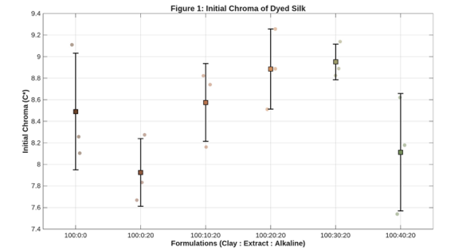
2.1 Color Saturation of Dyed Silk Fibers Color saturation was evaluated using Chroma (C*) in the CIELAB color system.
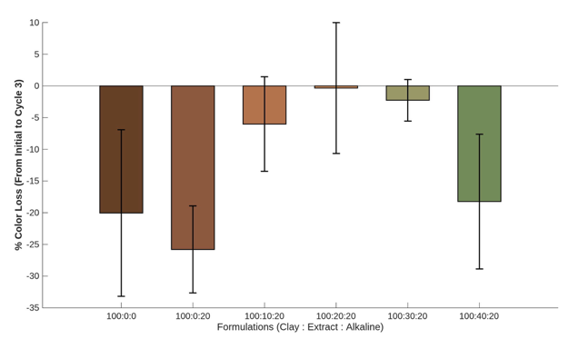
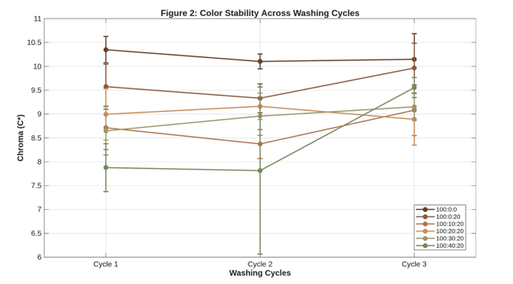
Fig.5 summarizes the initial Chroma values of silk fibers treated with different bio-mordant formulations. The control treatment (100:0:0) exhibited an average Chroma of approximately 8.50 ± 0.54, whereas formulation F1 (100:0:20) decreased significantly to 7.60 ± 0.32. Progressive addition of pomegranate peel extracts increased Chroma, reaching the highest value (8.95 ± 0.37) in formulation F4 (100:30:20). Increasing the extract to 40 mL (F5) slightly reduced Chroma to approximately 8.10 ± 0.54. These findings suggest that an appropriate tannin concentration provides sufficient coordination sites for Fe and Al while maintaining efficient interaction with silk fibroin and brazilein molecules. Excess tannin may competitively occupy coordination sites, thereby reducing dye uptake. 3) Washing Fastness of Dyed Silk 3.1 Color Stability During Repeated Washing Fig.6 illustrates the variation in Chroma values after repeated washing. The control and F1 exhibited greater fluctuations in Chroma, indicating weaker dye fixation. In contrast, formulations containing pomegranate peel extract maintained relatively stable Chroma values throughout the washing cycles. The improved stability is attributed to the formation of a dye–metal–fiber coordination network that effectively reduces dye leaching during laundering.

3.2 Percentage Color Loss Color retention was further evaluated using percentage color loss.
Fig. 7 compares the percentage color loss of dyed silk after three washing cycles. The control treatment exhibited the highest percentage color loss, indicating poor dye retention when natural mud was used alone. Incorporation of pomegranate peel extract significantly reduced color loss in all bio-mordant formulations. Formulation F4 (100:30:20) produced the lowest color loss (0.36 ± 3.27 %), whereas a further increase in tannin concentration (F5) resulted in slightly greater color loss. These results indicate that balanced proportions of natural mud, tannins, and alkaline activation maximize dye fixation and washing durability.
Conclusions
This study successfully developed an eco-friendly bio-mordant by combining local natural mud, pomegranate (Punica granatum) peel extract, and rice husk ash alkaline solution to improve traditional mud-assisted dyeing of silk fibers. Among the investigated formulations, the bio-mordant containing 100 mL natural mud, 30 mL pomegranate peel extract, and 20 mL rice husk ash solution (100:30:20) exhibited the optimum performance, producing the highest color saturation (Chroma, C*) and the lowest color loss after repeated washing. The improved dyeing performance is attributed to the coordination interactions among tannin-derived phenolic compounds, naturally occurring metal ions in the mud, and silk fibroin, resulting in enhanced dye fixation and washing durability.
Overall, the findings demonstrate that agricultural by-products can be successfully transformed into an effective bio-mordant for sustainable silk dyeing. This approach not only improves color quality and washing fastness but also promotes value-added utilization of agricultural waste and supports environmentally responsible textile production in accordance with the Bio-Circular-Green (BCG) Economy Model. Future work should further verify the coordination mechanism using advanced analytical techniques and evaluate the applicability of the developed bio-mordant to other natural dyes and textile fibers

Acknowledgments
Special thanks to Teacher
Watcharaporn Saenna for advice and data collection. We also thank Princess Chulabhorn Science High School, Buriram, for support in carrying out this study.

References
Bechtold, T. andMussak, R. (2009).
Handbook of Natural Colorants. Chichester: John Wiley & Sons.
Cardon, D. (2007).
Natural Dyes: Sources, Tradition, Technology and Science. London: Archetype Publications.
Kasiri, M.B. and Safapour, S. (2014).
Natural dyes and antimicrobials for green treatment of textiles. Environmental Chemistry Letters. 12(1): 1–13.
Samanta, A.K. and Agarwal, P. (2009).
Application of natural dyes on textiles. Indian Journal of Fibre & Textile Research. 34(4): 384–399.
Shahidi, F. and Ambigaipalan, P. (2015).
Phenolics and polyphenolics in foods, beverages and spices: Antioxidant activity and health effects – A review. Journal of Functional Foods. 18: 820–897.

