Fluxion_DDS: A Targeted Aspirin Delivery System Using Chitosan-Coated Magnetite Nanoparticles under Magnetic and Electric Field Control with a Model of Nanoparticle Behavior in Pulsatile Blood Flow for Thrombosis Treatment

Sarawut Tawasuk¹, Thirati Muenmontri¹
Siriwimon Wangwong^{1*}
¹Princess Chulabhorn Science High School Mukdahan, Bang Sai Yai, Mueang Mukdahan, Mukdahan, 49000 Thailand
*E-mail: w.siriwimon@pccm.ac.th

Abstract
Thrombotic disorders are a major contributing factor to stroke and cardiovascular diseases, which remain among the leading causes of mortality worldwide. Conventional pharmacological therapies are limited by their inability to achieve precise drug delivery while minimizing adverse effects on healthy tissues. Therefore, this study investigated the effect of chitosan concentration (0, 0.125, 0.250, 0.375, and 0.500 mg/mL) on the stability of aspirin-loaded magnetite nanoparticles synthesized via co-precipitation, as well as the relationships between nanoparticle linear velocity and the applied magnetic field and between aspirin release rate and the applied electric field. ATR-FTIR analysis confirmed the interaction of magnetite nanoparticles with chitosan and aspirin. Nanoparticles coated with 0.250 mg/mL chitosan exhibited the greatest stability (p < 0.001), with an average particle diameter of 86.7 ± 14.9 nm, a polydispersity index (PDI) of 0.470, a zeta potential of 39.8 ± 1.4 mV, and the highest aspirin loading capacity of 39.8 ± 0.6 mg/mL. Nanoparticle transport under an applied magnetic field was consistent with the Magnetophoresis model (R² = 0.9251, p < 0.001). Likewise, aspirin release under an applied electric field was consistent with the Nernst–Planck model (R² = 0.9768, p < 0.001). These findings demonstrate that the developed aspirin delivery system, together with a physics-based molecular dynamics model implemented in LAMMPS to predict nanoparticle behavior under pulsatile blood flow in PBS-based simulated physiological conditions, supports the development of targeted aspirin delivery systems for thrombosis treatment. Nevertheless, further validation under physiological conditions is required before practical application.
Keywords: Magnetite nanoparticles, Chitosan, Aspirin delivery system, Pulsatile blood flow, Thrombosis
Introduction
Thrombotic disorders are major contributors to stroke and cardiovascular diseases, which remain among the leading causes of mortality worldwide. Although conventional pharmacological therapies reduce thrombus formation, limitations in precise drug delivery and adverse effects on healthy tissues remain challenges. Therefore, targeted drug delivery systems capable of controlling nanoparticle transport and drug release have become an important focus in biomedical engineering.
Magnetite nanoparticles (Fe₃O₄) possess superparamagnetic properties that enable manipulation by external magnetic fields, making them promising carriers for targeted drug delivery (Laurent et al., 2008). However, their tendency to aggregate reduces colloidal stability under physiological conditions. Surface modification with chitosan, a biocompatible and biodegradable cationic biopolymer, improves nanoparticle stability and provides functional amino groups for drug interaction (Dash et al., 2011; Kanhakeaw et al., 2011). Chitosan-coated magnetite nanoparticles and aspirin-loaded chitosan nanoparticles have demonstrated improved stability and controlled drug release behavior, respectively (Kanhakeaw et al., 2011; Shi et al., 2014). Furthermore, combining magnetic field-guided nanoparticle transport with controlled drug release may enhance the precision and controllability of targeted drug delivery systems.
Therefore, this study aimed to investigate the optimal chitosan concentration for stabilizing aspirin-loaded magnetite nanoparticles and to evaluate nanoparticle transport under an applied magnetic field and aspirin release under an applied electric field in phosphate-buffered saline (PBS). A physics-based mathematical model integrating magnetophoresis, the Nernst–Planck model, and nanoparticle transport under pulsatile blood flow was developed to describe nanoparticle behavior. The proposed system is expected to provide a stable and controllable platform for targeted aspirin delivery and support future development of targeted drug delivery systems for thrombosis treatment.

Methodology
1) Investigating the optimal concentration of chitosan solution that affects the stability of coating magnetite nanoparticles.
The magnetite nanoparticles (Fe₃O₄) were synthesized by dissolving 29.20 g of ferric chloride hexahydrate (FeCl₃·6H₂O) and 10.74 g of ferrous chloride tetrahydrate (FeCl₂·4H₂O) in 120.0 mL of deionized water at 70 °C, followed by dropwise addition into 66.5 mL of ammonium hydroxide (NH₄OH) and stirring for 30 minutes using an overhead stirrer. The nanoparticles were magnetically separated, washed with deionized water, and dried at 60 °C. Chitosan solutions (0.25, 0.50, 0.75, and 1.00 %w/v) were prepared in 50.0 mL of 2% v/v acetic acid solution and mixed with 2.00 g of magnetite nanoparticles. The coating process was performed by adding the mixture into 300.0 mL of mineral oil containing 5.0 mL of sorbitan oleate, followed by 30.0 mL of 25% glutaraldehyde for crosslinking and stirring for 5 hours. The coated nanoparticles were separated, washed with deionized water, and dried at 50 °C. The stability of chitosan-coated magnetite nanoparticles was evaluated using a Zetasizer based on standard criteria. Finally, 0.05 g of aspirin was dissolved in 40.0 mL of deionized water and mixed with 2.00 g of chitosan-coated magnetite nanoparticles for 4 hours at room temperature. The nanoparticles were separated magnetically, and the remaining solution was analyzed using UV–Vis spectrophotometry 1800 to determine residual aspirin concentration.
2) Investigating the relationship between the linear velocity of the most stable magnetite nanoparticles and the applied magnetic field.
The most stable magnetite nanoparticles were added to 30.0 mL of phosphate-buffered saline (PBS) in a petri dish. Permanent magnets were then placed at specified distances, with the magnetic field intensity adjusted by adding more neodymium magnets. The particle movement was recorded using a camera with a frame rate of 240 fps. The video was then analyzed using Tracker software, scaling the actual distance, tracking the particle positions frame-by-frame, and calculating the linear average velocity at the beginning of the movement (the period before acceleration due to the magnetic field gradient). The experiment was repeated 5 times, and the results were recorded and reported along with theoretical equations.
3) Investigating the relationship between the drug release rate of the most stable magnetite nanoparticles and the electric field.
The most stable magnetite nanoparticles were added in a phosphate-buffered saline (PBS) solution simulating the life cycle of experimental cells. Parallel plate electrodes (using copper or aluminum) plates, were connected to a 2.0 voltage of DC power supply, and the distance between the parallel plate electrodes was adjusted to create different electric field intensities under specified experimental conditions. Solution samples were collected at specified intervals for analysis of the aspirin released from the nanoparticles. The absorbance was measured using a UV-Vis spectrophotometer 1800, and the released drug quantity was calculated. The experiment was repeated 5 times, results recorded, and compared to theoretical equations.
4) Developing a model of drug delivery systems under pulsatile blood flow for application in the thrombosis treatment.
Investigating the movement and distribution behavior of aspirin-loaded chitosan-coated magnetite nanoparticles under magnetic fields, as well as drug release behavior under normal and applied electric fields. The experimental results were analyzed together with pulsatile blood flow characteristics caused by cardiac activity to determine the relationship between magnetic and electric field, nanoparticle transport, and drug release rate. The obtained experimental data were used to develop a model integrating magnetophoresis, the Nernst–Planck equation, and the Womersley pulsatile blood flow model by using LAMMPS program to predict nanoparticle and drug delivery behavior for potential thrombosis treatment applications.

Result and Discussion
1) Investigating the optimal concentration of chitosan solution that affects the stability of coating magnetite nanoparticles.
Table 1 Show stability test results of chitosan-coated magnetite nanoparticles using Zetasizer.
Chitosan concent-ration (mg/mL) | Asprin concent-ration (mg/mL) | Particles diameter (nm) | PDI | Zeta potential (mV)
- | - | 14.6 ± 1.3 | 0.365 | 30.0 ± 0.2
1.250 | 0.200 | 58.4 ± 8.2 | 0.421 | 35.6 ± 1.2
2.500 | 0.200 | 86.7 ± 14.9 | 0.470 | 39.8 ± 1.4
3.750 | 0.200 | 246.5 ± 52.3 | 0.495 | 41.3 ± 1.6
5.000 | 0.200 | 419.1 ± 78.6 | 0.763 | 45.2 ± 0.7
Standard stability |  | 50.0 – 200.0 | < 0.300 | > 30.0
Experimental results showed that at a coating concentration of 2.500 mg/mL of chitosan solution on magnetite nanoparticles, the particles had a diameter of 86.7 ± 14.9 nm, (50–200 nm), and a zeta potential of 39.8 ± 1.4 mV (> 30 mV), which is within the standard range, indicating optimal stability (p < 0.001). However, the particles still had a PDI value higher than 0.300.
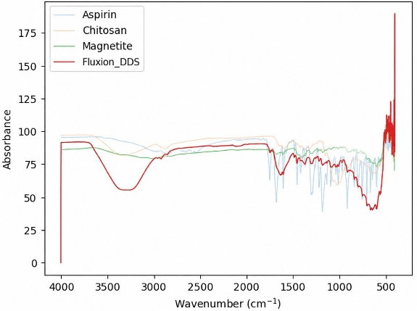
Fig. 1 Show the functional group interaction between magnetite nanoparticles, chitosan, and aspirin using ATR-FTIR.
Experimental results showed that in the 3200–3500 cm⁻¹ absorption was associated with the –OH and –NH groups of chitosan, while in the 1700 cm⁻¹ range of absorption was consistent with the C=O group of aspirin. Furthermore, in the 500-1000 cm⁻¹ absorption was related to the Fe–O bonds of magnetite. Overall, the analysis indicates successful chitosan coating and aspirin encapsulation in the nanoparticle system.
2) Investigating the relationship between the linear velocity of the most stable magnetite nanoparticles and the applied magnetic field.
Table 2 Show the results of the relationship between linear velocity of the most stable magnetite nanoparticles and the applied magnetic field.
Linear velocity (mm/s) |  | Magnetic field  (mT) | Magnetic field^{7/3}  (mT)^{7/3}
Average | M.D. | Magnetic field  (mT) | Magnetic field^{7/3}  (mT)^{7/3}
0.02 | - | 0.75 | 0.51
0.12 | 0.01 | 1.62 | 3.08
0.47 | 0.02 | 3.31 | 16.33
2.35 | 0.05 | 6.14 | 69.03
3.20 | 0.05 | 7.42 | 107.38
4.17 | 0.06 | 8.03 | 129.12
Note: The experimental results were analysed using the Tracker program.
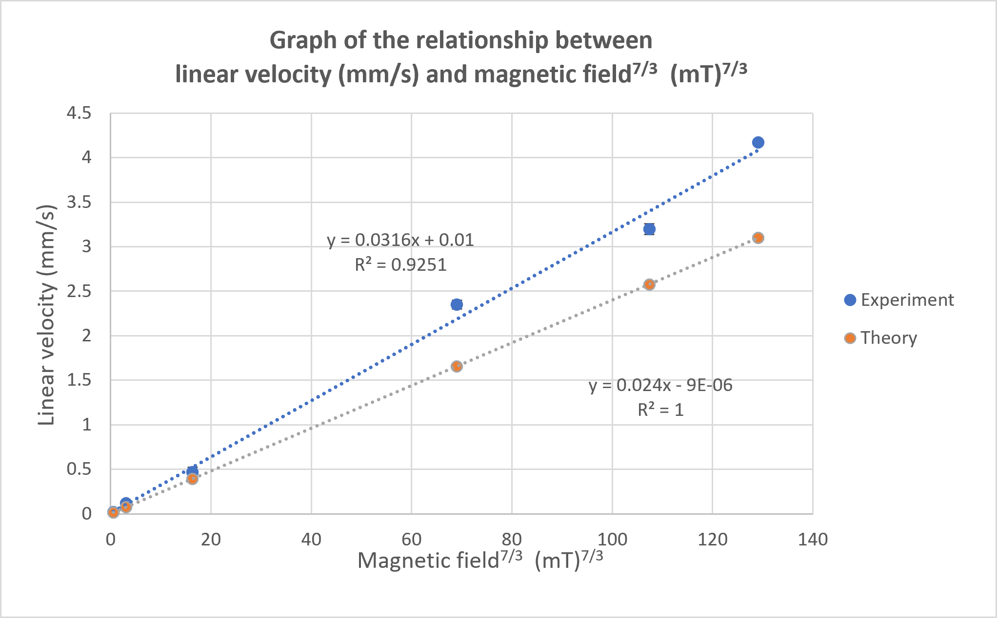
Fig. 2 Show the relationship between the linear velocity (mm/s) of chitosan-coated magnetite nanoparticles containing aspirin and the applied magnetic field (mT).
$v=\frac{V_{p}χ}{6π{μ_{0}}^{2}ηr}\sqrt{\frac{2π}{m}}⋅B^{\frac{7}{3}}$ (Eq. 1 Magnetophoresis)
Experimental results showed that the average linear initial velocity of chitosan-coated magnetite nanoparticles increased nonlinearly. When considering the graph using an applied magnetic field^{7/3}, the linear velocity showed a significant direct linear tendency (R² = 0.9251 with 28.14% of error from the data of theory trend, p < 0.001), consistent with the theoretical model of magnetic force acting on particles in a fluid, where the magnetic force depends on the slope of the field and the magnetic properties of the particles. Therefore, it can be concluded that the synthesized particles are sensitive to magnetic fields and their velocity and direction of movement can be systematically controlled.
3) Investigating the relationship between the aspirin release rate of the most stable magnetite nanoparticles and the applied electric field.
Table 3 Show the results of the relationship between the aspirin release rate of the most stable magnetite nanoparticles and the applied electric field.
Aspirin release rate (mg/s) |  | Distance of parallel plate electrodes (cm) | Electric field (V/cm)
Average | M.D. | Distance of parallel plate electrodes (cm) | Electric field (V/cm)
0.0024 | 0.0002 | - | -
0.0047 | 0.0004 | 2.00 | 1.00
0.0042 | 0.0004 | 2.50 | 0.80
0.0039 | 0.0003 | 3.00 | 0.67
0.0050 | 0.0003 | 3.50 | 0.57
Note: The experimental results were allowed the aspirin to be released over 10 minutes.
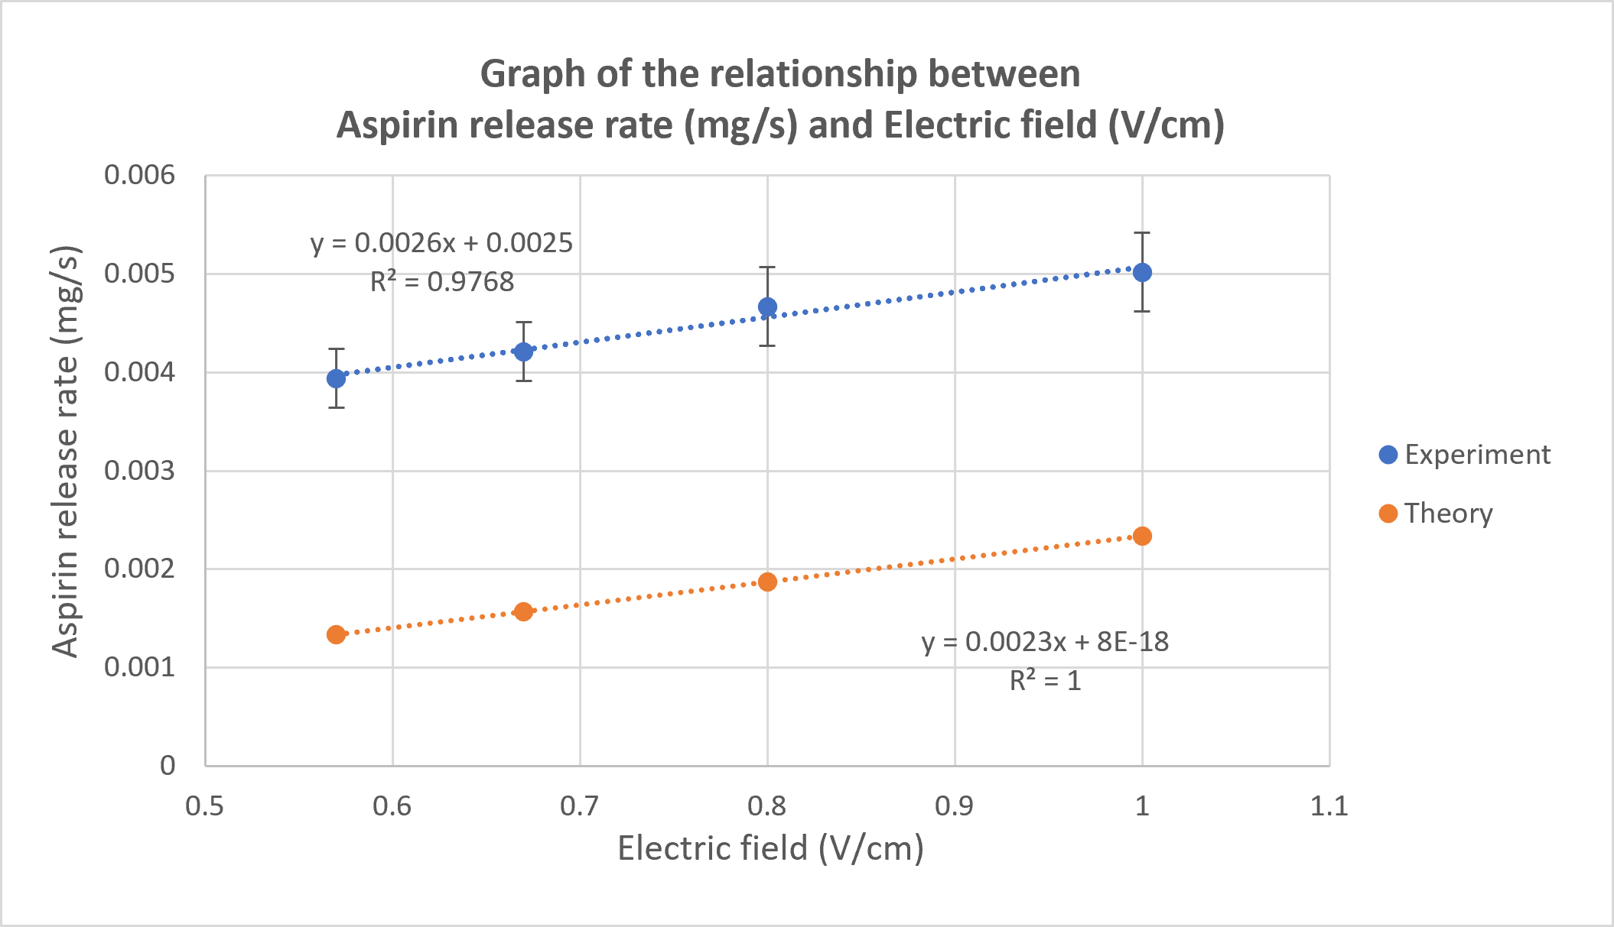
Fig. 3 Show the relationship between the aspirin release rate (mg/s) of chitosan-coated magnetite nanoparticles containing aspirin and the applied magnetic field (V/cm).
$J=(μCE-D\frac{dC}{dx})$ (Eq. 2 Nernst–Planck Model)
Experimental results showed that in the absence of an electric field, the average drug release rate was 0.0024 mg/s and tended to decrease over time, consistent with Higuchi's model ($M\left(t\right)=k\sqrt{t}$) describing diffusion-controlled drug release (The exact value deviates from the Y-intercept of the experimental results graph by 4.16%.). In contrast, with the application of an electric field, the drug release rate clearly increased with electric field intensity in a linear relationship (R² = 0.9768 with 13.04% of error from the slope of theory trend, p < 0.001), demonstrating that the electric field is a stimulating factor that enhances drug release. Therefore, this difference provides evidence that electric fields can increase the drug release rate and effectively transition the system from natural release to externally controlled release.
4) Developing a model of drug delivery systems under pulsatile blood flow for application in the thrombosis treatment.
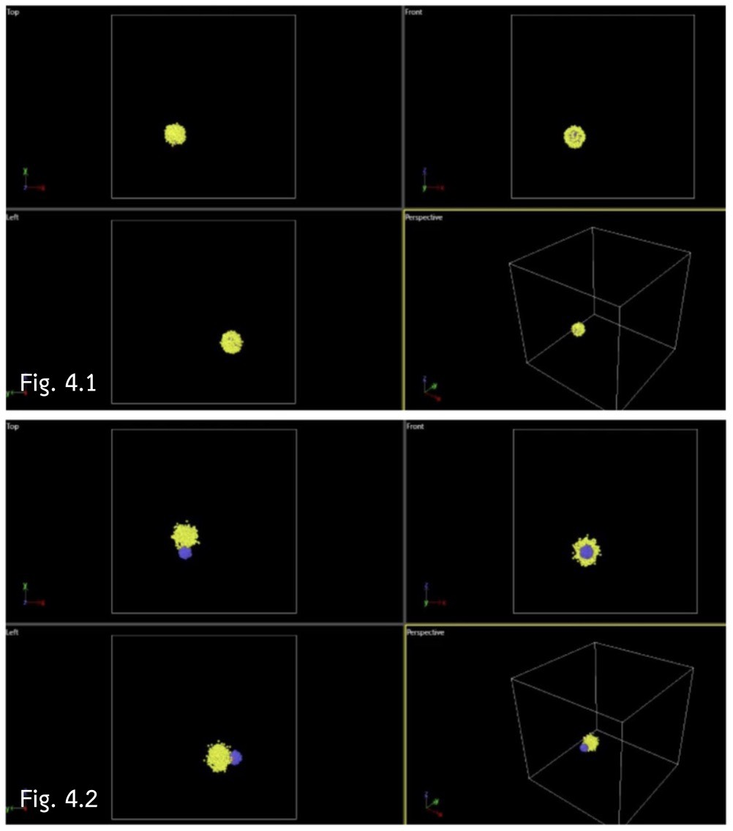
Fig. 4 Show the LAMMPS model of an aspirin (yellow) delivery system using chitosan-coated (blue) magnetite nanoparticles (red) under various forces conditions and pulsatile blood flow, comparing cases with (Fig. 4.2) and without (Fig. 4.1) an electric field-activated aspirin release rate (scale ratio based on experimental results).
The phenomenon can be explained using the following equation (under pulsatile blood flow with magnetic and electric field):
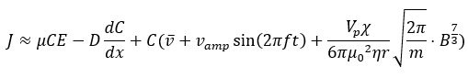
(Eq. 3 Fluxion_DDS Model)
From Eq. 3, the transport of aspirin released from chitosan-coated magnetite nanoparticles was approximated using a modified Nernst–Planck equation that combines normal diffusion according to Higuchi model, electromigration under an applied electric field, convective transport due to pulsatile blood flow represented by a sinusoidal velocity profile, and magnetophoretic motion under an external magnetic field with drag force due to the viscosity of the blood. As thrombus formation reduces the effective vascular cross-sectional area, local blood velocity changes according to the continuity principle ($Q=Av$), altering nanoparticle transport and the spatial distribution of released aspirin. Therefore, the proposed equation provides an approximate description of aspirin transport under physiological thrombotic conditions and provides a framework of targeted drug delivery systems.

Conclusions
Fluxion_DDS successfully demonstrated the feasibility of an externally controllable drug delivery platform. A chitosan concentration of 2.500 mg/mL produced the most stable nanoparticles (p < 0.001), while ATR-FTIR confirmed successful chitosan coating and aspirin encapsulation. Although the PDI exceeded the recommended value (0.300), this was likely due to the simplified co-precipitation synthesis procedure. The synthesized nanoparticles exhibited strong magnetic responsiveness, showing good agreement with the magnetophoresis model (R² = 0.9251, p < 0.001). Under normal conditions, aspirin release followed the Higuchi drug release model, whereas an external electric field significantly enhanced the release rate in excellent agreement with the Nernst–Planck model (R² = 0.9768, p < 0.001), demonstrating the transition from passive to externally controlled release. These experimentally validated parameters were incorporated into a LAMMPS simulation under pulsatile blood flow, providing a foundation for predicting nanoparticle transport under thrombotic conditions and supporting the future development of targeted drug delivery systems for thrombosis treatment.

Acknowledgments
Special thanks to Teacher Siriwimon Wangwong (project advisor) and Sceintific Equipment Center Ubon Ratchathani University for advice and data analysis. We also thank Princess Chulabhorn Science High School Mukdahan, for support in carrying out this study.

References
Kanhakeaw et al. (2011). Stabilization of magnetite nanoparticle with chitosan and chitosan network. NU. International Journal of Science, 7(2), 60-70. Retrieved August 25, 2025, from, https://scispace.com/pdf/stabilization-of-magnetite-nanoparticle-with-chitosan-and-1ahladbs9l.pdf.
Schuerle et al. (2013). Three-dimensional magnetic manipulation of micro- and nanostructures for applications in life sciences. IEEE Transactions on Magnetics. 49(1): 321–325. Retrieved August 25, 2025, from https://ieeexplore.ieee.org/document/6392417.
Shi et al. (2014). Experimental and mathematical studies on the drug release properties of aspirin loaded chitosan nanoparticles. BioMed Research International. 2014. Retrieved August 25, 2025, from https://pubmed.ncbi.nlm.nih.gov/24987696.
Womersley, J. R. (1955). Method for the calculation of velocity, rate of flow and viscous drag in arteries when the pressure gradient is known. The Journal of Physiology. 127(3): 553–563. Retrieved August 25, 2025, from https://pubmed.ncbi.nlm.nih.gov/14368548.

