Valorization of Orchid Waste for the Synthesis of Sulfur-Doped Carbon Quantum Dots for Paper-Based Fluorescent Sensors in Organophosphate Detection

Kantapitch Wanarat¹*, Kamolrat Wiboljak¹
Khunthong Klaythong¹ and Voranut Thongpool²
1Princess Chulabhorn Science High School Pathum Thani,
51 Village No. 6, Bo Ngoen Sub-district, Lat Lum Kaeo District, Pathum Thani 12140, Thailand
2Rajamangala University of Technology Thanyaburi
39 Village No, Rangsit-Nakhon Nayok Road, Khlong Hok, Khlong Luang, Pathum Thani 12120, Thailand
*E-mail: wkantapitch@gmail.com

Abstract
The presence of organophosphate (OPs) residues in vegetables and fruits is a food safety issue that affects both human health and the environment. Therefore, the development of effective methods for detecting such residues is necessary. This project aimed to develop a paper-based sensor coated with carbon quantum dots (CQDs) derived from orchid flower waste for the detection of OPs. The effects of various hydrothermal synthesis conditions were investigated. The results showed that the optimal condition was 200 °C for 5 hours, which produced CQDs with a well-developed carbon core and the highest fluorescence intensity. Nitrogen and sulfur doping were studied, and the results indicated that sulfur-doped CQDs (S-CQDs) exhibited the highest performance in responding to OPs. Specificity tests against other pesticide types showed that S-CQDs responded most specifically to OPs. In addition, the fluorescence intensity of CQDs decreased significantly with increasing concentrations of OPs. Based on this finding, a paper-based sensor was further developed to enhance its suitability for field applications. The results showed that immersing the paper in 2.25% (w/v) S-CQDs for 40 minutes yielded the highest fluorescence intensity. Upon exposure to OPs, clear changes in RGB values were observed. These findings demonstrate that the developed paper-based sensor can be used as a material for the accurate and rapid detection of OPs and has potential for practical applications. Furthermore, it adds value to waste materials and supports food safety management at both community and industrial levels.
keywords: Carbon quantum dots, Organophosphates, Pesticide residue, Orchid waste

Introduction
Organophosphate pesticides (OPs) are widely used in agriculture because of their high efficiency in pest control. However, their residues can harm human health and the environment. The World Health Organization (WHO) estimates that more than three million people suffer from pesticide poisoning each year (Kaushal et al., 2021). In Thailand, the continued use of OPs increases the risk of contamination in agricultural

products. Although analytical methods such as Gas Chromatography (GC) and High-Performance Liquid Chromatography (HPLC) are highly accurate, they require costly equipment and lengthy analysis (Mahmoudi et al., 2023)
Carbon Quantum Dots (CQDs) are fluorescent nanomaterials with excellent optical properties and high sensing potential. Sulfur doping has been shown to enhance their sensitivity toward organophosphate detection
(Jin et al., 2025). In addition, producing CQDs from orchid flower waste by the hydrothermal method adds value to agricultural waste and supports the circular economy. Combined with paper-based sensors, CQDs provide a low-cost and portable platform for on-site analysis (Sharma et al., 2025; Supchocksoonthorn et al., 2021).
However, visual interpretation of paper-based sensors may be affected by lighting conditions and human perception. Smartphone-based image analysis can improve the accuracy and reproducibility of detection (Zou et al., 2022). Therefore, this project investigates nitrogen- and sulfur-doped CQDs synthesized from orchid flower waste and develops a smartphone-assisted paper-based sensor for rapid, accurate, and low-cost detection of organophosphate pesticides, contributing to the Sustainable Development Goals (SDGs) related to health, sustainable production, and environmental protection.

Methodology
1. Optimization of CQD Synthesis
- Optimization of Hydrothermal Temperature
CQDs were synthesized from orchid flower waste at 150°C, 200°C, and 250°C. Optical properties

were characterized using UV–Vis and fluorescence spectroscopy.
- Optimization of Reaction Time
The optimum synthesis temperature was applied while varying the hydrothermal reaction time (3, 5, and 7 h) to determine the optimal condition.
- Optimization of Heteroatom Doping
Pure CQDs, N-CQDs, S-CQDs, and N,S-CQDs were synthesized using EDTA and L-cysteine. Their optical properties, functional groups (FTIR), and morphology (TEM) were characterized.
2. Performance Evaluation for OPs Detection
- Fluorescence Response
The fluorescence responses of different CQDs toward chlorpyrifos were compared to determine the most sensitive sensing material.
- Selectivity and Sensitivity
The selectivity of CQDs against different pesticides and the concentration-dependent fluorescence quenching toward chlorpyrifos were evaluated. Calibration curves and the limit of detection (LOD) were determined.
3. Development of a Paper-Based Sensor
- Optimization of Paper Sensor Fabrication The effects of CQD coating concentration and immersion time on fluorescence intensity were optimized.
- Analytical Performance Evaluation
The optimized paper sensor was tested with different chlorpyrifos concentrations. Images were captured using a smartphone and analyzed with ImageJ to construct a calibration curve and evaluate detection accuracy.

Result and Discussion
1. Optimization of CQD Synthesis
(1) Optimization of Hydrothermal Temperature
CQDs synthesized at 200°C exhibited the highest fluorescence intensity and strongest UV–Vis absorption, indicating the optimal synthesis temperature.
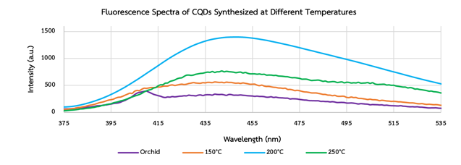
Graph 1 Fluorescence Spectra of CQDs at Different Synthesis Temperatures
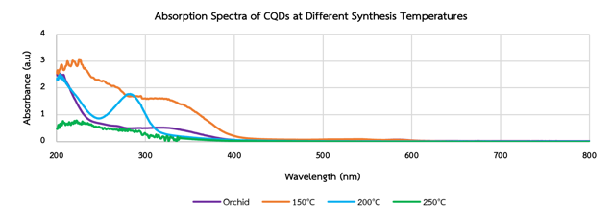
Graph 2 UV–Vis Absorption Spectra of CQDs at Different Synthesis Temperatures
(2) Optimization of Reaction Time
A hydrothermal reaction time of 5 h produced the highest fluorescence intensity, while 7 h resulted in sample drying.
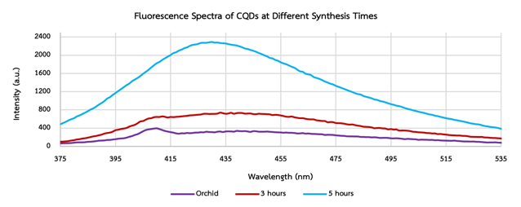
Graph 3 Fluorescence Spectra of CQDs at Different Synthesis Times
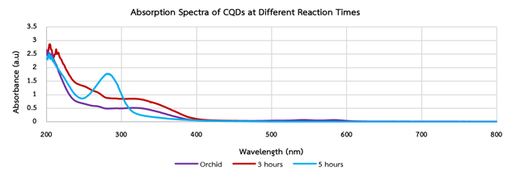
Graph 4 UV–Vis Absorption Spectra of CQDs at Different Reaction Times

(3) Optimization of Heteroatom Doping
S-CQDs showed the strongest fluorescence, while FTIR and TEM confirmed successful sulfur doping and nanoscale morphology.
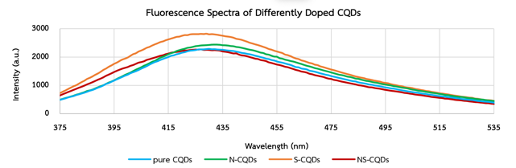
Graph 5 Fluorescence of CQDs with Different Dopants
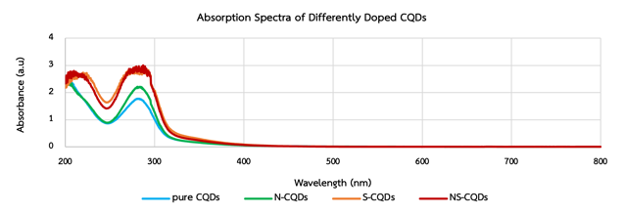
Graph 6 UV–Vis Absorption of CQD with Different Dopants
Figure 1 FTIR Spectrum of S-Doped CQDs
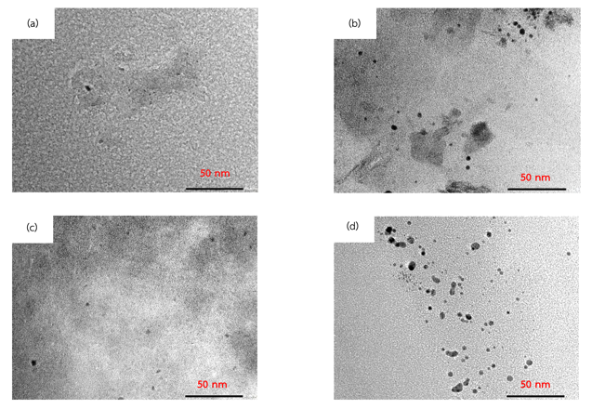
Figure 2 Transmission Electron Microscopy (TEM) Images of Differently Doped CQDs: (a) Pure CQDs, (b) N-CQDs, (c) S-CQDs, and (d) N,S-CQDs.

2. Performance Evaluation for OPs Detection
(1) Fluorescence Response
S-CQDs exhibited the greatest fluorescence quenching and rapid response

toward chlorpyrifos, with high selectivity over other pesticides.
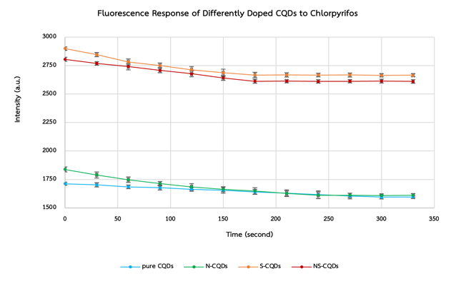
Graph 7 Changes in Fluorescence Intensity and Response Time of Differently Doped CQDs After Chlorpyrifos Add
(2) Selectivity and Sensitivity
S-CQDs achieved the best linearity
(R² = 0.9611) and the lowest limit of detection (53 nM), demonstrating superior sensing performance.
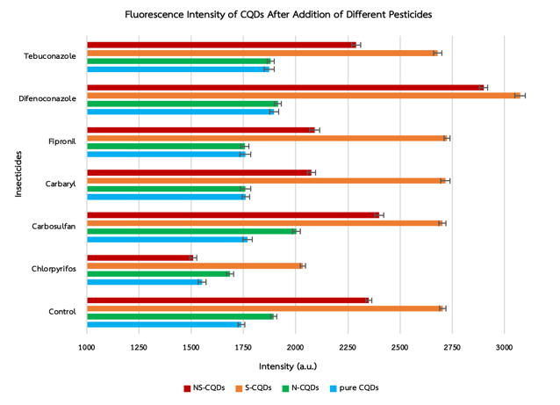
Graph 8 Fluorescence Response of CQDs to Pesticides
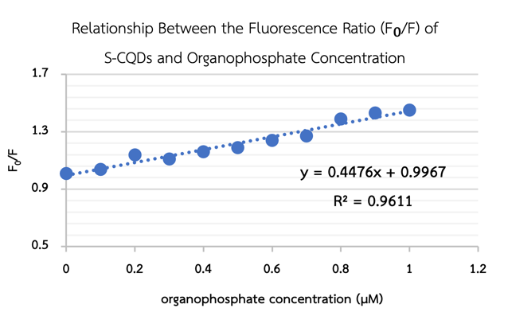
Graph 9 Relationship Between the Fluorescence Ratio (F₀/F) and Organophosphate Concentration for S-CQDs

3. Development of a Paper-Based Sensor
(1) Optimization of Paper Sensor Fabrication

The optimal paper sensor was prepared using 2.25% (w/v) S-CQDs with a 40 min coating time, producing the strongest fluorescence.
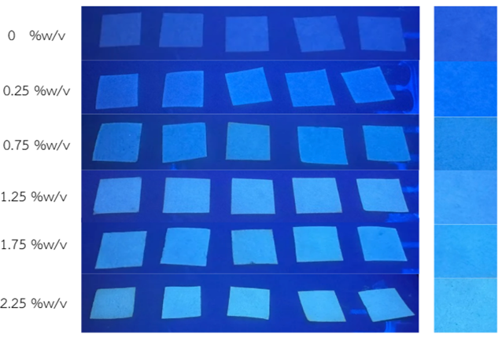
Figure 3 Fluorescence Images of Paper Sensors Coated with Different Concentrations of CQDs
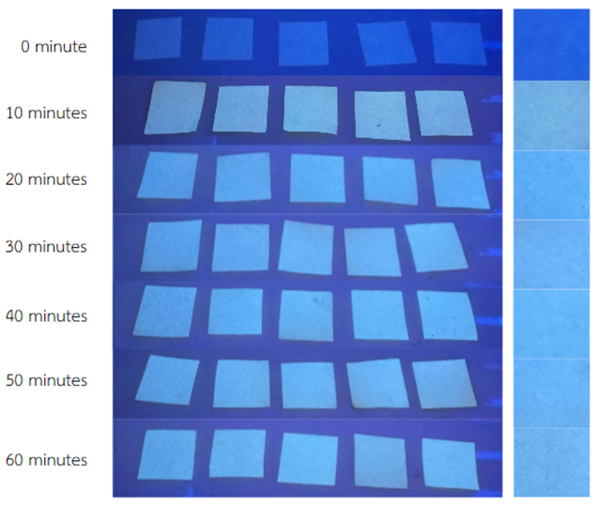
Figure 4 Fluorescence Images of Paper Sensors Coated for Different Immersion Times
(2) Analytical Performance Evaluation
The paper-based sensor showed an excellent linear relationship between RGB values and chlorpyrifos concentration (R² = 0.98), confirming its suitability for quantitative detection.
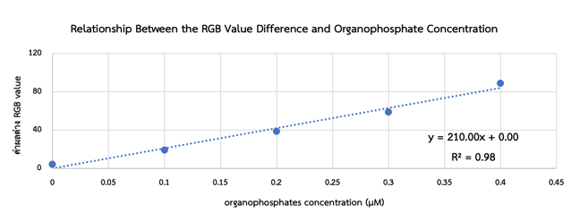
Graph 10 Relationship Between the RGB Value Difference of the Paper Sensor and Organophosphate Concentration

Conclusions
The present study successfully developed sulfur-doped Carbon Quantum Dots (S-CQDs) synthesized from orchid flower waste for rapid organophosphate pesticide detection. Optimization of the hydrothermal synthesis conditions revealed that 200°C and 5 h produced CQDs with the strongest fluorescence and well-developed carbon cores. Among the different doping strategies, S-CQDs exhibited the highest fluorescence intensity and favorable surface functional groups, demonstrating their suitability as fluorescent sensing materials.
The sensing performance of the developed CQDs was evaluated using chlorpyrifos as the target analyte. S-CQDs showed the fastest fluorescence response (3 min), the highest selectivity toward organophosphate pesticides, and the lowest limit of detection, with a strong linear relationship between the fluorescence ratio (F₀/F) and pesticide concentration (R² = 0.9611). FTIR analysis further confirmed the interaction between S-CQDs and organophosphate molecules, indicating that sulfur doping significantly enhanced sensing performance.
A paper-based fluorescent sensor was successfully fabricated using the optimized
S-CQDs. The optimal coating condition was achieved with 2.25% (w/v) S-CQDs and an immersion time of 40–60 min, providing the strongest fluorescence intensity. The developed paper sensor demonstrated excellent analytical performance, showing a linear correlation between the RGB value difference and organophosphate concentration (R² = 0.98),

enabling quantitative detection using smartphone-based image analysis.
Overall, the developed S-CQD paper-based sensor provides a rapid, sensitive, low-cost, and portable platform for organophosphate detection. By converting orchid flower waste into high-value fluorescent nanomaterials, this work supports sustainable waste valorization, field-based food safety monitoring, and the achievement of the Sustainable Development Goals (SDGs), particularly SDG 3 (Good Health and Well-being), SDG 12 (Responsible Consumption and Production), and SDG 15 (Life on Land).

Acknowledgments
The authors would like to express their sincere gratitude to Mr. Khunthong Klaithong, the project advisor, for his invaluable guidance, insightful advice, and continuous support throughout this research. The authors also gratefully acknowledge Associate Professor Dr. Woranut Thongpool, Department of Physics, Faculty of Science and Technology, Rajamangala University of Technology Thanyaburi, for providing laboratory facilities, research equipment, technical assistance, and valuable recommendations. Special thanks are extended to Dr. Samorn Patho, Director of Princess Chulabhorn Science High School Pathum Thani, for granting permission and supporting this research. The authors also gratefully acknowledge the 28th Young Scientist Competition (YSC 2026), supported by the National Science and Technology Development Agency (NSTDA) and the National Research Council of Thailand (NRCT), for providing financial support for this project.

References
Aladesuyi, O. A., & Oluwafemi, O. S. (2023). Synthesis of N, S co-doped carbon quantum dots (N,S-CQDs) for sensitive and selective determination of mercury (Hg²⁺) in Oreochromis niloctus (Tilapia fish). Inorganic Chemistry Communications, 153, 110843. https://doi.org/10.1016/j.inoche.2023.1 10843
Baker, S. N., & Baker, G. A. (2010). Luminescent carbon nanodots: Emergent nanolights. Angewandte Chemie International Edition, 49(38), 6726–6744.
https://doi.org/10.1002/anie.200906623
Campos, E., & Freire, C., (2016). Exposure to non-pesticides and thyroid function: A systematic review of epidemiological evidence. International Journal of Hygiene and Environment Health, 216(2), 1 – 48. https://doi.org/10.1016/j.ijheh.2016.
Dvir, H., Silman, I., Harel, M., Rosenberry, T. L., & Sussman, J. L. (2010). Acetylcholinesterase:
From 3D structure to function. Chemico-Biological Interactions, 187, 10 – 22.

https://doi.org/10.1016/j.cbi.2010.01.04
Jin, M., Lee, S., Lim, S. B., Lee, M., Park, J., Jung, H. D., Kang, M. H., & Na., K. (2025). Sulfur- Doped Carbon Dots as a Highly Selective and Sensitive Fluorescent Probe for Copper Ion Detection in Biological Systems. Small, https://doi.org/10.1002/smll.202410765
Kaushal, J., Khatri, M., & Arya, S. K. (2021). A treatise on Organophosphate pesticide pollution: Current strategies and advancements in their environmental degradation and elimination. Ecotoxicology and Environmental Safety, 207, 111483. https://doi.org/10.1016/j.ecoenv.2020.11 1483
Kazemi, M., Navarchian, A. H., & Ahangaran, F. (2023). Effects of silica surface modification with silane and poly(ethylene glycol) on flexural strength, protein-repellent, and antibacterial properties of acrylic dental nanocomposites. Dental Materials, 39(10), 863 – 871.

