NeuroTect: Intelligent Cerebral Artery Stenosis Detection from MRI via Deep Learning and Topological Data Analysis
Bunyakon Mungmetanapiboon ¹ , Teeraphat Puksap ¹ and Atiwarawat Panphanoun ^{1*}
Advisor : Sonruedee Srisawat¹ and Dr.Supreeya Phoethong ²
¹Princess Chulabhorn Science High School Phetchaburi, Kao-Yai, Cha-Am, Phetchaburi 76120, Thailand
² Hua-Hin Hospital, Hua-Hin, Hua-Hin, Phetchaburi 77110, Thailand
*E-mail: 67atiwarawat.pan@pccphet.ac.th

Abstract

According to the 2021 report of the World Health Organization (WHO), stroke is the third leading cause of death worldwide and continues to rise. This project aims to develop a system for analyzing cerebral artery stenosis from T2-weighted Magnetic Resonance Imaging (MRI-T2) by integrating deep learning techniques with Topological Data Analysis (TDA) to improve accuracy and the localization of abnormalities in medical images. MRI-T2 images are first processed using a U-Net convolutional neural network (U-Net CNN) for segmentation, after which the results are analyzed through two approaches: structural assessment based on radial changes and topological analysis via TDA. Extracted features are converted into risk scores ranging from 0 to 1, and the two scores are averaged to produce an overall risk estimate. The findings show that combining deep learning with TDA effectively identifies and segments stenotic regions with high spatial accuracy, with detected locations closely matching the true pathological areas on MRI-T2 images as confirmed by radiology experts. This demonstrates the potential of integrating artificial intelligence (AI) and TDA to support future medical diagnostics.

Keyword : stenosis MRI-T2 TDA U-Net CNN

Introduction
Stroke remains a severe and growing global health problem, particularly in developing countries. According to World Health Organization data from 2021, stroke is the third leading cause of death worldwide. A key contributing factor is cerebral artery stenosis, which is often associated with high-risk lifestyle behaviors such as consumption of high-fat diets, chronic stress, physical inactivity, and underlying conditions including hypertension, diabetes, and dyslipidemia. T2-weighted Magnetic Resonance Imaging currently plays a critical role in accurately detecting structural abnormalities of the brain and its vasculature. At the same time, deep learning techniques have increasingly been applied to the analysis of medical images for diagnosing various conditions. However, deep learning still faces several limitations, including the need for large volumes of training data, high computational complexity, and practical constraints in real clinical deployment—factors that leave deep-learning-only approaches to medical image analysis prone to error. To address these limitations, the research team proposes a system for analyzing cerebral artery stenosis from MRI-T2 images that combines deep learning with Topological Data Analysis. TDA, as a mathematical tool, is capable of extracting structural patterns from complex data even under limited data availability, without relying on a large number of parameters. Applying TDA alongside deep learning to the analysis of cerebral artery MRI-T2 images therefore has strong potential for characterizing abnormal vascular structures and precisely localizing sites of stenosis, thereby supporting early screening of at-risk patients and enabling physicians to plan treatment more effectively.

Methodology
1) Preliminary Research
The team studied approaches to using MRI-T2 images for the analysis of cerebrovascular disease, examined topological data analysis techniques—particularly their application to blood vessel structures and the derivable, applicable metrics—and reviewed and selected a CNN architecture suitable for processing medical images.

2) MRI Image Dataset Preparation
MRI-T2 images were fed into a U-Net convolutional neural network (U-Net CNN) to generate masks delineating the boundaries of the blood vessels. The model used was trained on a dataset of 505 files from the cerebral-artery-annotation research project. After obtaining a 3D model (Figure 2.2), a skeletonization technique was applied to reduce the structure to a one-dimensional central axis. This central axis represents the vessel's centerline, along which a set of points was subsequently placed. These coordinate points constitute the basic structural data used for the subsequent structural analysis.
3) Structural Analysis via TDA
The 3D model obtained from the previous step was converted into a point cloud representation (Figure 2.3) for use in stenosis detection. The (x, y, z) coordinates of the voxels identified as belonging to the blood vessel were used as input for Topological Data Analysis (TDA), through which persistence homology was computed. This study focuses on first-dimensional homology (H₁), which measures the number and size of holes (loops) present in the vascular structure. This computation relies on constructing a Vietoris–Rips complex filtration over the point cloud. The resulting persistence homology output is represented as a Persistence Barcode, which shows the lifespan of each topological feature in terms of its birth value and death value. The most significant value in the
Persistence Barcode is the highest death value, which is defined as the Critical Feature Value (CFV). This CFV can be used to compute the vessel radius at the site of stenosis using the following relationship, where r_st denotes the vessel radius at the stenotic site and r_healthy denotes the vessel radius under normal (healthy) conditions:
$$CFV=1-r_{st}$$
Once the stenotic radius is obtained, the healthy vessel radius can be computed as:
$$CFV=r_{healthy}-r_{st}$$
The two radius values are then used to compute the percentage of vessel stenosis as:
$$stenosis = 100(1 - \frac{r_{st}}{r_{health}})$$
4) Structural Analysis via Radial Deviation
The researchers carried out a field survey to study the survival of seagrass on Modtanoi Beach in Koh Libong Subdistrict, Kantang District, Trang Province. They also interviewed Ban Modtanoi local community tourism business to investigate the issue of declining seagrass density. This prompted the creation of a research project that aimed to create a seagrass planting process using natural materials to anchor the plants, thereby increasing their rates of survival and promoting growth. The study further included a soil quality analysis prior to and after seagrass planting. Four techniques form the created seagrass planting process, which are outlined as below: Bamboo quadrat, Sugarcane pot, Sugarcane pot and Bamboo quadrat, and Traditional wooden stake, and a Control group.
The researchers conducted a field experiment where seagrass was planted using four constructed planting methods together with one control group. The experimental sites were placed at three different locations: Site 1, 200 meters from the shoreline; Site 2, 250 meters from the shoreline; and Site 3, set up at 300 meters from the shoreline. In each location, seagrass was cultivated using each technique in triplicate, and the growth rate and survival rate were measured. This measurement involved leaf length, leaf width, and leaf number, over a three-month period from September to December 2024. The data were subsequently analyzed to derive results.
5) Fusion of Statistical Results with TDA
The system was evaluated using the following test results.
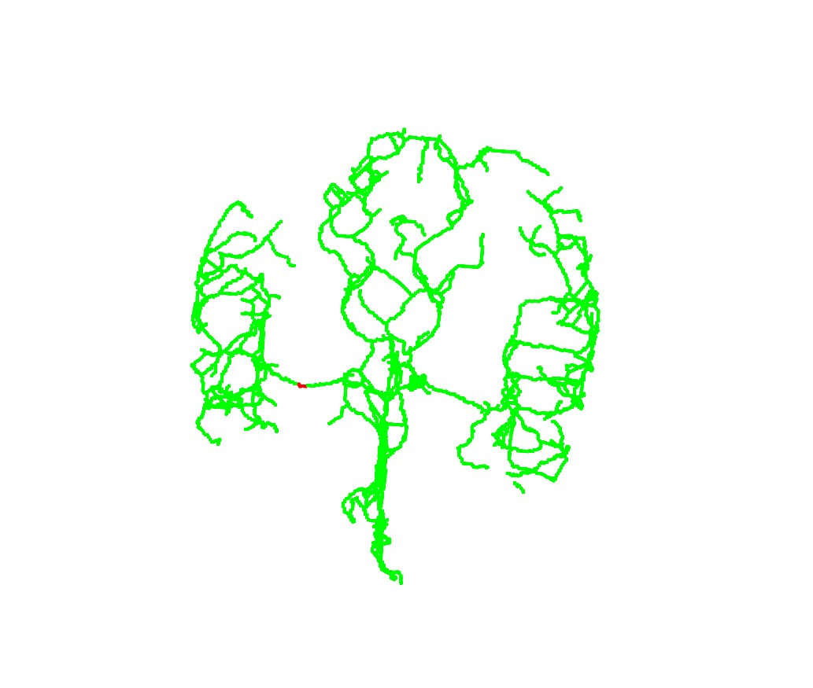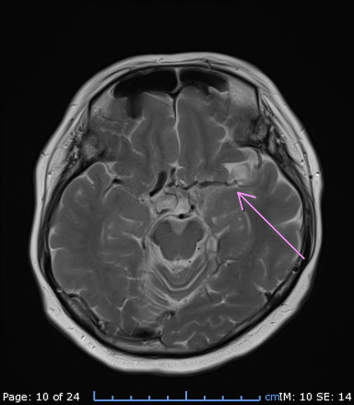
Figure 3.1 Detected points (left) and location of vessel stenosis (right) — Subject 1
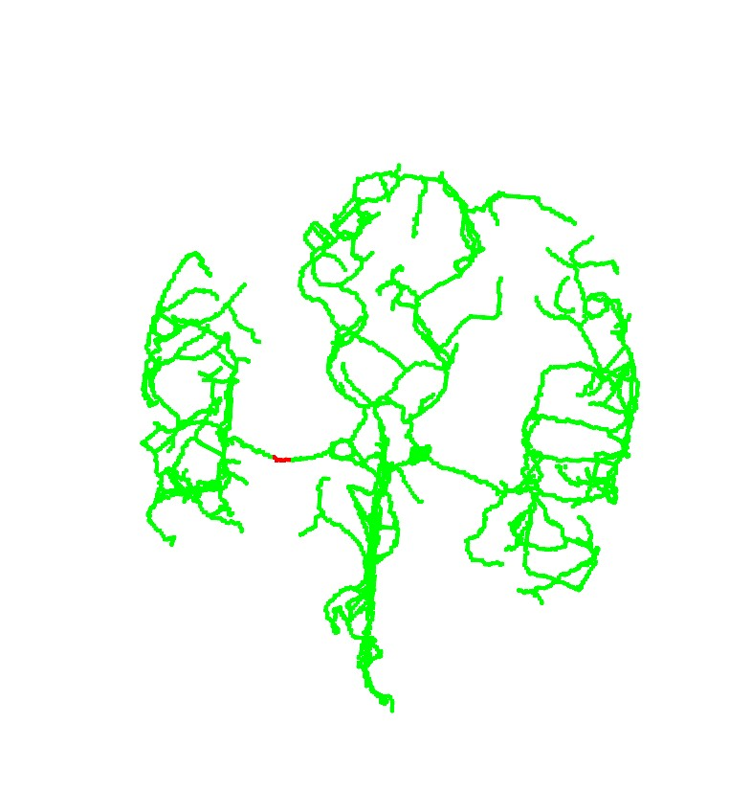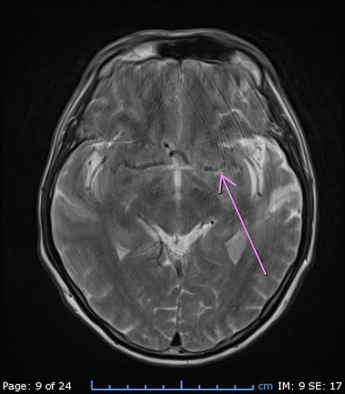
Figure 3.2 Detected points (left) and location of vessel stenosis (right) — Subject 2

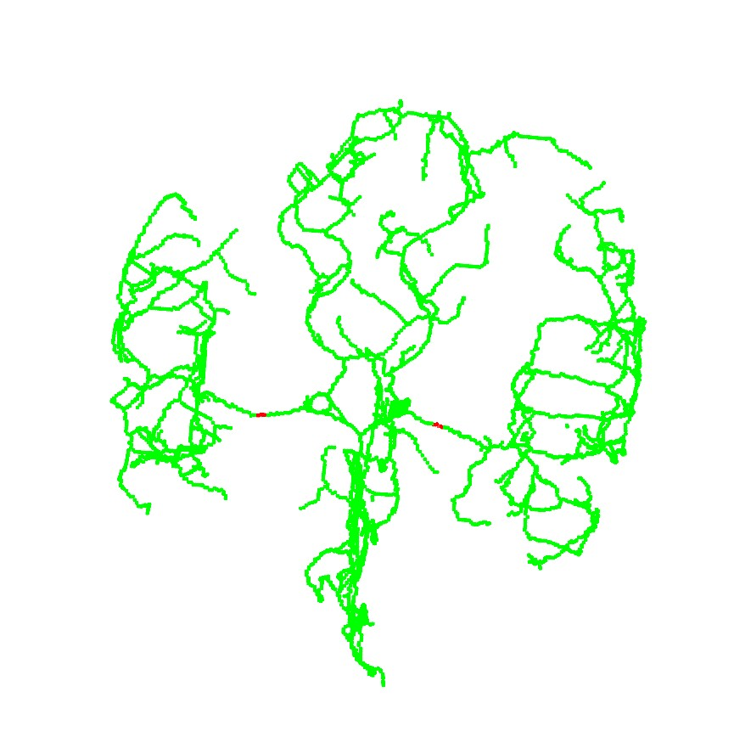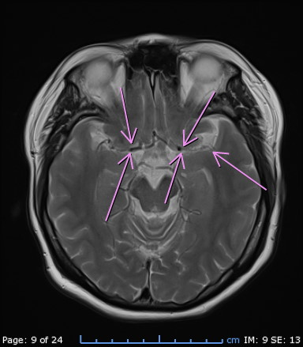
Figure 3.3 Detected points (left) and location of vessel stenosis (right) — Subject 3
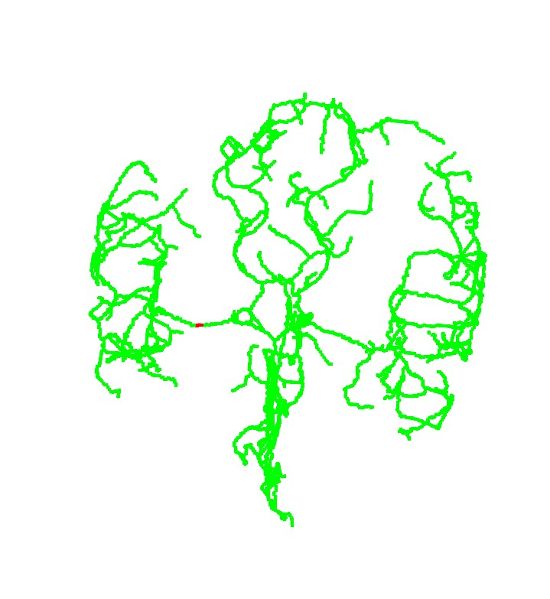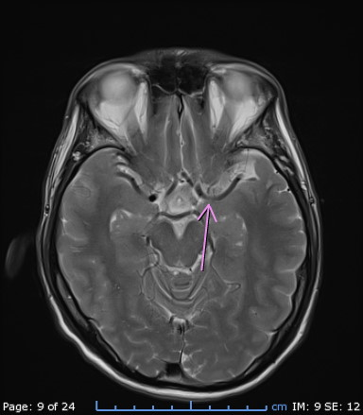
Figure 3.4 Detected points (left) and location of vessel stenosis (right) — Subject 4
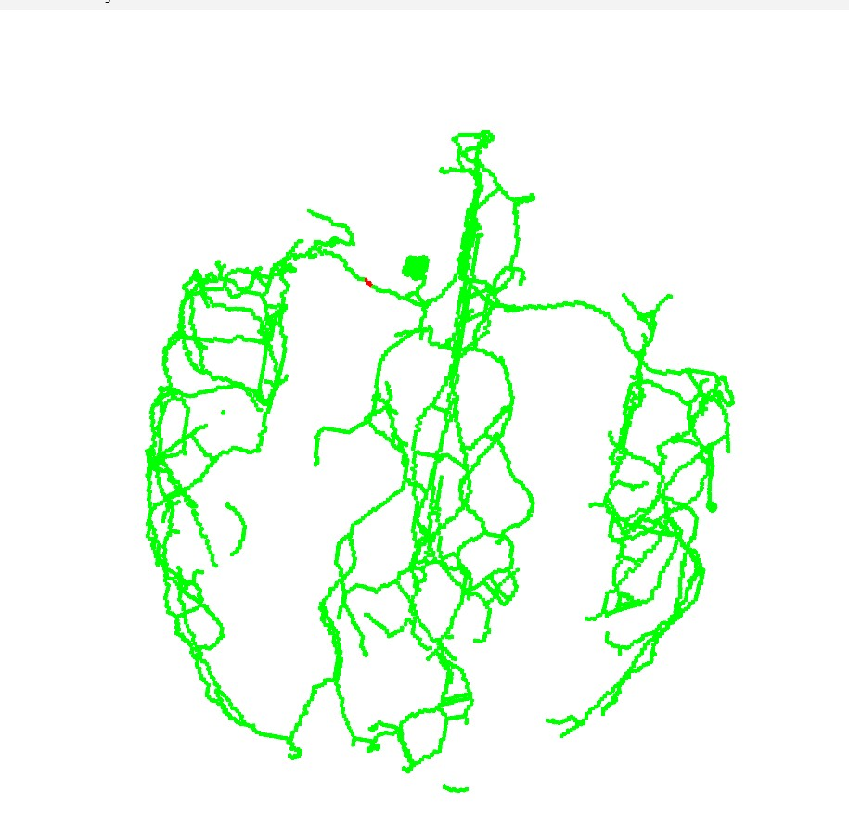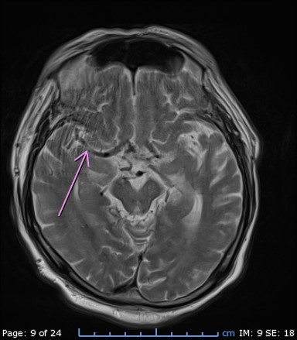
Figure 3.5 Detected points (left) and location of vessel stenosis (right) — Subject 5
Evaluation of the developed NeuroTect system showed that its spatial risk localization results were highly consistent with the assessments and diagnoses made by radiology specialists, confirming the system's accuracy in interpreting MRI-T2 image data. In particular, with respect to spatial accuracy, the locations detected by the system corresponded closely to the actual pathological sites on MRI-T2 images that had been confirmed and delineated by experts. Nevertheless, slight deviations were observed at the boundaries of the detected regions in some areas—discrepancies on the order of individual pixels—likely attributable to the complexity of the image signal near lesion edges.

Result and Discussion
The application of Topological Data Analysis (TDA) together with Distance Transform for localizing abnormalities on T2-weighted MRI images proved highly successful in the experiments, correctly and precisely identifying locations in all 5 of the 5 test datasets. These results clearly demonstrate that the system can accurately determine the coordinates of regions of interest with strong agreement to the reference locations. Two main factors contributed to this high accuracy and low error rate. The first is the Distance Transform process: the experimental results indicate that the coordinates measured by the developed algorithm closely matched the locations identified by expert physicians, with only minor pixel-level discrepancies likely arising from differences in how the centroid was determined across images of varying resolution, or from uneven intensity gradients in certain regions of the MRI. However, because Distance Transform converts the image into a distance map, it effectively suppresses such noise and more clearly reveals the central axis of the structure, thereby reducing the error associated with manual visual localization and yielding coordinates of high accuracy.
A second important factor is the use of topological (TDA) features. The experimental results show that localization accuracy did not depend solely on the completeness of the geometric shape, since errors reported in other studies are often caused by lesions on MRI images not conforming perfectly to idealized circular or elliptical shapes as assumed in standard geometric formulas. By incorporating TDA, the system gains the ability to detect persistent structural features (persistence homology), meaning that even when an abnormal region is irregular or asymmetric in shape, the system can still accurately process and identify the central axis position as well as the underlying structural relationships within the data.

Conclusions
In summary, this study confirms the success of an integrated approach that combines the image segmentation output of a U-Net convolutional neural network (U-Net CNN) with the structural analysis tool of Topological Data Analysis (TDA). This combination has proven to be a robust and reliable approach, yielding risk-assessment results with an acceptable level of accuracy for vascular structural analysis. Nevertheless, a significant limitation was identified during the subsequent, highly complex stage of 3D data processing—specifically, the stage requiring a skeletonization library to reduce the structure. The use of this library was found to be a major source of error in the final results, stemming from inaccuracies in identifying the central axis of the vascular structure. This underlying deficiency inevitably propagated forward, affecting the subsequent topological analysis stage as well.

Acknowledgments
This research project involved multiple stages, from background research and experimentation to data analysis and the preparation of this report, all of which were completed successfully with the assistance and guidance of many individuals. The research team wishes to thank Advisor Sonrudee Srisawat and Special Advisor Dr. Supreeya Phothong (M.D.) for their support, information, and guidance, which were essential to the completion of this project. The team also thanks Mr. Setthapong Kimphai, a senior student, for his continual advice and information that facilitated the project's progress, as well as Princess Chulabhorn Science High School Phetchaburi for its support of this project.

References
Bualabs. (2026)
Convolutional Neural Network (CNN): How CNN/ConvNet Works with the MNIST Dataset. Retrieved February 2, 2026, form https://www.bualabs.com/?p=2461
Gidea M and Katz Y. (2020, January).
Topological data analysis of vascular disease: A theoretical framework. Frontiers in Applied Mathematics and Statistics. 6(34): 1-9.
Hajij M, Zamzmi G, Batayneh F and Kim S. (2021).
TDA-Net: Fusion of persistent homology and deep learning features for COVID-19 detection from chest X-ray images. IEEE Transactions on Medical Imaging
RISC-MI. (n.d.).
Cerebral artery annotation. Retrieved from https://github.com/risc-mi/cerebral-artery-annotation
Wu S. (2023).
Cerebral blood flow predicts multiple demand network activity and fluid intelligence across the adult lifespan. NeuroImage.
Zhang B. (2020).
Cerebrovascular segmentation from TOF-MRA using model- and data-driven method via sparse labels. Neurocomputing.

