Innovation of High-Performance Nano Titanium Dioxide-Coated Wallpaper with Light-Diffusing Properties for Enhanced Brightness and Bacterial Reduction in Dental Room
TH Sarabun New 14 หนา

Nichapha Panbankled¹ and *Manunyapon Pimnoi¹
Chorruk Wongsawan¹, Ekasith Somsook² and Chiraporn Auechalitanukul³
¹Princess Chulabhorn Science High School Pathum Thani Village No.6, Bo Ngoen, Lat Lum Kaeo District, Pathum Thani 12140, Thailiand
²Mahidol University 272 Rama VI Rd., Ratchathewi District, Bangkok 10400, Thailand
³King Mongkut’s University of Technology Thonburi 126 Pracha Uthit Rd., Bang Mod,
Thung Khru District, Bangkok 10140, Thailand
*e-mail: manunyapon.pim@pcshspt.ac.th

Abstract

Dental clinics require a clean environment with adequate illumination to support dental procedures and reduce the risk of bacterial contamination in both the air and on wall surfaces.
This study aimed to develop high-performance titanium dioxide (TiO₂) nanoparticle-coated wallpaper capable of enhancing light diffusion and reducing bacterial accumulation in dental clinics.
TiO₂ nanoparticles were synthesized using the sol-gel method and mixed with acrylic resin before being coated onto wallpaper by the doctor blade coating technique. Four TiO₂ concentrations (0, 1, 3, and 5 wt%) were investigated. The performance of the coated wallpaper was evaluated in three aspects: (1) photocatalytic activity using methylene blue as an indicator of organic degradation, (2) antibacterial performance by determining the number of airborne bacterial colonies cultured on agar plates inside a simulated chamber, and (3) light diffusion performance by measuring the increase in illumination using a lux meter. The results showed that the wallpaper coated with 3 wt% TiO₂ exhibited the highest photocatalytic activity, achieving the greatest degradation of organic compounds, and significantly reduced the number of bacterial colonies. In addition, it improved light diffusion and increased the illumination level inside the simulated chamber compared with uncoated wallpaper without requiring additional electrical energy. Furthermore, this project supports several United Nations Sustainable Development Goals (SDGs), including SDG 3 (Good Health and Well-being), SDG 9 (Industry, Innovation and Infrastructure), SDG 11 (Sustainable Cities and Communities), SDG 12 (Responsible Consumption and Production), and SDG 13 (Climate Action). Therefore, TiO₂ nanoparticle-coated wallpaper has strong potential as an interior wall material for dental clinics to promote hygiene, improve lighting efficiency, and support the sustainable use of resources.
Keywords: TiO₂ nanoparticle-coated wallpaper; photocatalysis; light diffusion; antibacterial activity; dental clinic

Introduction
Dental clinics require a clean and well-lit environment to ensure accurate treatment and minimize the risk of cross-infection. Dental procedures generate aerosols through high-speed hand-pieces and air–water syringes, facilitating the spread of airborne microorganisms. Previous studies identified seven major bacterial genera in dental clinics, including Pseudomonas stutzeri, Staphylococcus spp., Streptococcus spp., Micrococcus spp., Enterobacter spp., Escherichia coli, and Bacillus spp., with Bacillus spp. accounting for 24% of all isolates. The average airborne bacterial concentration also exceeded the WHO indoor air quality guideline of 500 CFU/m³, emphasizing the need for improved infection control. Adequate illumination is equally important for clinical accuracy and visual comfort. Thai standards recommend a minimum illuminance of 2,400 lux in dental treatment areas, which is commonly achieved using LED or fluorescent lamps with a correlated color temperature of 4,000–5,000 K, leading to substantial electricity consumption. Although wallpaper is widely used to improve the indoor atmosphere, conventional wallpaper provides neither antibacterial activity nor enhanced light distribution. Consequently, frequent disinfection with alcohols, glutaraldehyde, or hydrogen peroxide is required, which may release volatile organic compounds (VOCs) in enclosed spaces. Titanium dioxide (TiO₂) is a promising n-type semiconductor widely recognised for its photocatalytic activity, enabling the degradation of organic pollutants and the inactivation of microorganisms under light irradiation. In addition, its high refractive index (approximately 2.5) enhances visible light scattering and reflection, making TiO₂ suitable for improving indoor illumination without increasing electrical energy consumption. Therefore, this study aims to develop a TiO₂ nanoparticle-coated wallpaper capable of simultaneously enhancing light diffusion and reducing bacterial accumulation in dental clinics. The proposed material is expected to improve hygiene, reduce electricity consumption, and decrease the use of chemical disinfectants, contributing to a safer and more sustainable healthcare environment.
Methodology
Synthesis and Characterization of TiO₂ Nanoparticles TiO₂ nanoparticles were synthesized using the sol–gel method in a controlled chamber maintained at 26°C and 40% relative humidity to ensure uniform particle formation. First, 40 mL of titanium isopropoxide (TTIP, Ti[OCH(CH₃)₂]₄) was diluted in 240 mL of isopropanol (C₃H₈O) under continuous magnetic stirring. The precursor solution was then added dropwise at approximately 50 drops min⁻¹ into 640 mL of deionized water containing 1.5 mL of 1 M nitric acid (65% HNO₃), producing a white TiO₂ precipitate. The suspension was stirred at 100°C for 3 h and centrifuged at 7,000 rpm for 15 min to collect the precipitate. The obtained powder was annealed at 150°C overnight to remove residual organic compounds and improve crystallinity, followed by calcination at 500°C for 1 h in air. The resulting white powder was ground into TiO₂ nanoparticles. The synthesized TiO₂ nanoparticles were characterized using X-ray diffraction (XRD) to determine their crystal phase and UV–Vis–NIR spectrophotometry to evaluate their optical properties and estimate the band gap.
Coating of TiO₂ Nanoparticles onto Wallpaper and Plastic Substrates Wallpaper and transparent plastic sheets (30 × 30 cm) were divided into four experimental groups (A–D), corresponding to TiO₂ concentrations of 0, 1, 3, and 5 wt%, respectively. TiO₂ nanoparticles were mixed with acrylic resin using a ball mill for 30 min to ensure homogeneous dispersion, followed by ultrasonication for 5 min to reduce particle agglomeration. The suspension was then ball-milled for an additional 30 min. Before coating, the wallpaper surface was cleaned with alcohol. The prepared coating suspension was subsequently applied to the wallpaper and plastic substrates using a doctor blade coater.

Evaluation of Photocatalytic Activity The photocatalytic activity of TiO₂-coated samples was evaluated using methylene blue (MB, 2 mg L⁻¹, 50 mL) as the model pollutant. Transparent plastic substrates coated with 0, 1, 3, and 5 wt% TiO₂ were prepared, with the uncoated sample (0 wt%) serving as the control. Each experiment was performed in triplicate. Samples (1 × 2 cm) were immersed in the MB solution and kept in the dark for 30 min to establish adsorption–desorption equilibrium. The suspensions were then irradiated with a fluorescent lamp under fixed conditions. Aliquots (3.5 mL) were collected at 0 and 60 min, filtered through a 0.45 μm syringe filter, and analyzed using a UV–Vis spectrophotometer at λmax = 664 nm. The percentage of MB degradation was calculated to compare the photocatalytic performance of the different TiO₂ coatings.

Evaluation of Antibacterial Activity and Light Enhancement Performance The experimental chamber was disinfected with 70% ethanol before each trial. Uncoated wallpaper was used as the control, while TiO₂-coated wallpaper served as the treatment. Wallpaper samples (A–D) were installed in their corresponding chambers, and Petri dishes were placed at two predetermined positions. The chamber was opened to allow airborne bacteria to settle onto the agar surfaces, after which the light source was switched on and the chamber was sealed for 48 h. Bacterial colonies from both sampling positions were counted, and the average colony number and percentage of bacterial colonies relative to the initial condition were determined. Subsequently, illuminance inside each chamber was measured using a lux meter in triplicate, and the average illuminance was calculated for each treatment.
Result and Discussion

Characterization of Titanium Dioxide (TiO₂) Nanoparticles
- Crystal Phase Analysis of Titanium Dioxide Nanoparticles by X-ray Diffraction (XRD)
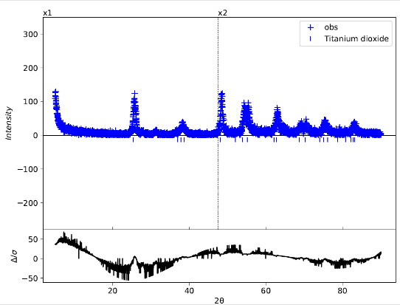
The crystal structure of the titanium dioxide (TiO₂) nanoparticles was analyzed using X-ray diffraction (XRD). The obtained XRD pattern exhibited characteristic diffraction peaks corresponding to TiO₂ nanoparticles, as shown in Figure 1.1.
Figure 1.1 X-ray diffraction (XRD) pattern of titanium dioxide (TiO₂) nanoparticles.
The XRD pattern showed several diffraction peaks at different 2θ positions. The major diffraction peak appeared at approximately 25.3°, corresponding to the (101) crystal plane of the anatase phase. Another prominent peak was observed at approximately 27.4°, corresponding to the (110) crystal plane of the rutile phase. Comparison with the standard reference data from the Joint Committee on Powder Diffraction Standards (JCPDS) confirmed that the synthesized TiO₂ nanoparticles consisted of a mixed crystalline phase of anatase and rutile.
- Optical Properties and Band Gap Analysis of Titanium Dioxide (TiO₂) Nanoparticles by UV–Vis–NIR Spectrophotometry
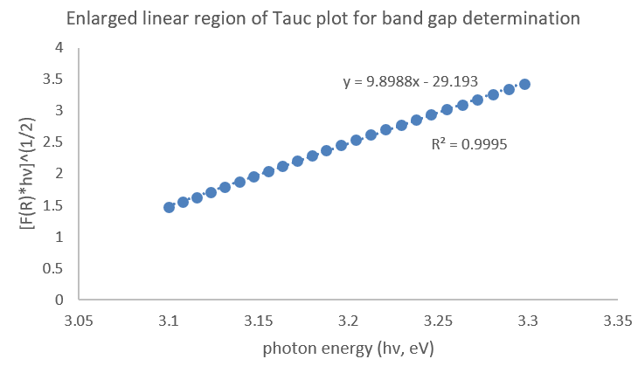
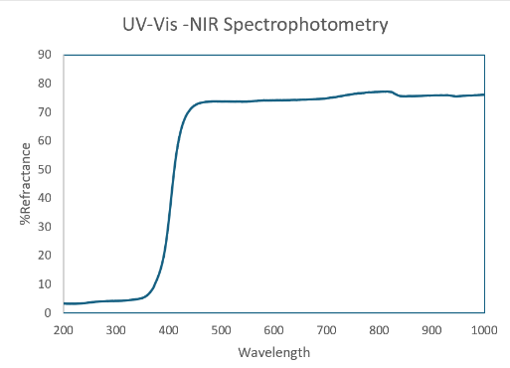
The optical properties of the TiO₂ nanoparticles were investigated by measuring their diffuse reflectance spectra (% Reflectance) over the wavelength range of 200–1000 nm. The reflectance decreased rapidly in the ultraviolet region. In addition, an absorption edge was observed at approximately 380–400 nm, indicating the onset of optical absorption. The reflectance spectrum is shown in Figure 1.2
Figure 1.2 Diffuse reflectance spectrum of titanium dioxide (TiO₂) nanoparticles.
The Tauc plot of the titanium dioxide (TiO₂) nanoparticles was constructed by converting the diffuse reflectance data using the Kubelka–Munk function. The relationship between [F(R)hν]¹ᐟ² and the photon energy (hν) was then plotted. The resulting graph showed an increase in [F(R)hν]¹ᐟ² with increasing photon energy, indicating an indirect allowed electronic transition. The Tauc plot is presented in Figure 1.3.
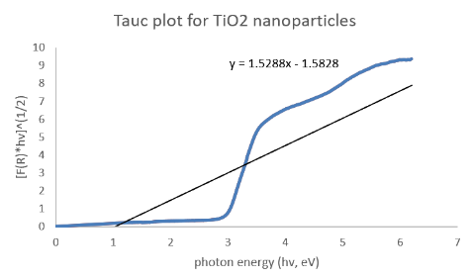
Figure 1.3 Tauc plot of titanium dioxide (TiO₂) nanoparticles.
Figure 1.4 shows the enlarged linear region of the Tauc plot used for determining the optical band gap energy. A linear fit was applied to the linear portion of the curve, and the intercept with the photon energy (hν) axis was used to estimate the band gap energy. Based on the fitted linear equation, the optical band gap of the titanium dioxide (TiO₂) nanoparticles was estimated to be approximately 2.95 eV.
Figure 1.4 Enlarged linear region of the Tauc plot used for determining the optical band gap of titanium dioxide (TiO₂) nanoparticles.
The crystal structure of the synthesized titanium dioxide (TiO₂) nanoparticles was characterized using X-ray diffraction (XRD). The results indicated that the synthesized material consisted of a mixed crystalline phase of anatase and rutile. The presence of this mixed-phase structure is consistent with previous reports indicating that TiO₂ nanoparticles can undergo partial phase transformation from the anatase phase to the rutile phase, depending on the synthesis conditions and heat treatment (Ba-Abbad et al., 2013).

Photocatalytic Performance of TiO₂-Coated Wallpaper
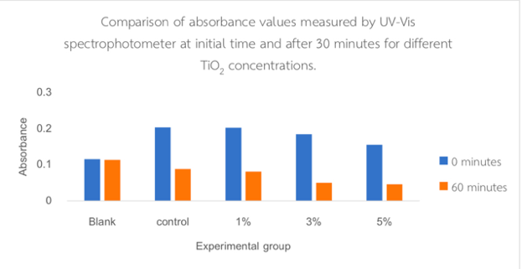
The photocatalytic activity of TiO₂-coated wallpaper was evaluated by monitoring the degradation of methylene blue (MB) under different TiO₂ concentrations (Blank, Control, 1%, 3%, and 5%). After reaching adsorption–desorption equilibrium, the absorbance of MB was measured at 664 nm using a UV–Vis spectrophotometer before irradiation and after 30 min of photocatalytic reaction. The initial absorbance values were 0.115, 0.203, 0.202, 0.184, and 0.155, which decreased to 0.113, 0.088, 0.081, 0.050, and 0.046, respectively (Figure 1.5).
Figure 1.5 Comparison of methylene blue solution absorbance at the initial time and after 30 min of photocatalytic reaction.
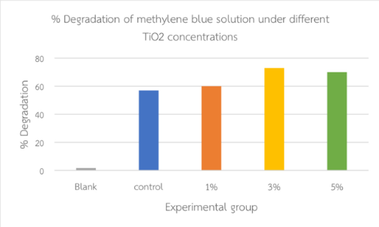
Based on these measurements, the corresponding MB degradation efficiencies were 1.7%, 57%, 60%, 73%, and 70%, respectively (Figure 1.6).
Figure 1.6 Comparison of the percentage degradation of methylene blue (MB) solution among different experimental groups.
The reduction in absorbance indicates the photocatalytic degradation of MB, consistent with the Beer–Lambert law, in which absorbance is directly proportional to dye concentration. One-way ANOVA revealed that TiO₂-coated samples (1%, 3%, and 5%) exhibited significantly greater MB degradation than the blank and control groups (p < 0.05), confirming the photocatalytic activity of TiO₂ (Fujishima et al., 2008). Among the tested concentrations, 3 wt% TiO₂ achieved the highest degradation efficiency (73%). Although the 5 wt% coating also showed high photocatalytic activity, its performance was not significantly different from that of the 3 wt% coating. This result is likely due to nanoparticle agglomeration at higher TiO₂ loadings, which reduces the effective surface area and increases light scattering, thereby limiting light penetration and the generation of electron–hole pairs (e⁻/h⁺) required for photocatalysis (Carp et al., 2004; Herrmann, 2010). Consequently, increasing the TiO₂ concentration beyond 3 wt% did not further improve photocatalytic efficiency.

Antibacterial Performance Against Airborne Bacteria
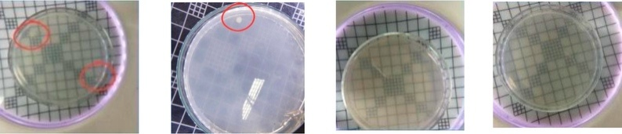
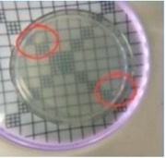
Figures 1.7–1.10 present the antibacterial performance of wallpaper coated with different TiO₂ concentrations (0%, 1%, 3%, and 5%) against airborne bacteria. The 0% TiO₂ (control) group showed numerous distinct bacterial colonies on the nutrient agar plates. In the 1% TiO₂ group, the number and density of bacterial colonies were noticeably reduced compared with the control. In contrast, 3% and 5% TiO₂ coatings showed no visible bacterial colonies, indicating a markedly enhanced antibacterial effect with increasing TiO₂ concentration.
Figure 1.7 control (0%) Figure 1.8 (1%)
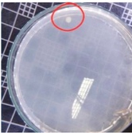
Figure 1.9 (3%) Figure 1.10 (5%)
Figures 1.7–1.10 show the antibacterial performance of wallpaper coated with different TiO₂ concentrations against airborne bacteria. The 0 wt% TiO₂ (control) sample exhibited numerous bacterial colonies, indicating that uncoated wallpaper has no inherent antibacterial activity (Fujishima et al., 2008). The 1 wt% TiO₂ coating reduced the number of bacterial colonies, demonstrating the antibacterial effect of photocatalytically generated reactive oxygen species. However, some colonies remained, suggesting that 1 wt% TiO₂ was insufficient for complete antibacterial coverage (Hajkova et al., 2007). In contrast, 3 wt% and 5 wt% TiO₂ showed no visible bacterial colonies and similar antibacterial performance, indicating that increasing the TiO₂ concentration beyond 3 wt% provides no additional benefit, likely due to surface saturation and nanoparticle dispersion limits (Carp et al., 2004). Therefore, 3 wt% TiO₂ was identified as the optimum concentration for inhibiting airborne bacteria.

Evaluation of Brightness Enhancement Performance Using a Small-Scale Simulated Model
The brightness enhancement performance of wallpapers coated with titanium dioxide (TiO₂) nanoparticles at different concentrations (0%, 1%, 3%, and 5%) was evaluated inside a small-scale simulated model. The brightness was measured using a lux meter, with three measurements performed for each experimental condition. The results showed that the brightness values varied depending on the concentration of TiO₂ nanoparticles.
In the first measurement, the wallpapers with TiO₂ concentrations of 0%, 1%, 3%, and 5% exhibited brightness values of 326, 364, 355, and 409 lux, respectively. In the second measurement, the brightness values were 350, 408, 409, and 375 lux, respectively. In the third measurement, the measured brightness values were 343, 394, 404, and 372 lux, respectively.
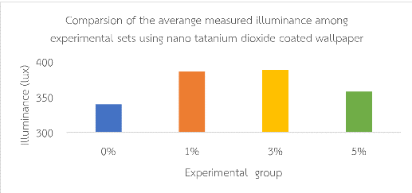
The average brightness values calculated from the three measurements were 340, 387, 389, and 358 lux for the 0%, 1%, 3%, and 5% TiO₂ concentrations, respectively. The results are presented in Figure 1.11.
Figure 4.11 Bar chart comparing the average illuminance values of TiO₂-coated wallpaper samples at different concentrations.
The results of the illuminance measurements for each experimental condition using TiO₂ nanoparticle-coated wallpapers at different concentrations (0%, 1%, 3%, and 5%) showed that the average illuminance values of the TiO₂-coated groups tended to be higher than those of the uncoated group.

Conclusions
The synthesized TiO₂ nanoparticles exhibited a mixed anatase–rutile crystalline phase and an optical band gap of approximately 2.95 eV, indicating favorable optical properties for visible-light photocatalytic applications. TiO₂-coated wallpaper significantly enhanced methylene blue degradation, antibacterial activity against airborne bacteria, and indoor illuminance compared with the uncoated control. Among the tested concentrations, the 3 wt% TiO₂ coating demonstrated the best overall performance, achieving 73% methylene blue degradation within 30 min, complete inhibition of airborne bacterial colonies comparable to the 5 wt% coating, and the highest illuminance. Increasing the TiO₂ concentration to 5 wt% did not provide further improvements, likely due to nanoparticle agglomeration, reduced effective surface area, and increased light scattering. These findings indicate that a 3 wt% TiO₂ coating provides the optimum balance between photocatalytic efficiency, antibacterial performance, and light enhancement, highlighting its potential for indoor surface applications.

Acknowledgments
This science project, entitled “Innovation of High-Performance Nano Titanium Dioxide-Coated Wallpaper with Light-Diffusing Properties for Enhanced Brightness and Bacterial Reduction in Dental Room,” has been successfully completed. The authors would like to express their deepest gratitude to Ms. Chorruk Wongsawan, the project advisor, for her invaluable guidance, insightful suggestions, and careful review throughout the entire course of the project, which greatly contributed to the improvement and completion of this work. The authors would also like to sincerely thank Associate Professor Dr. Ekasit Somsuk, Department of Chemistry, Faculty of Science, Mahidol University, and Assistant Professor Dr. Chiraporn Auechalitanukul, Department of Tool and Materials Engineering, Faculty of Engineering, King Mongkut’s University of Technology Thonburi, for kindly providing laboratory facilities, experimental equipment, and valuable advice that were essential to this study. Special thanks are extended to Dr. Samorn Pato, Director of Princess Chulabhorn Science High School, Pathum Thani, for granting permission to use the school’s facilities and resources for conducting this project. The authors gratefully acknowledge the 28th Young Scientist Competition 2025, organized by the National Science and Technology Development Agency (NSTDA) and the Research Division, for financial support and for providing the opportunity to further develop this project.
Finally, the authors would like to express their heartfelt appreciation to their parents and family for their continuous support, care, and encouragement, which played a vital role in the successful completion of this project.

References
Ba-Abbad, M. M., Kadhum, A. A. H., Mohamad, A. B., Takriff, M. S., Sopian, K. and Al-Shamali, S. S. (2013). Kinetics Transformation of Anatase to Rutile Phase for Titanium Dioxide Nanoparticles Prepared by Sol-Gel Method. Materials Science Forum, Vol. 756, 11-15. https://doi.org/10.4028/www.scientific.net/MSF.756.11
Carp, O., Huisman, C. L., and Reller, A. (2004). Photoinduced reactivity of titanium dioxide. Progress in Solid State Chemistry, 32, 33-177.
Deopura, Alagirusamy & Gupta. (2008). Polyester and Polyamides. https://www.sciencedirect.com/science/article/abs/pii/B9781845692988500134
Elham F. Mohamed & Gamal Awad. (2020). Photodegradation of gaseous toluene anddisinfection of airborne microorganisms from polluted air using immobilized TiO₂ nanoparticle photocatalyst-based filter. Environmental Science and Pollution Research, 27(3), 24507-24517. DOI:10.1007/s11356-020-08779-0
Fujishima, A., Hashimoto, K. and Watanabe, T. (2008). TiO₂ photocatalysis: Fundamentals and applications. Tokyo: BKC Inc.
Gottfried, D. S. (2015). Ultrasonic spray coating technology for thin films and surface functionalization. Journal of Coatings Technology and Research, 12(6), 889–900
Hajkova, P., Spatenka, P., Horsky, J., Horska, I. and Kolouch, A. (2007). Photocatalytic effect of TiO₂ films on viruses and bacteria. Plasma Processes and Polymers, 4(S1), S397-S401. https://doi.org/10.1002/ppap.200731008
Herrmann, J. M. (2010). Photocatalysis fundamentals revisited to avoid several misconceptions. Applied Catalysis B: Environmental, 99, 461-468
Kheamrutai Thamaphat, Pichet Limsuwan, and Boonlaer Ngotawornchai. 2008. “Phase Characterization of TiO2 Powder by XRD and TEM”. Agriculture and Natural Resources 42 (5). Bangkok, Thailand:357-61. https://li01.tcithaijo.org/index.php/anres/article/view/244620.
Philippe Garrigues. (2022). Challenges of TiO₂ heterogeneous Photocatalysis on cytostatic
compounds degradation: state of the art. Pages 42251-42274. https://link.springer.com/article/10.1007/s11356-021-17241-8
Scalarone, D., Lazzari, M. and Chiantore, O. (2012). Acrylic protective coatings modified with titanium dioxide nanoparticles: Comparative study of stability under irradiation. Polymer Degradation and Stability, Vol. 97, 2136-2142. http://dx.doi.org/10.1016/j.polymdegradstab.2012.08.014
Thirugnanasambandan, T., & Alagar, M. (2013). Titanium dioxide (TiO₂) Nanoparticles XRD Analyses: An Insight. Retrived 7 May 2025, from https://www.researchgate.net/publication/244990066_Titanium_dioxide_TiO2_Nanoparticles_XRD_Analyses_An_Insight

Velázquez-Palenzuela, A., Wang, H., Yang, N., Kim, D. and Christensen, J. K. (2021).
Preparation of TiO₂–based hollow microspheres by spray drying and their use as novel active pigments for photocatalytic coatings. Progress in Organic Coatings, Vol. 160, 1-11. https://doi.org/10.1016/j.porgcoat.2021.106518
Zhu, X., Han, S., Feng, W., Kong, Q., Dong Z., Wang, C., Lei, J. and Yi, Q. (2018). The effect of heat treatment on the anatase-rutile phase transformation and photocatalytic activity of Sn-doped TiO₂ nanomaterials. RSC Advances, Vol. 8, 14249-14257. https://doi.org/10.1039/C8RA00766G

