Performance Comparison of Activated Carbons from Various Biomass Precursors for Supercapacitor Electrode Applications

Phitchapa Metasak¹, Ravinan Ponghirun^{1*}, Thassaneeya Oy-Aree¹ and Priew Eiamlamai²

¹Princess Chulabhorn Science High School Lopburi No. 216, Huai Pong, Khok Samromg, Lopburi, 15120 Thailand
²National Energy Technology Center No. 114, Phaholyothin Road,Klong Nueng, Klong Luang, Pathumthani , 12120 Thailand
*e-mail: 05495@pccl.ac.th

Abstract
Agricultural waste-derived carbon materials have attracted increasing interest as sustainable electrode materials for energy storage. This study developed and compared activated carbons derived from spent coffee grounds, spent tea leaves, and a coffee–tea mixture for supercapacitor applications, using commercial activated carbon (YP50F) as a reference. The biomass precursors were carbonized and chemically activated with KOH at a 1:1 mass ratio at 700 °C. The resulting materials were characterized by SEM, BET, XRD, and Raman spectroscopy, while their electrochemical performance was evaluated using galvanostatic charge–discharge (GCD) and electrochemical impedance spectroscopy (EIS). All synthesized carbons exhibited predominantly amorphous structures and well-developed porosity. Among the biomass-derived samples, tea-waste activated carbon (T-K1-700) showed the highest specific surface area of 1,170 m² g⁻¹ and specific capacitance ranging from 150–160 F g⁻¹, outperforming YP50F (75–80 F g⁻¹) under identical conditions. T-K1-700 also demonstrated typical electric double-layer capacitance behavior and maintained stable charge–discharge performance. However, all synthesized materials exhibited increased charge-transfer resistance after cycling, whereas YP50F showed better electrochemical stability. These results indicate that KOH-activated tea-waste carbon is a promising, sustainable electrode material for supercapacitors and highlights the potential of agricultural waste valorization for environmentally friendly energy storage applications.

Keywords : activated carbon, tea waste, coffee waste, supercapacitors, energy storage

Introduction
The global consumption of tea and coffee beverages has continued to increase, generating substantial amounts of spent tea leaves (STL) and spent coffee grounds (SCG) from households, commercial establishments, and the food industry. These biomass residues are commonly discarded through conventional disposal methods, such as landfilling and incineration, ultimately resulting in significant waste management challenges and associated environmental concerns. Nevertheless, STL and SCG represent abundant renewable biomass resources with considerable potential for conversion into value-added carbon materials (Ioannidou and Zabaniotou, 2007; McNutt and He, 2019).
Primarily composed of lignocellulosic components, including cellulose, hemicellulose, and lignin, STL and SCG have attracted considerable attention as promising precursors for the production of functional carbon materials. Through carbonization and chemical activation processes, these biomass resources can be transformed into activated carbons with high specific surface areas, well-developed porous structures, and desirable surface properties. Among various activation methods, potassium hydroxide (KOH) activation is widely employed because it effectively promotes pore further development and enhances the physicochemical properties of carbon materials for energy storage applications (Wang and Kaskel, 2012; Sevilla and Fuertes, 2014). Biomass-derived activated carbons have demonstrated significant potential as electrode materials for supercapacitors due to their high surface areas, well-developed hierarchical pore structures, and outstanding electrochemical properties (Simon and Gogotsi, 2008; Zhang and Zhao, 2009; Sevilla and Fuertes, 2014).
However, comparative investigations of activated carbons derived from spent coffee grounds, spent tea leaves, and their binary mixed precursors for supercapacitor electrode applications remain insufficiently explored (Luo et al., 2022). Understanding the relationship between biomass precursor composition, carbon structure, and electrochemical performance is essential for developing efficient and sustainable electrode materials. Therefore, this study aims to directly compare the structural characteristics and the electrochemical performance of the fabricated symmetric supercapacitors assembled using activated carbons derived from SCG, STL, and their mixtures. In addition, the charge-transfer behavior and internal resistance of the fabricated electrodes are systematically investigated using Electrochemical Impedance Spectroscopy (EIS). The findings provide valuable insights into the effective utilization of abundant biomass wastes as low-cost, sustainable, and environmentally friendly electrode materials for energy storage applications.

Methodology

1. Preparation of Spent Coffee Grounds and Spent Tea Leaves
Spent coffee grounds (SCG) and spent tea leaves (STL) were washed with deionized (DI) water until the pH reached approximately 7. The cleaned biomass residues were dried at 85 °C, ground into fine powders, and sieved through a 150 µm mesh to obtain uniform particle sizes prior to activation.

2. Preparation of Activated Carbon
The dried SCG, STL, and SCG/STL mixture were chemically activated by mixing with potassium hydroxide (KOH) at a mass ratio of 1:1. The mixtures were heated at 170 °C on a hot plate until completely dry. Carbonization was subsequently carried out in a tubular furnace under a nitrogen atmosphere (200 mL min⁻¹) with a heating rate of 5 °C min⁻¹ to a final temperature of 700 °C, followed by a holding time of 2 h. The obtained activated carbons were washed with warm DI water (60–70 °C) until neutral pH and then dried at 65 °C until constant weight. Three activated carbon samples were prepared: The SCG-derived activated carbon (C-K1-700), The STL-derived activated carbon (T-K1-700), and SCG/STL mixture-derived activated carbon (CT-K1-700).

3. Electrode Fabrication and Supercapacitor Cell Assembly
Activated carbon, polyvinylidene fluoride (PVDF), and conductive additive were mixed at a weight by weight ratio of 80:10:10 using N-methyl-2-pyrrolidone (NMP) as the solvent. The slurry was homogenized using a planetary vacuum mixer at 500 rpm for 10 min and coated onto stainless-steel foil using a doctor blade coater. The coated electrodes were punched into circular discs with a diameter of 11 mm and dried at 85 °C for 24 h.
A typical symmetric Swagelok-type electrochemical cell was assembled using two identical activated carbon electrodes separated by a glass fiber separator soaked with sulfuric acid (H₂SO₄) electrolyte. The assembled cells were compressed to ensure sufficient electrical contact before electrochemical measurements.

4. Material Characterization
The morphology of the surface prepared activated carbons was examined using scanning electron microscopy (SEM). The specific surface area and pore characteristics were determined by Brunauer–Emmett–Teller (BET) analysis. The structural properties of the carbon materials were investigated using X-ray diffraction (XRD) and Raman spectroscopy. Raman analysis was performed to evaluate carbon defects and graphitic characteristics based on the D-band, G-band, and intensity ratio (I_{D}/I_{G}).

5. Electrochemical Measurements
The electrochemical performance was systematically evaluated using an AUTOLAB potentiostat/galvanostat. Galvanostatic charge–discharge (GCD) measurements were performed to investigate the charge–discharge behavior and to accurately determine the specific capacitance of the fabricated symmetric supercapacitors. Electrochemical impedance spectroscopy (EIS) was conducted to investigate the charge-transfer behavior, internal resistance, and ion transport characteristics of the electrodes. Cycling stability was evaluated by repeated GCD measurements for 30 charge–discharge cycles, and capacitance retention was calculated to assess the stability of the fabricated electrodes.

Results and Discussion
1. Physical and Structural Characterization

The physical and structural properties of the biomass-derived activated carbons were investigated in relation to electrochemical performance. Activated carbons prepared from spent coffee grounds (C-K1-700) and spent tea leaves (T-K1-700) were compared with commercial activated carbon (YP50F).

1.1 X-ray Diffraction (XRD) Analysis
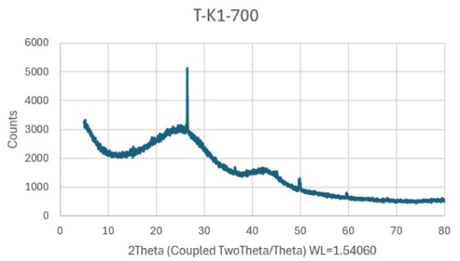
The XRD patterns obtained from all samples exhibited broad peaks at approximately 2$θ$= 24° and 43°, corresponding to the (002) and (100) planes of disordered graphitic carbon. This indicates the formation of amorphous carbon structures after carbonization.

Fig. 1. XRD patterns of biomass materials from coffee ground

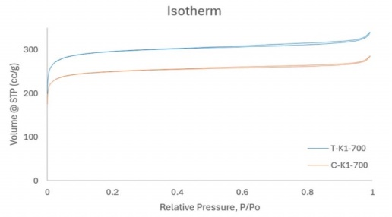
1.2 Scanning Electron Microscopy (SEM) Analysis

SEM images revealed the development of porous structures after KOH activation, which can enhance electrolyte ion accessibility and contribute to charge storage performance.

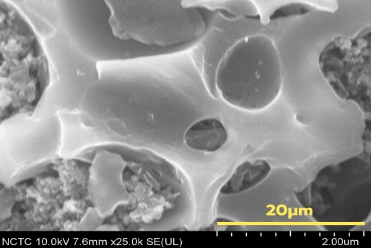
A
B

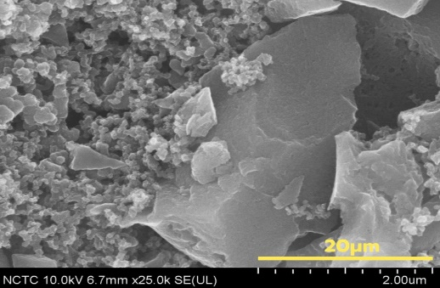

Fig. 2. The SEM images after carbonization

(A): T-K1-700 (B): YP50F

1.3 BET Surface Area and Pore Characteristics
The BET analysis demonstrated the effectiveness of KOH activation in developing porous carbon structures. Among the biomass-derived samples, T-K1-700 exhibited the highest specific surface area of 1,170 m²g⁻¹ with an average pore size of 1.799 nm, while C-K1-700 showed a specific surface area of 993 m²g⁻¹ and an average pore size of 1.78 nm. The pore sizes of both samples were predominantly found within the microporous range (<2 nm), which is particularly favorable for electric double-layer capacitor (EDLC) applications due to the increased surface area available for electrolyte ion adsorption and charge storage.

Fig. 3. The BET of biomass-derived
activated carbons

1.4 Raman Spectroscopy Analysis

Raman spectra of the carbon samples exhibited two characteristic bands: the D-band (~1350 cm⁻¹), associated with structural defects and disorder in carbon networks, and the G-band (~1590 cm⁻¹), corresponding to graphitic carbon structures. The calculated I_{D}/I_{G} ratios of C-K1-700 and T-K1-700 were 1.057 and 0.997, respectively, indicating the presence of defective and disordered carbon structures. These structural defects may provide additional active sites for ion adsorption and contribute to enhanced electrochemical activity.
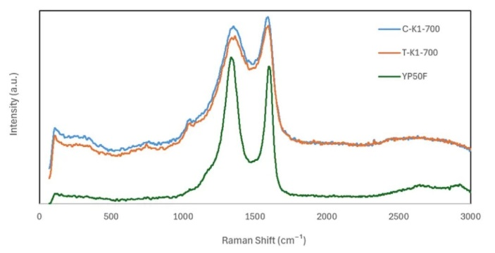

Fig. 4. Raman spectra of biomass-derived activated carbons

2. Electrochemical Performance Evaluation

The electrochemical properties of the activated carbon electrodes were evaluated using symmetric Swagelok cells with H₂SO₄ electrolyte.

2.1 Galvanostatic Charge–Discharge

(GCD) Performance
The GCD results measurements revealed that T-K1-700 exhibited the highest specific capacitance of 150–160 Fg⁻¹, approximately twice that of commercial YP50F (75–80 Fg⁻¹). The nearly triangular and symmetrical GCD profiles indicate an EDLC-dominated charge storage mechanism.

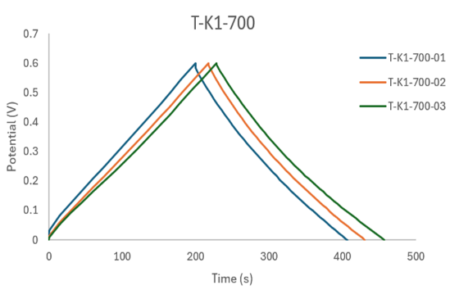
A
B

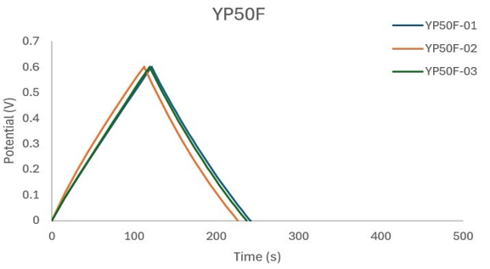

Fig. 5. The GCD results (A): T-K1-700 (B): YP50F

2.2 Electrochemical Impedance Spectroscopy (EIS) Analysis
EIS analysis showed differences in resistance behavior among the electrodes. After cycling, biomass-derived carbons exhibited increased charge-transfer resistance, particularly CT-K1-700, suggesting changes in ion transport behavior within the porous structure. In contrast, YP50F maintained more stable impedance characteristics.
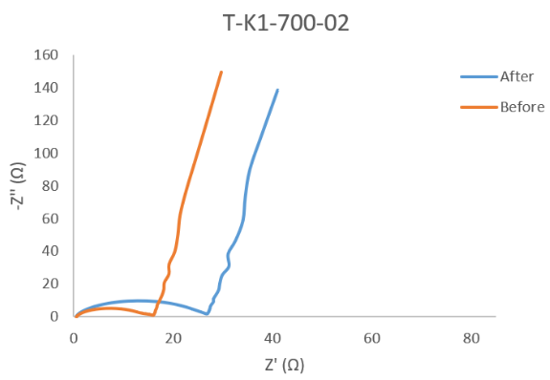
A
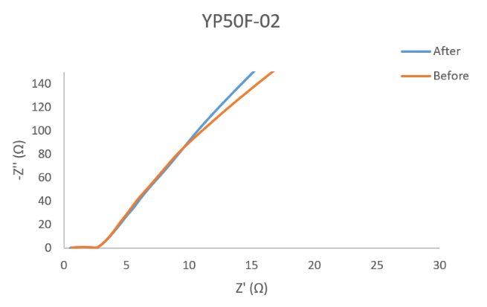
B
Fig. 6. The EIS results (A): T-K1-700 (B): YP50F

2.3 Cycling Stability Performance
Cycling stability was evaluated by 30 GCD cycles at 1 Ag⁻¹. T-K1-700 maintained high capacitance retention, demonstrating stable and reliable electrochemical performance under the investigated conditions.
A
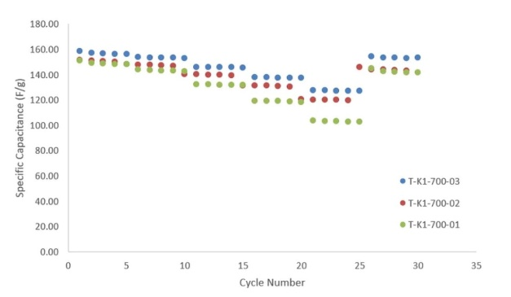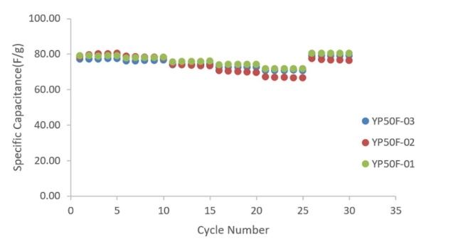
B
Fig. 7. The cycling performance graph
(A): T-K1-700 (B): YP50F

Conclusions
This study successfully developed high-performance activated carbon materials from agricultural biomass wastes, including spent coffee grounds (SCG) and spent tea leaves (STL), through carbonization and KOH chemical activation at 700 °C for supercapacitor electrode applications. Structural characterization cleary confirmed the formation of amorphous carbon with developed microporous structures. Among the prepared samples, T-K1-700 exhibited the highest specific surface area (1,170 m²g⁻¹) and the best electrochemical performance, achieving a specific capacitance of 150–160 Fg⁻¹, approximately twice that of commercial YP50F activated carbon.
The GCD and cycling results cleary demonstrated the capability of T-K1-700 for charge storage and stable operation under the investigated conditions. However, EIS analysis indicated limitations regarding the long-term electrochemical stability of biomass-derived carbons compared with commercial activated carbon. Overall, this study highlights the potential of converting agricultural waste into value-added porous carbon materials for energy storage applications, with continued optimization of activation processes and electrode structures needed to enhance long-term performance.

Acknowledgments
The authors would like to express their sincere gratitude to Princess Chulabhorn Science High School Lopburi for providing the facilities and continuous support that made this research possible.
The authors also gratefully acknowledge the National Energy Technology Center (ENTEC), National Science and Technology Development Agency (NSTDA), for providing access to scientific instrumentation, advanced laboratory facilities, and technical assistance throughout this study. Their continuous support was invaluable to the successful completion of this research.
References
Adan-Mas, A., et al.//(2021).//Coffee-derived
Activated Carbon from Second Biowaste for Supercapacitor Applications.//Waste Management,127,660-670. //https://doi.org/10.1016/j.wasman.2020. 11.043
Eom, H., et al.//(2021).//Recycling Black Tea Waste Biomass as Activated Porous Carbon for Long Life Cycle Supercapacitor Electrodes.//Materials, 14(21),6592.//https://doi.org/10.3390/ma 14216592
Ioannidou, O., & Zabaniotou,
A.//(2007).//Agricultural Residues as Precursors for Activated Carbon Production—A Review.//Renewable and Sustainable Energy Reviews, 11(9), 1966–2005.//https://doi.org/10.1016/j.rser.2006.03.013
Manasa, P., et al.//(2022).//Recent Progress on Biomass Waste-Derived Activated Carbon Electrode Materials for Supercapacitor Applications: A Review.//Journal of EnergyStorage,56,105290.//https://doi.or g/10.1016/j.est.2022.105290
Simon, P., & Gogotsi, Y.//(2008).//Materials for Electrochemical Capacitors.//Nature Materials, 7(11), 845-854.//
https://doi.org/10.1038/nmat2297
Wang, J., & Kaskel, S.//(2012).//KOH Activation of Carbon-Based Materials for Energy Storage.//Journal of Materials Chemistry, 22(45),23710-23725.
//https://doi.org/10.1039/C2JM34066F

