A Study of the Physical Properties of Alginate-Based Coatings Incorporate with Zingiber montanum and Curcuma longa Extracts for Inhibiting
TH sarabunPSK 16 หนา
ตัวอย่างบทความวิชาการ

Colletotrichum spp. in Nam Dok Mai Mangoes.
TH Sarabun New 14 หนา

Arawa Salaeh¹, Nakamon Sangket¹
Nussara Donraman¹*
¹Princess Chulabhorn Science High School Satun , Chalung, Mueang Satun, Satun, 91140 Thailand
*e-mail: nussara.d@pccst.ac.th
ระยะห่าง 2 cm
Abstract
ระยะห่าง 3 cm

Nam Dok Mai mango is a widely cultivated variety in Thailand, highly regarded for its sweet flavor, pleasant aroma, and premium quality, making it ideal for export. However, production faces significant challenges from anthracnose disease caused by the fungus Colletotrichum spp., which leads to fruit rot and substantial economic losses. This study developed an alginate coating enriched with Cassumunar ginger and turmeric extracts to combat anthracnose in Nam Dok Mai mangoes. Results showed that a 75:25 ratio, using a 95% ethanol solvent, achieved optimal physical properties and a 69.89% antifungal efficiency. This natural alternative effectively extends shelf life and reduces chemical reliance, offering a sustainable solution for the mango export industry.
TH Sarabun New 14

Keywords : Sodium Alginate, Cassumunar ginger, Curcuma longa, Curcumin, Anthracnose

Introduction
TH Sarabun New 14 ตัวหนา
Nam Dok Mai mango is one of the most widely cultivated mango cultivars in Thailand due to its excellent quality, including its sweet flavor, fine texture, and attractive appearance. These characteristics make it highly suitable for commercial production, particularly for export to major markets such as China, Japan, and South Korea, while remaining popular in the domestic market and generating significant income for Thai farmers.
However, maintaining export-quality fruit is challenged by anthracnose disease caused by Colletotrichum spp., which produces necrotic lesions on the fruit surface, reduces
fruit quality, and causes substantial economic losses. Survey reports have indicated that postharvest losses are particularly severe, with anthracnose damage reaching up to 46% at Talad Thai, the largest wholesale fruit market in Thailand.
To address this problem, alginate-based edible coatings have been investigated as a natural method for reducing water loss, delaying gas exchange, preventing pathogen infection, and extending fruit storage life. In addition, extracts from Zingiber montanum and Curcuma longa have been incorporated into the coating. These extracts contain bioactive compounds with antifungal activity against Colletotrichum spp. and have the potential to enhance disease resistance while reducing reliance on synthetic fungicides.
The combination of alginate edible coating with Zingiber montanum and Curcuma longa extracts is expected to improve anthracnose control by providing both a physical barrier and antifungal activity. This approach offers a promising, safe, and sustainable strategy for protecting mango quality and supporting commercial production.
TH Sarabun New 14 ตัวหนา
เนื้อหาเป็น TH Sarabun New 14 Point ตัวปกติ
TH Sarabun New 14 ตัวหนา
Methodology
1) Extraction of Zingiber montanum and Curcuma longa Extracts
เนื้อหาเป็น TH Sarabun New 14 Point ตัวปกติ
1.1 Preparation of Zingiber montanum and Curcuma longa Powders
1. Slice 1 kg each of Zingiber montanum and Curcuma longa rhizomes into thin pieces.
2. Dry the sliced rhizomes in a hot-air oven at 50°C for 2 days, or until completely dry.
3. Grind the dried rhizomes into fine powders.
1.2 Extraction of Zingiber montanum and Curcuma longa
1. Mix the Zingiber montanum and Curcuma longa powders at a 1:1 (w/w) ratio.
2. Add the mixed powders to the extraction solvent consisting of 95% ethanol and distilled water at a 1:4 (w/v) ratio.
3. Shake the mixture using an orbital shaker at 200 rpm for 30 minutes.
4. Filter the extract using a vacuum filtration system.
5. Remove the solvent from the filtrate using a rotary evaporator to obtain the crude extract.
2) Evaluation of the Antifungal Activity of Zingiber montanum and Curcuma longa Extracts
1. Culture Colletotrichum spp. on Potato Dextrose Agar (PDA) medium.
2. Evaluate the antifungal activity of the Zingiber montanum and Curcuma longa extracts using the disc diffusion method.
3. Record the diameter of the inhibition zone produced by the extracts.
3) Preparation of Alginate-Based Edible Coatings Containing Zingiber montanum and Curcuma longa Extracts
Prepare the edible coating by mixing sodium alginate with Zingiber montanum and Curcuma longa extracts at different alginate solution-to-extract ratios of 0:100, 25:75, 50:50, 75:25, and 100:0.
4) Evaluation of the Physical Properties of the Alginate-Based Edible Coating Containing Zingiber montanum and Curcuma longa Extracts
1. Determine the curcumin content in the Zingiber montanum and Curcuma longa extracts.
2. Evaluate the antifungal inhibition zone of the extracts.
3. Determine the viscosity and flow velocity of the edible coating according to Stokes’ law.
4. Evaluate the deterioration rate of Nam Dok Mai mangoes by measuring the L* (lightness) value.

Result and Discussion
The results of the study entitled “A Study of the Physical Properties of Alginate-Based Coatings Incorporate with Zingiber montanum and Curcuma longa Extracts for Inhibiting Colletotrichum spp. in Nam Dok Mai Mangoes” are presented as follows.
Different Solvents | Color of the extract
Different Solvents | Color Before Testing | Color After Testing
Control Group (Water) | Clear | Clear
Water | Yellow | Yellow
Ethyl Alcohol 95% | Orange-Yellow | Reddish-Orange
Table 1 Recording the Color of Curcumin in Curcuma longa and Cassumunar ginger Extracts
In the aqueous extract, the solution appeared yellow and remained unchanged after the assay. Conversely, the 95% ethanol extract exhibited a yellow-orange coloration, which subsequently shifted to reddish-orange post-testing.

Table 2 Recording the Inhibition Zone of Curcuma longa and Cassumunar ginger Extracts (cm)
Day | Inhibition Zone
Day | Water |  |  |  | Ethyl Alcohol 95%
Day | Trial 1 | Trial 2 | Trial 3 | Average | Trial 1 | Trial 2 | Trial 3 | Average
1 | 1.2 | 1.1 | 0.7 | 1.00 ± 0.26 | 2.1 | 3.0 | 2.5 | 2.53 ± 0.45
2 | 0.9 | 1.1 | 0.6 | 0.87 ± 0.25 | 2.2 | 3.1 | 2.5 | 2.60 ± 0.46
3 | 0.9 | 1.0 | 0.6 | 0.83 ± 0.21 | 2.3 | 3.2 | 2.6 | 2.70 ± 0.46
4 | 0.8 | 0.8 | 0.5 | 0.70 ± 0.17 | 2.3 | 3.4 | 2.7 | 2.80 ± 0.56
5 | 0.8 | 0.7 | 0.4 | 0.63 ± 0.21 | 2.4 | 3.4 | 2.7 | 2.83 ± 0.51
Overall average |  |  |  | 0.810 ± 0.22 |  |  |  | 2.692 ± 0.49
The aqueous extract exhibited a mean zone of inhibition of 0.810 cm. In comparison, the extract obtained using 95% ethyl alcohol demonstrated a significantly higher mean inhibition zone of 2.692 cm.
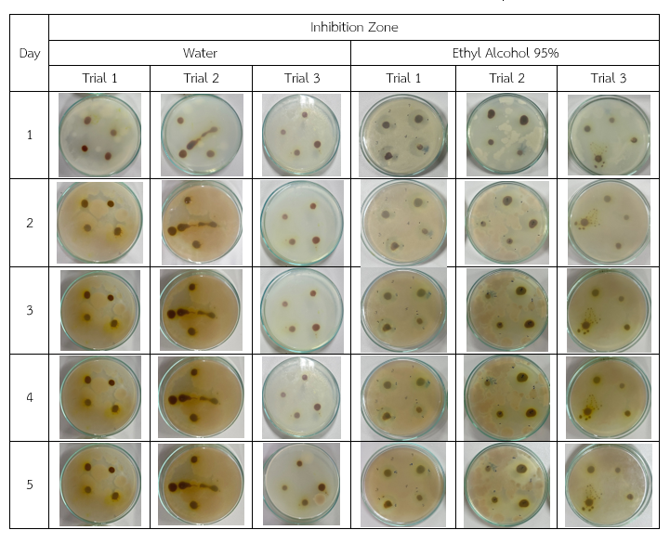
Table 3 Inhibition Zone of Curcuma longa and Cassumunar ginger Extracts
Table 4 Movement Rate of Steel Balls in Coating Substances (m/s)
TH Sarabun New 14 ตัวหนา
เนื้อหาเป็น TH Sarabun New 14 Point ตัวปกติ
Extract Ratio | Movement Rate of Steel Balls (m/s)
0:100 | 1.000
25:75 | 0.215
50:50 | 0.196
75:25 | 0.143
100:0 | 0.122
The results indicated that an increase in the alginate ratio led to a continuous decline in the velocity of the steel ball.
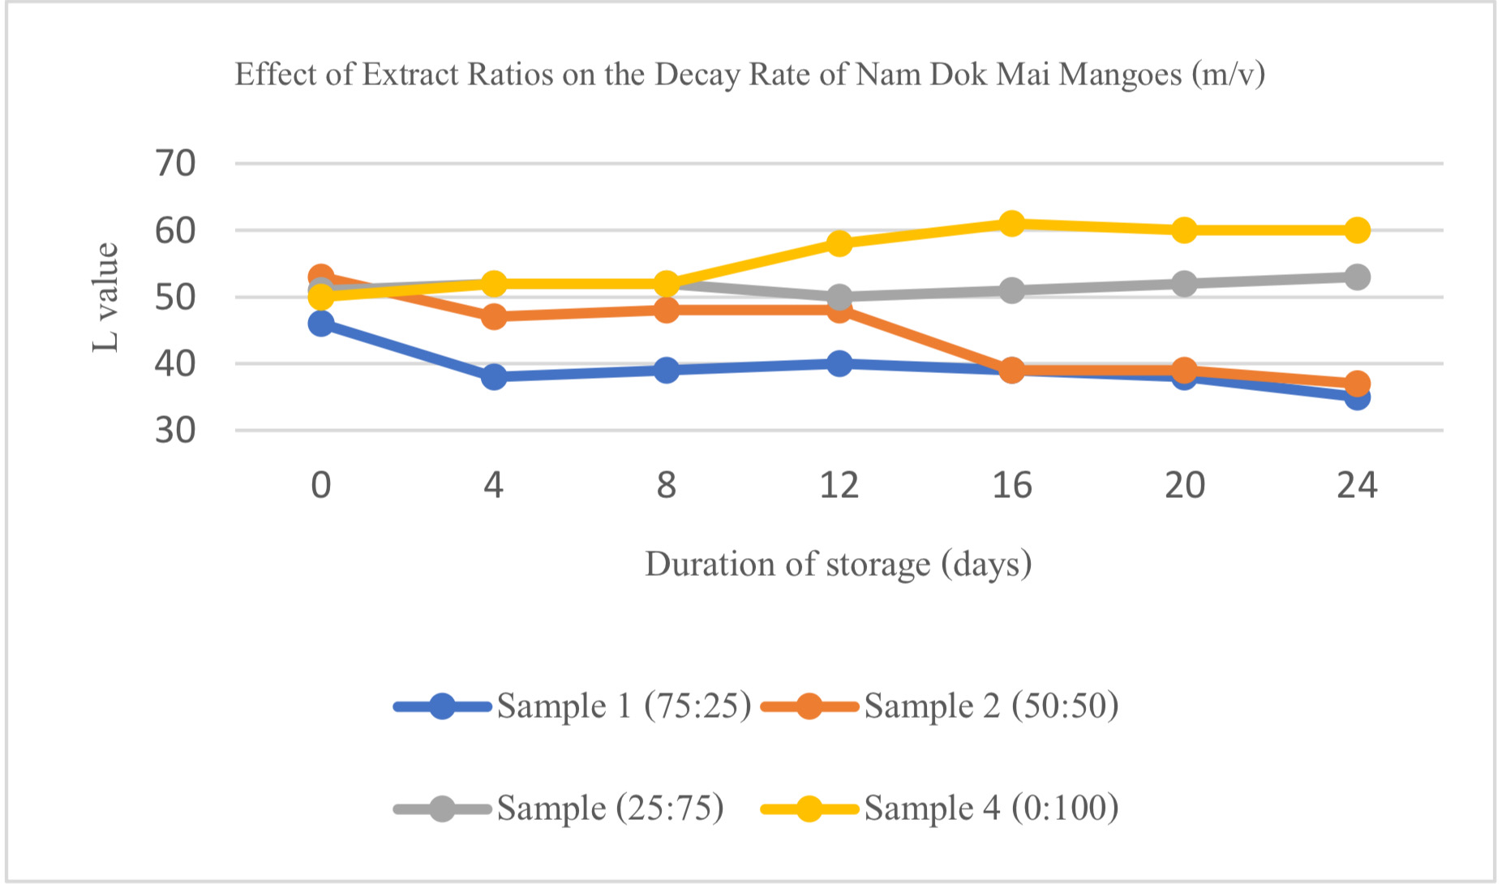
เนื้อหาเป็น TH Sarabun New 14 Point ตัวปกติ
Fig. 1 Effect of Extract Ratios on the Decay Rate of Nam Dok Mai Mangoes (m/v)

Conclusions
This study demonstrated that alginate-based edible coatings containing Zingiber montanum and Curcuma longa extracts effectively inhibited the growth of Colletotrichum spp. Extracts prepared with 95% ethanol contained detectable curcumin, whereas curcumin was not detected in extracts prepared with water.
The average inhibition zone of the aqueous extract was 0.81 cm, while the extract prepared with 95% ethanol produced an average inhibition zone of 2.69 cm, corresponding to an inhibition efficiency of 69.89%.
The evaluation of the physical properties of the edible coatings showed that the 75:25 formulation exhibited a steel ball velocity of 0.143 m/s, indicating the most suitable viscosity for fruit coating applications. In addition, formulations containing higher proportions of Zingiber montanum and Curcuma longa extracts were more effective in maintaining the freshness of Nam Dok Mai mangoes and delaying fruit decay. Overall, the 75:25 formulation provided the best balance between antifungal activity, appropriate physical properties, and preservation efficiency, making it the optimal formulation for extending the postharvest quality of Nam Dok Mai mangoes.

Acknowledgments
This research was conducted with valuable guidance and advice, as well as generous support in terms of laboratory facilities and equipment, from the Chemistry and Biology Program, Princess Chulabhorn Science High School Satun. The authors also gratefully acknowledge the Plant Protection Research and Development Division, Bangkok, Thailand, for kindly providing the Colletotrichum spp. isolates used in this study.

References
Postharvest and Processing Research and
Development Division. (8 August 2025). The use of plant extracts to control anthracnose disease in postharvest fruits without chemical fungicides.
https://www.doa.go.th/plan/
Faculty of Pharmaceutical Sciences,
Ubon Ratchathani University.
(4 August 2025). Curcuma longa [Thai
crude herbal drug database].
https://phar.ubu.ac.th/herb-DetailThaicrudedrug/34
Faculty of Pharmaceutical Sciences,
Ubon Ratchathani University.
(4 August 2025). Zingiber montanum
[Thai crude herbal drug database].
https://phar.ubu.ac.th/herb-DetailThaicrudedrug/96
Research and Innovation Development Center,
Dhurakij Pundit University.
(12 August 2025). The use of crude Aloe vera peel extract to control anthracnose and stem-end rot diseases in Nam Dok Mai mangoes grown in Pran Buri District, Prachuap Khiri Khan Province.
https://www.dpu.ac.th/dpurdi/research/354
จำนวนหน้าต้องไม่เกิน 6 หน้ากระดาษ
TH Sarabun New 14 ตัวหนา

