Study on the Efficiency of a Test Strip for Glucose Concentration in Synthetic Urine Using Crude Papain Extract from Carica papaya ‘Kaek Dam’ as a Catalyst in the Colorimetric Reaction of Tetramethylbenzidine and Hydrogen Peroxide

Thosaengdao Laopha¹, Kanisa Hompromma¹ Suebsakune Kuttiyawong¹*

Tananya Thongdannua¹*
¹ Princess Chulabhorn Science High School Kalasin, Dong Ling, Kamalasai, Kalasin 46130, Thailand

*e-mail: thaosaengdao2102@gmail.com

Abstract
Diabetes mellitus is a global health concern that requires regular glucose monitoring for effective disease management. Commercial paper-based glucose test strips commonly employ a glucose oxidase (GOx)-horseradish peroxidase (HRP) enzymatic system to generate a colorimetric response; however, HRP is relatively expensive, requires purification, and is largely imported, limiting the development of affordable point-of-care diagnostic devices. This study investigated the feasibility of using crude papain extract from Carica papaya ‘Kaek Dam’ as a natural peroxidase mimic for a low-cost paper-based glucose biosensor. Crude extracts from the peel, flesh, and seeds of immature papaya were analyzed using the Bradford protein assay, and the seed extract, which exhibited the highest protein concentration, was 1,792.09 ppm selected for further experiments. Catalytic activity was evaluated using the GOx-TMB-H₂O₂ system by measuring absorbance at 652 nm. A paper-based biosensor was fabricated by immobilizing crude papain extract, TMB, and trehalose onto filter paper and tested with synthetic urine containing glucose concentrations ranging from 0 to 20 mM with GOx. Colorimetric responses were quantified by RGB image analysis. The biosensor produced a concentration-dependent blue color, and both spectrophotometric and RGB analyses showed a positive correlation between glucose concentration and color intensity, confirming the catalytic capability of crude papain extracted. These findings demonstrated that crude papain extract was a sustainable and low-cost alternative to HRP for paper-based glucose sensing and had potential for environmentally friendly point-of-care diagnostics in resource-limited settings.
keywords : Crude papain extract, Peroxidase-like activity, Paper-based biosensor, Glucose detection, Synthetic urine
Introduction

Diabetes mellitus is a major global health problem characterized by persistent hyperglycemia that can lead to serious complications if not properly monitored. While blood glucose measurement is the clinical standard, urine glucose testing offers a rapid, non-invasive, and low-cost alternative for preliminary screening and routine monitoring, particularly in resource-limited settings.
Commercial urine glucose test strips commonly employ a glucose oxidase (GOx)-horseradish peroxidase (HRP) system, in which GOx produces hydrogen peroxide (H₂O₂) and HRP catalyzes the oxidation of 3,3′,5,5′-tetramethylbenzidine (TMB) to generate a blue color proportional to glucose concentration. However, the high cost, purification requirements, and limited stability of HRP have prompted the search for sustainable natural alternatives.
Papain, a cysteine protease extracted from immature papaya ( Carica papaya ‘Kaek Dam’) , has demonstrated peroxidase-like catalytic activity. Thailand, particularly the Kaek Dam cultivar, is a rich source of papain, making crude papain extract an attractive, low-cost, and environmentally friendly substitute for HRP. Nevertheless, its application as a natural peroxidase mimic in paper-based glucose biosensors remains largely unexplored.
Therefore, this study developed a paper-based glucose biosensor using crude papain extract from Carica papaya ‘Kaek Dam’ as a natural peroxidase mimic. Crude extracts from different papaya tissues were evaluated to identify the most effective catalyst, which was then incorporated into a paper-based sensing platform. The analytical performance of the biosensor was assessed using synthetic urine containing various glucose concentrations, demonstrating the potential of locally sourced papain for sustainable and affordable point-of-care glucose detection.

Methodology

1. Preparation of Crude Papain Extract
Fruits of Carica papaya ‘Kaek Dam’ were collected for papain extraction. Crude extracts were prepared separately from the peel, flesh, and seeds using sodium acetate-acetic acid buffer (pH 5.6) The mixtures were homogenized and centrifuged, and the supernatants were collected as crude papain extracts.
To quantify the crude enzyme, the protein concentrations of the extracts were determined using the Bradford assay with bovine serum albumin as the standard protein. Absorbance was measured at 595 nm, and the extract exhibiting the highest protein concentration was selected for subsequent experiments.
2. Evaluation of Peroxidase-Like Activity
The catalytic activity of the selected crude papain extract was evaluated using the TMB- H₂O₂ colorimetric system. Glucose solutions (0.1, 0.2, 0.3, 0.4, and 0.5 mM) were incubated with GOx to generate H₂O₂. The reaction mixture containing TMB, crude papain extract, and the GOx-treated glucose solution was then prepared, and the absorbance was measured using a UV-Vis spectrophotometer at 652 nm.
3. Fabrication of Paper-Based Test Strips
Paper-based test strips were fabricated by coating filter paper (1 × 3 cm) with a reagent solution containing crude papain extract, TMB, and trehalose as a stabilizer. The coated strips were dried at room temperature and stored in light-protected containers until use.

4. Evaluation of the Paper-Based Glucose Test Strip
Synthetic urine containing glucose concentrations of 0, 5, 10, 15, and 20 mM was prepared. Prior to testing, each glucose solution was incubated with GOx to produce hydrogen peroxide. Subsequently, 100 µL of the reaction solution was applied to the fabricated test strip. After color development, the strips were photographed under constant lighting conditions, and color intensity was quantified using RGB values obtained from the Color Identifier application.
5. Statistical Analysis
Experimental data were expressed as the mean ± standard deviation (SD). Protein concentration, absorbance, and RGB values were analyzed to evaluate the relationship between glucose concentration and color intensity.

Results and Discussion
The concentration of crude papain extract from ‘Kaek Dam’ papaya was determined by comparing its absorbance with albumin standard solutions (300–1500 ppm). Absorbance was measured at 595 nm in triplicate, and the concentration was calculated using the Beer–Lambert Law:
A=ϵbc

1 Analysis of the Concentration of Crude Papain Enzyme Extract from ‘Kaek Dam’ Papaya Compared with albumin standard solution
The analysis determined the concentration of crude papain enzyme extract from ‘Kaek Dam’ papaya by comparing it with albumin standard solution at five concentration levels: 300, 600, 900, 1200, and 1500 ppm. Absorbance was measured at 595 nm and the data was analyzed using a linear equation (y = 0.000571x + 1.545968) based on the Beer-Lambert Law
Table 1 : Concentration of crude papain enzyme extract from ‘Kaek Dam’ papaya compared with albumin standard protein solution
Concentration  (ppm) | Absorbance |  |  | Average | SD
Concentration  (ppm) | 1 | 2 | 3 | Average | SD
0 | 1.602 | 1.601 | 1.599 | 1.601 | ±0.002
300 | 1.660 | 1.654 | 1.658 | 1.657 | ±0.003
600 | 1.862 | 1.860 | 1.856 | 1.859 | ±0.003
900 | 2.046 | 2.047 | 2.041 | 2.045 | ±0.003
1200 | 2.313 | 2.316 | 2.315 | 2.315 | ±0.002
1500 | 2.370 | 2.367 | 2.367 | 2.368 | ±0.002
Papaya Peel | 2.155 | 2.153 | 2.151 | 2.153 | ±0.002
Papaya Flesh | 1.738 | 1.737 | 1.733 | 1.736 | ±0.003
Papaya Seeds | 2.569 | 2.569 | 2.569 | 2.569 | ±0.000

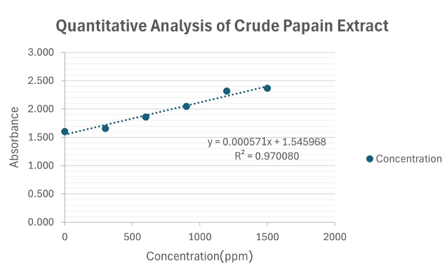
Figure 1. Albumin standard curve used for the quantitative analysis of crude papain extract.
The protein concentration of crude papain enzyme extracts from different parts of Kaek Dam papaya was determined using the Bradford assay with albumin solution as the standard protein. The absorbance values increased proportionally with protein concentration, demonstrating a linear relationship in accordance with the Beer–Lambert Law.
Among the tested samples, papaya seed extract exhibited the highest absorbance, indicating the highest protein (papain) content. The calculated protein concentrations were 1,063.36 ppm for the peel, 332.89 ppm for the flesh, and 1,792.09 ppm for the seeds.
Overall, the crude extract obtained from Kaek Dam papaya seeds showed the highest protein concentration (1,792.09 ppm). Therefore, the seed extract was selected as the biocatalyst source for the subsequent development and evaluation of glucose test strips.
2. Colorimetric response of reaction solutions to glucose concentrations of 0, 0.1, 0.2, 0.3, 0.4, and 0.5 mM.
The absorbance spectra were analyzed over the 500–800 nm wavelength range using a UV–Vis spectrophotometer.
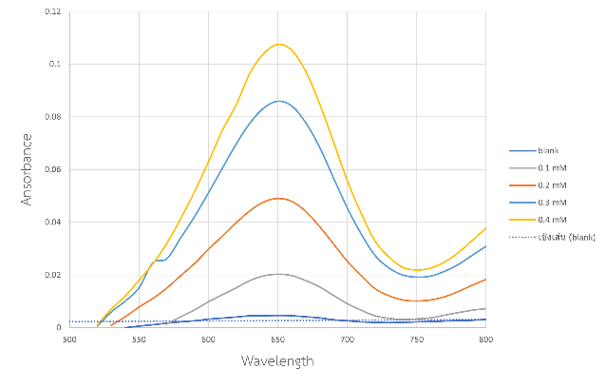(a)
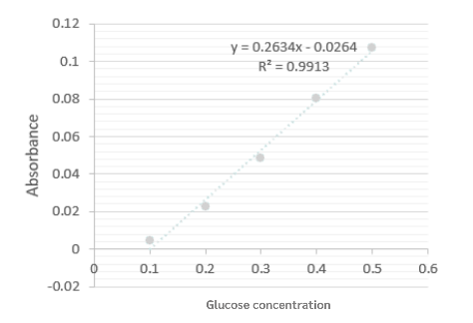(b)
a)Absorbance spectra of glucose reaction solutions over the wavelength range of 500–800 nm and (b) calibration curve of glucose concentration versus absorbance at 652 nm.
The absorbance spectra of glucose reaction solutions (0–0.5 mM) were measured using a UV–Vis spectrophotometer over the wavelength range of 500–800 nm. All samples exhibited a maximum absorbance at 652 nm, which was selected for subsequent glucose determination. The calibration curve (0.1–0.5 mM) showed excellent linearity, with the regression equation y = 0.2634x − 0.0264 and a coefficient of determination of R² = 0.9913, demonstrating the suitability of the developed colorimetric system for quantitative glucose detection.
3. Colorimetric response of TMB- and crude papain-coated paper test strips to glucose solutions at concentrations of 0, 5, 10, 15, and 20 mM.
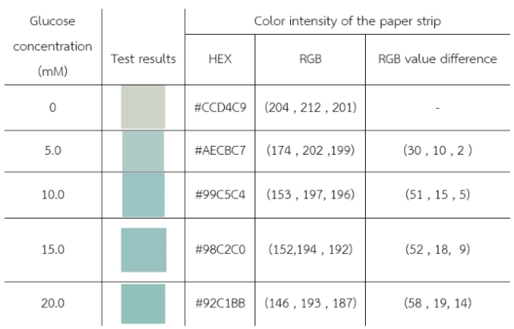
Note: Color values were extracted from digital images using the Color Identifier: Color Picker application.
As shown in Table 2, the color intensity of the paper test strips increased with increasing glucose concentration, demonstrating the effective colorimetric response of the developed sensor. This behavior is consistent with the glucose oxidase reaction, in which higher glucose concentrations produce more hydrogen peroxide, resulting in greater oxidation of the chromogenic substrate and enhanced color development. RGB analysis showed an inverse relationship with glucose concentration: higher RGB values corresponded to lower glucose concentrations, whereas lower RGB values indicated higher glucose concentrations. However, the color response gradually plateaued at higher glucose concentrations, likely due to enzyme or chromogenic substrate saturation, slightly reducing the sensor’s ability to distinguish glucose concentrations in the upper detection range.
4. Colorimetric Detection of Glucose in Artificial Urine
Table 3. Colorimetric response of TMB- and crude papain-coated paper test strips to glucose-spiked synthetic urine (0–20 mM).
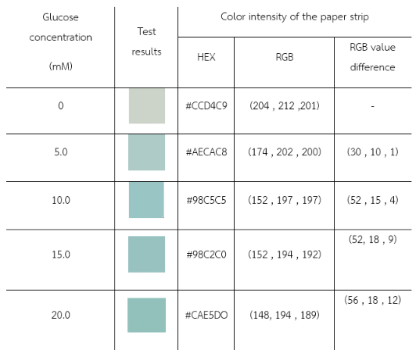
Note: Color values were extracted from digital images using the Color Identifier: Color Picker application.
As shown in Table 3, the color intensity of the paper test strips increased with increasing glucose concentration in synthetic urine, demonstrating the effective colorimetric response of the developed sensor. RGB analysis showed an inverse relationship between glucose concentration and RGB values, with lower RGB values corresponding to higher glucose concentrations. At higher glucose concentrations, the color response gradually plateaued, likely due to enzyme or chromogenic substrate saturation, slightly reducing the sensor’s discrimination at the upper detection range.

Conclusions
This study successfully developed a paper-based glucose test strip using crude papain extract from Carica papaya ‘Kaek Dam’ as a peroxidase-like catalyst. Among the crude extracts obtained from different parts of the papaya fruit, the seed extract exhibited the highest protein concentration was 1,792.09 ppm and was selected for further investigation. The selected extract effectively catalyzed the oxidation of TMB in the presence of hydrogen peroxide, producing a blue color whose intensity increased with glucose concentration.
The fabricated paper-based test strip successfully differentiated glucose concentrations in synthetic urine through both visual observation and RGB color analysis, demonstrating the feasibility of using crude papain extract as a low-cost alternative to horseradish peroxidase (HRP). The proposed approach combines simple fabrication, rapid colorimetric detection, and the utilization of locally available agricultural resources, making it suitable for affordable point-of-care glucose screening.
Although further studies are required to evaluate long-term stability, analytical sensitivity, selectivity, and performance in real urine samples, the findings demonstrate the potential of crude papain extract as a sustainable biocatalyst for paper-based biosensors. This work provides a promising foundation for the development of environmentally friendly and accessible glucose detection devices for healthcare applications.

Acknowledgments
The authors would like to express their sincere gratitude to Princess Chulabhorn Science High School Kalasin for providing laboratory facilities and continuous support throughout this study. The authors also gratefully acknowledge their research advisor for valuable guidance, constructive suggestions, and encouragement during all stages of the project. Special thanks are extended to everyone who contributed to this research directly or indirectly.
References
Antibodies Incorporated. (n.d.). HRP redox reaction driven TMB color development. Retrieved August 3, 2025, from https://www.antibodiesinc.com/pages/hrp-redox-reaction-driven-tmb-color-development

Chanpeng, V., & Leksawasdi, N. (2014). Papain. Undergraduate report, Food Process Engineering Program, School of Agro-Industry, Faculty of Agro-Industry, Chiang Mai University

Chen, Y., Zhong, Q., Wang, Y., Yuan, C., Qin, X., & Xu, Y. (2019). Colorimetric detection of hydrogen peroxide and glucose by exploiting the peroxidase-like activity of papain. RSC Advances. 9: 16566–16570.

Cowart, S. L., & Stachura, M. E. (1990). Glucosuria. In H. K. Walker, W. D. Hall, & J. W. Hurst (Eds.). Clinical methods: The history, physical, and laboratory examinations. Chapter 139. Boston: Butterworths.

Department of Industrial Promotion. (2008). Sales target and marketing target model. Retrieved from http://library.dip.go.th/multim6/ebook/2552/HAN%20%E0%B8%81%E0%B8%AD%E0%B8%A569620%E0%B8%8151-13.pdf
Duangkaew, D., Thamrongchot, D., & Chulaya, W. (2022). Comparison of crude papain enzyme extract content from peel and seed of unripe papaya. Southeast Bangkok Journal of Science and Technology. 8(1): 1–9.

Food Network Solution. (2003). Papain. Retrieved July 14, 2025, from https://www.foodnetworksolution.com/wiki/word/1081/papain

Horticultural Research Institute, Department of Agriculture. (n.d.). Database of Kaek Dam Sisaket papaya variety. Retrieved July 29, 2025, from https://www.doa.go.th/hort/?page_id=54073

Jeong, M., Kwon, S., & Lee, H. (2022). Colorimetric detection of glucose using papain as an alternative to horseradish peroxidase. Journal of Emerging Investigators. Retrieved from https://emerginginvestigators.org/articles/22-152

