Development of an Ergonomic Backrest Based on Spinal Curvature
via Polynomial Interpolation for Office Syndrome Mitigation

Member Kittphum Thong-on, Ranatchai Wonganan*
Advisor and Co-Advisor Nisachon Iaddee, Kamthorn Chaileuk
¹Princess Chulabhorn Science High School Satun, Chalung, Mueang, Satun 91140
*e-mail: ranatchai.w@pccst.ac.th

Abstract
Nowadays, daily activities across all age groups—ranging from students to working professionals and the elderly—heavily rely on sitting at desks for extended periods. Sitting in improper postures or utilizing chairs that lack adequate ergonomic support can lead to long-term adverse health effects, such as chronic back pain and Office Syndrome. Notably, these issues are increasingly prevalent among children and school-aged youth. Selecting chairs that adapt to the user's anatomy is therefore critical for preventing health complications and promoting proper physical development.
Consequently, the project team developed a mathematics project entitled Development of an Ergonomic Backrest Based on Spinal Curvature via Polynomial Interpolation for Office Syndrome Mitigation The objectives are as follows: 1) To develop chair backrests that truly conform to actual human physiology across different age groups, and 2) To alleviate chronic back pain caused by Office Syndrome. This is achieved by implementing a mathematical framework via the Polynomial Interpolation method to connect anthropometric coordinate points across six critical anatomical landmarks: the seat-contact point (buttocks), the waist, the apex of the back curve, the upper back, and the base of the neck.
The results demonstrate that the proposed method can successfully shape chair backrests to match the human spinal curve. By using Polynomial Interpolation to link the six anthropometric landmarks—compiled from standard body dimension data from NASA and the WHO and categorized by gender and age groups from 6 to over 60 years old—the spinal coordinates were subsequently adjusted through a Point Transformation process for backrest design. This approach generates smooth and highly accurate backrest contours, yielding a total of 16 distinct backrest equation models. These models provide precise support to vital areas of the spine, particularly the Lumbar Apex, thereby effectively reducing pressure distribution and the load on back muscles.
keywords : Human Spinal Curvature, Office Syndrome, Polynomial Interpolation

Introduction
Nowadays, the daily routines of many individuals—ranging from students and working professionals to the elderly—heavily rely on sitting at desks for extended periods. Sitting in improper postures or using chairs that lack ergonomic support can lead to long-term adverse health effects, such as back pain and Office Syndrome. Notably, these issues are increasingly prevalent among children and students. Beyond disrupting daily life, such ailments can negatively impact physical development. Selecting chairs that adapt to the user's anatomy is therefore crucial for preventing health complications and promoting proper posture.
Driven by this rationale, the project team developed a mathematics project entitled "Development of an Ergonomic Backrest Based on Spinal Curvature via Polynomial Interpolation for Office Syndrome Mitigation." The primary objectives are to construct graph models of human spinal curves categorized by age groups and gender, and to design personalized ergonomic backrests. This is achieved by utilizing a mathematical framework through the Polynomial Interpolation method to connect anthropometric coordinate points across six key anatomical landmarks: the seat-contact point (buttocks), the waist, the most prominent part of the back, the upper back, and the base of the neck.
This study is expected to provide prototype backrest graphs that truly align with the physiology of individuals across different ages, thereby effectively reducing the risk of Office Syndrome and back pain.

Methodology

1. Human Spinal Curvature Graphing

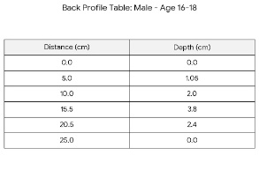
Anthropometric coordinate data representing the human spinal column on a two-dimensional plane were investigated and compiled across various age groups and genders.
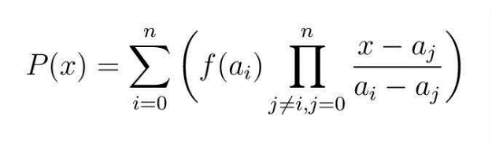

Fig.1 Back Profile Table
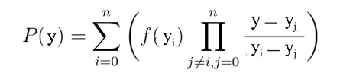
Subsequently, human spinal polynomial equations for each respective age and gender category were constructed utilizing the Polynomial Interpolation method.

The resulting spinal curvature equations were then plotted and superimposed onto reference images to visualize the human spinal graphs corresponding to each demographic group.
2. Ergonomic Chair Backrest Graphing
The coordinate points of the human spinal graphs were optimized by determining the ideal seat-to-backrest distance and lumbar depth. Based on anthropometric data crystallized from the World Health Organization (WHO) and Webb Associates, optimal values classified by gender and age indicated that the backrest depth should be increased by approximately 5 cm.



Fig.2 Backrest Coordinates
Utilizing these optimized parameters, ideal backrest polynomial equations for each specific age and gender group were generated via Polynomial Interpolation.

These finalized backrest equations were subsequently plotted onto reference images to illustrate the ergonomically optimized backrest curvature graphs for each target demographic.
3. Ergonomic Backrest Model Design by Age and Gender Based on Optimal Graphs
Three-dimensional simulation models of the chair backrests were developed based on the finalized ergonomic graphs. To achieve physical realism, the backrest models were structured by extending the Z-axis by +40 cm to define the length, and increasing the thickness along both the X and Y axes by +5 cm.

Result and Discussion
1. Human Spinal Curvature Graphs by Age Group and Gender
ช่วงอายุ 6-9 ปี
x = 6.84×10⁻⁵y⁵ – 2.92×10⁻³y⁴ + 3.98×10⁻²y³ – 1.95×10⁻¹y² + 0.481y

x = 7.58×10⁻⁵y⁵ – 3.12×10⁻³y⁴ + 4.06×10⁻²y³ – 1.88×10⁻¹y² + 0.449y
ช่วงอายุ 10-12 ปี
x = 5.99×10⁻⁵y⁵ – 2.89×10⁻³y⁴ + 4.53×10⁻²y³ – 2.64×10⁻¹y² + 0.686y
x = 6.26×10⁻⁵y⁵ – 2.92×10⁻³y⁴ + 4.53×10⁻²y³ – 2.64×10⁻¹y² + 0.623y
ช่วงอายุ 13-15 ปี
x = 3.90×10⁻⁵y⁵ – 2.15×10⁻³y⁴ + 3.86×10⁻²y³ – 2.55×10⁻¹y² + 0.737y
x = 4.42×10⁻⁵y⁵ – 2.38×10⁻³y⁴ + 4.16×10⁻²y³ – 2.69×10⁻¹y² + 0.740y
ช่วงอายุ 16-18 ปี
x = 3.37×10⁻⁵y⁵ – 2.03×10⁻³y⁴ + 4.02×10⁻²y³ – 3.01×10⁻¹y² + 0.942y
x = 3.52×10⁻⁵y⁵ – 2.03×10⁻³y⁴ + 3.81×10⁻²y³ – 2.67×10⁻¹y² + 0.807y
ช่วงอายุ 19-29 ปี
x = 3.73×10⁻⁵y⁵ – 2.28×10⁻³y⁴ + 4.59×10⁻²y³ – 3.51×10⁻¹y² + 1.09y
x = 4.26×10⁻⁵y⁵ – 2.53×10⁻³y⁴ + 4.94×10⁻²y³ – 3.65×10⁻¹y² + 1.08y
ช่วงอายุ 30-44 ปี
x = 3.78×10⁻⁵y⁵ – 2.32×10⁻³y⁴ + 4.72×10⁻²y³ – 3.64×10⁻¹y² + 1.13y
x = 4.19×10⁻⁵y⁵ – 2.50×10⁻³y⁴ + 4.93×10⁻²y³ – 3.67×10⁻¹y² + 1.09y

ช่วงอายุ 45-59 ปี
x = 3.64×10⁻⁵y⁵ – 2.25×10⁻³y⁴ + 4.59×10⁻²y³ – 3.54×10⁻¹y² + 1.11y
x = 3.71×10⁻⁵y⁵ – 2.24×10⁻³y⁴ + 4.46×10⁻²y³ – 3.33×10⁻¹y² + 1.02y
ช่วงอายุ 60 ปีขึ้นไป
x = 3.74×10⁻⁵y⁵ – 2.37×10⁻³y⁴ + 5.00×10⁻²y³ – 4.05×10⁻¹y² + 1.27y
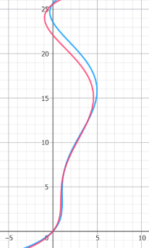
x = 3.58×10⁻⁵y⁵ – 2.23×10⁻³y⁴ + 4.60×10⁻²y³ – 3.61×10⁻¹y² + 1.10y


Fig.3 Spinal Curvaturre
2. Ideal Backrest Graphs by Age Group and Gender
ช่วงอายุ 6-9 ปี
x = 6.84×10⁻⁵y⁵ – 2.92×10⁻³y⁴ + 3.98×10⁻²y³ – 1.95×10⁻¹y² + 0.481y + 5.0
x = 7.58×10⁻⁵y⁵ – 3.12×10⁻³y⁴ + 4.06×10⁻²y³ – 1.88×10⁻¹y² + 0.449y + 5.0
ช่วงอายุ 10-12 ปี
x = 5.99×10⁻⁵y⁵ – 2.89×10⁻³y⁴ + 4.53×10⁻²y³ – 2.64×10⁻¹y² + 0.686y + 5.0

x = 6.26×10⁻⁵y⁵ – 2.92×10⁻³y⁴ + 4.53×10⁻²y³ – 2.64×10⁻¹y² + 0.623y + 5.0
ช่วงอายุ 13-15 ปี
x = 3.90×10⁻⁵y⁵ – 2.15×10⁻³y⁴ + 3.86×10⁻²y³ – 2.55×10⁻¹y² + 0.737y + 5.0
x = 4.42×10⁻⁵y⁵ – 2.38×10⁻³y⁴ + 4.16×10⁻²y³ – 2.69×10⁻¹y² + 0.740y + 5.0
ช่วงอายุ 16-18 ปี
x = 3.37×10⁻⁵y⁵ – 2.03×10⁻³y⁴ + 4.02×10⁻²y³ – 3.01×10⁻¹y² + 0.942y + 5.0
x = 3.52×10⁻⁵y⁵ – 2.03×10⁻³y⁴ + 3.81×10⁻²y³ – 2.67×10⁻¹y² + 0.807y + 5.0
ช่วงอายุ 19-29 ปี
x = 3.73×10⁻⁵y⁵ – 2.28×10⁻³y⁴ + 4.59×10⁻²y³ – 3.51×10⁻¹y² + 1.09y + 5.0
x = 4.26×10⁻⁵y⁵ – 2.53×10⁻³y⁴ + 4.94×10⁻²y³ – 3.65×10⁻¹y² + 1.08y + 5.0
ช่วงอายุ 30-44 ปี
x = 3.78×10⁻⁵y⁵ – 2.32×10⁻³y⁴ + 4.72×10⁻²y³ – 3.64×10⁻¹y² + 1.13y + 5.0
x = 4.19×10⁻⁵y⁵ – 2.50×10⁻³y⁴ + 4.93×10⁻²y³ – 3.67×10⁻¹y² + 1.09y + 5.0
ช่วงอายุ 45-59 ปี
x = 3.64×10⁻⁵y⁵ – 2.25×10⁻³y⁴ + 4.59×10⁻²y³ – 3.54×10⁻¹y² + 1.11y + 5.0
x = 3.71×10⁻⁵y⁵ – 2.24×10⁻³y⁴ + 4.46×10⁻²y³ – 3.33×10⁻¹y² + 1.02y + 5.0

ช่วงอายุ 60 ปีขึ้นไป
x = 3.74×10⁻⁵y⁵ – 2.37×10⁻³y⁴ + 5.00×10⁻²y³ – 4.05×10⁻¹y² + 1.27y + 5.0
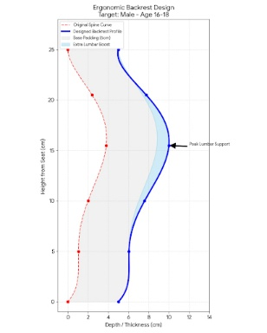
x = 3.58×10⁻⁵y⁵ – 2.23×10⁻³y⁴ + 4.60×10⁻²y³ – 3.61×10⁻¹y² + 1.10y + 5.0


Fig.4 Backrest Curvature

3. Optimized Chair Backrest Models by Age Group and Gender
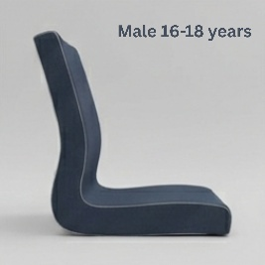

Fig.5 Backrest Model

Conclusions
The project, titled "Development of an Ergonomic Backrest Based on Spinal Curvature via Polynomial Interpolation for Office Syndrome Mitigation." was conducted with the primary objective of designing ergonomic chairs that mitigate the risk of Office Syndrome and back pain across various age groups. By integrating the mathematical principles of Polynomial Interpolation with global anthropometric standards established by NASA and the WHO, six critical anatomical landmarks were identified to serve as the core dataset for mathematical calculation: the seat-contact point (buttocks), the waist, the most prominent part of the back, the upper back, and the base of the neck.
The findings demonstrate that substituting these six coordinate points into the polynomial method yields spinal curvature equations highly specific to both gender and age group. These equations allow for the definitive plotting of sagittal (side-view) spinal profiles. Comparative analysis of the resulting graphs indicates distinct structural variations governed by the anatomical factors of each age demographic.
Consequently, these physiological profiles were utilized as blueprints for customized backrest designs. The project team refined the equations by incorporating an optimized clearance adjustment of +5.0 cm, successfully generating backrest contours that maximize structural support and optimize pressure distribution.
The successful modeling phase—focusing on cohorts aged 60 and above, as well as working professionals and students—confirms that the mathematically generated curves can be effectively translated into concrete, demographic-specific backrest simulations. This approach delivers precise spinal alignment support, presenting a sustainable, data-driven methodology for reducing Office Syndrome risks and promoting long-term ergonomic wellness.

Acknowledgments
The project team would like to express our profound gratitude to Mrs.Nisachon Iaddee and the faculty members of the Mathematics Department, as well as the executive board of Princess Chulabhorn Science High School Satun, for generously dedicating their time to provide invaluable knowledge, guidance, material support, and this exceptional opportunity.
We would also like to extend our sincere thanks to our parents for their unwavering encouragement, and to our peers for their continuous support and assistance throughout the execution of this project.
Finally, the project team sincerely hopes that this study will serve as a beneficial resource for those interested in pursuing further research in this field.

References
Standring, S. (Ed.). (2015). Gray's Anatomy: The
Anatomical Basis of Clinical Practice. 41st ed. Place of publication unknown: Elsevier.
Thawinan Wongsurriya. (2019). 206455 Numerical
Analysis: Chapter 1 Interpolation Theory. Chiang Mai. Faculty of Science, Chiang Mai University. Retrieved July 11, 2026, from https://math.science.cmu.ac.th/thawinan/206455/2562-1/206455_note_ch01.pdf
Webb Associates (Ed.). (1978). Anthropometric
Source Book Volume I: Anthropometry for Designers (NASA Reference Publication 1024). Washington, D.C.: National Aeronautics and Space Administration.
World Health Organization. (2007). WHO Child
Growth Standards: Methods and development. Geneva: WHO Press. Retrieved July 11, 2026, from https://www.who.int/toolkits/child-growth-standards
World Health Organization. (2007). Child Growth
Standards: Methods and Development. Geneva. World Health Organization. Retrieved July 11, 2026, from https://www.who.int/toolkits/child-growth-standards

