D-TRACK: AI-Based Durian Disease Detection via Image Processing and Deep Learning

Kittikhun Masuk Jeehan Langyanai
Rungnapa Boontham
Princess Chulabhorn Science High School Satun138 Moo. 12 Chalung, Mueang, Satun 91140, Thailand
e-mail : jehan.l@pccst.ac.th

Abstract
Durian is one of Thailand's most important economic crops and a major source of export revenue. However, diseases such as root rot, stem rot, and foliar diseases continue to reduce yield and fruit quality. Current disease monitoring mainly relies on farmers' visual inspection and experience, making early detection difficult and often leading to increased crop losses and higher orchard management costs.
To address this challenge, D-TRACK was developed as an automated durian disease monitoring system integrating Artificial Intelligence (AI), Deep Learning, robotics, and a web-based platform. A robotic prototype autonomously captures orchard images, while the YOLOv8 model detects and classifies diseases from durian leaf images. The analysis results are displayed through the web platform, allowing users to conveniently monitor orchard conditions.
Experimental results showed that the proposed model achieved a disease detection accuracy of 95.68%. Images collected from real orchards were successfully analyzed through the integrated system, demonstrating its practicality for automated disease surveillance. The innovation has the potential to reduce agricultural losses, improve orchard management efficiency, and support the advancement of smart and sustainable agriculture.
keywords : Artificial Intelligence (AI), Agricultural Robotics, Smart Orchard Management
Introduction
Thailand is one of the world's leading producers and exporters of durian, generating significant economic value each year. However, durian cultivation is severely affected by plant diseases, particularly root rot and stem rot caused by Phytophthora palmivora, which reduce yield, weaken trees, and cause substantial economic losses for farmers.
Currently, disease monitoring relies mainly on visual inspection and farmers' experience. This approach is labor-intensive, time-consuming, and prone to human error, especially in large orchards, often resulting in delayed disease detection and rapid disease spread.
To address these challenges, D-TRACK was developed as an intelligent durian disease monitoring system integrating Artificial Intelligence (AI), Deep Learning, robotics, cloud technology, and a web-based orchard management platform. A cable-based robotic system autonomously captures orchard images, while a YOLOv8 model detects plant diseases. The analyzed results are automatically synchronized to the online platform, providing real-time notifications, orchard mapping, historical records, disease trend analysis, and management recommendations.
By automating the entire monitoring process, D-TRACK reduces labor requirements, inspection time, and crop losses while enabling farmers to monitor orchard conditions remotely. The platform also has the potential to support smart and sustainable agriculture and can be adapted for disease monitoring in other economic crops.

Methodology
The development of D-TRACK: AI-Based Durian Disease Detection via Image Processing and Deep Learning was carried out through four main stages: dataset collection, artificial intelligence model development, prototype system development, and system performance evaluation.
2.1 Data Collection and Dataset Preparation
The project team studied common durian diseases, image processing techniques, and relevant artificial intelligence technologies. Images of both healthy and diseased durian leaves were collected from various sources, including photographs captured under real orchard conditions, to construct a dataset for AI model development.
After data collection, high-quality images were selected and annotated to identify disease categories and affected regions. The dataset was then divided into training, validation, and testing sets for model development and performance evaluation.

2.2 AI Model Development
The proposed system employed Deep Learning using the YOLOv8 model for durian disease detection. The prepared dataset was used to train the model, enabling it to learn disease characteristics and accurately identify infected regions on durian leaves.
After training, the model was evaluated using previously unseen test images to assess its detection accuracy, disease classification capability, and object localization performance.
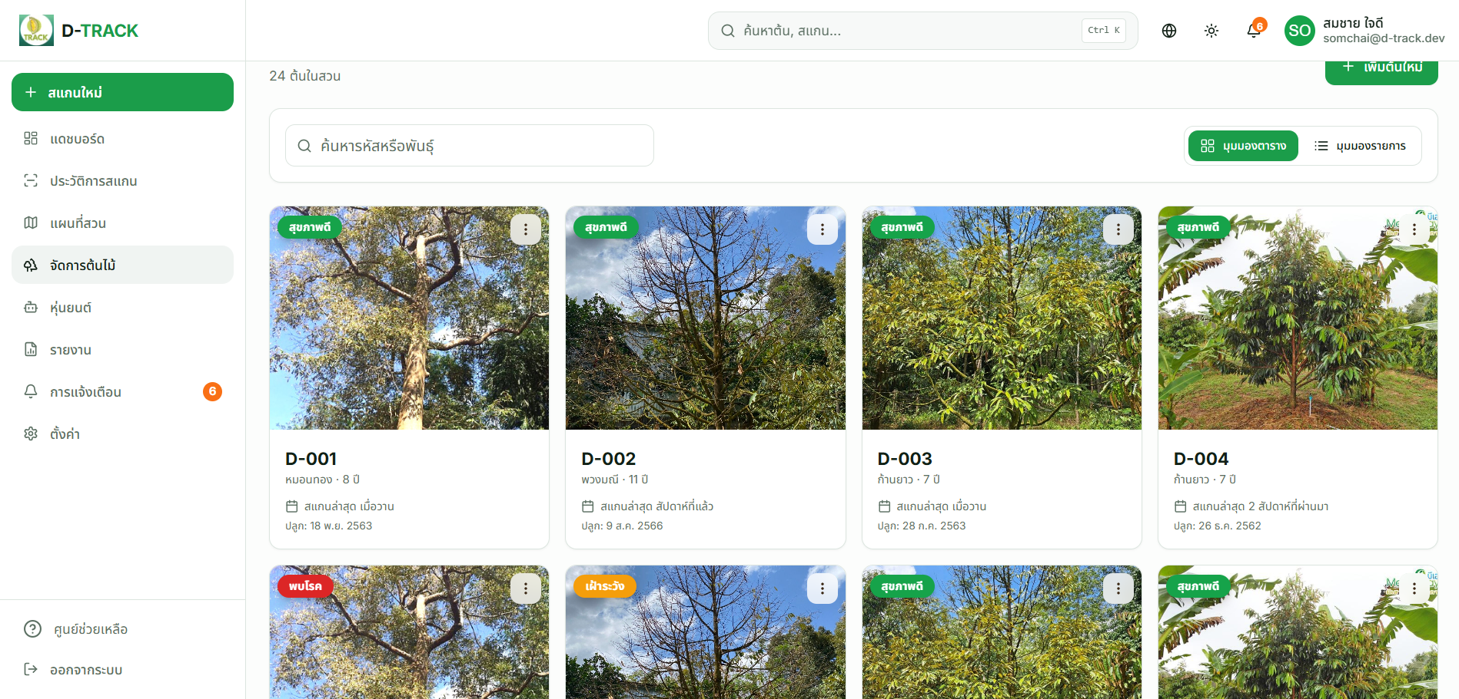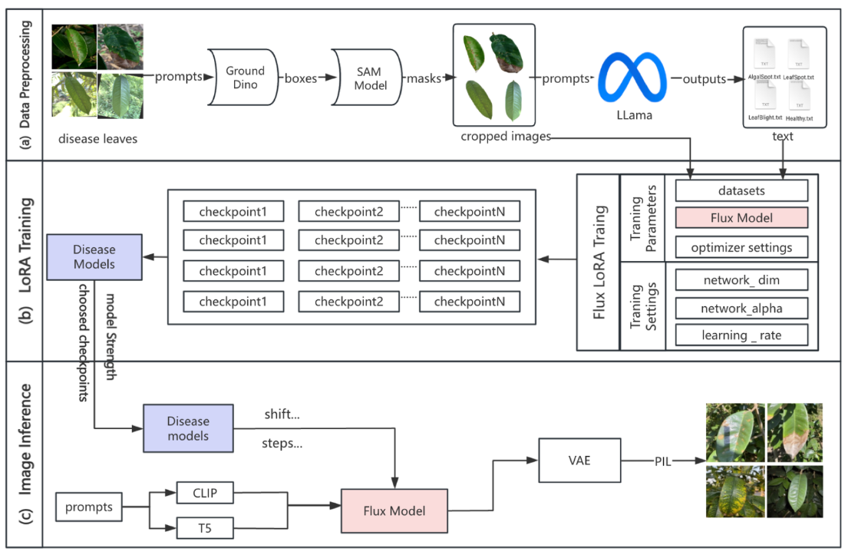
Fig. 1 AI Model Training Workflow
2.3 Prototype Development
The D-TRACK web platform was developed to receive images and display AI-based disease detection results. The system automatically retrieves uploaded orchard images, analyzes them using the AI model, and presents the results through a user-friendly webinterface.
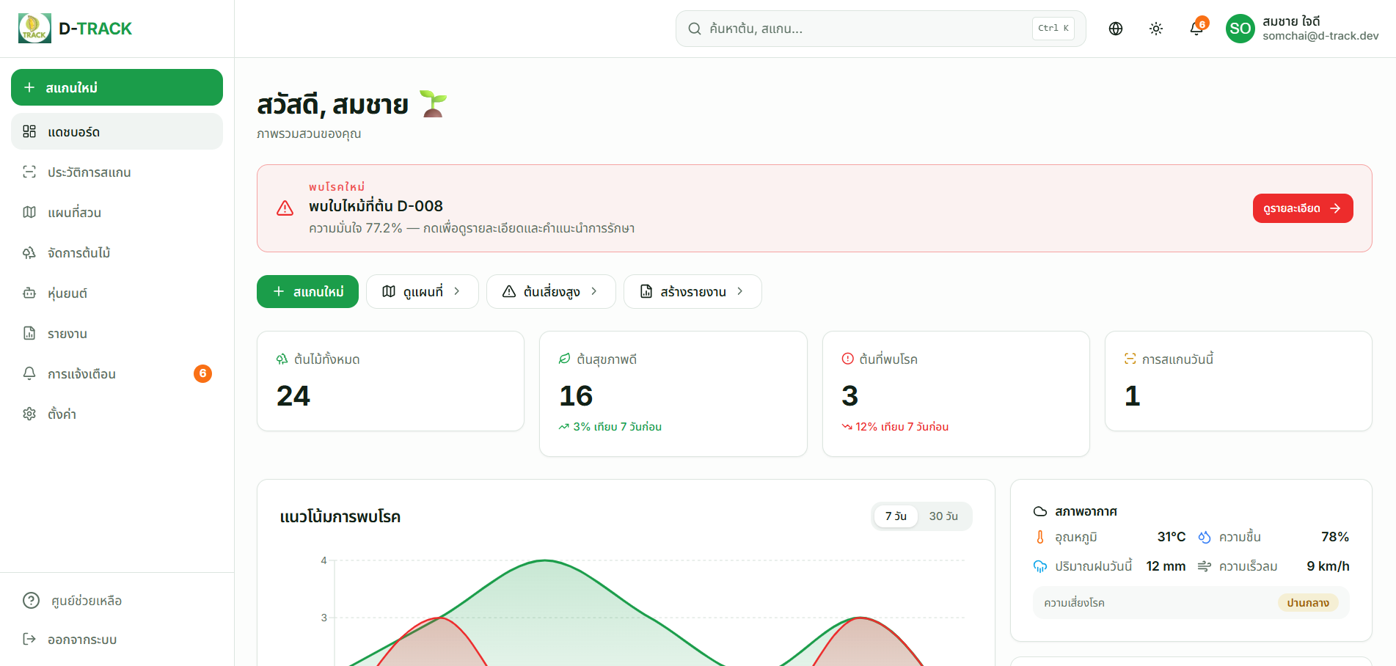
Fig. 2 D-TRACK Web Application Interface
A cable-based robotic prototype equipped with a camera was also designed and assembled for field image acquisition in durian orchards. The prototype autonomously captures images on a predefined schedule and uploads them to cloud storage, where they are automatically processed by the D-TRACK platform.
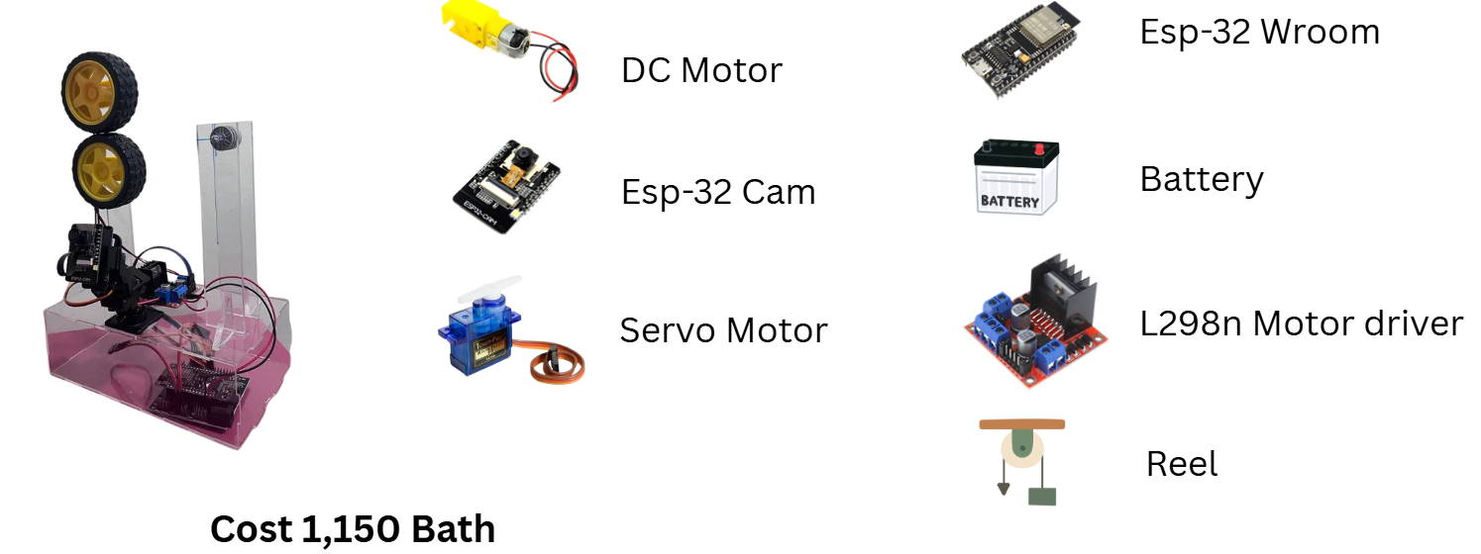
Fig. 3 D-TRACK Cable-Based Robotic Prototype

2.4 System Evaluation
The prototype was deployed in a real durian orchard to collect image data for system evaluation. The captured images were automatically analyzed by the D-TRACK platform using the AI model to detect plant diseases.
System performance was evaluated based on detection accuracy, reliability, and practical usability by comparing the detection results with visible disease symptoms. The evaluation also identified current limitations and potential improvements to further enhance the system for fully autonomous operation in future applications.

Result and Discussion
The development of D-TRACK: AI-Based Durian Disease Detection via Image Processing and Deep Learning successfully resulted in a functional prototype integrating an artificial intelligence model, a web-based orchard management platform, and a cable-based robotic system for autonomous image acquisition.
The AI model, developed using Deep Learning with the YOLOv8 architecture, demonstrated high performance in detecting and classifying diseases from durian leaf images, achieving an overall accuracy of 95.68%. These results indicate that the model effectively learned disease characteristics and accurately distinguished healthy leaves from infected ones.
The D-TRACK web platform successfully integrated with the AI model and cloud storage system, enabling automated image retrieval, disease analysis, and result visualization. The platform provides real-time disease notifications, interactive orchard mapping, historical inspection records, disease trend analysis, automated report generation, and disease management recommendations, allowing farmers to conveniently monitor orchard conditions through a single online interface.
The cable-based robotic prototype was successfully deployed in a real durian orchard. The robot autonomously captured high-quality leaf images according to a predefined schedule and uploaded them to the cloud via a wireless network. The D-TRACK platform automatically retrieved the uploaded images, performed AI-based disease detection, and presented the results without requiring manual intervention. Field testing confirmed that the integrated system operated reliably and continuously under real operating conditions.
Although the current prototype demonstrated satisfactory performance, several limitations remain. The AI model has been trained primarily using durian leaf images and currently supports a limited range of diseases. Future development will focus on expanding the training dataset, supporting disease detection on additional plant organs such as stems, roots, and fruits, integrating more advanced sensors, and further improving system robustness for large-scale commercial deployment.
Overall, the experimental results demonstrate that D-TRACK is a practical and effective smart agriculture platform capable of integrating robotics, artificial intelligence, cloud computing, and digital orchard management into a fully automated workflow. The innovation has strong potential to reduce labor requirements, minimize crop losses, improve orchard management efficiency, and serve as a scalable solution for disease monitoring in other economically important crops.

Conclusions
The results of the D-TRACK project demonstrate that integrating Artificial Intelligence (AI) with computer vision technology provides an effective approach for automated durian disease monitoring. The developed YOLOv8 model achieved an overall detection accuracy of 95.68%, indicating that the training dataset was sufficiently representative for learning disease characteristics and accurately distinguishing healthy leaves from infected ones.
The integration of the AI model with the D-TRACK web platform further improves the practicality of the system by enabling automated image analysis, real-time disease notifications, interactive orchard mapping, historical inspection records, disease trend analysis, and automated report generation. These capabilities allow farmers to monitor orchard conditions remotely without continuously supervising field inspections, reducing labor requirements while improving the efficiency of orchard management.
The cable-based robotic prototype also demonstrated the feasibility of autonomous field operation. The robot successfully captured images according to a predefined schedule, uploaded them to cloud storage through a wireless network, and enabled the D-TRACK platform to automatically retrieve and analyze the images without manual intervention. This fully integrated workflow demonstrates the practical application of robotics, cloud computing, and artificial intelligence for smart agriculture.
Although the current prototype performed satisfactorily, several limitations remain. The AI model has been trained primarily on durian leaf images and currently supports a limited number of diseases. Future development should focus on expanding the dataset, extending disease detection to other plant organs such as stems, roots, and fruits, integrating additional environmental sensors, and improving system robustness for large-scale commercial deployment.
Overall, D-TRACK demonstrates strong potential as a practical smart orchard management platform that combines robotics, artificial intelligence, cloud technology, and digital agriculture into a fully automated system. The innovation is capable of reducing labor, minimizing crop losses, improving orchard management efficiency, and providing a scalable solution for precision agriculture and future applications in other economically important crops.
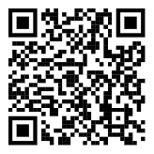
Fig. 4 Overview of the Complete D-TRACK System

Acknowledgments
The completion of this computer project, "D-TRACK: AI-Based Durian Disease Detection via Image Processing and Deep Learning," would not have been possible without the invaluable guidance and support of Ms. Rungnapa Boontham, our project advisor. We sincerely appreciate her insightful advice, constructive suggestions, continuous encouragement, and dedicated efforts in reviewing and improving both the content and presentation of this project throughout its development.
We would also like to express our sincere gratitude to all teachers of the Computer Science Department, Princess Chulabhorn Science High School Satun, for their encouragement, guidance, and continuous support, which greatly contributed to the successful completion of this project.
Finally, we hope that this project will serve as a valuable reference for students, researchers, and anyone interested in artificial intelligence, computer vision, deep learning, and smart agricultural technologies.

References
Department of Agriculture. (2023). Durian Diseases and Pest Management. Bangkok: Department of Agriculture. Retrieved June 30, 2026, from https://www.doa.go.th
Goodfellow, I., Bengio, Y., & Courville, A. (2016). Deep Learning. Cambridge, MA: MIT Press.
Jocher, G., Chaurasia, A., & Qiu, J. (2023). YOLO by Ultralytics. Retrieved June 30, 2026, from https://docs.ultralytics.com
OpenCV Team. (2024). OpenCV Documentation. Retrieved June 30, 2026, from https://opencv.org
Padiyath, G., et al. (2023). Plant Disease Detection Using Deep Learning Techniques: A Review. Computers and Electronics in Agriculture, 205, 107654.
Roboflow. (2024). Roboflow Documentation. Retrieved June 30, 2026, from https://docs.roboflow.com
Ultralytics. (2023). YOLOv8 Documentation. Retrieved June 30, 2026, from https://docs.ultralytics.com
Wikipedia contributors. (2025). Phytophthora palmivora. Retrieved June 30, 2026, from

