Development of a Biosensor Test Kit Containing Butterfly Pea and Red Cabbage Extracts for Heatstroke Risk Assessment

Katinan Koror¹ and Pariyakorn Sawasdee¹
Pornpan Chomwong¹ Chamras Promptmas²
¹Princess Chulabhorn Science High School Suphanburi No.89 Village No. 3, Thung Khok, Song Phi Nong, Suphanburi, 72110 , Thailand
²Mahidol Salaya University No.999 Phutthamonthon Sai 4 Rd, Salaya, Phutthamonthon, Nakhon Pathom, 73170, Thailand
*e-mail: kokantinan182@gmail.com
Abstract

This project aims to investigate the effectiveness of a test strip containing extracts from butterfly pea (Clitoria ternatea) and red cabbage (Brassica oleracea var. capitata f. rubra) for assessing the risk of heat stroke. The test strip utilizes anthocyanin extracts, which exhibit color changes in response to variations in pH. The experiment began with the extraction of anthocyanins from the natural plant sources, followed by an investigation of their color changes across different pH levels. The extracts were then coated onto filter paper with suitable sweat-absorption properties.
The results demonstrated that the developed test paper successfully changed color according to the pH of sweat. Sweat pH was found to be associated with the lactic acid concentration in sweat. As the acidity of sweat increased, the lactic acid level also increased, indicating a higher risk of heat stroke. Therefore, the pH test strip developed in this study is a suitable method for rapid risk assessment and provides an effective tool for monitoring and evaluating the risk of heat stroke.

keywords : Heat stroke, Global warming, Indicator, Acidity
Introduction
At present, the world is facing the problem of global warming, which refers to the continuous increase in the Earth's average temperature caused by the greenhouse effect. This phenomenon occurs because the Earth is unable to release heat absorbed from solar radiation efficiently, resulting in a steady rise in global surface temperatures. The consequences of global warming include the melting of polar ice caps, heavy rainfall, prolonged droughts, and more frequent extreme weather events. In August 2024, the global average surface temperature reached 16.82°C, the highest ever recorded, which was 0.71°C higher than the average temperature for August during the period 1991–2020. In addition to these environmental impacts, rising temperatures also pose serious health risks to humans. Exposure to excessive heat forces the heart and skin to work harder to regulate body temperature. When this process continues for an extended period, it can lead to heat stroke.
Heat stroke is a life-threatening condition in which the body's core temperature rises to an abnormally high level due to prolonged exposure to hot and humid environments, intense physical activity, wearing non-breathable clothing, or inadequate water intake. Vulnerable groups include outdoor workers, older adults, individuals with obesity, children, and people who consume alcohol. Heat stroke can cause severe damage to vital organs such as the brain, kidneys, lungs, and heart. Common symptoms include altered mental status, nausea and vomiting, flushed skin, rapid heartbeat, rapid breathing, headache, low blood pressure, seizures, and elevated lactic acid levels in sweat (Synphaet Hospital, 2023). The number of heat stroke-related deaths has been increasing worldwide, and it is projected that by 2050, the number of fatalities could increase by threefold.
Anthocyanins are natural pigments responsible for the red, purple, and blue colors found in many plants. They belong to the flavonoid group and possess strong antioxidant properties that help protect cells from damage caused by free radicals, thereby reducing the risk of various chronic diseases. Anthocyanins are commonly found in purple and red plants such as butterfly pea flowers, red cabbage, blackberries, and mulberries. One of their notable characteristics is their ability to change color according to pH. Anthocyanins appear dark blue under alkaline conditions (pH > 7), purple at neutral pH (pH = 7), and red to orange under acidic conditions (pH < 7).
Based on the information above, the research team recognized the growing health risks associated with rising global temperatures, particularly the increasing incidence of heat stroke. Therefore, this project focuses on developing a pH-sensitive test strip containing extracts from butterfly pea flowers and red cabbage to assess the risk of heat stroke. The developed test strip is intended to provide a simple, rapid, and practical method for early risk assessment, thereby helping to prevent heat stroke and reduce its adverse health impacts resulting from global warming.

Methodology
1) Preparation of Butterfly Pea and Red Cabbage Extracts
Fresh butterfly pea flowers (Clitoria ternatea L.) were separated from their calyces, and 200 g of fresh petals were weighed. The petals were blended using a Panastar PN-2562 blender for 10 minutes with the addition of 50 mL of distilled water during blending. Fresh red cabbage (Brassica oleracea var. rubra) was finely chopped, and 100 g of fresh tissue was blended under the same conditions with 50 mL of distilled water. The resulting extracts were concentrated using a rotary evaporator at 45°C and 100 rpm to obtain anthocyanin-rich extracts.
2) Preparation of Anthocyanin-Coated Test Paper
Whatman filter papers No. 1 and No. 93 were selected as the supporting materials. Twenty milliliters of each anthocyanin extract were poured into a Petri dish, and the filter paper was immersed in the solution for 10 minutes to allow complete absorption. The coated papers were then dried in a hot-air oven at 40°C for 30 minutes. After drying, the papers were cut into strips measuring 6 cm × 2 cm using a paper cutter.

3) Preparation of Artificial Sweat
Artificial sweat was prepared by dissolving 0.25 g of urea, 0.25 g of sodium chloride, 0.175 g of glucose, and 0.175 g of magnesium salt in 100 mL of distilled water. Lactic acid was then added in 0.5 mL increments using a micropipette. The pH of the solution was measured with a pH meter and adjusted to obtain artificial sweat samples with pH values of 3, 4, 5, 6, and 7.
4) Evaluation of Color Response and Performance of the Test Strips
The prepared test strips with different anthocyanin ratios and filter paper types were placed on a white background. Artificial sweat samples of different pH values were dropped onto each strip, and the color change was observed after 10 seconds. Photographs were taken, and the results were recorded. The tested strips were subsequently analyzed using image analysis software to quantify color differences and evaluate the clarity and sensitivity of the color response.
5) Evaluation of the Light Stability of Anthocyanins on Filter Paper
Concentration of Lactic acid ( mol/l) | R (±Δ) | G (±Δ) | B (±Δ)
0.020 | 148 ± 12 | 62 ± 8 | 158 ± 14
0.035 | 163 ± 12 | 58 ± 8 | 142 ± 14
0.041 | 172 ± 15 | 54 ± 8 | 128 ± 13
0.082 | 185 ± 15 | 48 ± 8 | 102 ± 15
0:164 | 196 ± 15 | 44 ± 8 | 82 ± 13
0:205 | 212 ± 15 | 38 ± 8 | 70 ± 15
The prepared test strips were divided into four experimental groups according to the anthocyanin source and filter paper type: (1) butterfly pea extract on Whatman No. 1 paper, (2) red cabbage extract on Whatman No. 1 paper, (3) butterfly pea extract on Whatman No. 93 paper, and (4) red cabbage extract on Whatman No. 93 paper. One set of each group was exposed to ultraviolet (UV) light, while an identical set was stored in the dark as a control. Samples were collected after 5, 10, and 15 hours of storage, and color measurements were performed to evaluate
the photostability of the anthocyanin-coated papers
Result and Discussion
1) To compare the effectiveness of the developed test strips in assessing the risk of
อัตราส่วน ( กะหล่ำปลี : อัญชัน ) | R (±Δ) | G (±Δ) | B (±Δ)
100:0 | 158 ± 12 | 68 ± 10 | 162 ± 12
75:25 | 145 ± 12 | 63 ± 10 | 175 ± 12
50:50 | 125 ± 15 | 58 ± 10 | 190 ± 15
25:75 | 105 ± 15 | 52 ± 10 | 205 ± 15
0:100 | 90 ± 15 | 55 ± 10 | 215 ± 15
Table 1. Ratios of Butterfly Pea and Red Cabbage Extracts
The RGB analysis showed that increasing the proportion of butterfly pea extract resulted in a continuous increase in the Blue (B) value, while the Red (R) value gradually decreased. In contrast, the Green (G) value exhibited only slight changes. These results indicate a shift in color tone from reddish-purple to bluish-purple, which is consistent with the characteristics of anthocyanins. This color transition can be attributed to the higher proportion of ternatins, the major anthocyanin pigments in butterfly pea flowers, which enhance the blue coloration.
that the survival rate of seagrass was indeed Table 2. Lactic Acid Concentrations That Induced Color Changes in the Test Paper
As the concentration of lactic acid increased, the Red (R) value increased continuously, whereas the Blue (B) value decreased and the Green (G) value showed a slight decrease. These changes indicate the structural transformation of anthocyanins from the quinoidal base form to the flavylium cation under acidic conditions, resulting in a more pronounced red coloration. This observation is consistent with the structural equilibrium mechanism of anthocyanins, in which decreasing pH shifts the equilibrium toward the red-colored flavylium cation.

2) To develop and evaluate a test strip for assessing the risk of heat stroke
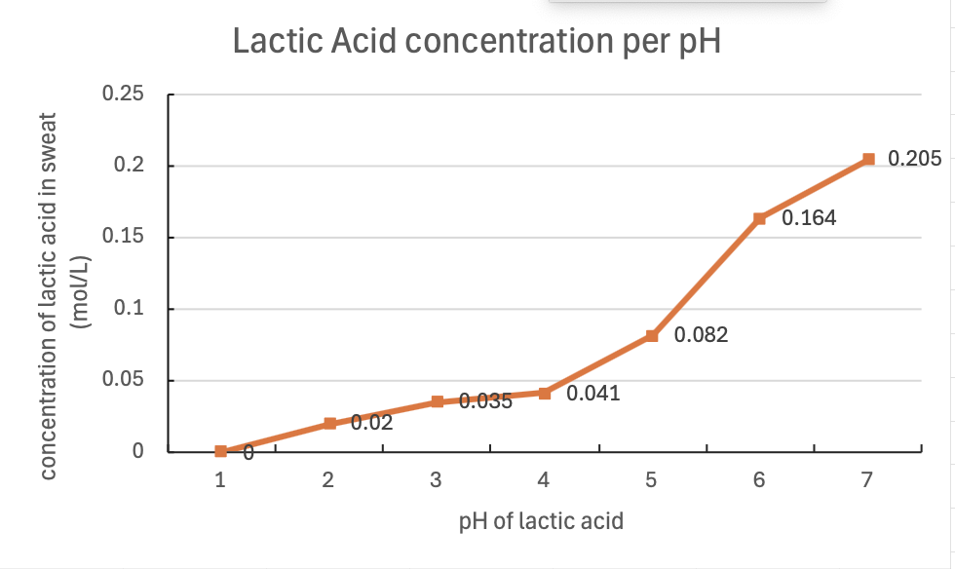

Graph 1. Relationship Between Lactic Acid Concentration and Sweat pH
The graph illustrating the relationship between pH and lactic acid concentration showed that the concentration tended to increase with changes in pH. A significant increase was observed at pH values above 5. This trend reflects the dissociation equilibrium of lactic acid, which causes the system to become more sensitive to pH variations within certain ranges. Therefore, this relationship can be applied for evaluating acidity-related risks.

Conclusions
1) To compare the effectiveness of the developed test strips in assessing the risk of
The color changes of red cabbage and butterfly pea extracts were investigated by analyzing RGB values (Red, Green, and Blue) using Python-based image analysis under controlled photographic conditions. The results showed that experimental groups with increasing proportions of butterfly pea extract exhibited a continuous increase in the Blue (B) value, while the Red (R) value decreased and the Green (G) value changed only slightly. These results are consistent with the characteristics of anthocyanins, in which higher proportions of ternatins contribute to a more prominent blue coloration.
Furthermore, the effect of lactic acid concentration on color changes was investigated. The results demonstrated that increasing lactic acid concentration caused a continuous increase in the Red (R) value, while the Blue (B) value decreased and the Green (G) value showed a slight decrease. These changes indicate the response of anthocyanin pigments to acidic conditions, resulting in a shift toward red coloration.
2) To develop and evaluate a test strip for assessing the risk of heat stroke
From the development of a biosensor test strip containing butterfly pea and red cabbage extracts for assessing the risk of heat stroke, it was found that an increase in lactic acid concentration in sweat affected the overall pH of sweat. This is because lactic acid is an acidic compound and serves as one of the major components influencing sweat pH.In growth rate, the leaf length of seagrass cultivated with the
Acknowledgments
We would like to express our sincere gratitude to Mahidol University for providing support, facilities, and valuable resources that contributed to the successful completion of this research project. We also appreciate all individuals who provided guidance and assistance throughout this study.
References
[1] อรัณย์ภัค; และ ภิญญาพัชญ์. (2564). การประเมินความเสี่ยงเกิดโรคฮีทสโตรกของพนักงงานก่อสร้างงานโยธาวารสารวิทยาศาสตร์วิศวกรรมศาสตร์และ
เทคโนโลยี, 1(1), 1-12.
[2] กรมชลประทาน. (2564). เหงื่ออก สัญญาณที่อาจบอกได้ว่าร่างกายผิดปกติ. ศูนย์ความรู้กลางกลมชลประทาน
http://kmcenter.rid.go.th/kmc16/2015/cop/cop10/2564/1/18-2-64.pdf
[3] จุฬาลงกรณ์มหาวิทยาลัย. (ม.ป.ป). ฮีทสโตรก (Heat Stroke) Sweat
lands.http://www.cai.md.chula.ac.th/lesson/lesson4410/data/sweat.htm
[4] จป ทูเดย์. (2566). “ภาวะโลกเดือด” อากาศร้อนจัดและผลกระทบต่อสิ่งมีชีวิตทั่วโลก
.https://www.jorportoday.com/news/global-boiling
[5] คณะแพทยศาสตร์โรงพยาบาลรามาธิบดี มหาวิทยาลัยมหิดล. (2567). ฮีทสโตรก (Heat Stroke) อันตรายจากอากาศร้อนที่ไม่ควรมองข้าม. https://www.rama.mahidol.ac.th/ramachannel
[6] มหาวิทยาลัยเทคโนโลยีสุรนารี. (ม.ป.ป). Human anatomy and Physiology ofintegumentarySystem
http://sutir.sut.ac.th:8080/jspui/bitstream.pdf
[7] Rahman, M., Al Islam, A., Kirawanich, P., Moniruzzaman, M., Alenezi, A. M., & Soliman, M. S. (2026).A Metamaterial-Based Biosensing Approach for Detecting Dilution Level Change of Blood.
[8] Measurement: Journal of the International Measurement Confederation, 184, 118656. https://doi.org/10.1016/j.measurement.2025.118656.
[9] Julia C et al., (2025). Wearable microfluidic biosensors with haptic feedback for continuous monitoring of hydration biomarkers in workers
[10] Jie Ma. (2024). Evaluation of sweat based biomarkers using wearable biosensors for monitoring stress and fatigue: a systematic review
[11] Asma Akter. (2024). Recent Studies on Smart Textile-Based Wearable Sweat Sensors for Medical Monitoring : A Systematic Review
[11] Zhu, W., et al. (2025). Natural anthocyanin-based wearable colorimetric pH indicators with enhanced of performance. Journal of Environmental Chemical Engineering.
[12] Hailu, F. W., et al. (2025). Development of simple and biodegradable pH indicator films combining anthocyanin extracts from butterfly pea and red cabbage. Environmental Chemistry Letters.. Information Systems Management, 39(2), 138–155. https://doi.org/10.1080/10580530. 2021.1887982

