An AI System for Detecting Gum Inflammation from Photographs.
Kotchakorn Kaewnark¹*, Nathanon Wanitphasakun¹, Awiruth Vichaisri¹, Nuttavadee Talee¹
and Darussakorn Maneerat²
¹Princess Chulabhorn Science High School Lampang, Don Fai, Mae Tha, Lampang 52151, Thailand
²Chiangrai Prachanukroh Hospital, Wiang, Mueang Chiang Rai, Chiang Rai 57000, Thailand
*E-mail: 00036Kotchakorn@pcccr.ac.th

Abstract

Gingivitis is one of the most prevalent oral diseases in Thailand, yet many individuals remain unaware of their condition and have limited access to professional dental care. Delayed diagnosis may lead to the progression of gingivitis into more severe periodontal diseases. This study presents GumAI, an artificial intelligence–based system for the preliminary detection of gingivitis from intraoral photographic images. A dataset of 1,500 annotated oral photographs was collected and divided into training (70%), validation (20%), and testing (10%) sets. ResNet50 was employed for gingivitis classification, while YOLOv8 was used to detect and localize inflamed gingival regions using bounding-box detection. The trained models were integrated into a user-friendly application connected to the LINE Messaging API, enabling convenient image submission and automated screening. Experimental results showed that ResNet50 achieved a classification accuracy of 90.0%, whereas YOLOv8 achieved 85.5% accuracy in localizing gingival inflammation. These findings demonstrate that the proposed system can effectively support early gingivitis screening, improve access to oral healthcare, and assist dental professionals, particularly in underserved communities. Future work will focus on expanding the dataset and improving model robustness under diverse imaging conditions.

Keywords: Gingivitis, Artificial Intelligence, Deep Learning, ResNet50, YOLOv8

1. INTRODUCTION
Gingivitis is one of the most prevalent oral health conditions worldwide and represents the earliest stage of periodontal disease. Although often regarded as a minor dental problem, untreated gingival inflammation can progress to periodontal tissue destruction and ultimately result in tooth loss. In addition, poor
Oral health has been associated with several

systemic diseases, including cardiovascular
disease, diabetes mellitus, and respiratory disorders [6]. In Thailand, approximately 80.2% of the population experiences gingivitis, while only 22.4% have access to dental services due to barriers such as limited time, high treatment costs, and the unequal distribution of dental healthcare resources, particularly in rural areas [5]. These challenges emphasize the need for accessible and effective methods for early gingivitis screening.
Recent advances in artificial intelligence (AI) have demonstrated significant potential in medical and dental image analysis. Deep learning techniques have been successfully applied to automated tooth detection, image segmentation, and gingival structure analysis from dental images [1,4]. Furthermore, AI-based mobile health (mHealth) technologies using smartphone photographs have shown promising results for the preliminary detection of gingivitis, providing a convenient and reliable screening approach for populations with limited access to professional dental care [2,6]. The integration of AI with mobile technologies, therefore, offers an effective strategy for improving early diagnosis and prevention.

Motivated by these public health challenges and technological advancements, this study proposes GumAI, an artificial intelligence–based system for detecting gingival inflammation from oral photographic images. By combining AI-based image analysis with the LINE Messaging API, the proposed system enables convenient, automated, and accessible preliminary screening through a widely used mobile communication platform [3]. The ultimate goal is to support early detection of gingivitis, improve access to oral healthcare, and promote timely intervention, particularly in underserved communities.

2. LITERATURE REVIEW
Previous studies have demonstrated the effectiveness of artificial intelligence (AI) in dental image analysis and automated diagnosis. Deep learning techniques have been successfully applied to tooth detection, image segmentation, and gingival tissue analysis with
high accuracy, significantly improving diagnostic efficiency [1,4]. In addition, AI-based mobile health (mHealth) systems have shown promising potential for detecting gingivitis from smartphone photographs, providing a convenient and accessible approach for preliminary oral health screening, particularly in underserved communities [2]. These findings indicate that AI-assisted image analysis can effectively support the early detection of oral diseases and provide a strong foundation for the development of the proposed GumAI system

3. METHODOLOGY
3.1 Research Methodology
This study developed an AI-based system for detecting gingival inflammation from oral photographs. The workflow included dataset collection, data preprocessing, model development, model evaluation, and application development, as illustrated in Figure 1.

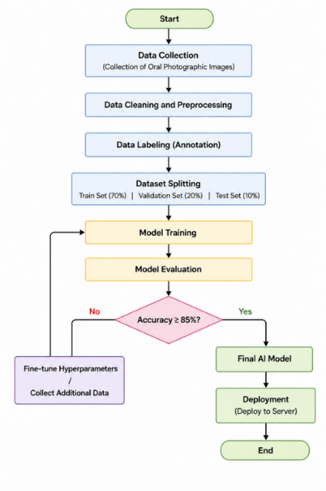
Figure 1. Overall Research Workflow

3.2 Dataset Collection
A total of 1,500 oral photographic images were collected from publicly available scientific databases. The dataset included healthy and gingivitis cases and was divided into 70% training, 20% validation, and 10% testing sets.

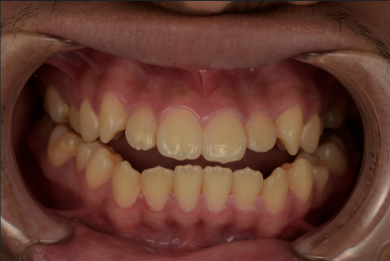
Figure 2. Dataset Examples

3.3 Data Preparation and Preprocessing
The collected images were preprocessed through image cleaning, resizing, normalization, and bounding-box annotation. Images were then categorized into healthy and gingivitis classes to prepare the dataset for model training

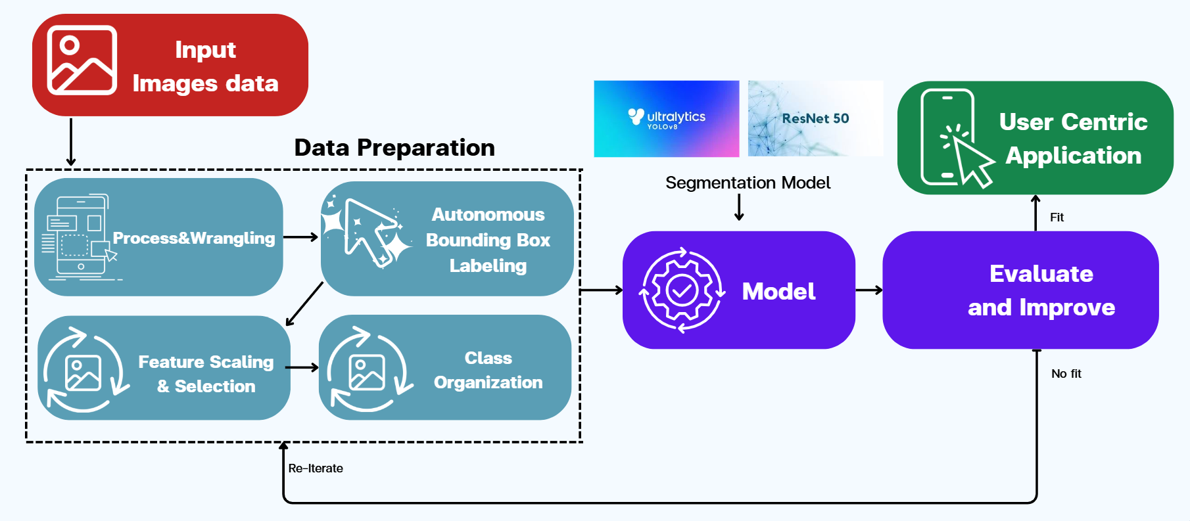
Figure 3.Data Preprocessing Workflow

3.4 Model Development
Two deep learning models were implemented in this study. ResNet50 was used for gingivitis classification, while YOLOv8 was applied to detect and localize inflamed gingival regions using bounding-box detection.

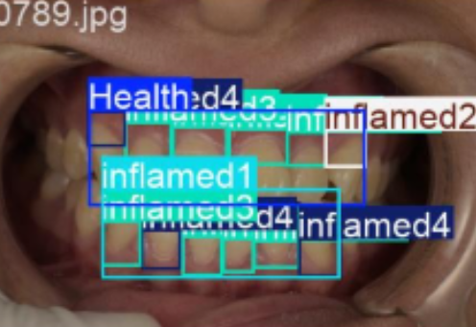
Figure 4. Example of Model Detection Output

3.5 Model Training and Evaluation
The models were trained using the prepared dataset and evaluated on the testing set. Performance was assessed using accuracy, precision, recall, F1-score, and mAP, together with confusion matrices and performance curves.

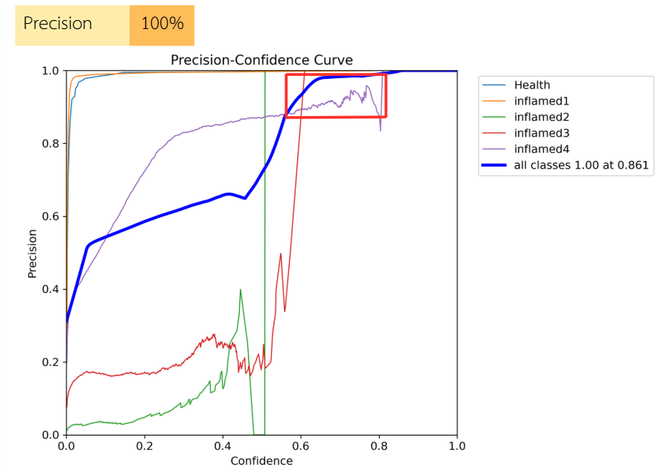
Figure 5. Precision–Confidence Curve

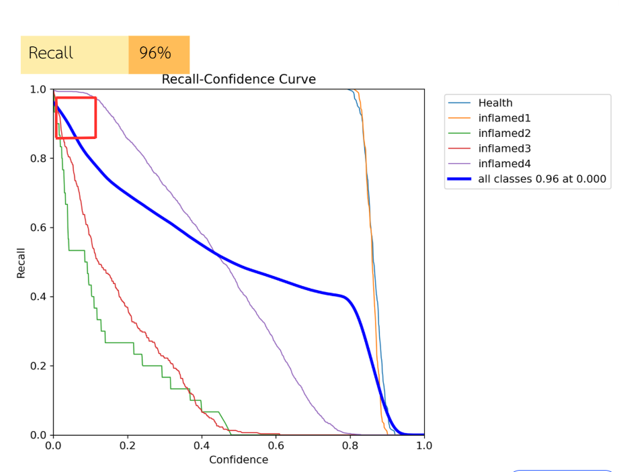
Figure 6. Recall–Confidence Curve

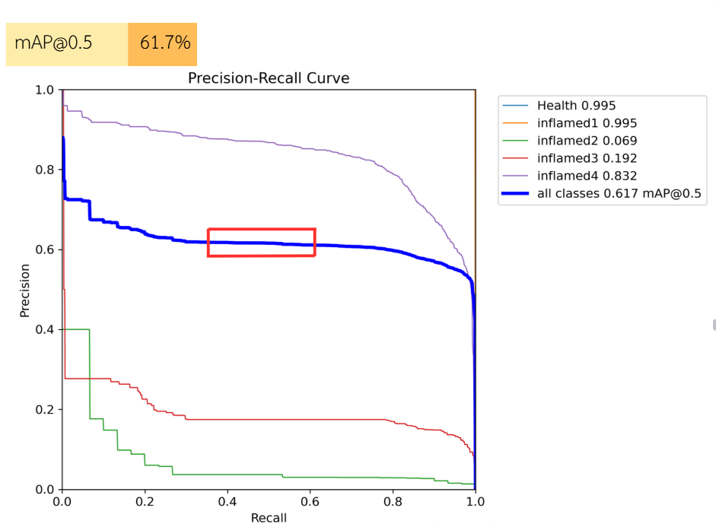
Figure 7. F1–Confidence Curve

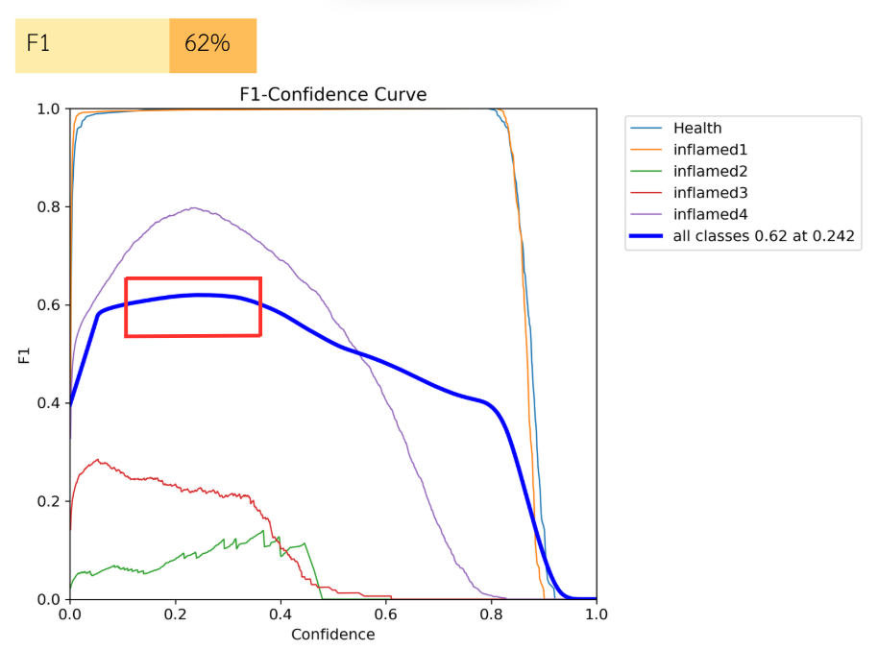
Figure 8. Precision–Recall Curve

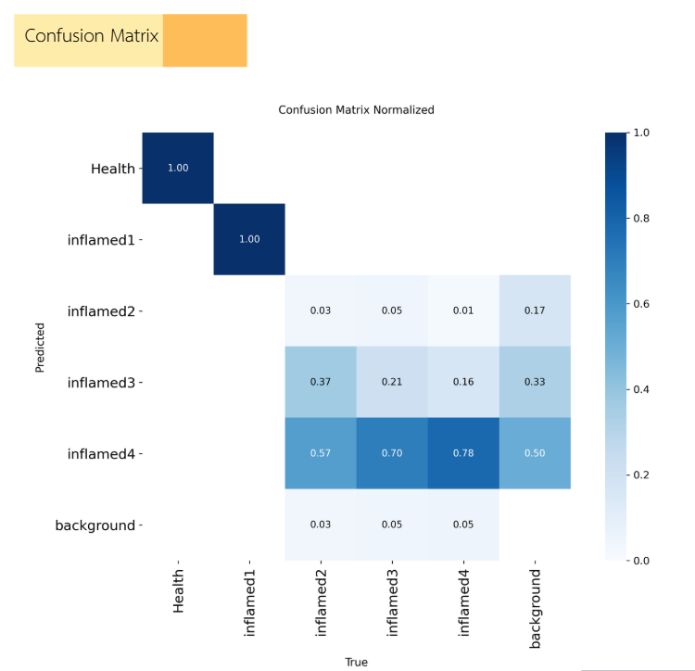
Figure 9. Confusion Matrix Figure

3.6 Application Development
The trained models were integrated into a user-friendly mobile application connected to the LINE Messaging API. Users can upload oral photographs, receive AI-based gingivitis detection results, and obtain preliminary oral health recommendations.



Figure 10. Application Workflow

(1) Step 1 Upload photo
(2) Step 2 AI analysis
(3) Step 3 Result and recommendation

4. RESULTS AND DISCUSSION
The performance of the proposed AI-based system for detecting gingival inflammation was evaluated using a dataset of 1,500 oral photographic images. Two deep learning models, ResNet50 and YOLOv8, were implemented and tested in this study. The experimental results showed that the ResNet50 model achieved an average classification accuracy of 90%, while the YOLOv8 model achieved an accuracy of 85.5%. In addition to classification, YOLOv8 was able to identify and localize inflamed gingival regions using bounding box detection.

Table 1. Performance Comparison of the Proposed AI Models
Model | Purpose | Accuracy(%)
ResNet50 | Gingivitis Classification | 90.0
YOLOv8 | Gingival Inflammation Detection | 85.5

ResNet50 achieved the highest classification accuracy, while YOLOv8 successfully localized inflamed gingival regions using bounding-box detection.

As shown in Table 1, the ResNet50 model achieved a higher classification accuracy compared to YOLOv8. This indicates that ResNet50 is more effective for distinguishing between healthy gingiva and gingivitis in photographic Images The evaluation metrics, including precision, recall, and F1-score, indicated that both models were capable of reliably detecting gingivitis from photographic images. These findings demonstrate that artificial intelligence techniques can effectively assist in the preliminary screening of gingival diseases. The results are consistent with previous studies that applied AI in dental image analysis, suggesting that the proposed system has strong potential for use in oral health screening, particularly in areas where access to dental professionals is limited.

5. CONCLUSION
This study presented the development of GumAI, an artificial intelligence–based system designed to detect gingival inflammation from oral photographic images. The system utilized deep learning models, including ResNet50 and YOLOv8, to analyze visual characteristics of gingival tissues. The experimental results showed that ResNet50 achieved a classification accuracy of 90%, while YOLOv8 achieved 85.5% accuracy with the ability to localize inflamed regions using bounding box detection. These findings demonstrate that artificial intelligence can effectively assist in the preliminary screening of gingivitis using photographic images. The proposed system has the potential to support early detection of gingival diseases and improve accessibility to oral health screening, particularly in areas with limited access to dental services.

6. ACKNOWLEDGMENT
The authors would like to express their sincere appreciation to Princess Chulabhorn Science High School Lampang for providing academic support and research facilities throughout this study. The authors are deeply grateful to their research advisor for continuous guidance, valuable suggestions, and unwavering encouragement. Special thanks are also extended to Chiangrai Prachanukroh Hospital for its expert consultation and professional support in the field of dentistry, which significantly contributed to the development and completion of this research.

REFERENCES
Aykol-Sahin G., Yucel O., Eraydin N., Keles G.C., Unlu U., and Baser U. (2024).
Efficiency of Oral Keratinized Gingiva Detection and Measurement Based on Convolutional Neural Network.
Journal of Periodontology.
Chau R.C.W., Cheng A.C.C., Mao K., Thu K.M., Ling Z., Tew I.M., and Lam W.Y.H. (2025). External Validation of an AI mHealth Tool for Gingivitis Detection among Older Adults at Daycare Centers: A Pilot Study.
International Dental Journal.
Wankawisant A. (2022).
LINE Messaging API Documentation.
Go Online Thailand.
Leite A.F., Van Gerven A., Willems H., Beznik T., Lahoud P., Gaêta-Araujo H., Vranckx M., and Jacobs R. (2021).
Artificial Intelligence-Driven Novel Tool for Tooth Detection and Segmentation on Panoramic Radiographs. Clinical Oral Investigations, 25, 2257–2267.
จิราพร และคณะ. (2566).
รายงานสภาวะสุขภาพช่องปากแห่งชาติ ครั้ง ที่ 9 ประเทศไทย พ.ศ. 2566. กรมอนามัย กระทรวงสาธารณสุข.
Terry P.D., Wilson O.L., Heaton M.L., Triplett O., Heidel R.E., and Dhand R. (2025). Accuracy of Digital Photographs for Assessing Inflammatory Gum Disease in Epidemiologic Studies. Frontiers in Oral Health.

